Parent Council Update
22 March 2023

Staffing
Next session staffing – Mainstream 66.9 FTE, LCSC 13 FTE. This represents a slight decrease in the mainstream allocation and a slight increase in the LCSC allocation. Expected total intake to S1 is 210 – 190 Mainstream and 20 LCSC. This figure could change between now and August.
In mainstream, vacancies in Maths (x3), Modern Languages (x1). In LCSC, 2 vacancies.
SLT changes – Mr Urquhart is expected to return to Caldervale sometime after Easter.

PEF Spend 2022/23 Overview and Impact
Total PEF allocation was £154000
Counselling accounted for £25000 of total PEF spend.
- 41 pupils accessed the service
- Child Outcome Rating Scales (CORS) were taken each session and the data analysed upon disengagement: 36 out of the 41 pupils felt counselling had helped them, with an average of 35.67% improvement
- Wide range of issues being addressed in sessions included: anxiety, psychiatric issues, support in onward referral to CAMHS, loss of a parent, addiction issues, eating disorders, young carers, self harm, disordered attachments among many others.
- Clients are also offered Art Therapy within this counselling service, the majority find the use of the art materials beneficial in helping them express and understand their situation
- Overall view of pupils is that the counselling service is positive and beneficial to them
- Has positively impacted on attendance and engagement

This is in addition to the central funded counselling service – the outcomes of that service are broadly similar.

Staffing accounted for approx. £95000 of PEF spend
An additional 3 teachers were recruited through PEF funding last year. Two staff enabled more time to be created on the timetable for the interventions outlined on attached sheet to be arranged. This also allowed Pupil Support to be provided with 3 additional periods of non class contact time to support pupils and to focus on improving and supporting attendance.

Our Transition Teacher has focussed on supporting learners with literacy and numeracy, building on work which was carried out in P7.

Additional Interventions – See attached – approx £30000

A PT Interventions was appointed to lead a range of interventions over the year – impact of this is on the attached sheet.

Coming out of Covid, much of the focus of our PEF spend has been on young people’s Health & Wellbeing, with a view to increasing engagement and reducing exclusions. Overall, our exclusions have reduced to 46 half days this session, which is down from 160 half days last session (2021/22) and 416 half days in session 2018/19, which was the last full year before Covid.

Next Session PEF Spend
Total allocation will remain at £154000.
Planned spend :
Appointment of DHT funded by PEF to oversee all aspects of PEF programme, including interventions in Health and Wellbeing and Literacy and Numeracy. Cost : Approx £40000
Data collected from primary schools and from our own tracking systems indicate that there is still a significant need for interventions in Literacy and Numeracy. DHT PEF with transition teacher will lead on this.
Health & Wellbeing, and young people’s mental health, remains a priority for us. Interventions will be explored to support this within the school, and using a range of partners. We will also investigate costs for continuing counselling next session. Approx £24000 is anticipated.
MCR Pathways – this is a mentoring programme which will support disengaging learners. Cost approx. £40000
Staffing to allow Pupil Support staff to have increased management time to continue to focus on attendance and supporting young people - £20000

Non PEF matters
PT Employability We will appoint a PT Employability using additional funding from Skills Development Scotland. This post holder will lead on employability in the curriculum, and work with our business partners to secure a range of work related activities for our pupils.
VSE NLC Visit Colleagues from NLC will visit the school week beginning 24th April to validate our self evaluation of learning and teaching. We have been gathering a range of data on this over the last few months, and are currently developing an action plan to move our learning and teaching forward. Colleagues will visit classes and meet with groups of pupils to discuss learning and teaching across the school, and feed back to us.
Kooth Online Counselling Service North Lanarkshire recently procured ‘Kooth’ to provide an online counselling service. It involves self-referrals and gives our young people the opportunity to seek support anonymously should they choose. See attached sheet.
Saturday School This has been ongoing over last couple of weeks. A note of the offering is attached to this update. There will also be an Easter School offering on Tues 4th & Weds 5th April.
Tracking Calendar next session We plan to review our tracking calendar for next session. This will be negotiated with the teaching staff through the normal working time discussions. We would welcome some opinions on the current timings / frequency of tracking information – the actual reports used cannot be changed.
At present :
S1
October
Parents night January
May – full report

S2
November
February – full report
Parents night February
S3
December – full report
Parents night February
April

S456
October
Parents night November
January – with comments
March

Forthcoming key dates :
Last day of term - 31st March
Easter school - Tues 4th & Weds 5th April
Schools reopen - Monday 17th April
Last day for seniors (S456) - Friday 21st April
Study leave - Monday 24th April - Friday 2nd June.
Exam diet is 24 April to 31 May
Monday 1st May - Holiday
Tuesday 2nd May - Inservice day
Monday 8th May – Coronation Day Holiday
Friday 26th & Monday 29th May - Holiday
P7 Transition days - 22nd, 23rd and 24th May
New timetable scheduled for Monday 5th June
Prom - Weds 7th June, Dalziel Park Hotel
Weds 28th June - school closes for summer at 1pm

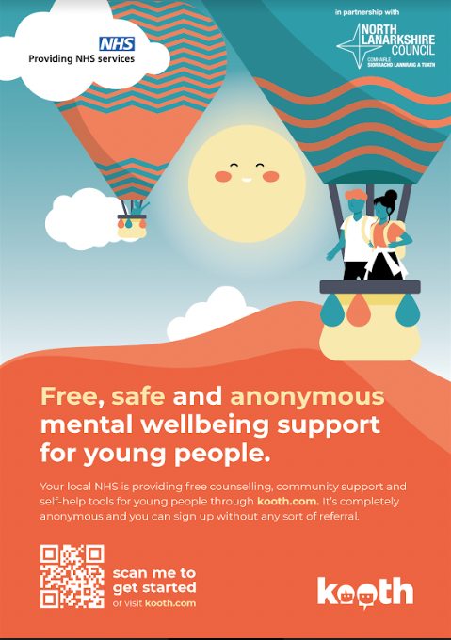

Saturday School Schedule

DAY | Subject | Teacher | TIME | Level
Saturday  11TH MARCH | Modern Studies | Mr McLean | 9.00-11.00 | NAT 5
 |  |  | 11.15 – 13.15 | HIGHER
 | Biology | Mr Ritchie | 9.00 – 11.00 | HIGHER
 |  |  | 11.15 – 13.15 | NAT 5
 | Business Management | Mrs Diamond | 9.00-11.00 | NAT 5
 |  |  | 11.15 – 13.15 | HIGHER
 | English | Mrs Sinclair | 9.00-11.00 | HIGHER
 |  |  | 11.15 – 13.15 | NAT 5
 | History | Miss Petale | 9.00-11.00 | NAT 5
 |  |  | 11.15 – 13.15 | HIGHER
Saturday  18TH MARCH | Modern Studies | Miss Loughran | 9.00-11.00 | NAT 5
 |  |  | 11.15 – 13.15 | HIGHER
 | Biology | Miss Docherty | 9.00 – 11.00 | HIGHER
 |  |  | 11.15 – 13.15 | NAT 5
 | Spanish | Miss McGlynn | 9.00-11.00 | NAT 5
 |  |  | 11.15 – 13.15 | HIGHER
 | Design | Mr Watters | 9.00-11.00 | NAT 5
 |  |  | 11.15 – 13.15 | HIGHER
 | Maths | Mr McArthur | 9.00-11.00 | NAT 5
 |  |  | 11.15 – 13.15 | HIGHER
 | Practical Woodwork | Miss Spalding | 9.00 – 11.00 | NAT 5
 |  |  | 11.15 – 13.15 | NAT 5
Saturday  25TH MARCH | Biology | Miss Littlejohn | 9.00 – 11.00 | HIGHER
 |  |  | 11.15 – 13.15 | NAT 5
 | Spanish | Miss McGlynn | 9.00-11.00 | HIGHER
 |  |  | 11.15 – 13.15 | NAT 5
 | Design | Miss McMillan | 9.00 – 11.00 | NAT 5
 |  |  | 11.15 – 13.15 | HIGHER
 | Chemistry | Miss McCarron | 9.00 – 11.00 | AH
 |  |  | 11.15 – 13.15 | AH
 | Graphic Communication | Miss Spalding | 9.00 – 11.00 | HIGHER
 |  |  | 11.15 – 13.15 | NAT 5

PEF Improvement Reporting - March 2023
TASK / ACTIVITY: Girls Can

Evaluative statement / impact on learners (How are you doing? How do you know?)
The group have finished 75% of their Bronze Youth Achievement Award paperwork and have been working on their personal challenges. As well as the BYA, the girls have successfully achieved the following qualifications:
- CPR
- Intro to boccia
- Fundamentals
- Intro to Kurling
- Disability awareness
- Intro to tri-golf

The pupils were able to use some of these qualifications in practise, as they spent two days each at Hilltop Primary, taking a leadership role to teach one of the sports they had learned to P1 pupils. The girls had to plan, practise, and then implement a lesson. Vikki said they took responsibility for this and were fantastic at the school.
The girls recently completed a Form with questions using the 'Achieving', 'Healthy' and 'Responsible' Shanarri indicators:
Question | Avg Rating
Taking part in Girls Can gives me the opportunity to be involved in sporting activities. | 9.33
Taking part in Girls Can gives me the opportunity to help me build my confidence. | 9.00
Taking part in Girls Can encourages me to play a responsible role in school | 7.67
Taking part in Girls Can encourages me to play a responsible role in my community | 7.67
Taking part in Girls Can allows me to gain more skills. | 9.50
I am encouraged to share my views. | 8.17
I enjoy learning in a smaller setting outwith the classroom. | 9.17
I feel included within the group. | 8.67
The last section asked for a comment:
“I feel like this because I feel included in the group”
“I like going to girls can it has made me come to school more on Tuesdays”
“Being in a smaller group like this makes me feel as if I can talk aloud more and helps me giving my
confidence when talking aloud to others.”
“I feel included in exercises and that I talk more, and that my confidence has improved”
“It’s a good opportunity I have been given and I come to school more because of it”

Vikki has reported a significant increase in the girls’ confidence, so I have highlighted the response that evidences this. The pupils are scheduled to go to the @HOME centre in April and will get their introduction to Youth Work qualification.
The girls who did Girls Can last year are still involved in the @HOME centre in their spare time, and Vikki believes this will be the same with the current cohort. Many of the girls have expressed interest in pursuing a career in coaching / teaching or working with children due to their participation in Girls Can.

PEF Improvement Reporting - March 2023
TASK / ACTIVITY: S3 Karate / Support for Sport

Evaluative statement / impact on learners (How are you doing? How do you know?)
The group are currently collecting the paperwork to get their Karate Licence so that Vinny can grade them.
The group filled in a Form with questions using the 'Achieving' and 'Healthy' Shanarri indicators:
Question | Avg Rating
I feel that Karate gives me the opportunity to take part in active sport. | 7.25
Whilst doing Karate I can experience success. | 7.25
I feel that Karate helps my mental health | 9.50
I feel that Karate helps my physical health | 5.50
During Karate I feel part of the school community | 3.00
I have enjoyed the Karate Intervention | 8.25
The boys didn’t add a comment at the end, but we had a group discussion where they stated that working in a smaller group was beneficial, and that they enjoyed being out of difficult classes and feeling like they were achieving something. They also said that they would like to continue with karate.

As well as achieving their licence and being graded, the boys responded that they felt that the Karate intervention helped their mental health. When asked to elaborate on this, the pupils explained that being able to be good at something made them feel good, and that working with a male role model in a more informal setting helped them relax and pay attention more than in a classroom situation.
This group also meets with a North Lanarkshire coach on Wednesdays and have chosen the activity of Football. The boys will also have the opportunity to visit Airdrie Leisure Centre to get an induction and sign up for a free gym membership.

PEF Improvement Reporting - March 2023
TASK / ACTIVITY: S3 Support for Sport/Leadership with Mr McLean

Evaluative statement / impact on learners (How are you doing? How do you know?)
This group work with a North Lanarkshire coach on Wednesdays and with R McLean on Fridays completing leadership and life skills. Mr McLean has used his experience in Boys Brigade to create activities that develop skills, build confidence, and encourage the pupils to be responsible.
On Wednesdays, the boys chose the activity of football, and will soon have the opportunity to visit Airdrie Leisure Centre to get an induction and a free gym membership.
The boys completed a Form with questions using the 'Achieving', 'Healthy' and 'Responsible' Shanarri indicators:

Question | Avg Rating
Taking part in this intervention gives me the opportunity to be involved in sporting activities. | 9.50
Taking part in this intervention gives me the opportunity to help me build my confidence. | 8.00
Taking part in this intervention encourages me to play a responsible role in school | 7.00
Taking part in this intervention encourages me to play a responsible role in my community | 7.67
Taking part in this intervention allows me to gain more skills. | 9.00
I am encouraged to share my views. | 9.50
I enjoy learning in a smaller setting outwith the classroom. | 9.67
I feel included within the group. | 9.67
The last section asked for a comment, so we discussed anything they’d like to add. The consensus was that they enjoyed working with Mr McLean and felt he was a positive male role model for them. They enjoy working in a smaller setting and asked about continuing something like this next year. They commented that they felt like they had the opportunity to complete tasks that would help them more than the classes that they were missing.

PEF Improvement Reporting - March 2023
TASK / ACTIVITY: S3 Live N Learn

Evaluative statement / impact on learners (How are you doing? How do you know?)
The S3 completed a workshop called “Mindset Matters” which was to help prepare them for S4 and the expectations around exams. The pupils worked with Jen, doing activities that are to build confidence and resilience by developing personal responsibility and a growth mindset.
Jen spoke highly of the S3’s and praised their willingness to participate. After the workshops, the S3 had to fill in an evaluation form to provide feedback. The results for the question “how confident are you about your upcoming assessments and exams” was answered as follows:

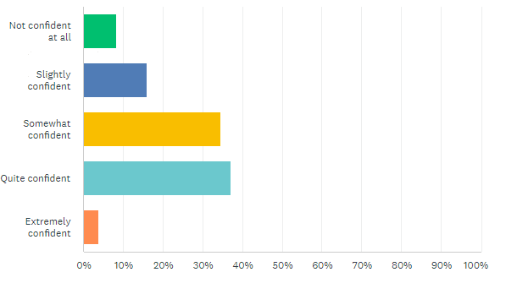

Jen explained that their programme of workshops aims to close the attainment gap by working with young people to achieve equity in educational outcomes by raising aspirations, building confidence and changing attitudes.
Live N Learn also worked with S4-S6, building upon the visits from last year to reiterate the messages and increase efficacy. We are still waiting on the feedback from these sessions as they were rescheduled only took place at the end of February. However, anecdotally the pupils have expressed that they enjoyed the workshops and found them incredibly helpful in providing study techniques and boosting their confidence.

