

Driving Equity and Excellence

Improvement Action Plans

Session 2025-26

School: | Calderbridge PS
Cluster: | Coltness
Head Teacher: | Diana Osborne

Improvement Plan Summary
School Priority 1: | To raise attainment and engagement in writing for all pupils, with a targeted focus on improving access, progress, and enjoyment for pupils with ASD through inclusive teaching strategies and personalised support.
School Priority 2: | To improve the quality, consistency, and engagement of science teaching and learning, with a specific focus on developing pupils’ skills in scientific enquiry and investigative thinking as part of a broader STEM curriculum.
Nursery Class Priority: | To improve children’s ability to sustain and extend their learning across different areas of the nursery by enhancing transitions within play, strengthening practitioner responsiveness, and creating a coherent, connected learning environment indoors and outdoors.

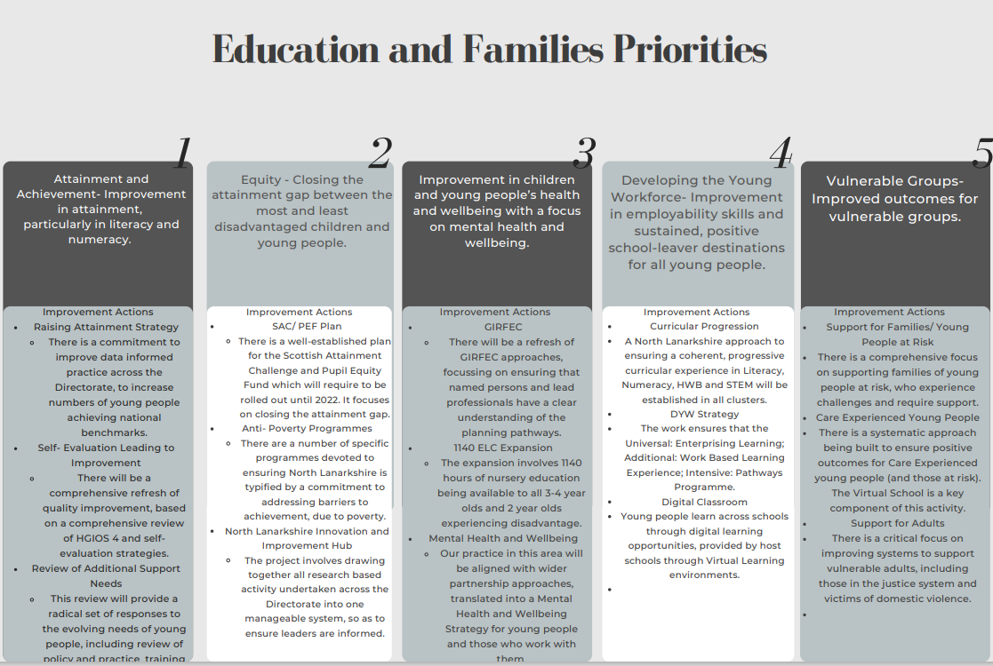

School Vision and Values
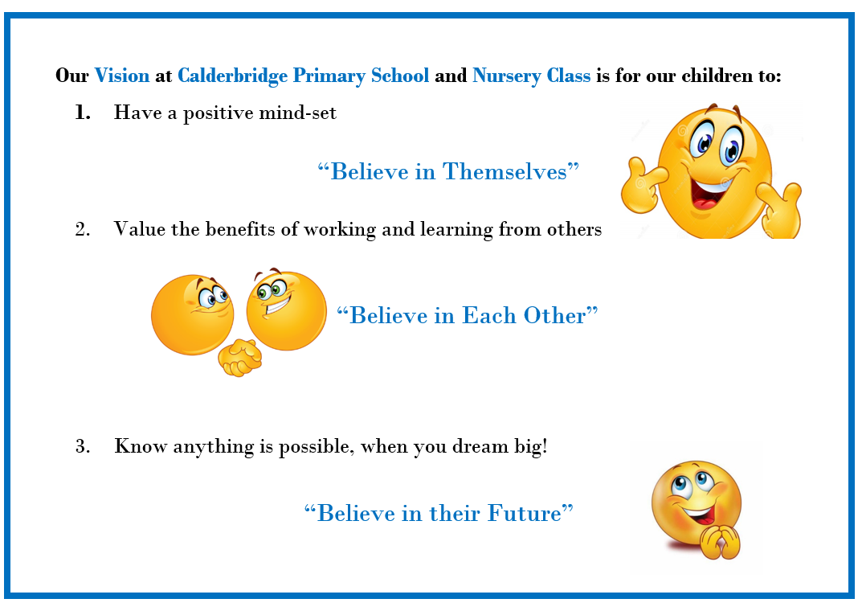Our Core Values are to be Ready, Respectful and Safe!

Audit and Consultation

In arriving at our improvement priorities, the school has taken account of Education and Families’ priorities, an audit of the previous year’s improvement plan and engagement with parents/carers and learners.

Details of engagement (pupils, parents/carers, partners)

Staff Meetings
Parent Surveys and Focus Groups
Pupil Voice Activities
EFM strategic planning session and review of AIR
Community Engagement

If your annual improvement priorities are part of a wider, longer term, 3-year strategic plan, please use the template below to outline your longer-term plan. (This overview is optional and does not need to be completed but will provide an overview of your improvement journey.)

 | Priority 1 | Priority 2 | Nursery
Year 1: Session 2025-2026 | To raise attainment and engagement in writing for all pupils, with a targeted focus on improving access, progress, and enjoyment for pupils with ASD through inclusive teaching strategies and personalised support | To improve the quality, consistency, and engagement of science teaching and learning, with a specific focus on developing pupils’ skills in scientific enquiry and investigative thinking as part of a broader STEM curriculum. | To improve children’s ability to sustain and extend their learning across different areas of the nursery by enhancing transitions within play, strengthening practitioner responsiveness, and creating a coherent, connected learning environment indoors and outdoors.
Year 2: Session 2026-2027 | To strengthen oracy, communication, and language skills across the curriculum, ensuring all pupils—particularly those with communication needs—have the tools to express themselves, interact meaningfully, and access learning effectively. | To improve the consistency and quality of learning and teaching in Technologies and Engineering for all learners by ensuring increased engagement in purposeful, creative, and collaborative problem-solving contexts. | To enhance children's independence, decision-making, and ability to lead their own learning through increased autonomy, voice, and purposeful access to resources and environments.
Year 3: Session 2027 - 2028 | To embed real-world, purposeful learning experiences that develop pupils’ confidence, creativity, and problem-solving through interdisciplinary projects, pupil voice, and community engagement. | To improve the consistency and quality of learning, teaching, and assessment of STEM for all learners by ensuring progression in knowledge and skills, increased pupil engagement, and meaningful application through interdisciplinary and real-world contexts. | To foster children’s social and emotional competence by strengthening collaboration, communication, and empathy through purposeful group experiences, emotional literacy, and community connections.

2025-26 Improvement Plan

Priority 1: Long Term Outcome  What do you hope to achieve? What is going to change? For whom? By how much? By When? |  | To raise attainment and engagement in writing for all pupils, with a targeted focus on improving access, progress, and enjoyment for pupils with ASD through inclusive teaching strategies and personalised support
Person(s) Responsible  Who will be leading the improvement? | PEF PT Laura Livingstone and Literacy Working Party

(Please insert the relevant information below using the codes above)
NIF Priority: 3, 5 |  | NIF Driver:1,2,3,4,6
NLC Priority:1,2,,5 |  | QI:1.1, 1.3, 1.5, 2.4, 2.3
PEF Intervention:4,5,6,7 |  | Developing in Faith/UNCRC:
If you used any aspect of your PEF fund to support this priority; please detail the expenditure here:
PEF PT Differential
RATIONALE (WHY?) Why have you identified this as a priority? What data did you have to support this?
This priority has been identified in response to attainment data, learning conversations, and classroom observations, which indicate a gap in writing outcomes and engagement, particularly for pupils with ASD. Many pupils with additional needs face barriers to writing, including difficulties with language processing, sensory regulation, and task initiation.
Tracking data shows lower progress rates in writing compared to reading and maths, while feedback from pupils with ASD highlights a lack of confidence and enjoyment in writing tasks. By focusing on inclusive strategies and personalised support, we aim to remove barriers, improve access, and raise both achievement and enjoyment in writing fr all learners.
Resources: Please include costs and, where relevant, state where cost is being met from, specifically if using PEF. Please denote PEF/or colour code if preferred, to indicate where PEF spend aligns with targets.

PEF PT to lead improvement and build capacity of staff to support learners with ASD barriers to overcome challenges, improving engagement and attainment.

EXPECTED IMPACT  (SHORT TERM TARGETS) | INTERVENTIONS/ACTIONS TO SUPPORT IMPROVEMENT: HOW? |  | HOW WILL YOU TRACK PROGRESS?  MEASURES | EVALUATION CHECKPOINT 1 (Internal Process) | EVALUATION CHECKPOINT 2 (Internal Process)
What will be the benefit for learners (be specific)? | What are you going to do to make the change? What key actions are required? Consider links to the NIF Drivers. |  | What ongoing information will demonstrate progress? (Qualitative, Quantitative – short/medium/long term data)
Clear picture of strengths/gaps; ASD learners identified for targeted support by August 2025 and updated June 2026 | - PT PEF with Literacy WP to audit current writing provision and pupil barriers (including for ASD) |  | Qualitative Evidence:  - Case studies of individual ASD learners showing improved access to writing tasks.  - Pupil voice from ASD learners on how accessible and enjoyable writing feels now.  Quantitative Evidence:  - Number of ASD pupils identified with specific writing support plans in place.  - Progress data from baseline writing assessments to end-of year attainment in writing.
Increased participation and reduced writing anxiety for identified pupils by June 2026 | - Majority of Class Teachers will implement inclusive classroom strategies (visuals, scaffolds, sensory supports, comics etc)  - Identified CT will introduce assistive technology (Clicker, dictation tools, laptops) where appropriate.  - CT will use low-stakes, high-interest writing experiences to reduce anxiety. |  | Qualitative Evidence:  - Pupil Learning Conversations: comments indicating greater confidence, reduced frustration, or increased enjoyment during writing.  - Teacher observations: more independent initiation of writing tasks, less reliance on prompts or adult support.  - Learning visits / jotter reviews: visible use of visuals, structured supports, and evidence of pupil-led writing choices.  Quantitative Evidence:  - Engagement tracking: increase in time spent on writing tasks and number of pupils completing tasks independently.  - Behavioural data: reduction in writing-related incidents (e.g. refusals, anxiety behaviours logged).  - Writing attainment: improvement in formative assessments.
Increase staff confidence and consistency in supporting all learners by June 2026 | - PT PEF to carry out research in collaboration with Educational Psychology.  - PT PEF with Ed Psych to deliver CPD on neurodiversity, inclusive writing practice and autism-friendly classrooms  - Peer & SLT learning visits.  - CT’s share case studies and classroom adaptations through staff sharing opportunities. |  | Qualitative Evidence:  - Staff reflections in survey showing increased understanding and application of inclusive strategies.  - Peer observations highlighting inclusive teaching approaches being used consistently.  - Professional dialogue during team meetings or moderation sessions evidencing shared language and practice.  Quantitative Evidence:  - Pre- and post-CPD surveys showing improvement in staff confidence and perceived competence.
Identified pupils will have increased motivation and improved outcomes in writing | - CT plan and deliver personalised writing tasks for identified ASD learners  - SLT will monitor Girfme plans and planning to show specific strategies in place to overcome barriers to writing.  - Literacy working party will create a guide for staff to refer to help identify strategies.  - Collaborative tracking, monitoring and target setting meetings. |  | Qualitative Evidence:  - Pupil voice: expressions of enjoyment, pride, or preference for writing tasks linked to their interests or strengths.  - Teacher observations: increased task engagement, independence, and focus during writing activities.  - Writing samples: evidence of individualised content, structure, or support being used effectively.  Quantitative Evidence:  - Frequency of completed writing tasks: more regular output from targeted pupils.  - Progress against individual targets met.  - Assessment data: termly tracking showing progress in writing attainment for identified ASD pupils.
Identified pupils will have improved structure, fluency, and independence in writing | - CT Introduce targeted writing interventions (e.g. Talk for Writing, Colourful Semantics, Clicker)  - PEF PT with SAM Group will identify appropriate assistive technology and provide pupil and staff training.  - CT will improve practice in providing quality feedback and actioning next steps. |  | Qualitative Evidence:  - Pupil jotters/ documents: show improved organisation, use of language structures, and increased length/complexity of writing.  - Teacher observations: note increased independence, sustained writing effort, and transfer of strategies into class writing.  - Learning conversations: increased confidence and clarity about how to approach writing tasks.  Quantitative Evidence:  - Baseline cold vs. hot assessments: measurable improvements in writing attainment (e.g. sentence construction, punctuation, paragraphing).  - Number of pupils meeting writing targets.
Positive shift in attitudes towards writing, especially for ASD pupils | - Learning conversations carried out to capture pupil voice on writing confidence and enjoyment |  | Qualitative Evidence:  - Learning conversations o showing greater self-awareness and positive feelings about writing.  - Pupil feedback on specific tasks or strategies (e.g. "I liked using the story map because it helped me start").  Quantitative Evidence:  - Pre- and post-attitudinal surveys  - Frequency of completed writing tasks as an indirect measure of motivation and ownership.
Clear evidence of progress and narrowing of attainment gaps for identified pupils by June 2026 | - Track progress and engagement in writing over time  - Target Setting and progress meetings  - CT will carry out cold and hot tasks  - Development of self, peer and teacher assessment and next steps being actioned.  - Moderation activities |  | Qualitative Evidence:  - Work scrutiny samples across terms showing improvements in quality, structure, and depth of writing.  - Pupil learning conversations: pupil reflections on how their writing has improved or become more enjoyable over time.  Quantitative Evidence:  - Termly attainment data showing improved writing levels for target groups, especially ASD pupils.  - Writing moderation records confirming progression and consistency in assessment.
Final evaluation (for submission):

Priority 2: Long Term Outcome  What do you hope to achieve? What is going to change? For whom? By how much? By When? |  | To improve the quality, consistency, and engagement of science teaching and learning, with a specific focus on developing pupils’ skills in scientific enquiry and investigative thinking as part of a broader STEM curriculum.
Person(s) Responsible  Who will be leading the improvement? | PT Pamela Cairney and Digital Working Party

(Please insert the relevant information below using the codes above)
NIF Priority: 3, 5 |  | NIF Driver: 2, 5
NLC Priority: 4 |  | QI: 1.1, 1.2, 1.3, 2.2, 2.3
PEF Intervention:8 |  | Developing in Faith/UNCRC:
If you used any aspect of your PEF fund to support this priority; please detail the expenditure here:

RATIONALE (WHY?) Why have you identified this as a priority? What data did you have to support this?
Last session, the successful introduction of the North Lanarkshire Digital Literacy Pathways provided a strong foundation for digital learning. However, medium-term planning, staff evaluations, and staff discussion have identified that many areas of STEM—particularly Science and Scientific Enquiry—are not being explicitly taught.
Staff have reported low confidence in STEM pedagogies and highlighted that science resources are outdated or insufficient. In addition, pupil consultation revealed that learners are often unmotivated in science and do not always recognise when they are being taught science or engaging in enquiry.
This session, we will address this gap by building staff confidence in delivering high-quality STEM learning, with a particular focus on Science and Scientific Enquiry. We will strengthen our understanding and use of the NL Science pathways, improve the quality and consistency of science teaching, and ensure pupils experience engaging, practical science learning that develops their investigative thinking and skills for life.
Resources: Please include costs and, where relevant, state where cost is being met from, specifically if using PEF. Please denote PEF/or colour code if preferred, to indicate where PEF spend aligns with targets.

Science equipment (see NL STEM ‘kit-list’) and storage
MathsBURST online modules, teaching resources, assessments and required resources.

EXPECTED IMPACT  (SHORT TERM TARGETS) | INTERVENTIONS/ACTIONS TO SUPPORT IMPROVEMENT: HOW? |  | HOW WILL YOU TRACK PROGRESS?  MEASURES | EVALUATION CHECKPOINT 1 (Internal Process) | EVALUATION CHECKPOINT 2 (Internal Process)
What will be the benefit for learners (be specific)? | What are you going to do to make the change? What key actions are required? Consider links to the NIF Drivers. |  | What ongoing information will demonstrate progress? (Qualitative, Quantitative – short/medium/long term data)
Almost all learners will develop and apply their digital literacy skills through meaningful cross-curricular learning experiences. | We will embed the NL Digital Literacy pathways, giving all learners regular, purposeful opportunities to use digital tools in their learning.  ‘ |  | Qualitative Evidence:  - Planning and observations show regular integration of digital tools in cross-curricular contexts  Quantitative Evidence:  - Almost all of teachers consistently using NL Digital Literacy pathways in planning  - Number of cross-curricular projects completed that include digital components
Almost all learners will experience more consistent, structured science teaching with opportunities for enquiry-based learning. | Audit current science provision and map use of NLCScience Pathways and Scientific Enquiry |  | Qualitative Evidence:  - Staff planning and evaluations showing increased use of pathways and enquiry focus.  - Feedback from staff surveys and learning conversations indicating improved understanding and confidence.  Quantitative Evidence:  - Almost all of teachers using NL Science Pathways consistently across planning by Feb 26.
All children will be provided with the opportunity to progressively build enquiry skills, and the ability to apply scientific thinking to real-life contexts. | Develop a progressive Scientific Enquiry framework (linked to NL pathways) |  | Qualitative Evidence:  - Staff feedback indicates increased confidence in planning and teaching enquiry skills  - Pupil voice reflects better understanding and use of enquiry vocabulary and processes  Quantitative Evidence:  - Increase in planned science lessons explicitly referencing specific enquiry skills
Almost all learners experience high-quality, consistent science lessons where they are actively involved in hands-on investigations. | Provide CLPL on teaching Scientific Enquiry (incl. fair testing, observation, analysis, drawing conclusions) |  | Qualitative Evidence:  - Staff feedback and evaluations show increased confidence in teaching enquiry skills  - Observations show improved delivery of enquiry-based lessons and use of consistent language across majority classes  Quantitative Evidence:  - Increase in lessons featuring enquiry elements (tracked through planning or observation)
Learners will be more engaged and motivated through hands-on science investigations that develop enquiry skills. | Introduce termly class-based or whole-school science investigations |  | Qualitative Evidence:  - Pupil voice shows increased enthusiasm, and understanding of scientific enquiry  - Classroom observations show active involvement in hands-on tasks a  Quantitative Evidence:  - Number of investigations planned and delivered across classes each term
Improved resources will support participation in investigations, boosting understanding, and enquiry skills for almost all learners. | Improve science resources to support practical investigations at all stages |  | Qualitative Evidence:  - Staff feedback indicates increased confidence in delivering practical science lessons  - Observations show greater use of hands-on investigations across stages  - Pupil voice reflects improved engagement in practical science activities  Quantitative Evidence:  - Resource audit shows increase in availability and use of science materials across classes  - Number of practical science lessons increases (tracked via planning)  - Tracking data shows improvement in pupil enquiry skills linked to practical experiences
Pupil STEM Leaders will promote a positive attitude to science, increase participation in enquiry, and build leadership and confidence across the school. | Launch Pupil STEM Leaders to promote enquiry learning and peer support |  | Qualitative Evidence:  - Pupil voice indicates increased confidence, leadership, and enthusiasm for science  - Science Champions actively contribute to class investigations, assemblies, and clubs  Quantitative Evidence:  - Number of pupils participating as Science Champions across the school  - Increase in pupil-led science activities or contributions to enquiry-based learning
Most learners can identify their progress, evaluate their success, and set next steps using agreed success criteria. | Introduce consistent use of shared learning intentions and success criteria (SC) across all classes, with regular opportunities for self and peer assessment to support reflection, progress tracking, and next-step planning. |  | Qualitative Evidence:  - Learner conversations show understanding of success criteria and ability to reflect on progress  - Class observations show regular use of learning intentions and SC in lessons  - Staff feedback reflects increased pupil independence and ownership of learning  Quantitative Evidence:  - Almost all lessons observed using clearly displayed and discussed LIs and SC  - Tracking data shows improved pupil progress linked to clearer understanding of learning goals
Almost all learners will develop and apply their digital literacy skills through meaningful cross-curricular learning experiences. | We will embed the NL Digital Literacy pathways, giving all learners regular, purposeful opportunities to use digital tools in their learning.  ‘ |  | Qualitative Evidence:  - Planning and observations show regular integration of digital tools in cross-curricular contexts  Quantitative Evidence:  - Almost all of teachers consistently using NL Digital Literacy pathways in planning  - Number of cross-curricular projects completed that include digital components
Targeted learners will improve their spatial reasoning skills, leading to stronger numeracy and mathematics attainment and enhanced readiness for future STEM learning. | Deliver targeted CLPL to identified class teachers in the use of MathsBURST, focusing on developing spatial reasoning to raise maths attainment. This will be achieved through strategic partnerships. Teachers will apply learning to plan and deliver spatialised maths lessons. |  | Qualitative Evidence:  - Teacher reflections and CLPL evaluations indicate increased confidence and competence in delivering spatialised maths lessons  - Planning and classroom observations show integration of spatial reasoning strategies and MathsBURST approaches  Quantitative Evidence:  - Pre- and post-intervention data from the MathsBURST assessment shows measurable improvement in pupil spatial reasoning skills  - Improved attainment scores in class assessments for targeted learners
Final evaluation (for submission):

Priority 3: Long Term Outcome  What do you hope to achieve? What is going to change? For whom? By how much? By When? |  | To improve children’s ability to sustain and extend their learning across different areas of the nursery by enhancing transitions within play, strengthening practitioner responsiveness, and creating a coherent, connected learning environment indoors and outdoors
Person(s) Responsible  Who will be leading the improvement? | Jill Dowson, DHT and Nursery staff

(Please insert the relevant information below using the codes above)
NIF Priority: 4, 5 |  | NIF Driver: 1, 3 and 5
NLC Priority: HGIOELC |  | QI: 1.1, 2.2, 2.3, 2.4, 3.2 and 3.3
PEF Intervention: N/A |  | Developing in Faith/UNCRC:
If you used any aspect of your PEF fund to support this priority; please detail the expenditure here:

RATIONALE (WHY?) Why have you identified this as priority? What data did you have to support this?

This priority was identified to ensure all children develop knowledge, understanding, and skills across all curricular areas. Observations, practitioner feedback, and engagement data highlighted inconsistencies in how children sustained and extended their learning across the nursery. By strengthening transitions within play, enhancing practitioner responsiveness, and creating a more connected and coherent environment, we aim to support deeper, continuous learning—maximising engagement, independence, and progress for all children.

Resources: Please include costs and, where relevant, state where cost is being met from, specifically if using PEF. Please denote PEF/or colour code if preferred, to indicate where PEF spend aligns with targets.

EXPECTED IMPACT  (SHORT TERM TARGETS) | INTERVENTIONS/ACTIONS TO SUPPORT IMPROVEMENT: HOW? |  | HOW WILL YOU TRACK PROGRESS?  MEASURES | EVALUATION CHECKPOINT 1 (Internal Process) | EVALUATION CHECKPOINT 2 (Internal Process)
What will be the benefit for learners (be specific)? | What are you going to do to make the change? What key actions are required? Consider links to the NIF Drivers. |  | What ongoing information will demonstrate progress? (Qualitative, Quantitative – short/medium/long term data)
The majority of children will transition more independently and smoothly across different areas, maintaining engagement in play. | Audit and improve the flow of transitions between indoor and outdoor areas to reduce disruption to learning. |  | Qualitative:  - Practitioner observations note reduced adult prompts needed during transitions.  - Learning stories capture examples of children independently extending play across areas (e.g., moving from small world to mark-making to extend a narrative).  - Staff reflections in planning meetings indicate improved confidence in supporting child-led transitions.  Quantitative:  - Leuven Involvement Scale scores remain consistently high before, during, and after transitions for the majority of children.  - Reduction in incidents of disengagement, unsettled behaviour, or support required during transition points
Most practitioners will confidently extend and scaffold learning through timely, responsive interactions. | Provide focused CPD for staff on responsive interactions, sustained shared thinking, and in-the-moment planning. |  | Qualitative:  - CPD feedback and practitioner reflections show increased awareness of what effective, responsive interactions look like.  - Observations capture more frequent use of open-ended questioning, sustained shared thinking, and in-the-moment planning.  - Peer or senior leader feedback notes improved confidence and intentionality during interactions.  Quantitative:  - CPD attendance and follow-up surveys show a high percentage of staff reporting improved understanding and confidence (e.g., 80%+ feel more confident post-training).
Learning will be more continuous and coherent, enabling most children to revisit, build upon, and deepen ideas over time | Introduce consistent routines and signals that support most children to move independently and purposefully between spaces. |  | Qualitative:  - Observations and learning stories show children returning to previous interests or themes and developing them with increasing complexity.  - Learning Journals reflect continuity in learning over time (e.g., a child’s interest in transport evolving into map-making or role-play).  Quantitative:  - Progress tracking shows children making steady developmental gains across linked learning areas.  - A higher percentage of planned experiences are built upon children’s prior knowledge
Increased levels of involvement and engagement will be observed across the nursery environment. | Embed regular practitioner observations and reflections to identify and respond to children’s interests and learning needs. |  | Qualitative Data  - Regular observations document children sustaining attention for longer periods, showing focus, enthusiasm, and purpose in their play.  - Learning stories capture more examples of deep engagement, with children returning to themes or initiating extensions to their own learning.  - Practitioner reflections and team discussions highlight noticeable improvements in children's concentration, curiosity, and motivation during free play and adult-guided experiences.  Quantitative Data  - Leuven Involvement Scale assessments, carried out termly, show a measurable increase in the number of children consistently scoring 4 or 5 (high involvement).  - Monitoring of area usage shows more balanced and purposeful use of all learning zones, indicating increased engagement across the full environment.

PEF ALLOCATION: £


nOrth Lanarkshire Council
Education & FAMILIES
EQUITY PLAN 2025-26
(Internal recording; random sampling of PEF/Equity Plans
will continue throughout the session).

Rationale for EQUITY (PEF) plan
Please provide below detail around your rationale for the Equity plan. Highlight how PEF expenditure is integrated to support improvement priorities.
For priorities around equity please detail the poverty related gap which you are addressing and the data which supports your rationale.
Consider the following: attainment, health & wellbeing, attendance, exclusion, participation, engagement.

Link to Improvement Plan | Detailed Costings | Priority/Description | Intended Outcome/Impact  Please describe your planned use of SAC resource/PEF allocation and what you intend to achieve. | Evidence/Measures  Please indicate what evidence you are going to collect to show impact and progression.
Attainment in Writing | Differential PEF PT | To close the poverty-related attainment gap in writing by improving outcomes for identified pupils through targeted literacy interventions, inclusive classroom practices, and enhanced support for health, wellbeing, and engagement. | Identified pupils will make measurable progress in writing attainment, narrowing the poverty-related gap.  Learners will show increased confidence, motivation, and stamina in writing tasks.  All pupils will benefit from more inclusive and responsive teaching practices.  Improved wellbeing and engagement will lead to more consistent participation and improved learning outcomes in literacy. | Standardised writing assessments (e.g. SNSA, school-based benchmarks) for targeted pupils  Teacher judgment data from tracking and moderation  Progress in extended writing samples (before/after interventions)  Learning conversation. Children know targets and how to improve
All areas | PEF Match Funding 2 x 0.5 | To improve the health and wellbeing of targeted pupils affected by poverty and/or facing barriers related to diversity, through nurturing, inclusive, and trauma-informed approaches that support emotional regulation, resilience, and readiness to learn. | Targeted pupils will feel safe, included, and supported, improving their emotional wellbeing and readiness to learn.  Learners affected by poverty or barriers linked to diversity will show increased resilience, self-regulation, and positive relationships with peers and staff.  Improved attendance, engagement, and participation in learning and wider school life.  Staff will feel more confident in delivering nurturing, trauma-informed approaches, supporting long-term wellbeing and inclusion. | Pupil surveys and check-ins.  Observations of mood, behaviour, and engagement.  Use of wellbeing tools - SHANARRI or Leuven Scale.  Pastoral logs – reduced no. Of incidents.  Feedback from pupils on how they feel and manage challenges through LC  Attendance and lateness tracking (focus for targeted pupils).  Records of participation in school activities or clubs.  Staff self-evaluations and reflections detailing impact and informing next steps.  PLP – GIRfme, CSP showing improvements over time

Appendix 1:
When considering your School Improvement Priorities, you are asked to provide links to the following, as well as the Quality Indicators within HGIOS4 and HGIOELC:
UNCRC | HGIOS 4 | National Improvement Framework
Article 1 - definition of the child  Article 2 - non-discrimination  Article 3 - best interests of the child  Article 4 - implementation of the Convention  Article 5 - parental guidance and child's evolving capacities  Article 6 - life, survival and development  Article 7 - birth registration, name, nationality, care  Article 8 - protection and preservation of identity  Article 9 - separation from parents  Article 10 - family reunification  Article 11 - abduction and non-return of children  Article 12 - respect for the views of the child  Article 13 - freedom of expression  Article 14 - freedom of thought, belief and religion  Article 15 - freedom of association  Article 16 - right to privacy  Article 17 - access to information from the media  Article 18 - parental responsibilities and state assistance  Article 19 - protection from violence, abuse and neglect  Article 20 - children unable to live with their family  Article 21 – adoption  Article 22 - refugee children  Article 23 - children with a disability  Article 24 - health and health services  Article 25 - review of treatment in care  Article 26 - social security  Article 27 - adequate standard of living  Article 28 - right to education  Article 29 - goals of education  Article 30 - children from minority or indigenous groups  Article 31 - leisure, play and culture  Article 32 - child labour  Article 33 - drug abuse  Article 34 -sexual exploitation  Article 35 - abduction, sale and trafficking  Article 36 - other forms of exploitation  Article 37 - inhumane treatment and detention  Article 38 - war and armed conflicts  Article 39 - recovery from trauma and reintegration  Article 40 - juvenile justice  Article 41 - respect for higher national standards  Article 42 - knowledge of rights  Article 14 - freedom of thought, belief and religion  Article 15 - freedom of association  Article 16 - right to privacy  Article 17 - access to information from the media  Article 18 - parental responsibilities and state assistance | 1.1: Self-evaluation for self-improvement  1.2: Leadership for learning  1.3: Leadership of change  1.4: Leadership and management of staff  1.5: Management of resources to promote equity  2.1: Safeguarding and child protection  2.2: Curriculum  2.3: Learning teaching and assessment  2.4: Personalised support  2.5: Family learning  2.6: Transitions  2.7: Partnerships  3.1: Ensuring wellbeing, equality and inclusion  3.2: Raising attainment and achievement  3.3: Increasing creativity and employability  PEF INTERVENTIONS  - Early intervention and prevention  - Social and emotional wellbeing  - Promoting healthy lifestyles  - Targeted approaches to literacy and numeracy  - Promoting a high quality learning experience  - Differentiated support  - Using evidence and data  - Employability and skills development  - Engaging beyond the school  - Partnership working  - Professional learning and leadership  - Research and evaluation to monitor impact  EDUCATION AND FAMILIES’ PRIORITIES  - Improvement in attainment, particularly literacy and numeracy  - Closing the attainment gap between the most and least disadvantaged children  - Improvement in children and young people’s health and wellbeing with a focus on mental health and wellbeing  - Improvement in employability skills and sustained, positive school leaver destinations for all young people  - Improved outcomes for vulnerable groups  A QUALITY FRAMEWORK FOR ELC  1 Leadership  1.1 Leadership and management of staff and resources  1.2 Staff skills, knowledge, values and deployment  1.3 Leadership of continuous improvement  2 Children thrive and develop in quality spaces  2.1 Children experience high quality spaces  3 Children play and learn  3.1 Play and learning  3.2 Curriculum  3.2 Learning Teaching and Assessment  4 Children are supported to achieve  4.1 Nurturing care and support  4.2 Wellbeing, inclusion and equality  4.3 Children’s progress  4.4 Safeguarding and child protection | NIF Priorities  - Placing the human rights and needs of every child and young person at the centre of education;  - Improvement in children and young people’s health and wellbeing;  - Closing the attainment gap between the most and least disadvantaged children and young people;  - Improvement in skills and sustained, positive school leaver destinations for all young people ;  - Improvement in attainment, particularly in literacy and numeracy.  NIF Drivers  - School and ELC Leadership  - Teacher and Practitioner Professionalism  - Parent/Carer Involvement and Engagement  - Curriculum and Assessment  - School and ELC Improvement  - Performance Information  NIF Outcomes  - A globally respected, empowered, and responsive education system with clear accountability at every level that supports children, young people, and adult learners to thrive. The system enables the development of their knowledge, skills, values, and attributes that give them the best opportunity to succeed and contribute to Scotland’s society and economy.  - Young people experiencing the benefit of schools and early years settings working in excellent partnerships with wider children’s services and other partners, families, and communities, in line with the GIRFEC approach.  - Inclusive and relevant curriculum and assessment which gives young people the knowledge and skills necessary to contribute to society, and shape a sustainable future, while celebrating and supporting progression for all.  - High levels of achievement across the curriculum for all learners, with action to close the poverty-related attainment gap  - Highly skilled teachers and school-leaders driving excellent learning, teaching and assessment for all, especially those with additional support needs  - Improving relationships and behaviour, and attendance, with increased engagement in learning and a culture of dignity and respect for all.  - An education system engaging in digital technology to enhance all aspects of learning and teaching, supported by a digitally skilled workforce and tackling digital inequality.
Developing In Faith
Roman Catholic Schools are required to provide links within their SIP and SIR to the themes contained within ‘Developing in Faith’, as requested by the Bishops’ Conference of Scotland.
1. Honouring Jesus Christ as the Way, the Truth and the Life
2. Developing as a community of faith and learning
3. Promoting Gospel Values
4. Celebrating and Worshiping
6. Serving the common good.

