Driving Equity and Excellence

Improvement Action Plans

Session 2023-24

School: | Calderbridge PS & NC
Cluster: | Coltness

Improvement Plan Summary
Cluster Priority: | To identify needs of learners and young people early through reliable and valid assessment  information. As a cluster we will provide, all children with additional support needs high quality.  targeted support. We will ensure parents and partners work in partnership to support children and  young people. Well planned interventions are leading to positive outcomes for children with additional support needs
School Priority 1: | To ensure a more cohesive writing programme that is based on the principles of how children learn,  identifies children’s next steps in learning, plans to meet these and ensures progression for every child.  Attainment of children who are inconsistent make good progress from their prior levels of attainment.  Attainment over time continues to improve.
School Priority 2: | To develop children’s skills in digital learning. Our curriculum will include digital pathways and a  digital environment to facilitate the develop of new skills which will also be explored in the classroom.  We are going to increase staff’s confidence in digital pedagogies leading to sustainable change in digital.  learning.
Nursery Class Priority: | To improve planning to include NLC early level planners for literacy and numeracy. Ensure planned experiences are developmentally appropriate and tailored to meet all children’s individual learning needs.  Practitioners use imaginative and appropriate ways to involve children in planning learning. Learning  experiences planned ensure continuous improvement for children in literacy and numeracy.

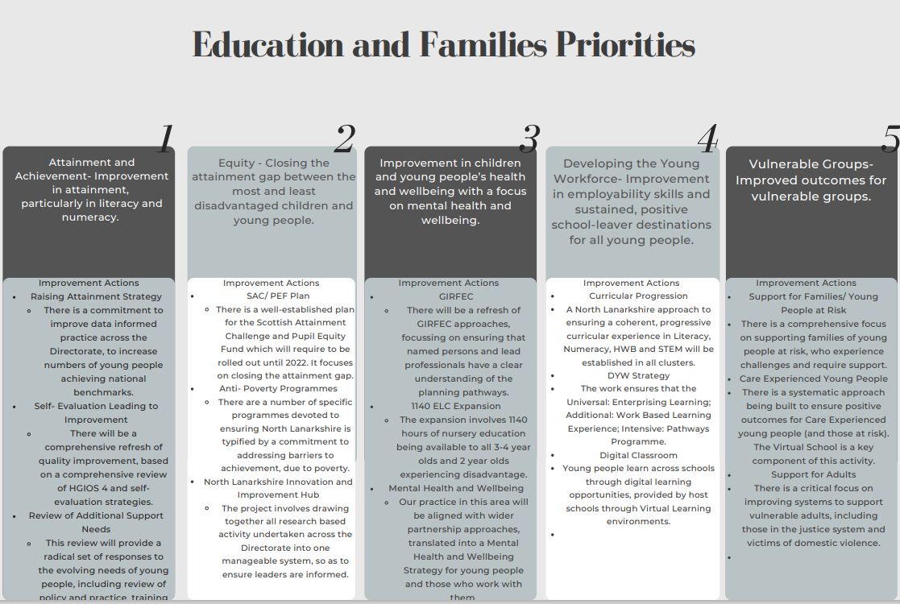

School Vision and Values
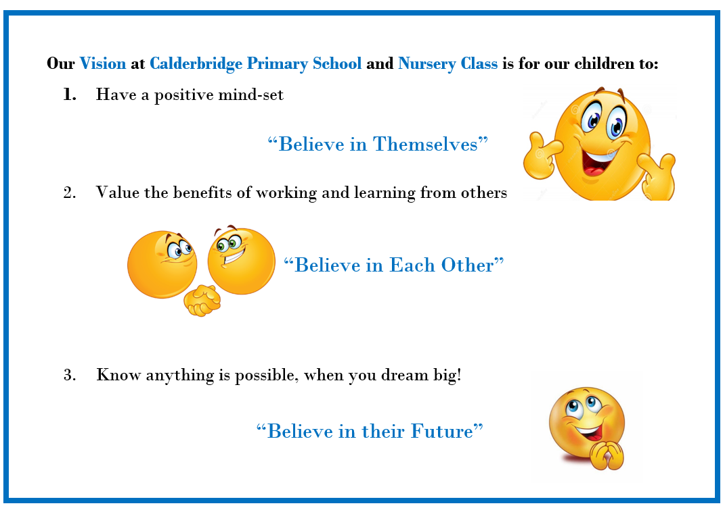
Our Core Values are to be Ready, Respectful and Safe!

Audit and Consultation

In arriving at our improvement priorities, the school has taken account of Education and Families’ priorities, an audit of the previous year’s improvement plan and engagement with parents/carers and learners.

Details of engagement (pupils, parents/carers, partners)

Priorities shared with pupils and families at assembly and school newsletter. Views with be gathered from all partners as we progress through the year when we report on progress and measure impact.

2023-24 Improvement Plan

Cluster Priority : Long Term Outcome  What do you hope to achieve? What is going ot change? For whom? By how much? By When? |  | To identify needs of learners and young people early through reliable and valid assessment  information. As a cluster we will provide, all children with additional support needs high quality targeted support. We will ensure parents and partners work in partnership to support children and young people. Well planned interventions are leading to positive outcomes for children with additional support needs
Person(s) Responsible  Who will be leading the improvement? | Head of establishment/Head of Department within the cluster

(Please insert the relevant information below using the codes above)
NIF Priority: 1,2,3 |  | NIF Driver:1,3,4
NLC Priority: 3 |  | QI:1.3,1.5, 2.4, 2.7, 3.1,3.2
PEF Intervention: 2 |  | Developing in Faith/UNCRC: 3,42
If you used any aspect of your PEF fund to support this priority; please detail the expenditure here.
SAC teachers. HWB targeted offer. Teen Talk offer.
RATIONALE (WHY?) Why have you identified this as priority? What data did you have to support this?
Several children across the cluster are not achieving their full potential because of poor mental wellbeing. All schools have a system to track children and young people's attainment and achievement levels and have identified learners who require additional support from within the cluster to break down barriers to learning. The children identified have an additional support plan and have exhausted supports within the school
Resources: Please include costs and, where relevant, state where cost is being met from, specifically if using PEF. Please denote PEF/or colour code if preferred, to indicate where PEF spend aligns with targets.

EXPECTED IMPACT  (SHORT TERM TARGETS) | INTERVENTIONS/ACTIONS TO SUPPORT IMPROVEMENT: HOW? |  | HOW WILL YOU TRACK PROGRESS?  MEASURES | EVALUATION CHECKPOINT 1 | EVALUATION CHECKPOINT 2
What will be the benefit for learners (be specific) | What are you going to do to make the change? What key actions are required? Consider links to the NIF Drivers? |  | What ongoing information will demonstrate progress? (Qualitative, Quantitative – short/medium/long term data)
Barriers to learning will be minimised for learners through identification of needs at targeted/intensive level. | Using the CAR approach identify group of learners from progress and achievement data base who are not thriving because of poor mental wellbeing. Wellbeing is impacting attainment and achievement. |  | Wellbeing assessment data – National Practice Model  Reading, Writing, Maths attainment. TPJ.  Wider achievements Record.  Attendance.
Team around the child will be involved in assessing progress and planning next steps to ensure success | Early identification of need and barriers to learning identified. Further assessment may be required to increase understanding of barriers to learning. Partnership working with partner agencies. Knowledge of resources available within the cluster to improve wellbeing of children and young people. |  | Outcome Star assessment of wellbeing  Diagnostic assessment literacy and numeracy where appropriate.  Service available to support wellbeing of children and young people in place and in use.  RfA identified service accepted and engaged. Report available detailing progress
Children and young people and their parents will be fully involved in the decision-making progress and how their needs are to be met. | Consultation meeting with parents and pupils to discuss needs and next steps. Agree multiagency approach and agree dates to plan and review progress. |  | Minutes of meetings  Plan of meetings
Staff will ensure children's learning is specific through use of use individualised progression pathways. | High quality assessment indicates learners' strengths and development needs. Correct pathway selected to support planning and progression of skills HWB, Literacy and/or numeracy. |  | Progression through pathway(s)  Attainment gap reduced
Staff will further develop their own skills through collaborative working with others, to increase their capacity to meet the needs of learners. | Partnerships have clear agreements where the purpose, aims, roles and responsibilities are clear and understood by all involved. The school and partners share skills, knowledge and experience and take part in joint professional learning opportunities. |  | Learning plan – detailed roles, responsibilities and impact of partnership working  Professional Learning Record – impact of skills development in improving outcomes for learners
Learners' wellbeing, attainment and achievement levels will improve following interventions. | The school will build and develop strong partnerships with partners through planning children’s learning and evaluating progress. Through effective partnership working we will improve our learning provision and secure positive change for children, young people and families in our community.  Our partnerships will increase parental engagement in their children’s learning. Their involvement will have a positive impact on raising attainment and achievement particularly in literacy and numeracy. |  | PLP  Minutes of meetings  Improvements in children's performance  Parents and children’s views
Final evaluation:

Priority 1: Long Term Outcome  What do you hope to achieve? What is going ot change? For whom? By how much? By When? |  | To put in place a cohesive writing programme that is based on the principles of how children learn, identifies children’s next steps in learning, and ensures progression for every child. Targeted children in P3 make good progress from their prior levels of attainment.  Attainment over time continues to improve.
Person(s) Responsible  Who will be leading the improvement? | PT Laura Livingstone, Literacy Working Party

(Please insert the relevant information below using the codes above)
NIF Priority: 5 -To improve attainment for all, particularly in literacy and numeracy |  | NIF Driver:2,4
NLC Priority:1 |  | QI 3.2, 2.2,2.3,1.1& 1.2
PEF Intervention: |  | Developing in Faith/UNCRC: 3
If you used any aspect of your PEF fund to support this priority; please detail the expenditure here.

RATIONALE (WHY?) Why have you identified this as priority? What data did you have to support this?
Self-evaluation activities have shown that the teaching and learning of writing needs to improve. Assessment of learners writing highlights a need for staff to upgrade children’s sentence structures and language skills. Success in using Colourful Semantics, and research into the principles of how children learn have identified that children must first internalise the language structures needed to write. Research has led to the identification of the Talk for Writing methodology which shows that where this is applied systematically across a setting, attainment is of a significantly higher standard than the national average. In session 22/23, Literacy working party have piloted some aspects and are reporting early improvements in the quality of writing against the benchmarks.
Resources: Please include costs and, where relevant, state where cost is being met from, specifically if using PEF. Please denote PEF/or colour code if preferred, to indicate where PEF spend aligns with targets.
PEF PT, PEF SfL Teacher

EXPECTED IMPACT  (SHORT TERM TARGETS) | INTERVENTIONS/ACTIONS TO SUPPORT IMPROVEMENT: HOW? |  | HOW WILL YOU TRACK PROGRESS?  MEASURES | EVALUATION CHECKPOINT 1 | EVALUATION CHECKPOINT 2
What will be the benefit for learners (be specific) | What are you going to do to make the change? What key actions are required? Consider links to the NIF Drivers? |  | What ongoing information will demonstrate progress? (Qualitative, Quantitative – short/medium/long term data)
Learner’s sentence structures and language will improve because of the development of our writing curriculum. A whole school approach using creative and innovative methods to the learning and teaching of writing will improve learners' engagement. | Provide staff with opportunities to engage in Talk for writing training across the school and nursery.  Mentor and coach staff within the classroom in the learning and teaching of writing.  Monitor quality of learning and teaching through learning visits to inform next steps.  Provide staff opportunity to learn from each other following SLT visits through peer observations  Facilitate collegiate working sessions to moderate writing using NLC targets, and descriptive targets from TfW.  Class teacher to assess children's progress  Children will take part in learning conversations to showcase skills taught.  Target setting meetings and jotter monitoring will be carried out to monitor and evidence this progress. |  | Professional judgement data  Jotter Monitoring  Peer Learning Visits using self-evaluation rubric for QI2.3.  Learning Conversations-pupil views.
Learners will have made progress from their prior levels of attainment in writing. | SLT use the CAR approach in leading change, and will make changes based on evidence, monitor impact of changes and refine and adapt as appropriate. Research will influence training sessions.  Target setting meetings will be carried out to monitor progress and jotter monitoring to observe progress of descriptive writing through ‘cold’ and ‘hot’ tasks. |  | Jotter monitoring  Professional judgement data  Target Setting  Progression through pathways.
Learning will be relevant to the needs of every child and ensures progress because teachers apply the principles of planning, observation, assessment, recording and reporting as an integral feature of learning and teaching. | Staff training in the assessment, planning, observation, recording and reporting of writing through the Talk for Writing program will ensure that every child makes progress.  Staff will be trained in the use of ‘Hot’ and ‘Cold’ tasks alongside pupil learning conversations and a range of evidence to analyse children’s writing and plan appropriate, focused learning and next steps.  Target setting to discuss the progress of each child.  Planning by the Cluster Resource Teacher will provide additional support for identified children to ensure progress. |  | Jotter monitoring  Medium term planning  Learning Conversations
Learners’ experiences in writing are appropriately challenging and enjoyable and well matched to their needs and interests. | Pupils will take part in a survey to share their views on their writing experiences.  Training in the assessment and planning of writing will ensure that learning and teaching is matched well to children’s interests and needs and provides appropriate challenge.  Learning conversations will be carried out with all children to demonstrate their success and share their interests.  Writing stimulus will take account of the interests of the children and working party will look at a range of digital technology to support and enhance writing. |  | Jotter Monitoring  Learning Conversations  Pupil survey
Children can demonstrate their writing skills at a higher level having had access to improved, structured and meaningful writing sessions. | Staff will implement training.  Peer and LT Learning visits will be undertaken to share good practise and to allow staff to self- assess and improve learning.  Jotter monitoring will be carried out to monitor progress. |  | Jotter Monitoring  Learning Conversations  Learning visits
Final evaluation:

Priority 2: Long Term Outcome  What do you hope to achieve? What is going ot change? For whom? By how much? By When? |  | To develop children’s skills in digital learning. Our curriculum will include digital pathways and a digital environment to facilitate the develop of new skills which will also be explored in the classroom.  We are going to increase staff’s confidence in digital pedagogies leading to sustainable change in digital learning.
Person(s) Responsible  Who will be leading the improvement? | PT Pamela Cairney and Digital Working Party

(Please insert the relevant information below using the codes above)
NIF Priority: 4 |  | NIF Driver: 2, 4
NLC Priority: 4 |  | QI: 1.1, 1.3, 2.2
PEF Intervention: 5, 8, |  | Developing in Faith/UNCRC: 3
If you used any aspect of your PEF fund to support this priority; please detail the expenditure here.

RATIONALE (WHY?) Why have you identified this as priority? What data did you have to support this?
Medium term plans, staff evaluations and discussions during staff meetings have identified that many aspects of the digital skills and computing science curriculum are not being explicitly taught. We will improve our children’s skills in digital literacy and computing science by increasing staff’s confidence in digital pedagogies and the teaching and learning of digital literacy and computing science. Last session the new NL digital literacy and computing science pathways were introduced with a focus on CRIS. This session we will extend our knowledge and understanding of these pathways to increase staff’s confidence, improve our digital curriculum and develop our children’s skills in digital literacy and computing science.
Resources: Please include costs and, where relevant, state where cost is being met from, specifically if using PEF. Please denote PEF/or colour code if preferred, to indicate where PEF spend aligns with targets.

Devices

EXPECTED IMPACT  (SHORT TERM TARGETS) | INTERVENTIONS/ACTIONS TO SUPPORT IMPROVEMENT: HOW? |  | HOW WILL YOU TRACK PROGRESS?  MEASURES | EVALUATION CHECKPOINT 1 | EVALUATION CHECKPOINT 2
What will be the benefit for learners (be specific) | What are you going to do to make the change? What key actions are required? Consider links to the NIF Drivers? |  | What ongoing information will demonstrate progress? (Qualitative, Quantitative – short/medium/long term data)
Learning experiences planned will be appropriate for all learners and reflect children’s skills and abilities. Planning clearly identifies what is to be learned and assessed. | Staff will be trained to use One Note to plan digitally. Planning will be evaluated by class teachers and the leadership team regularly and evaluations will inform the next steps in learning. Pathways will show rate of progression of all learners. |  | Qualitative data will be collected termly.  Learning conversations  Evaluations
Children will receive improved learning and teaching experiences as all staff will be provided with professional learning activities to teach computing science and digital literacy effectively. | Teaching staff will complete a survey which will identify and evaluate their confidence and skill in teaching digital literacy and computing science. The Digital Working party will complete the digital self-evaluation toolkit. All data collected will be used to inform next steps and a CLPL training schedule will be agreed (including in class training, peer observations etc) |  | Survey data. (beg/mid/end)  Digital self-evaluation toolkit.  CLPL training schedule.
Learners will develop their digital skillset as the curriculum has been refreshed in line with current education thinking. Staff will work with the digital team to improve creative and innovative approaches to digital learning and teaching. | The PT and working party will research current digital pedagogies and plan for the teaching and learning of the skills of digital literacy and computing science and through other curricular areas. We will build on our current effective partnerships (including the Digital Pedagogy Team and 3Discovery Team) to enhance the teaching and learning of digital literacy and computing science. A progressive programme of work will be created and adapted to the needs of our learners. All stakeholders will be involved with the creation of a draft digital policy.  High quality teaching and learning of digital literacy and computing science skills will be planned for using the NL pathways. This will include model lesson and team teaching. Opportunities for children to extend their digital skills will be planned for through other areas of the curriculum. |  | Minutes of meeting.  Calderbridge Programme of work.  Draft digital policy.  Learning conversations  Focused observations Children views/discussion with digital leaders  Planning.
Learners will be empowered to champion digital literacy and computing science within our school. | PT and digital working party to familiarise self with digital award scheme and create plan toward achieving. All digital leaders will plan for improvements in the learning and teaching of digital literacy and computing science and our digital journey. |  | Minutes of meeting.  Digital Award plan.
Final evaluation:

Priority 3: Long Term Outcome  What do you hope to achieve? What is going ot change? For whom? By how much? By When? |  | To improve planning to include NLC early level planners for literacy and numeracy. Ensure planned experiences are developmentally appropriate and tailored to meet all children’s individual learning needs. Practitioners use imaginative and appropriate ways to involve children in planning learning. Learning experiences planned ensure continuous improvement for children in literacy and numeracy.
Person(s) Responsible  Who will be leading the improvement? | DHT Jill Dowson and Nursery Team

(Please insert the relevant information below using the codes above)
NIF Priority: 1, 3, 5 |  | NIF Driver: 1, 4, 5
NLC Priority: 1, 3, 5 |  | QI: 1.1, 2.2, 2.3, 3.2
PEF Intervention: |  | Developing in Faith/UNCRC: 3
If you used any aspect of your PEF fund to support this priority; please detail the expenditure here.

RATIONALE (WHY?) Why have you identified this as priority? What data did you have to support this?
Sel evaluation activities have identified the need for improved pathways which staff can use to plan for of all learners, ensuring continuous progress within and beyond the playroom for all children.

Pre learning visit discussions indicated a need for staff to improve their knowledge of experiences and outcomes, pathways and benchmarks. How the Es and Os inform learning experiences for children including those who have additional support needs and those requiring challenge. Planning should reflect the needs and progression of all learners.
NLC pathways show progression across Early Level and discussions look favourable in improving learning and teaching experiences for children.

Resources: Please include costs and, where relevant, state where cost is being met from, specifically if using PEF. Please denote PEF/or colour code if preferred, to indicate where PEF spend aligns with targets.

EXPECTED IMPACT  (SHORT TERM TARGETS) | INTERVENTIONS/ACTIONS TO SUPPORT IMPROVEMENT: HOW? |  | HOW WILL YOU TRACK PROGRESS?  MEASURES | EVALUATION CHECKPOINT 1 | EVALUATION CHECKPOINT 2
What will be the benefit for learners (be specific) | What are you going to do to make the change? What key actions are required? Consider links to the NIF Drivers? |  | What ongoing information will demonstrate progress? (Qualitative, Quantitative – short/medium/long term data)
Curriculum framework is well matched to the stages of development for our young children | Introduce new NLC planners which include progressive pathways.  SLT, Lead Practitioner and other nursery staff will familiarise themselves with NLC online pathways.  Involve all team members in the planning process. |  | Improvement Meeting calendar.  Minutes of meetings.  Staff surveys.
Learning experiences planned will be a result of children's interest and prior learning to ensure continuous progress within and beyond the playroom | SLT will upskill staff through a mentoring and coaching approach using Es and Os.  Staff will plan, deliver and assess daily adult led experiences in the playroom and outdoors, responding to engagement level and curiosity. |  | Monitoring of weekly and medium/long term planning
Children’s literacy and numeracy skills will develop as all practitioners will take responsibility for planning experiences, ensuring continuity and progression | SLT will involve staff in the tracking of progress and setting of targets using a universal and targeted approach.  Staff will plan group and individual programmes, including targeted interventions where required. |  | Tracking and Target Setting  Observations.  SLT learning visits  Learner Conversations
Our approach to capturing and recording children’s progress and achievements at key points in time provides reliable evidence which leads to significant improvement to learning and developmental outcomes for children | SLT playroom visits and Peer observations to identify good practice, strengths, development needs.  Staff will carry out high quality observations naturally through everyday activities and interactions. Observations will record focused and responsive learning opportunities. |  | SLT and Peer observations  Tracking and Target Setting
All staff have a shared understanding of children’s progress and achievements through talking together with parents/carers and colleagues within and beyond our setting, | Nursery staff will involve children, parents/carers and outside agencies in decisions about progress, learning and any support required. |  | Children’s views  Parent/Carer surveys  Other agency evaluations
Final evaluation:

nOrth Lanarkshire Council
PEF ALLOCATION: £

SAC RESOURCE:

Education & FAMILIES
EQUITY PLAN 2022-23

Rationale for EQUITY plan
Please provide below detail around your rationale for the Equity plan. Highlight how PEF expenditure/SAC resourcing is integrated to support improvement priorities.
For priorities around equity please detail the poverty related gap which you are addressing and the data which supports your rationale.
Consider the following: attainment, health & wellbeing, attendance, exclusion, participation, engagement.

Link to Improvement Plan | Detailed Costings | Priority/Description | Intended Outcome/Impact  Please describe your planned use of SAC resource/PEF allocation and what you intend to achieve | Evidence/Measures  Please indicate what evidence you are going to collect to show impact and progression
1  Cluster | PEF Funding 1FTE  PEF Funding match school and service 1FTE  PEF Funding match school and service 1FTE  PEF Funding match school and service 1FTE  SAC  SAC | Laura Livingstone, to raise attainment in literacy and develop skills  Susan Ireland, CT responsibility for P4  Carrier Leiper, CT responsibility for P6  Lauren McGuiness, SfL  Samantha Hamil  Cluster Attainment Teacher  Janice Welsh, Cluster Attainment Teacher | PT will drive forward change in the learning and teaching of writing and lead the staff in raising attainment for all. LL will support our most vulnerable learners through targeted support in partnership with parents and partners. LL will mentor staff in improving learning and teaching of literacy across the school and nursery.  To release Wendy Todd, who will provide social, emotional, and mental wellbeing support to children who are at risk of not achieving their potential through The COSY COVE (nurture base) 7 individual/groups can be supported daily. HWB hub is an intervention which is measured at regular intervals. HT and nurture teacher work in partnership with planning support.  Release PTs class commitment. Increase management capacity to lead change across the school and nursery, work in partnership with parents and agencies in improving outcomes for all.  Release DHTs class commitment. Increase management capacity to lead change across the school and nursery, work in partnership with parents and agencies in improving outcomes for all.  To improve attainment for children who are impacted by poverty and not fulfilling their potential  To improve outcomes for targeted learners who are facing significant barriers to learning.

EQUITY CHECKPOINT 1: JANUARY 2023

Priority | What is going well? (Impact) | How do you know? (Evidence) | Describe any changes you have made/will make to your Equity plan | Support required? Next steps
EQUITY CHECKPOINT 2: MAY 2023

Priority | What is going well? (Impact) | How do you know? (Evidence) | Describe any changes you have made/will make to your Equity plan | Support required? Next steps
Appendix 1:
When considering your Cluster and School Improvement Priorities, you are asked to provide links to the following, as well as the Quality Indicators within HGIOS4 and HGIOELC:
UNCRC | HGIOS 4 & HGIOELCC | National Improvement Framework: priorities and drivers
Article 1 - definition of the child  Article 2 - non-discrimination  Article 3 - best interests of the child  Article 4 - implementation of the Convention  Article 5 - parental guidance and child's evolving capacities  Article 6 - life, survival and development  Article 7 - birth registration, name, nationality, care  Article 8 - protection and preservation of identity  Article 9 - separation from parents  Article 10 - family reunification  Article 11 - abduction and non-return of children  Article 12 - respect for the views of the child  Article 13 - freedom of expression  Article 14 - freedom of thought, belief and religion  Article 15 - freedom of association  Article 16 - right to privacy  Article 17 - access to information from the media  Article 18 - parental responsibilities and state assistance  Article 19 - protection from violence, abuse and neglect  Article 20 - children unable to live with their family  Article 21 – adoption  Article 22 - refugee children  Article 23 - children with a disability  Article 24 - health and health services  Article 25 - review of treatment in care  Article 26 - social security  Article 27 - adequate standard of living  Article 28 - right to education  Article 29 - goals of education  Article 30 - children from minority or indigenous groups  Article 31 - leisure, play and culture  Article 32 - child labour  Article 33 - drug abuse  Article 34 -sexual exploitation  Article 35 - abduction, sale and trafficking  Article 36 - other forms of exploitation  Article 37 - inhumane treatment and detention  Article 38 - war and armed conflicts  Article 39 - recovery from trauma and reintegration  Article 40 - juvenile justice  Article 41 - respect for higher national standards  Article 42 - knowledge of rights | 1.1: Self-evaluation for self-improvement  1.2: Leadership for learning  1.3: Leadership of change  1.4: Leadership and management of staff  1.5: Management of resources to promote equity  2.1: Safeguarding and child protection  2.2: Curriculum  2.3: Learning teaching and assessment  2.4: Personalised support  2.5: Family learning  2.6: Transitions  2.7: Partnerships  3.1: Ensuring wellbeing, equality and inclusion  3.2: Raising attainment and achievement  3.3: Increasing creativity and employability  Specific to HGIOELC  3.2: Securing children’s progress  3.3: Developing creativity and skills for life | NIF Priorities  - Placing the human rights and needs of every child and young person at the centre of education  - Improvement in children and young people’s health and wellbeing;  - Closing the attainment gap between the most and least disadvantaged children and young people;  - Improvement in skills and sustained, positive school leaver destinations for all young people  - Improvement in attainment, particularly in literacy and numeracy.  NIF Drivers  - School and ELC Leadership  - Teacher and Practitioner Professionalism  - Parent/Carer Involvement and Engagement  - Curriculum and Assessment  - School and ELC Improvement  - Performance Information
PEF INTERVENTIONS
- Early intervention and prevention
- Social and emotional wellbeing
- Promoting healthy lifestyles
- Targeted approaches to literacy and numeracy
- Promoting a high quality learning experience
- Differentiated support
- Using evidence and data
- Employability and skills development
- Engaging beyond the school
- Partnership working
- Professional learning and leadership
- Research and evaluation to monitor impact
Education and Families Priorities
- Improvement in attainment, particularly literacy and numeracy
- Closing the attainment gap between the most and least disadvantaged children
- Improvement in children and young people’s health and wellbeing with a focus on mental health and wellbeing
- Improvement in employability skills and sustained, positive school leaver destinations for all young people
- Improved outcomes for vulnerable groups
Developing In Faith
Roman Catholic Schools are required to provide links within their SIP and SIR to the themes contained within ‘Developing in Faith’, as requested by the Bishops’ Conference of Scotland.
1. Honouring Jesus Christ as the Way, the Truth and the Life
2. Developing as a community of faith and learning
3. Promoting Gospel Values
4. Celebrating and Worshiping
6. Serving the common good.

