Modern Studies
S1 BGE
Edmodo code: idu73c

LOCAL DEMOCRACY
During S1, pupils have learned about local democracy, through the eyes of a local family and a local councillor. The course focusses on needs and wants in society, including essential services like health, through education to leisure and recreation.
The changes in society as a result of Covid-19 are profoundly linked to the learning in this unit: it would be a genuinely worthwhile task to have a (safely managed) discussion within your family as to what changes they have noticed and what impact this will be having more widely on individuals, communities, society and the economy. Asking the 5W questions (Who? What? When? Where? Why? + How?) can be a simple, effective way to structure a conversation about Modern Studies learning.
The benefit of this type of activity is that it engages young people and other members of the household in a natural learning activity. This helps to foster creativity, which employers and educators say is a critical skill they look for in young people leaving school.
During the recent crisis, information has been issued to citizens at different levels, including from local authorities, like North Lanarkshire, as well as from the Scottish and UK governments. It can be useful to think about what each of these different levels of government is responsible for at these times to help us understand those roles and why we are getting information from more than one official source.
Website links:
- For more online learning about local democracy, follow this link to understand more about the role of local councillors in Scotland: http://www.localcouncillor.scot/ On this site, you can find videos and detailed information about the work councillors do and how it relates to all of us as citizens.
- To find out more about democracy at level of the Scottish Parliament, follow this link to their Education Centre site: https://www.parliament.scot/visitandlearn/education.aspx Here you will find a number of interactive activities, including games, quizzes and videos.
- The UK parliament also has an educational website at the following address, for more details about democracy at a UK level: https://www.parliament.uk/educationcentre

LOOKING AHEAD TO S2 -
HUMAN RIGHTS
As Modern Studies pupils move from S1 into S2, we begin to look in more detail at their rights, both as human beings and specifically, their rights as children and young people. During the course, we further develop our understanding of needs and wants by looking at the four categories of children’s rights: Survival; Development; Participation; and Protection. These are useful lenses through which to explore these rights; it can therefore help to look at the rights under the convention and consider which of these four categories they may fall under – this could prove a worthwhile task if studying at home.
Website links:
- The main focus of our learning on the rights of the child stems from the United Nations Convention on the Rights of the Child. Follow this link to find out more about this convention: https://www.unicef.org.uk/what-we-do/un-convention-child-rights/
- Here you can directly download a summary of the rights under the convention: https://downloads.unicef.org.uk/wp-content/uploads/2019/10/UNCRC_summary-1_1.pdf?_ga=2.14654711.1590974045.1585743558-1797154863.1585743558&_gac=1.195577694.1585743561.CjwKCAjw95D0BRBFEiwAcO1KDDr3dypkvCIjzC9A9vir0L3wXx_8yWcSS1egYGEhHSIg3_72N_ca8hoCKkUQAvD_BwE Try listing three rights you think are most important and three rights you think are least important. Use a page divided in two with headings to organise this work. This task helps pupils to think about values and develops skills including literacy (reading, writing) and prioritisation.
- Save the children have also put together materials on the UNCRC which they designed to be accessible for children themselves: https://www.savethechildren.org.uk/what-we-do/childrens-rights/united-nations-convention-of-the-rights-of-the-child

S2 BGE
HUMAN RIGHTS AND GUNS IN THE USA

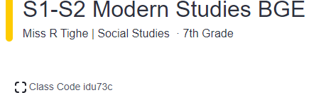
Ed Modo

S2 Useful Websites:
https://www.bbc.co.uk/bitesize/subjects/zs48q6f 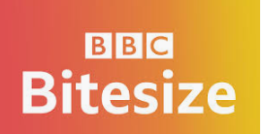

https://www.whitehouse.gov/ 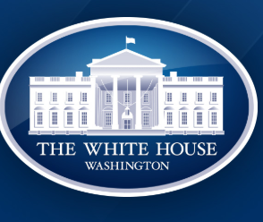

https://home.nra.org/

https://www.tes.com/teaching-resources Register for Free!

https://www.twinkl.co.uk/ Register for Free!

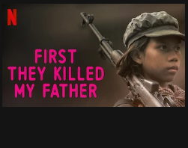

S2 Mini Assignment S2 Human Rights and Conflict
Episode 4: Politics Child Soldiers
S2 Human Rights and Terrorism: Syrian Conflict

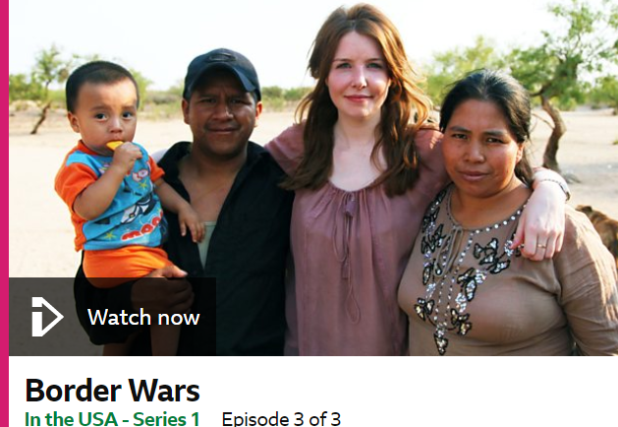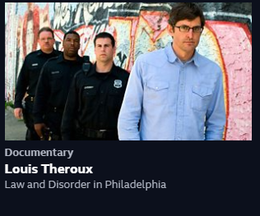

S3 Modern Studies – Useful links and websites
- www.edmodo.com S3 Group Code: qbtd2u

S3 Modern Studies – Useful links and websites
- www.edmodo.com S3 Group Code: qbtd2u

Crime and the Law

Education Scotland: Crime & the Law
https://education.gov.scot/improvement/learning-resources/crime-and-law

Police Scotland –
Focus on statistics and the things police are doing in communities to keep people safe e.g stop and search
https://www.scotland.police.uk/

Committing a crime in Scotland – Use this website to create a timeline of what happens from the point when an offender commits a crime right up until they go to court.
https://www.mygov.scot/charged-crime/

Bitesize : Crime & the Law– daily lessons coming from April 20th
https://www.bbc.co.uk/bitesize/topics/z4m2pv4

Democracy in Scotland

Bitesize: Democracy in Scotland – daily lessons coming from April 20th
https://www.bbc.co.uk/bitesize/topics/zr7qtfr

Scottish Government Website – Focus on the structure of the Scottish Government and devolved powers
https://www.gov.scot/about/

