S2
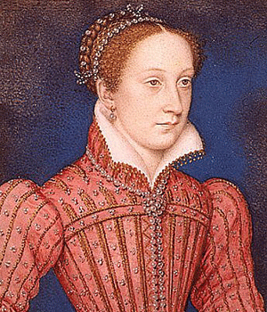

Cumbernauld Academy Humanities Dept
[mARY qUEEN OF sCOTS]
What was the reformation?
- Can you remember the last time you were in church? - Tell your partner why you were there.
- Imagine everyone went to church on a Sunday – what would your community be like?
- Other than Rangers or Celtic what do you know about Catholics and Protestants?
By the end of this section you should be able to:
- Explain what the Reformation was
- Describe the differences between the protestant and Catholic faiths
- Imagine why these differences cause tension today
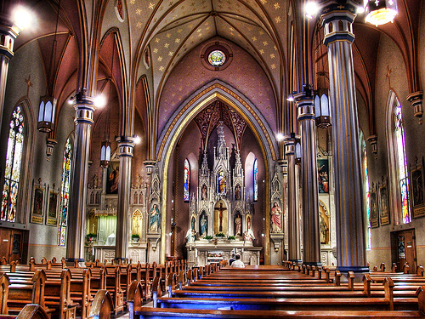
By 1500 most Europeans were Catholics. They used God to explain things they didn’t understand: if their harvest was bad, it was because God wished it to be; Heaven and Hell were thought to be real places.

In the 16th Century, some people tried to change the Catholic religion. They wanted to make it better than they believed it was. They wanted to reform it. These changes can be called the Reformation.

Who was Martin Luther?
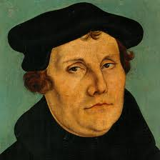
Luther had been a monk and then a professor at the German university of Wittenberg. He hated what he saw as the greedy and Lazy attitudes of many Catholics. In 1517 he made a list of all the things he thought were wrong with the Catholic Church and nailed them to his front door for his neighbours to read.

Reformation: The action or process of reforming an institution or practice

You can read his list below

- Travelling holy con-men called Pardoners make lots of money by persuading people that they can buy forgiveness for their sins. They also sell fake holy relics – objects that are supposed to have once belonged to Jesus or one of the saints.
- Churchmen make too much money from the land given to their church by the king. Every year a peasant has to pay up to a tenth of all the products from his land and flocks to the church.
- Ordinary people cannot understand much of what is said during the mass. The Bible is written in Latin and the church services are held mainly in this language as well.

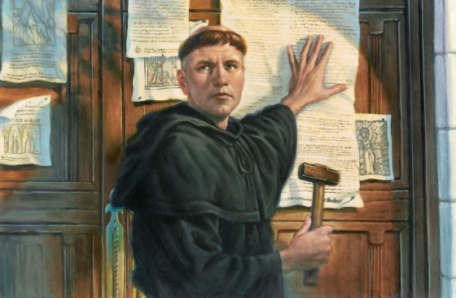
After making his public protest, Luther was sent a letter from the Pope expelling him from the Catholic faith. He burnt the Pope’s letter in the middle of the market place. Luther spent the next few years in hiding but his ideas for a reform of the church spread across Europe. His followers became known as “Protestants” because they protested against the Catholic Church.

Who was John Calvin?
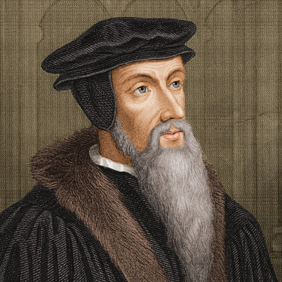
A young Frenchman called John Calvin heard Luther’s ideas and added that services should be simpler, as they were in the early days of Christianity. He complained that church buildings had become a grand show of gold images. He said that churches should lose all displays of wealth and have simple blank walls.

Calvin believed that there should be no bishops; the worshipers at each church should choose their own rulers. This sort of church is called “Presbyterian”. In the end, the followers of Luther and Calvin set up their own form of Christian religion and they became known as the Protestant Reformers. For the next 600 years, Catholics and Protestants often argued and sometimes fought violently.

At this time, the rulers of a country decided which religion the people would follow. King Henry 8th of England converted to Protestantism but King James 5th of Scotland remained Catholic.

Activities Answer the following questions in full sentences

- Why was the Catholic religion so powerful in 1500? Explain to a partner.

- Write a short paragraph explaining what Luther said was wrong with the Catholic religion in 1517.

- How did the Protestants get their name?

- Who chose the leaders of Calvin’s Presbyterian churches? Do you think this was a good or bad idea? Explain your answer.

- Write out the following statements and decide which describe the Catholic religion and which describe the Protestant religion:

- The pope is the head of the church and is chosen by god.

- A church should be a bright and colourful place to worship god.

- The king or queen of the country is the head of the church.

- Churches should have pictures on walls, stained glass windows, silver cups and a large stone alter.

- Money should not be wasted on decorations or robes for the priest.

- The bible and prayer books are written in Latin.

- The bible should be in a language that the worshipers understand, not in Latin.

- A church should be a plain and simple place.

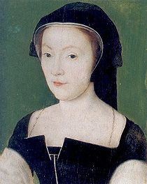
By the end of this section you should be able to:
- Describe how Mary Queen of Scots and Elizabeth of England were related
- Explain why James 5th was upset his wife had given birth to a girl
- Explain why Mary was a threat to Elizabeth

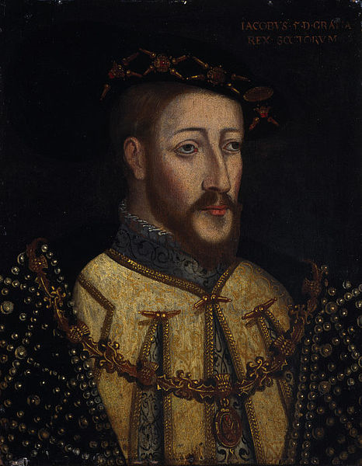
On December 8th 1542

At Linlithgow Palace the Queen of Scots, Mary of Guise had a baby, a girl.

A few days later the young girl was christened in the nearby Church of St Michael. She was named Mary after her mother. Her father, King James V, was not at the birth or the christening. He was lying gravely ill at his hunting lodge in Falkland Palace in Fife.

His sickness was more of the mind than of the body. His army had recently been defeated by the English at Solway Moss and he was expecting an imminent invasion of Scotland. When the news was brought to him of the birth of his daughter rather than a hoped for son who perhaps one day would lead the defence of his country, he sighed

“Alas! It came with a lass and it will pass with a lass.”

He was thinking of how his family, the Stuarts, had come to rule Scotland through a girl, the daughter of King Robert the Bruce, Marjorie, who had married Walter the Stewart.

Perhaps he believed she would not survive because his two baby sons had died.

A few days later on December 14th 1542, the King died leaving Mary to become Queen of Scots when she was six days old.

Thus began the reign of a woman of beauty and surprise, of fascination and tragedy; a Queen whom many loved and some sought bitterly to destroy.

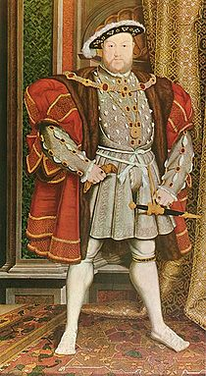
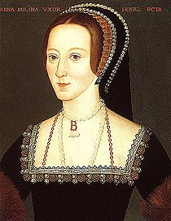
7 SEPTEMBER 1533

At Greenwich Palace, Anne Boleyn Queen Consort of England had a baby, a girl
Elizabeth's life was troubled from the moment she was born. Henry VIII had changed the course of his country's history in order to marry Anne Boleyn, hoping that she would bear him the strong and healthy son that his first wife Catherine of Aragon never did.
Anne did eventually conceive a son, but he was stillborn. By that point, Henry had begun to grow tired of Anne and began to arrange her downfall.
Most, if not all, historians agree that Henry's charges of incest and adultery against Anne were false, but they were all he needed to sign her execution warrant.
She was beheaded on the Tower Green on May 19, 1536, before Elizabeth was even three years old.
Her father went on to marry another four times

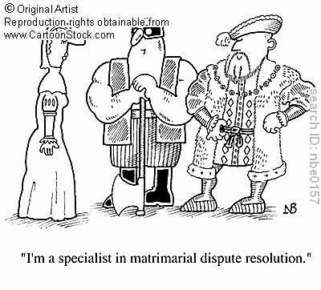
Catherine of Aragon

Anne Boyeln
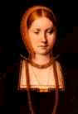
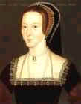

Divorced, beheaded, died; Divorced beheaded survived
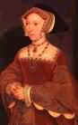
Jane Seymour married Henry VIII just 11 days after the death of Anne Boleyn. He was 45 years old, Jane was 28. She gave birth to a son, Edward, in October 1538.

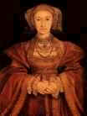
Anne of Cleves a 24 year old German Princess became Henry VIII's fourth wife but was divorced after six months.

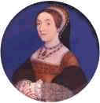
Kathryn Howard the 15 year old daughter of Edmund Howard, Kathryn, cousin of Anne Boleyn became Henry VIII's fifth wife. She was executed for adultery after two years of marriage at age 16.

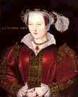

Katherine Parr became Henry VIII's sixth wife. She outlived Henry and died in childbirth in 1548.

After the death of both her Protestant brother Edward and her Catholic sister Mary, Elizabeth became Queen in 1558 and made England a Protestant country.

She had many Catholic enemies who wanted to see her replaced by her cousin Mary Queen of Scots. According to the Laws of Succession, Mary was next in line to the throne should Elizabeth remain childless. This was a popular idea to many people as if Mary became the Queen then England would be a Catholic country again.

The year Elizabeth became Queen; Mary challenged her to the throne but failed.

Answer the following questions in full sentences

1. Explain James V’s last words “Alas! It came with a lass and it will pass with a lass.”

2. How old was Mary when she became Queen of Scotland?

3. What were the charges faced by Anne Boleyn?

4. What was the real reason why Henry wanted to get rid of Anne?

Study the Family Tree

5. How was Mary related to King Henry VIII of England?

- How was Mary related to Queen Elizabeth I of England?

- Which wife gave henry his son Edward?

- What religion was Henry’s daughter Mary?
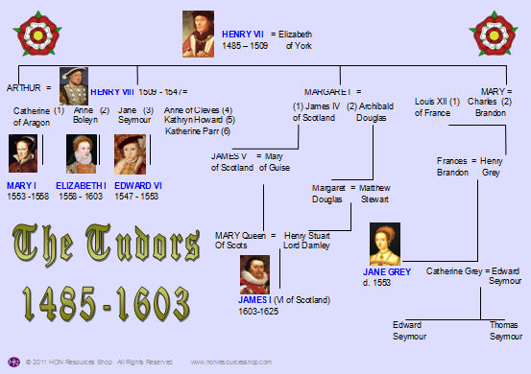

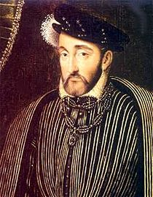

Mary of Guise knew that the English danger was still
very real so when the French offered to renew the
Auld Alliance she gladly agreed.

Part of the arrangement was that six year old Mary would go to France to be brought up there and later marry the Dauphin, the French King’s son.
Mary’s mother was French and was a devout Catholic. She ensured that her daughter would grow up to follow her beliefs.

When a country’s monarch cannot rule (in this case Mary was not old enough) a regent rules in their place. Mary’s mother, Mary of Guise remained in Scotland and ruled as regent until Mary was old enough.

At Dumbarton the young girl embarked on a French galley and waved goodbye to her mother. The English had refused safe passage so for safety their route took them to the west of Ireland. They travelled through a terrible storm to France and safety and a few brief years of happiness.
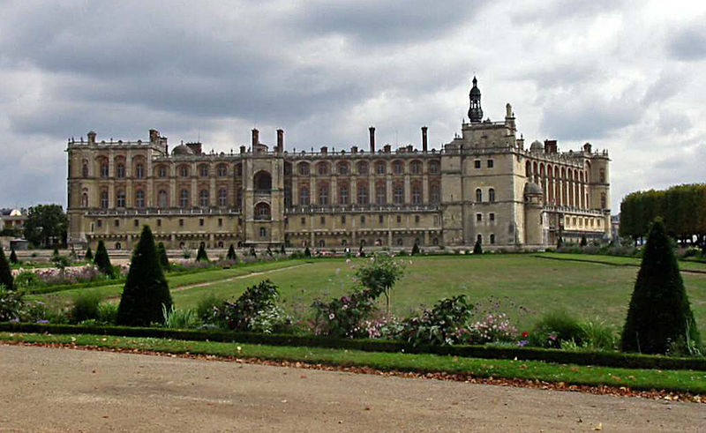

The Château de Saint-Germain-en-Laye

Princess at the French Court

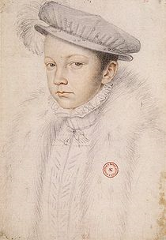
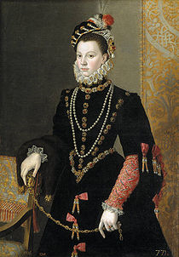
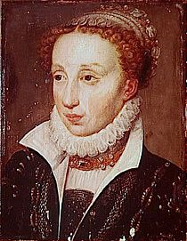

Mary spent the next thirteen years at the French court where she was brought up with the royal children.

There were three, Francis the Dauphin who was a year younger than Mary and his two younger sisters, Elisabeth and Claude. Mary seems to have been popular with all:

“Our little Scottish Queen has but to smile to turn all French heads”
(French Queen, Catherine de Medici.)

When she first arrived in France the French court was at Rouen. It was always on the move, partly in order to see that all the country was being properly governed but also for reasons of health and hygiene.

Wherever the court went, all the government officials went too.

As many as 18,000 travelled about France together on horseback or wagons carrying clothes, furniture, crystal and crockery, in fact, everything the court might need.

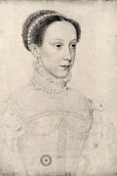

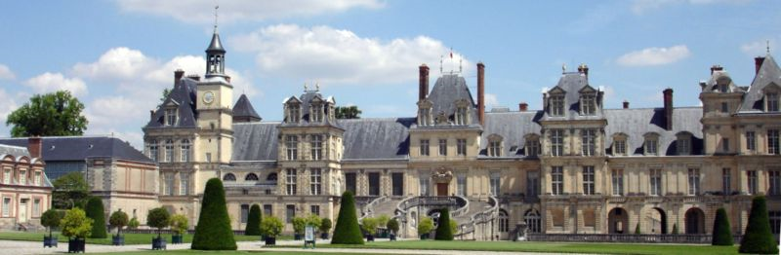

Château de Fontainebleau

From January to April 1550, Mary and the royal children were living in St Germain, near Paris; they spent a short time nearby at Fountainbleau until May; returned to St Germain for the summer and moved on to three other palaces between October and the end of the year.

The inside of these palaces were quite splendid. Visitors would have marvelled at floors of polished wood or marble. Walls were covered with coloured frescoes or intricate tapestries.
Furniture was of great beauty and craftsmanship. Hand painted porcelain was as fragile as eggshells. Palaces were places of breathtaking splendour but they didn’t have toilets.

Members of the royal family had commodes padded in Velvet. There were 150 servants to look after the royal children. These included 28 menservants, 22 nursemaids, 4 masters of the wardrobe, 5 doctors, and 4 barbers.

In 1554, at the age of 12, Mary was given a separate household of her own. Mary had stables of her own.

She was a superb natural athlete. She learned embroidery, which she enjoyed for the rest of her life. She loved music and played the harp and the lute. Mary spoke French, of course, and learned Spanish, Latin, Italian and Greek. She was surrounded with beautiful paintings and sculpture. She also learned to argue effectively.

Overall, Mary had a happy, busy, lively childhood.

Answer the following questions in full sentences

1. How old was Mary when she left Scotland?

2. Who ruled Scotland?

3. Who was Mary brought up with?

4. Why did the French Court move around?

5. Describe the Royal Palaces.

6. Give examples of some of the things that Mary learnt during her time in
France.

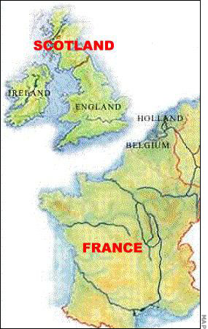

A Royal Wedding

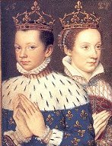

To confirm the alliance between Scotland and France, arrangements were made in 1558 for Mary to marry the Dauphin – a marriage of convenience but one that suited the partners well. They had been brought up together and were very fond of each other. In some ways they were not well matched.

Mary was 5 ft 10 ins, had bright auburn hair and clear, clean skin.

Francis was short – 5 ft, and although he was fond of outdoor sports, especially hunting, he had a pale, sickly appearance and was never in great health.

The wedding took place in April 1558 in the great Cathedral of Notre Dame in Paris. On that day, Mary became Dauphine of France as well as Queen of Scots.

1. Write a short script to show a day in the life of Mary.

2. Draw a picture of Mary and Francis on their wedding day.

In 1559 the peace and contentment of the young couple’s life was soon and suddenly shattered.

The French King, Henry II died after a jousting accident. At the young age of fifteen and a half, the young Dauphin became King Francis II of France and Mary became Queen of France as well as Queen of Scots.

A widow at 18

Francis’ health had always been fragile. One cold evening in November 1559 he returned from hunting complaining of a violent earache. His condition steadily became worse. Mary spent weeks patiently nursing her husband.

However, on the 5th of December 1559, a month after his seventeenth birthday, Francis died.

Mary’s mother died in 1560 and Mary made the decision to return to Scotland in 1561.
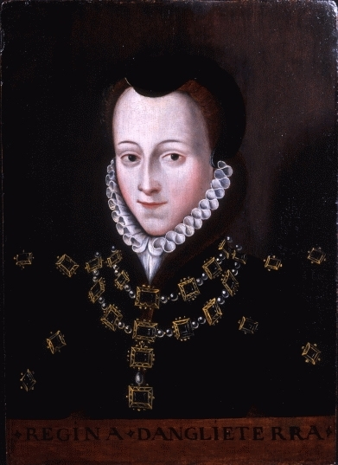

Arrival at Leith

Mary arrived home to Scotland on the 18th of August 1561. They sailed into Leith about 9 O’Clock in the morning. The place was thick with mist and no one had expected her to arrive so soon.

John Knox, the leader of the Protestant Church wrote

“The mist was so thick and so dark. The sun was not seen to shine two days before nor two days after.”

He said that it was a bad omen. Some people believe that there may have been an eclipse of the sun on that day.

Mary had arrived sooner than expected and so, as the royal party disembarked, Mary was greeted by a relatively small crowd of people and a few officials.

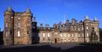
The Queen, dressed in mourning but accompanied by her colourfully dressed party, posed the local officials with a dilemma. They had no idea where to take her or what to do with her. So the house of a local merchant was used for her to rest while messages were sent to Edinburgh.

Mary then travelled to Holyrood House.

She rode there in a grand procession. The way was lined with a cheering crowd. The people of the town performed plays and made speeches to welcome her.

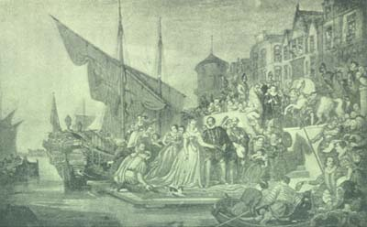

Answer the following questions in full sentences

- Why did Mary become Queen of France in 1559?

- What age was Mary when her husband died?

- Why did Mary decide to return to Scotland?

Extension

- Write 2 short newspaper articles about Mary’s arrival at Leith.

- Each should reflect a differing view on the arrival, one positive, the other negative.

- Your articles could include interviews (eg. with Mary, John Knox or the general public).

- You can include facts and opinions as well as bias and exaggeration.

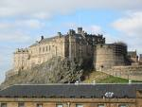
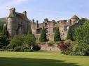
Mary’s Life in Scotland

At this time the Royal Court travelled around the country, staying at royal residences such as Edinburgh Castle, Stirling Castle and Falkland Palace.

To rule effectively the royal court needed to travel around to meet with lairds and other officials. Communication was slow and messages were carried by a messenger on horseback.

There were a large number of servants and there could be up to 100 people living and working in a royal residence.

Mary had a very active life and loved horse riding, dancing, hunting and all kinds of sports and would play royal tennis while at Falkland.

She was the first woman to play golf, which she did at St Andrews.
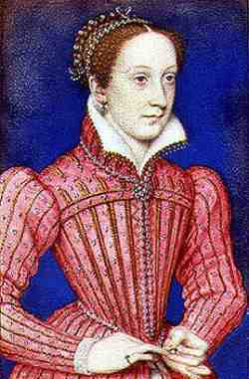

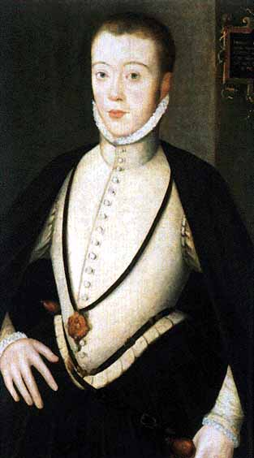
In 1565 Mary was twenty-two and had as many suitors as a royal beauty might expect to have.

One of them was a distant cousin, Henry, Lord Darnley.

Henry was tall, about 6 ft 6 ins, thin and handsome with very blond hair and an easy, personable manner. However he was a spoilt boy of 19 who had been advised by his father to catch Mary’s eye and win her heart in order to get to the throne.

When he was visiting the court at Stirling Castle he fell ill with measles. The soft-hearted Mary helped nurse him. Perhaps Mary was reminded of nursing her first husband.

Their relationship grew into what Mary considered to be love and before long Darnley had won his aim. They were to be married on the 29th of July 1565 in Holyrood Palace. Mary had to marry again to have a child who would be heir to the Scottish throne.

This marriage was a mistake for Mary.

Many Scottish nobles feared that Mary and her husband might try to undermine the new Protestant order in Scotland.
Thus began a series of wars between Mary and her brutal, devious, self-seeking nobles.
Mary gave Darnley the title of King but kept the real power to herself and he resented this. However, she soon became pregnant. Mary soon began to realise that Darnley was rude, proud and lazy. He had no principles, no values, and no interests, except himself.

As soon as Mary was his wife he began to reveal just how much love he had for her. He began to seek fun outside the Palace in wine, women and song. He became rather a pathetic figure, not least in Mary’s eyes. She found it difficult to have any respect for him.

Darnley was an ideal tool for the devious nobles. They spread the belief of a relationship between Mary and a popular musician at her court; David Rizzio.

Jealously created a monstrous fantasy and it ended in blood.

Answer the following questions in full sentences

Imagine that you are Mary. Write either:

- A diary entry
Or
- A letter to a friend

shortly after your marriage to Darnley when you have found out about his true character. Explain why you married him and express your thoughts and disappointment.

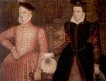

David Rizzio

David Rizzio was an Italian musician who had come to Scotland as a servant. His skills as a musician soon brought him to the attention of Mary.

He was a gentle, civilised man with a clear, rich voice. In appearance, Rizzio was very short, about 5 ft, dark and had a trim pointed beard. The Scots lords persuaded Darnley that Rizzio had replaced him in the affections of his wife and that this problem could be solved by a little murder.

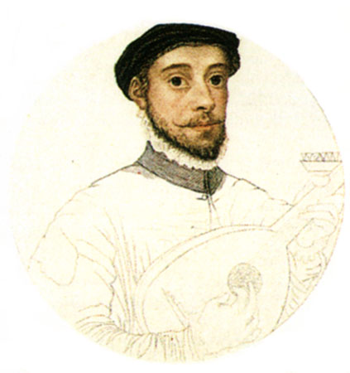

The Murder of Rizzio

In March 1566 Mary was six months pregnant. She had just begun supper with David Rizzio and some friends in Holyrood House when they heard a noise. Darnley came into her room with Lord Ruthven and the other plotters. Lord Ruthven entered the room dressed in armour. David Rizzio was frightened and hid behind Mary but they pulled him out and stabbed him. He was then dragged away screaming and was stabbed fifty-six times outside the room. He died from his wounds.

Mary and Darnley’s son, James, was born 3 months later on the 19th of June 1566.
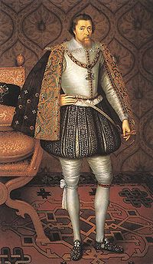

James 6th and 1st

Answer the following questions in full sentences
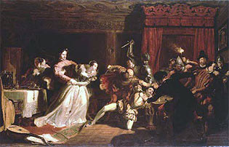

1. Who was Rizzio?

2. Why did Darnley plot to murder Rizzio?

3. Describe the events of Rizzio’s murder.

The Murder of Lord Darnley

Lord Darnley was murdered a few months after his son was born. The murder is still a mystery.

Lord Darnley was recovering from an illness at a house at Kirk o’ Field near Edinburgh. Mary nursed him for a few days but one evening she left him and went out. Soon after she left the house was blown up. The Earl of Bothwell sent messages to find out what had happened. They found Darnley and his servant dead in the garden. Witnesses say they heard Darnley pleading for mercy. He appeared to have been strangled.

We still do not know who killed Darnley, though at the time some people believed that Mary was involved. Others believe that the Earl of Bothwell and other conspirators had planned to blow up the house and that Mary was not involved.
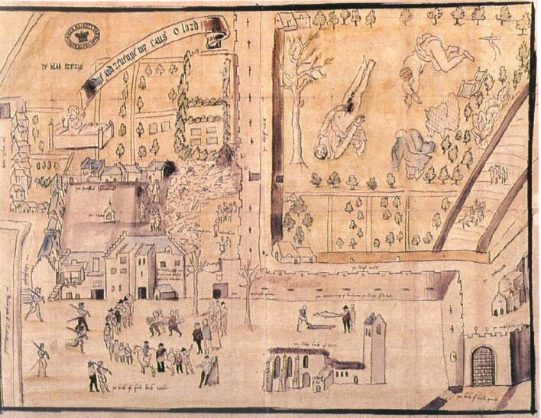
A drawing of the Kirk O’Field murder scene

Answer the following questions in full sentences
1. Describe the events of Darnley’s murder.
2. Who were the main suspects?

Mary and the Earl of Bothwell

Mary was now very unpopular.

Many believed that she was involved in the murder of Lord Darnley. It did not help that Mary did not behave like a grieving widow – she was seen playing golf at St Andrews only days after Darnley’s death.

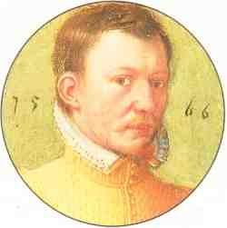
The Earl of Bothwell divorced his wife and, only 3 months after Darnley’s murder, Mary married Bothwell. This shocked the Scottish people.

Some people believe that Mary was forced to marry Bothwell.

The Protestant nobles now united against Mary and Bothwell. The nobles eventually met Mary and Bothwell’s army at the Battle of Carberry on the 15th of June 1567. Mary surrendered, her troops deserted her and Bothwell fled!

Escape from Lochleven Castle

Mary was taken as a prisoner to Lochleven Castle. There she miscarried Bothwell’s twins. Mary managed to escape, disguised in servants clothes.

She managed to raise an army but was defeated by her Scottish enemies.

In desperation she fled to England and appealed to Queen Elizabeth I of England to help her. Elizabeth was very suspicious of her cousin as she worried that Mary’s supporters might try to kill her.

Many people think this is because Elizabeth did not want to be compared to the beautiful Mary.
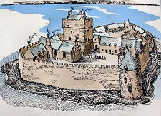

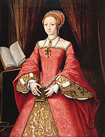
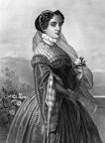

In 1568, Elizabeth faced these facts:

- Mary was still a firm Catholic, despite her marriage to Bothwell
- Mary was still closely linked to France, who remained unfriendly to England.
- Mary was still heir to the English throne and to many the rightful Queen
- She was Elizabeth’s cousin and a Queen as well

Mary had possibly been involved in the murder of Darnley.

Elizabeth knew that some of her Catholic subjects might support Mary, who might also have backing to overthrow her with the aid of the French.

On the one hand Elizabeth may disapprove of Mary’s actions but on the other hand she disliked rebels and had sympathy for Mary’s position.

What could Elizabeth do?

- Mary could be sent back to Scotland where the rebels would likely imprison her.
- Mary could be sent to France, but she might receive help for Charles IX to regain her throne in Scotland or launch a bid for the English throne.
- Mary could be imprisoned in England, but could become the centre of plots against Elizabeth.
- Execute Mary

Answer the following questions in full sentences
- Who were the parents of Elizabeth I?

- Why did many people believe that Elizabeth was illegitimate?

- Why was Elizabeth suspicious of Mary?

- Copy out the box of choices Elizabeth had

- Copy out this table into your book, and then copy the arguments into the right column.

Execute Mary | Save Mary
Mary said she knew nothing about the plots against Elizabeth

Mary was a Queen- chosen by God

Elizabeth didn’t really believe the 1586 evidence- it may have been forged or Mary may have been tricked.

Parliament wanted Mary Queen of Scots to be put to death

Mary had written letters to powerful people abroad. She asked for help to escape.

Mary was a Catholic queen who threatened the English church escape.

.
Mary was Scottish so couldn’t be tried by an English court

In 1586, Elizabeth’s spies found evidence that Mary had been involved in plots.
escape.

As long as Mary was alive, plots against Elizabeth would continue.

Bolton Castle
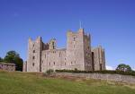
Elizabeth decided to imprison Mary.

At the age of only 25, Mary was imprisoned for a
period of 19 years.

She would remain captive until her death.

To begin with Mary was placed in Bolton Castle where she remained until 26 January 1569. She was then moved on to Tutbury Castle.

During these early years in captivity, Elizabeth called for an inquiry to prove that Mary had been involved in the murder of Darnley.

This inquiry was based solely on the evidence of eight “Casket letters”,

The Casket letters were supposedly written by Mary and Bothwell proving that they had been involved in a conspiracy against Darnley. Many people doubted how authentic these letters were. Mary herself claimed that her handwriting was not difficult to copy and they were in fact forgeries.

During her time in imprisonment, Mary was always well treated by Elizabeth but always well guarded. She had her own servants including a physician and a secretary, she enjoyed embroidery, played cards, had visitors and kept pets. She was also allowed to go on supervised horse rides in the countryside. Whilst imprisoned at Chatsworth House she was fascinated by the local caves, and one group of stalactites is called Queen Mary’s Pillar.

Unfortunately Mary suffered from poor health.

She longed for freedom and to be reunited with her son.

Mary’s friends plotted to set her free and restore her to the Scottish throne. However, Elizabeth had spies keeping an eye on Mary and always found out about the plans.

One of these plots to free Mary involved the Duke of Norfolk who wanted to marry Mary. He was executed when Elizabeth found out about the plot because he had planned to put Mary on the throne in Elizabeth’s place. However, Elizabeth refused to order the death of Mary without definite proof that Mary was involved in the plot.

As a result of the numerous plots to free Mary, she was not allowed to communicate by letter.

The Babington Plot

Throughout her time in captivity Mary’s life was in constant danger as Parliament continually tried to persuade Elizabeth to execute her. All they had to do was prove that Mary was involved in a plot against Elizabeth and they would have all the evidence they needed.

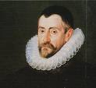
Sir Francis Walsingahm was Elizabeth’s secretary of state and the man in charge of protecting her. In December 1595, he arrested a man called Gilbert Clifford. While being interviewed he confessed to being involved in a Catholic plot to overthrow Elizabeth.

Walsingham decided to use this confession to
his advantage.

He offered to release Clifford if he agreed to work as a double agent. Clifford agreed and went to his contact on the French embassy telling them that he knew how to smuggle letters to and from Mary.

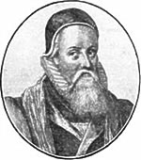
He explained that every week a barrel of beer was sent from Burton to where Mary was staying. He arranged to have letters placed in a waterproof package in the stopper of the barrel.

Another double agent, Thomas Philips who was inside the prison, told Mary of how she would be receiving the letters. However, before they were placed in the barrel they were read by Walsingham.

More importantly he was able to read the letters that Mary was writing to her friends in France and Spain.

In these letters Mary explained how she wanted their help to become Queen by invading England.

Walsingham allowed the letters to continue as he wanted to find out who else was involved in the plot. Eventually on 25 June 1586, Mary wrote a letter to Anthony Babington. In his reply, Babington wrote that he and a group of six friends were going to murder Elizabeth.

Walsingham now had all the evidence he needed to act against what became known as ‘The Babington Plot.’

Babington was arrested and his home searched for documents that would provide evidence against him. When interviewed, he made a confession in which he said that Mary had written a letter supporting the plot.
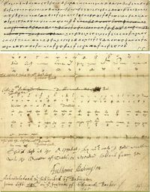

Mary's letter to Babington

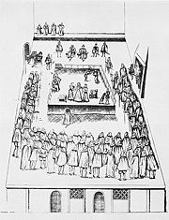
Anthony Babington and six others were executed for high treason on 15 September 1586. An attempt to kill the monarch was the most serious crime in England and the punishment was to be hung, drawn and quartered.

The men were tied face downward on a hurdle drawn by horses. They were then dragged through the streets of London. At Tyburn they were hung for a short time. After being revived the men had their intestines cut out. At the execution the crowd complained about the agonies the men had to suffer before they died.

When she heard this Elizabeth gave instructions that the rest of the conspirators due to be executed the following day were to be dead before being cut down.

The next big question Elizabeth faced was what to do about Mary?
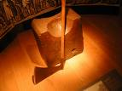

Answer the following questions in full sentences

- What did Elizabeth decide to do about Mary?

- Why was it difficult to prove that the ‘Casket Letters’ were written by Mary?

- What was life like for Mary during her time in imprisonment?

- Compare Mary’s time in prison to what you would consider to be a normal standard of life in prison.

- How much freedom did Mary have to do what she wanted?

- How did Mary’s friends deal with her being imprisoned?

- Describe what the ‘Babington Plot’ was?

- What punishment was given to Anthony Babington and the other conspirators?

- How did the crowds of people feel about the punishments they were given?

- How did Elizabeth react to the executions?

Decision Point 2

Should Elizabeth accept Parliaments demands for Mary’s execution?

Elizabeth was now faced with a difficult decision as Parliament were trying to encourage her to have Mary executed.

- Copy the following table into your jotter.

Arguments in favour of execution | Arguments against execution

- Organise the following points into the correct column on the table:
Mary was Elizabeth’s cousin and a monarch appointed by God. By executing her, Elizabeth would set a dangerous example

The Ridolfi Plot involved the Duke of Norfolk, Philip of Spain and the Pope. By keeping Mary alive, Elizabeth ran the risk of foreign invasion.

The Rising of the Northern Earls was the first serious attempt to overthrow Elizabeth. By keeping Mary alive she was putting her own life in danger.

Elizabeth’s excommunication made her a target for Catholic plotters. By keeping Mary alive, Elizabeth was providing them with a champion

Although both the Northern Rising and the Ridolfi Plot were aimed at placing Mary on the throne, there was no evidence that Mary herself was involved.

The most serious argument against executing Mary was that it could trigger a foreign invasion or a catholic rebellion at home. In 1572, England was not prepared for either

Mary was put on trial for high treason and found guilty on 15th October 1586.

Source A describes Mary’s views on her trial:
“Can I be responsible for the criminal projects of a few desperate men, which they planned without my knowledge of participation?”

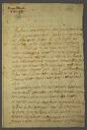
Mary’s last letter
Despite all the evidence, Elizabeth was still against executing Mary and for six weeks refused to sign the death warrant. She was worried about what other countries would think of her if she ordered Mary’s execution. Despite her feelings, Parliament and Walsingham insisted that Mary should die. Elizabeth eventually gave in to the pressure and she signed the order in February 1587.

Mary’s Last Hours

Mary was told about her execution on the afternoon of 7th February. Her last letter was completed at 2 o’clock in the morning of Wednesday 8th February 1586, six hours before her execution was due to take place at Fotheringay Castle. Her last letter was to Henri III, her former brother in law, then King of France. In it Mary states that she is being put to death for her Catholic religion and her right to the English crown. She also asks him to take care of her servants. The rest of her time was spent doing the following:

- She prayed and wrote her will which requested the release of her servants.
- She requested that she be buried in France.

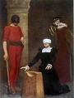
The Execution

Mary was beheaded at Fotheringay Castle at 8.00am on Wednesday 8th February 1587, aged 44.

At the execution, Mary drew attention to the fact that she was denied the opportunity to review evidence, and was denied access to legal counsel. She also stated that as she had never been an English subject, she could not be convicted of treason.

At the execution Mary was heard to say

“Into thy Hands O Lord, do I commit my spirit.”

She was also dressed in red which is a sign of martyrdom in the Catholic Church and was so frail she had to be helped onto the scaffold. In the presence of the Commissioners and Ministers of Queen Elizabeth and a crowd of people, the executioner struck Mary with his axe. The first blow missed her neck and hit Mary in the back of the head. Her servants claimed to have seen her lips move and heard her utter the words “sweet Jesus.” The executioner struck Mary a second time, and this time successfully removed the head. When the executioner lifted up her head, he found that he had a wig in his hands and that the actual head was still on the scaffold. No one had known that she had lost her hair. Then her body moved. Underneath her skirt, a small dog was seen. Mary had brought her dog to her own execution. In 1612, her son James who was King of England and Scotland brought her body to Westminster Abbey where she was buried in a magnificent tomb.
Elizabeth’s Reaction

Afterwards, Elizabeth claimed that she did not give permission for the execution of her cousin. As a result, Davidson, the man responsible for the execution was fined £6000 and imprisoned in the Tower of London.
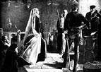

Answer the following questions in full sentences

- When and where did the execution take place?

- What claim did Mary make at the execution?

- Why was Mary dressed in red for her execution?

- Describe the events of the execution. (Write three separate points to describe this)

- What did Elizabeth attempt to claim after Mary had been executed?

Extension

Produce a newspaper article about the execution of Mary Queen of Scots.

You must decide whether you are:

- A supporter of Queen Elizabeth
- A supporter of Mary Queen of Scots

Think about the attitude your article will have e.g. are you supportive of or against the execution?

Mary Queen of Scots Video Questions

Mary’s arrival in Scotland
Circle the correct answer

- What was Mary’s reaction to her arrival in Scotland?

Sad Happy Worried Nervous worried

- How does Mary show her power over the Lords of Scotland?

Takes his horse slaps him Bows to them

- Why were the Huntley family not invited to greet the Queen on her arrival?

Catholic Protestant English

Hearing Mass

- What happened when people discovered that Mary was hearing Mass?

Heard it with her Broke the door down complained

- Who is the leader of the Mob?

John Knox John Frasier John Comen John Dear

- What does he call Mary and her mother?

Monstrous regiment of women Agents of God Beautiful Women

- Who did he say he must obey before anyone else?

God Elizabeth 1st Mary

Mary Queen of Scots Video Questions

Circle the correct answer
Council Meeting

- Why don’t the men stand when Mary Enters?

She’s a different religion she’s Ugly they don’t like her

Elizabeth and Lord James

- According to Elizabeth what is the reason why Mary goes to Mass?

She wants to embarrass Elizabeth she wants to replace Elizabeth as Queen
- How does Elizabeth solve the problem?

Tell Lord James to get rid of the Huntley’s Tell Lord James to get rid of Mary

Huntley’s revenge

- What does Huntley do to revenge the insult to the Queen?

Kill the offender File a complaint Challenge the offender to a dual

- What happens to him?

He is beheaded he is hung he is tortured he is electrocuted

- Who does Huntley tell Mary to be beware of?

Lord James Lord Darnley Lord Bothwell Lady Huntley

Mary Queen of Scots Video Questions

Circle the correct answer

- What does Mary tell the waiting crowd?

That it was a scot killing a Scot that it was a catholic killing a protestant

- What does Bothwell suggest she do?

Council Meeting

- Why were the lords clapping?

Because Mary executed a catholic Because Mary has executed a protestant

- What is Mary’s decision?

She is getting married she is going back to France She is pregnant

1ST Meeting

- How does Mary react when she meets Darnley?

Falls in love hates him instantly thinks he speaks wonderful French

- Who is Darnley related to?

James 2nd James 3rd Edward 4th James 6th
- Are the Scottish Lords happy?

No Yes

Mary Queen of Scots Video Questions

Circle the correct answer

- What is Mary’s reaction to Bothwell’s outburst?

She imprisons him she beheads him she sends him abroad

- What is Rizzio’s problem with the marriage to Lord Darnley?

She likes him too much he is not royal enough he is too good looking

- What is Lord James’ reaction to the marriage?

He threatens Mary He is happy for them he is confused

- What job does Mary give to Bothwell?

Bodyguard butler cook driver

2nd Marriage

- What is wrong with Darnley on the wedding night?

Drunk Angry tired hungry

- What is Elizabeth’s reaction to the marriage?

Anger Worry happy sad

- How does Lord James plan to fix it?

Kill Darnley get Mary to execute Darnley kidnap Darnley

Mary Queen of Scots Video Questions

Circle the correct answer

- What does Bothwell say is wrong with Darnley?

Drunk again feeling unwell missing gambling

- What does Lord James want Darnley to do?

Kill Rizzio Leave the castle doors open leave a window open

- What will Darnley get in return?

The Crown money a horse

- Describe the murder of Rizzio in your jotters using the following words

Daggers Screaming Violent Stabbing Ladies

- Why couldn’t Bothwell help?

He was locked in his room he is drunk he is sleeping

- What was Mary’s reaction?

Heart Broken Angry Happy worried

- What does Bothwell do when Darnley appears?

Arrange for Mary’s escape Arrange for the execution of all murderers

Mary Queen of Scots Video Questions

Circle the correct answer
War

- What stops the fight against Lord James?

The English Border The rain the English Army

- What is Bothwells reaction to Mary’s order?

Anger He’s fine with it doesn’t care

- Why did Mary not want to cross into England?

Did not want to risk war was getting dark Horses could not swim

- What was Bothwell’s message to Mary?

Mary is pregnant Mary is dead Mary has fled

Birth

- What is the sex of Mary’s baby?

Boy Girl

- What does Mary make Darnley swear to?

That the baby is his that the baby is a boy that the Baby is alive

- What does Mary want her soldiers to do?

Protect the baby prince with their lives Protect Lord Darnley

Mary Queen of Scots Video Questions

Circle the correct answer
Death of a consort

- What makes Bothwell want to kill Darnley?

He rapes Mary he hits Mary he attacks Bothwell

- What makes Mary want to kill Darnley?

He takes the Baby he drinks too much He attacked Bothwell

- How is Darnley to die?

In a fire drown smothered fall

- How does he die?

Strangled Stabbed shot with an arrow Stoned

- How does Mary save Bothwell from execution?

Marries him sends him away abroad hides him

- Why do the people of Scotland turn against Mary?

Because he marries Bothwell because she is French because she is catholic

- What does Lord James do to Mary?

Imprison her Kill her let her escape

