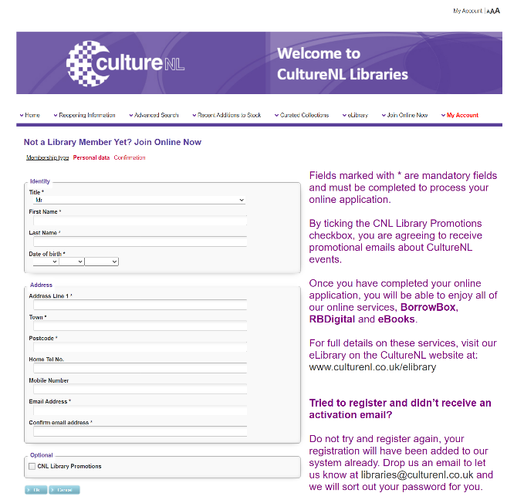
Step 1
Create a CultureNL online account. This is the website that North Lanarkshire Council use for their library service. You can find the website below by following this link: CultureNL. Use your Glow email account for this!
IF you already have a library card with NLC, you can sign in using that instead.

________________________________________________________
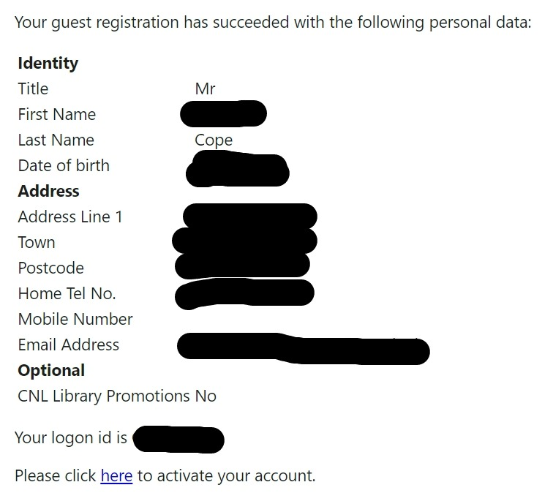
Step 2
Once you have signed up, you will receive an email from libraries@culturenl.co.uk confirming you’ve signed up. If you don’t receive an email, make sure to check any Spam or Junk Mail folders!
Your email will look something like the one here.
You need to click ‘here’ to finish setting up your account.
The ‘logon id’ is what you’ll need to access BorrowBox.

__________________________________________________________________________________
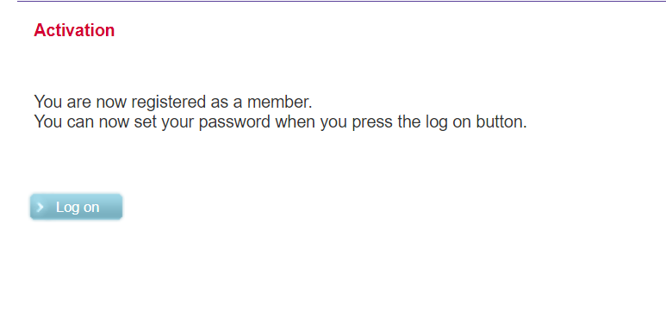
Step 3
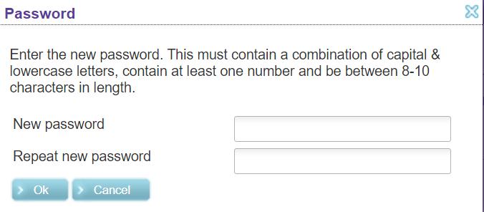
Once you click the link in the email, you’ll be taken to this screen, confirming you are now a member of the library.
Click ‘log on’, and you will be asked to create a password. Try and make something memorable (like your Glow password).

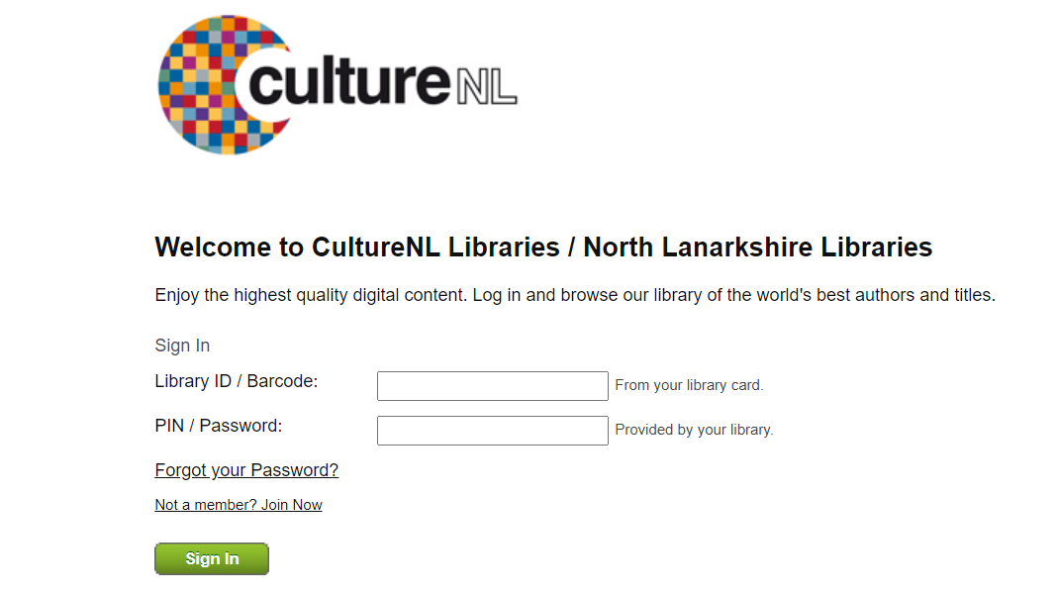
Step 4
Congratulations! You should now be registered. That means you can use BorrowBox now. You can find their library once you log in with the details: Login - BorrowBox (bolindadigital.com)
Your Library ID will be the ‘logon id’ you received in your email.
Your Password will be the password you set in the previous step.
__________________________________________________________________________________
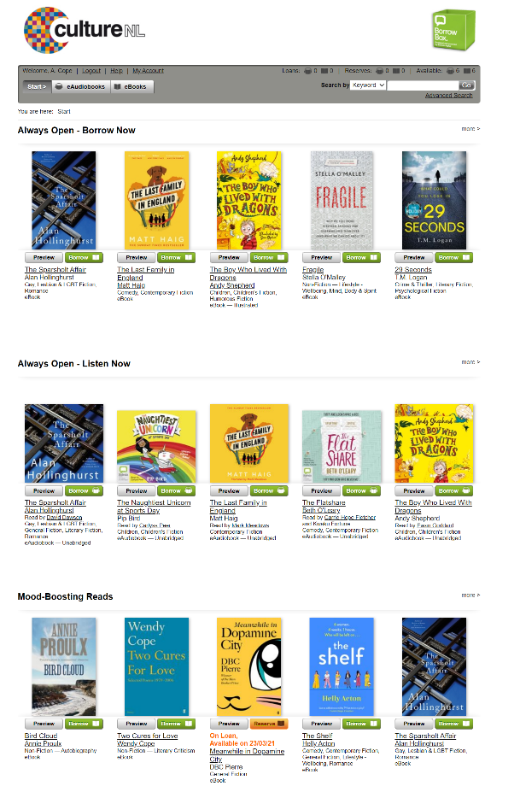
Step 5
You should now be logged in to BorrowBox.
You can ‘eloan’ a book for 28 days. You can have up to 6 books at any one time (I will update if this changes!).
Once you find a book you like, click borrow.
You’ll then be brought to a screen to confirm your ebook loan. You then can download it immediately from the internet (if you’re on a PC/Laptop) or from the BorrowBox Mobile app.

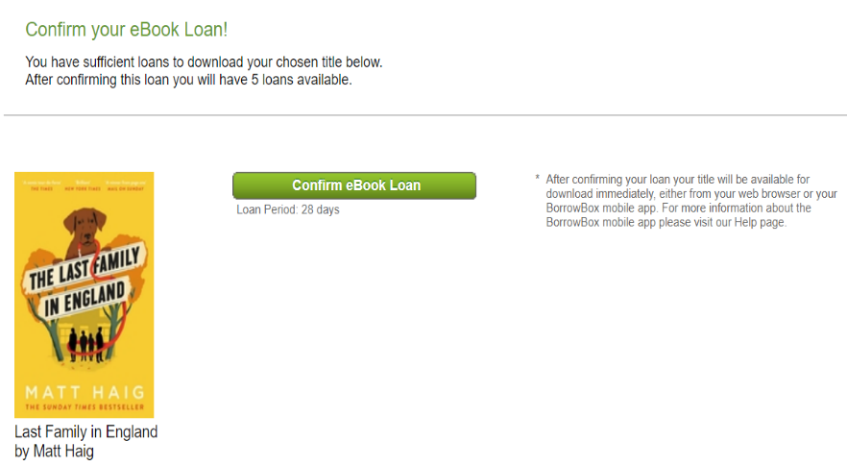

Step 6 (app setup)
If you want to use the app - Download the BorrowBox app from your respective app store.
Once you download it and open the app, you’ll be brought to the page on the left. You’ll need to search for the library. To find it, type in CultureNL Libraries.
Sign in with your logon id and password you set up earlier.
Once you accept the terms and conditions, you’ll be brought to the main page on the right. This will show you how many books you have taken out and how many you are allowed to borrow.
There are tabs for audiobooks, ebooks and a search tab if you are looking for something in particular (which if you’re in the Book Club, you will be!)
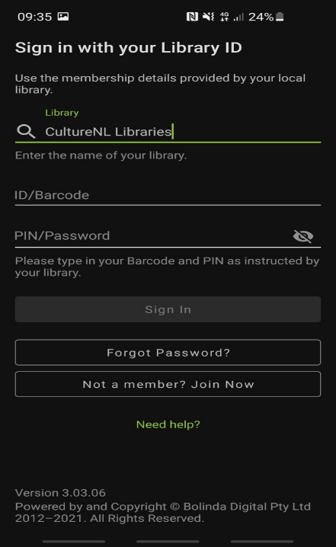
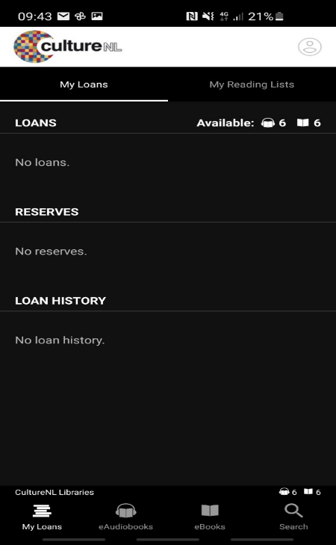
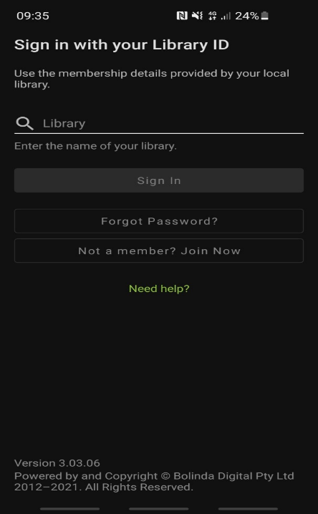

Here are the devices that can download and use the BorrowBox app:
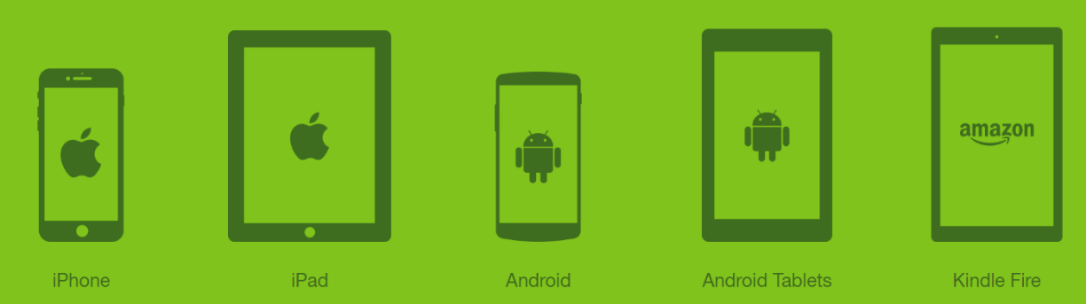

That’s about all you need to know! If you need any more help with signing up for BorrowBox, just ask Mrs Hall or Mr Cope.

