Using and Accessing the different Apps in Glow to support Home Learning

Log in to Glow and then select the App Library option from the Menu at the top.

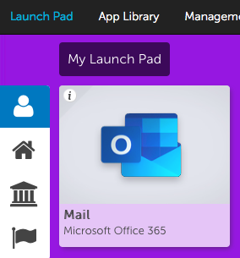

This will take you into the App Library where you can select the following.

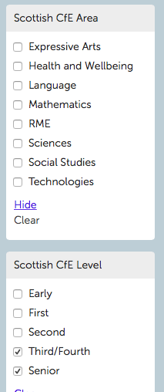
The menu at the left hand side of the page will allow you to select the different curricular areas you wish to see learning Apps for.

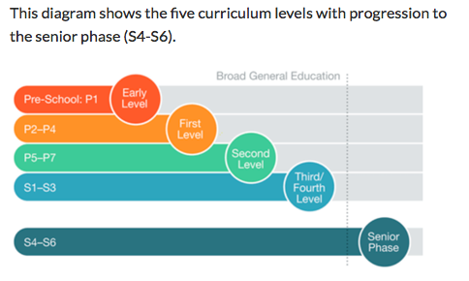
You should then select the CfE level.

Once you have selected the Level and curricular area, if you wish to add an App to your Personal Launchpad, click on the App and then Add to my Launchpad.

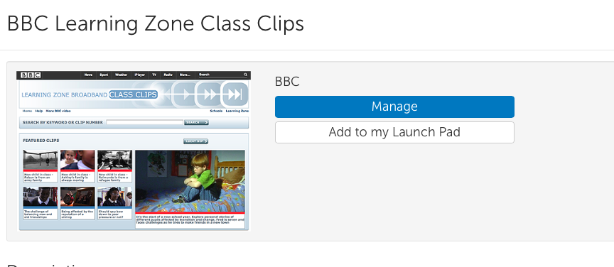

Select Launchpad at top left-hand corner. You will be able to access the App as soon as you log in.

Accessing Word, Excel, PowerPoint etc on Glow.

Follow the procedure above but in the search menu at the top enter Office 365.

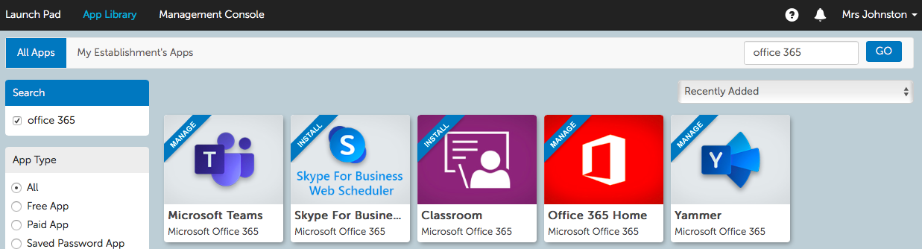

Select the tile and Add to my Launchpad.

You will now have access to most of the Microsoft Office Suite.
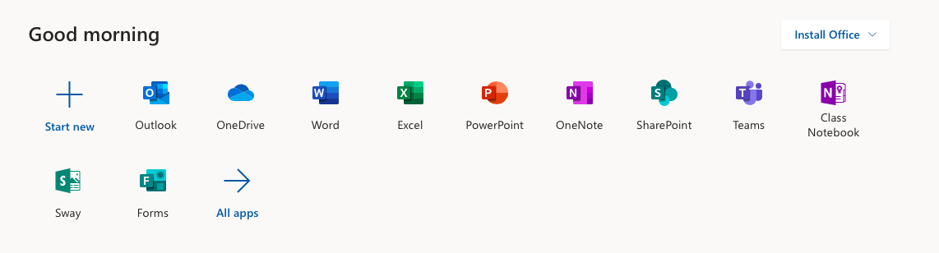
You can also Install Office to your home computer by selecting the Install Office option and follow the online instructions.

