Cumbernauld Academy
Pupil Help Sheet in Accessing Glow Teams
Log into Glow using your Glow Username and Password (please be careful as after 3 attempts you will lock yourself out and your password will need to be reset by a member of staff)
Click on the following icon to take you to the school page then select Mail.
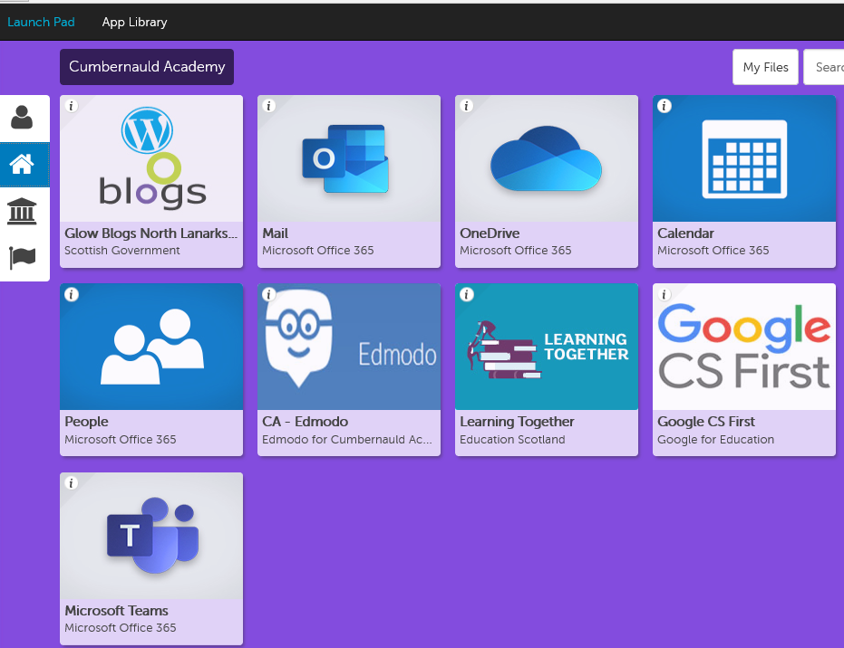
Once you are in your Mail, you should see an Invite to the Team in your Inbox or you may see an Email with a link to request membership. Click on the link to access your invite.
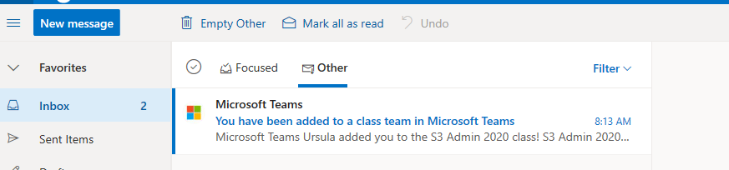

Open the Invite and Click on the link to open the Team as shown below:
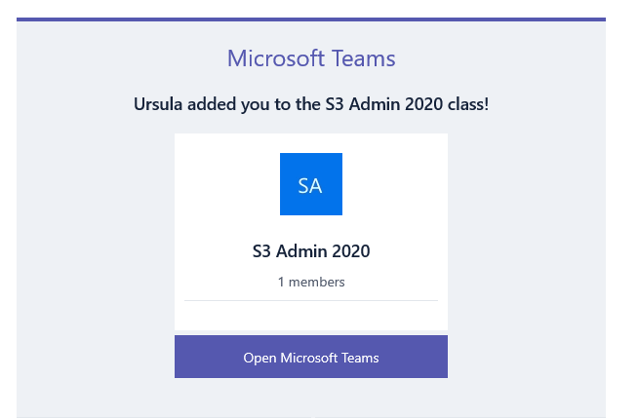

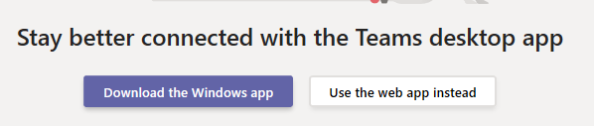
Select Use the Web App instead.

Your Team should appear as a Tile.
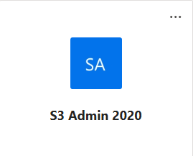Select the tile to take you to the Team.

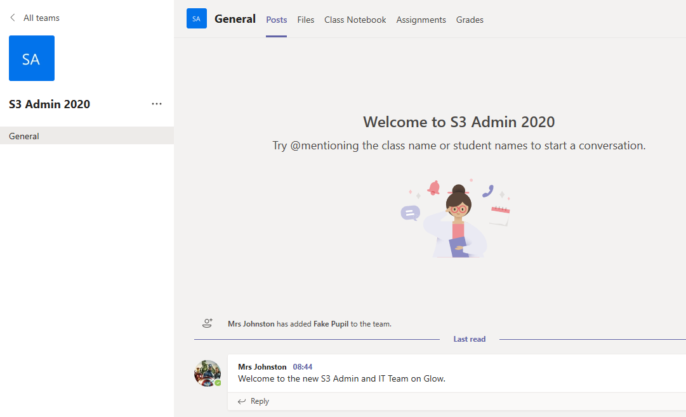

Using the different areas of the Team

Files
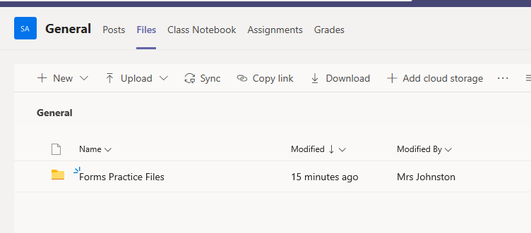

You will be able to access and download any files your teacher has uploaded to Glow.
Assignments
If your teacher has assigned you a particular piece of work, the instructions and dates will be here. You will also receive an email informing you that you have been allocated an assignment.

You can access and key in directly onto any file that has been attached to the assignment. Once completed, select Submit assignment. Your teacher will then be able to mark and feedback.
Posts
You can message staff and keep in contact with everyone in your class. It’s like Group Messaging but remember staff also see every message posted.