N5 Computing Science – Web Design and Development

Due Date: Date

Name

Homework 4

The 2 files below are linked to display a web page about countries of the world.

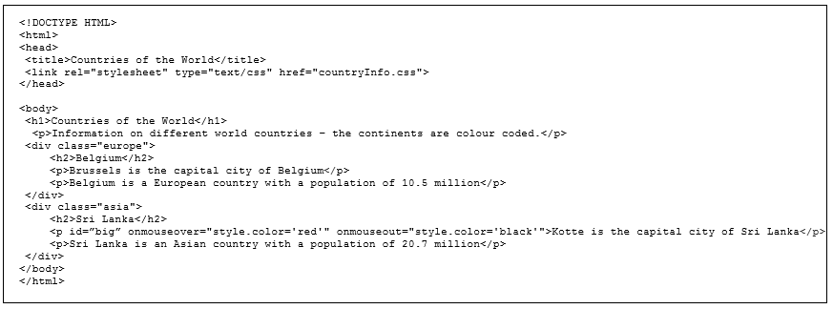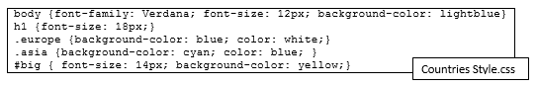

1. Name the type of CSS stylesheet being used and explain why it is called this. Explain how the CSS rules are applied to the HTML.

________________________________________________________________________________________________________________________________________________________________________________________________________________________________________________________________________________________________________________________________________

1. Complete the blanks in the HTML Link tag line to add in the CSS code.
2. Identify in the CSS file the id and class selectors and explain how they are applied to specific tag styling in the HTML.

_____________________________________________________________________________________________________________________________________________________________________________________________________________________________________________________________________________________________________________________________________________________________________________________________________________________________________________________________________________________________________________________________________________________________________________________________

1. What does the DIV element do in HTML? Explain why DIV is useful with class/id selectors.

________________________________________________________________________________________________________________________________________________________________________________________________________________________________________________________________________________________________________________________________________

1. Below are 3 of the paragraphs with different tag stylings coming from the CSS rules. For each of the <p> text shown below explain where they are getting their styling from and how they look.

|  |  |
| --- | --- |
| “Information on different world…” |  |
| “Sri Lanka is an Asian country…” |  |
| “Kotte is the capital city…” |  |

1. To split up the information the developers plan to add only a few countries per web page. They are going to end up with around 50 web pages so explain the advantages of the formatting and layout coming from an external stylesheet.

________________________________________________________________________________________________________________________________________________________________________________________________________________________________________________________________________________________________________________________________________

1. There is dynamic content on the web page – explain what this means and name the language used to add interactive coded elements on the web.

________________________________________________________________________________________________________________________________________________________________________________________________________________________________________________________________________________________________________________________________________

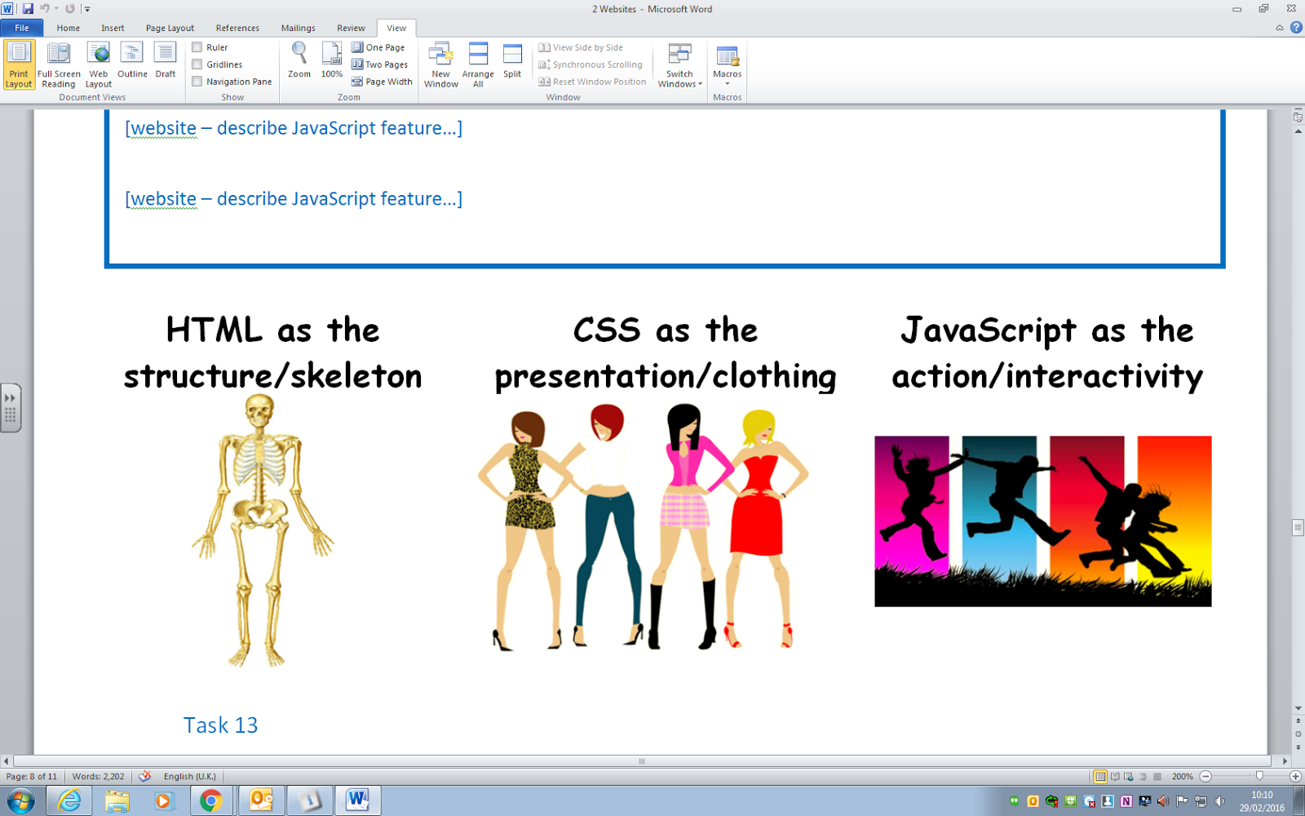

1. With reference to the pictures above explain how the 3 main coding languages of the web create modern websites.

________________________________________________________________________________________________________________________________________________________________________________________________________________________________________________________________________________________________________________________________________

1. Describe what the JavaScript on the example web page does while naming and explaining the specific mouse events used from the language.

________________________________________________________________________________________________________________________________________________________________________________________________________________________________________________________________________________________________________________________________________

1. Give examples of 2 other real world uses of JavaScript on web pages.

________________________________________________________________________________________________________________________________________________________________________________________________________________________________________________________________________________________________________________________________________

1. When testing a website name and describe 3 areas that would to be checked.

____________________________________________________________________________________________________________________________________________________________________________________________________________________________________________________________________________________________________________________________________________________________________________________________________________________________________________________________________________________________________________

1. When evaluating a Website explain what Fitness for Purpose is.

____________________________________________________________________________________________________________________________________________________________________