N5 Computing Science – Web Design and Development

Due Date: Date

Name

Homework 3

Below is the HTML and CSS code for Hector the Tax Inspector’s home page – please read carefully.

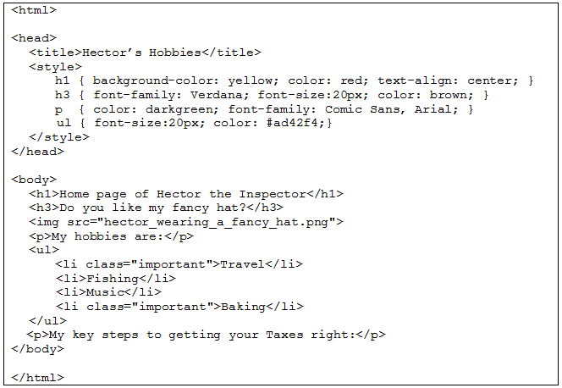

1. Fully name CSS, explain what it is used for and describe how its rules are set out.

__________________________________________________________________________________________________________________________________________________________________________________________________________________________________________________________________________________________________________________________________________________________________________________________________________________________

1. Interpreting the code above explain what the web page information will look like.

______________________________________________________________________________________________________________________________________________________________________________________________________________________________________________________________________________________________________________________________________________________________________________________________________________________________________________________________________________________________________________________________________________________________________________________________

1. Hector needs to complete his web page with a numbered list of his tips for getting your taxes right – keep financial statements, run the online tax calculator and then pay before March. Write the HTML code to display this and please note the word “online” should be a link to the [www.tax.gov.uk](http://www.tax.gov.uk) website.
2. The numbered list needs styling – write CSS code to make sure the numbered list is Tahoma font, aligned to the right, size 16 text and coloured orange on a yellow background.
3. Hector also has a photo of his tax office that he wants at the bottom of the web page – the file is in a folder called “images” next the page’s code file, it is called “Headquarters Front”, needs to be dimensions 450 x 300 and needs a text description if it doesn’t display in the browser. Write a tag below to include this picture on the web page.
4. Name what type of Cascading Style sheet is shown on the previous page example and explain why it is called that.

________________________________________________________________________________________________________________________________________________________________________________________________________________________________________________________________________________________________________________________________________

1. Using the paragraph CSS declarations explain how the styling would “Cascade” across a whole page.

________________________________________________________________________________________________________________________________________________________________________________________________________________________________________________________________________________________________________________________________________

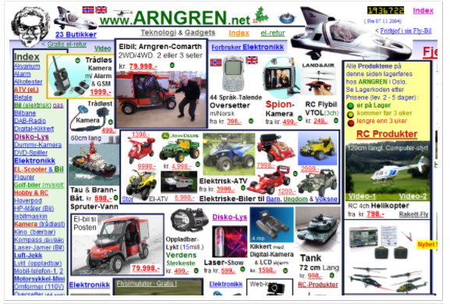

1. Evaluate the web page above and describe 2 specific reasons it has not got effective user interface design.

________________________________________________________________________________________________________________________________________________________________________________________________________________________________________________________________________________________________________________________________________

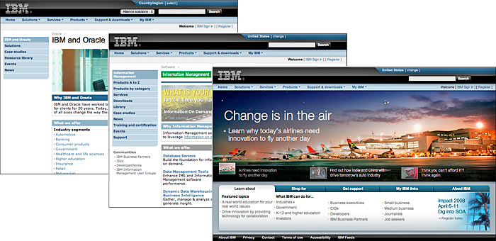

1. For the web page above describe an end-user requirement and a related functional requirement.

________________________________________________________________________________________________________________________________________________________________________________________________________________________________________________________________________________________________________________________________________

1. Making reference to consistency explain why the site above has good user interface design and describe another positive feature to the page layout.

________________________________________________________________________________________________________________________________________________________________________________________________________________________________________________________________________________________________________________________________________