N5 Computing Science – Web Design and Development
Due Date: Date
Name
Homework 2
Below is the home page for a school website.
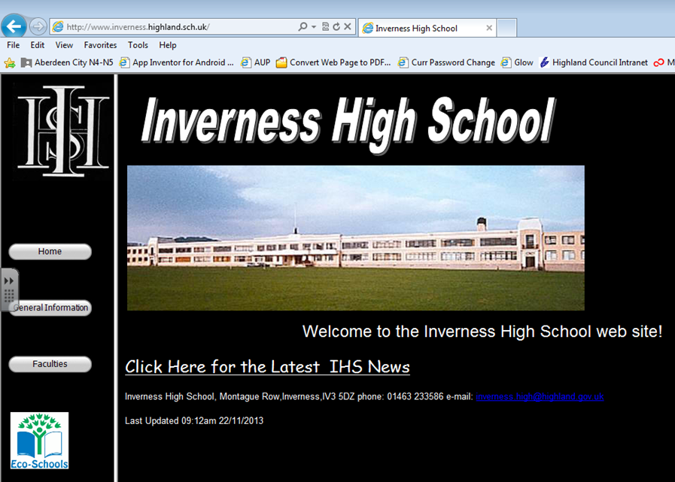

- Explain what Internal links and External links are relating your answers to examples above.
________________________________________________________________________________________________________________________________________________________________________________________________________________________________________________________________________________________________________________________________________
- Above are another 2 links on the website. Name and explain the type of addressing they use and how you can tell if they are internal or external links.
________________________________________________________________________________________________________________________________________________________________________________________________________________________________________________________________________________________________________________________________________
- On the music department page pupils have put photos of their favourite artists and audio files of their favourite songs. Explain the ways they’re in breach of the law.
________________________________________________________________________________________________________________________________________________________________________________________________________________________________________________________________________________________________________________________________________
- The music department are recording their own compositions but the quality isn’t good enough, explain a setting that they can change so the recorded files are better quality.
________________________________________________________________________________________________________________________________________________________________________________________________________________________________________________________________________________________________________________________________________
- The art department have been taking photos but they also find the settings on the camera are not giving top quality, explain 2 settings they can change to up the quality of the JPEG files.
________________________________________________________________________________________________________________________________________________________________________________________________________________________________________________________________________________________________________________________________________
- Explain why a balance of quality vs file size needs to be considered when working with multimedia files.
________________________________________________________________________________________________________________________________________________________________________________________________________________________________________________________________________________________________________________________________________
- Fully name the code used to develop web pages and explain how the data to output is set out.
______________________________________________________________________________________________________________________________________________________________________________________________________________________________________________________
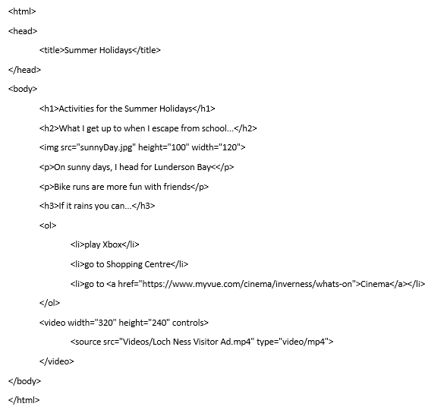
- A PSE pupil is creating a web page about Summer holidays. Reading through the HTML explain all the features and information that would be seen on the web page.
________________________________________________________________________________________________________________________________________________________________________________________________________________________________________________________________________________________________________________________________________________________________________________________________________________________________________________________________________________________________________________________________________________________________________________________________________________________________________________________________________________
- The pupil has an mp3 file called Happy Holidays that they want to add to the web page. In the box below write the line of HTML for them to put the sound file in the page.

