N4/5 Computing Science – Software Design and Development
Due Date: Thu 8th Dec
Name
Homework 12 – Exam Style
1. A program has to take in a student’s name, last month’s grade point average and this month’s grade point average. It is required to find out the difference between this month’s and last month’s grade point average - if the difference is negative a letter is printed or point average is fine and pupil ticked off on system.
(a) Outline the I P O of the problem above.
Input(s):___________________________________________________________________________
Process(es):________________________________________________________________________
__________________________________________________________________________________
Output(s):_________________________________________________________________________
- Make up names for 2 example variables in this program but they must be shown to be different data types.
Variable Name:______________________________ Data Type:________________________
Variable Name:______________________________ Data Type:________________________
- Explain the arithmetic calculation that needs to be done in this solution
__________________________________________________________________________________
__________________________________________________________________________________
__________________________________________________________________________________
__________________________________________________________________________________
- Write rough code below that shows the construct that would decide between and set out the possible outputs.

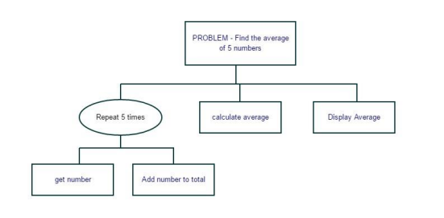2. Look at the program design below.
(a) Name the type of design shown.
__________________________________________________________________________________
(b) Describe in plain English what the program does in order.
__________________________________________________________________________________
__________________________________________________________________________________
__________________________________________________________________________________
__________________________________________________________________________________
3. The section of program below is part of a program related to sales of an object.
…
Line 7 For loop repeats 12 times for counter x
Line 8 sales total = sales total + monthly sales [x]
Line 9 Next x
…
- What kind of algorithm is shown? Explain what this section of the program does.
__________________________________________________________________________________
__________________________________________________________________________________
__________________________________________________________________________________
__________________________________________________________________________________
- Line 10 needs to find the monthly average of sales, write an instruction below to do this.

- Explain how the fixed loop counter x is used to traverse and move through the array above.
__________________________________________________________________________________
__________________________________________________________________________________
__________________________________________________________________________________
__________________________________________________________________________________
- Just one month has to be chosen by the program for each day’s sales to be looked at. Write an instruction utilising a function to pick any single month.

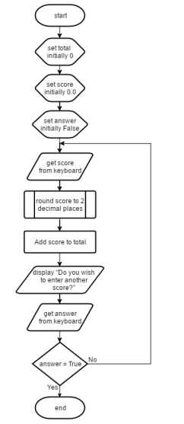4. Trace through the program algorithm illustrated below.
(a) Name the design notation shown and describe why it is useful for thinking through programs.
_____________________________________________________
_____________________________________________________
_____________________________________________________
_____________________________________________________
(b) What type of loop is shown in this algorithm? Explain how you know.
_____________________________________________________
_____________________________________________________
_____________________________________________________
_____________________________________________________
(c) Describe in plain English what this program does.
_____________________________________________________
_____________________________________________________
_____________________________________________________
_____________________________________________________
_____________________________________________________
_____________________________________________________
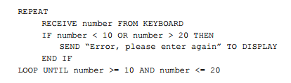5. Look at the standard algorithm below.

(a) State the design notation used for the program above.
__________________________________________________________________________________
(b) Name the standard algorithm shown and describe what it is for in this program.
__________________________________________________________________________________
__________________________________________________________________________________
__________________________________________________________________________________
__________________________________________________________________________________
(c) If the number received is 21 explain what will happen as that data executes through the code.
__________________________________________________________________________________
__________________________________________________________________________________
__________________________________________________________________________________
__________________________________________________________________________________
__________________________________________________________________________________
__________________________________________________________________________________
__________________________________________________________________________________
__________________________________________________________________________________
(d) In a programming language you are familiar with re-write this Input Validation algorithm.

6. Look at the code solutions below that work but are not very efficient. Rewrite the algorithms using better coding constructs for efficiency.
(a) Take in cash withdrawal amount
Bank balance assigned bank balance – withdrawal amount
Take in cash withdrawal amount
Bank balance assigned bank balance – withdrawal amount
Take in cash withdrawal amount
Bank balance assigned bank balance – withdrawal amount
Take in cash withdrawal amount
Bank balance assigned bank balance – withdrawal amount
Take in cash withdrawal amount
Bank balance assigned bank balance – withdrawal amount

(b) if Primary_School == “Merkinch”
Print Code Club Voucher
if Primary_School == “Dalneigh”
Print Code Club Voucher
if Primary_School == “Central”
Print Code Club Voucher

(c) if Reading > 2000
Display “optimum working”
if Reading > 1000
Display “efficient working”
if Reading > 500
Display “working but inefficient”
if Reading <= 500
Display “performance check required”

- Using a Reading data value 2500 explain why your algorithm is a more efficient solution.
__________________________________________________________________________________
__________________________________________________________________________________
__________________________________________________________________________________

