**Database Queries using SQL: Exercise 4**

**Task 1**

The SuperHero database stores details of movie characters in a table called SuperHero. Each of the characters has played a role in a super hero movie. The table has 8 fields shown below.

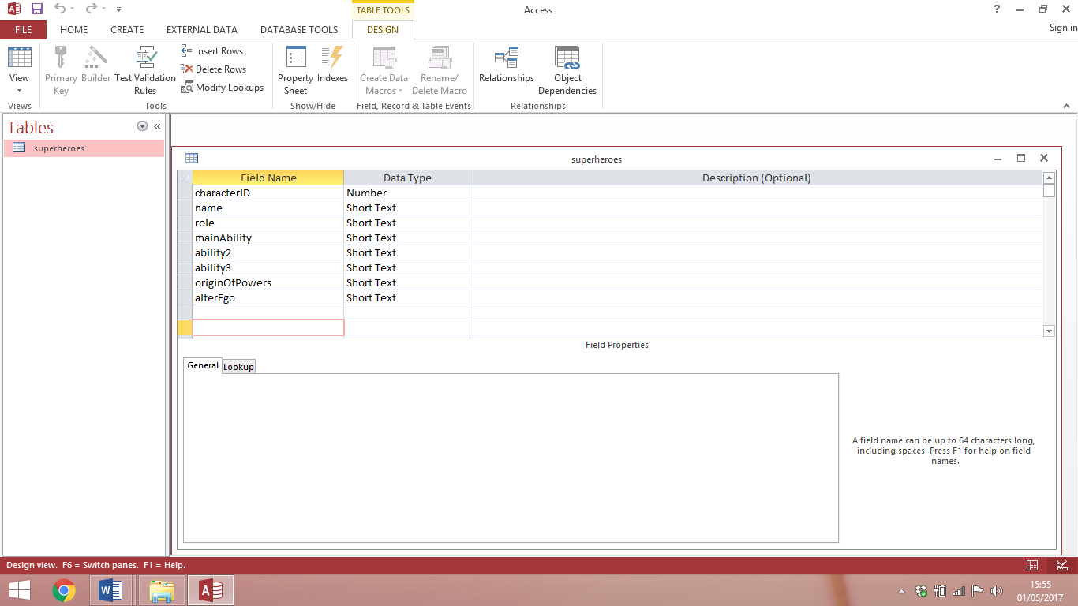

Design SELECT queries to perform each of the following tasks.

1. Search the database to find a character who played the role of 'Super Hero' with 'acrobatics' as his/her main ability. Display the character’s name, role and main ability.

|  |  |
| --- | --- |
| Field(s) |  |
| Table |  |
| Search criteria |  |
| Sort order |  |

1. Search the database to find a character who played the role of 'Henchman' whose main ability is 'strength'. Display the character’s name, role and main ability.

|  |  |
| --- | --- |
| Field(s) |  |
| Table |  |
| Search criteria |  |
| Sort order |  |

1. Search the database to find a character who played the role of 'Super Villain' whose main ability is 'magic' and whose origin of power is 'training'. Display the character’s name, role, main ability and origin of power.

|  |  |
| --- | --- |
| Field(s) |  |
| Table |  |
| Search criteria |  |
| Sort order |  |

1. Search the database to find a character who played the role of 'Super Hero' with the main ability ‘magic’ whose origin of power is 'training'. Display the character’s name, role, main ability and origin of power.

|  |  |
| --- | --- |
| Field(s) |  |
| Table |  |
| Search criteria |  |
| Sort order |  |

1. Search the database to find a character who played the role of 'Super Villain' whose origin of power is 'chemicals' and who has 'gadgets' as ability 2. Display the character’s name, role, ability2 and origin of power.

|  |  |
| --- | --- |
| Field(s) |  |
| Table |  |
| Search criteria |  |
| Sort order |  |

1. Search the database to find a character who played the role of 'Team member' and has the main ability 'water breathing'. Display the character’s name, role and main ability.

|  |  |
| --- | --- |
| Field(s) |  |
| Table |  |
| Search criteria |  |
| Sort order |  |

1. Search the database to find a character who played the role of 'Super Hero' who has the main ability 'flight', ability 2 'super-strength' and origin of power 'technology'. Display the character’s name, role, main ability, ability2 and origin of power.

|  |  |
| --- | --- |
| Field(s) |  |
| Table |  |
| Search criteria |  |
| Sort order |  |

1. Search the database to find a character who played the role of 'Super Villain' with the main ability 'intelligence' and ability 2 'martial arts'. Display the character’s name, role, main ability and ability2.

|  |  |
| --- | --- |
| Field(s) |  |
| Table |  |
| Search criteria |  |
| Sort order |  |

**Task 2**

Open the SuperHero database and complete the queries below. The SuperHero table stores details of characters who played roles in super hero movies.

Use your query designs from Task 1 to help create the SQL statement for each task.

1. Search the database to find a character who played the role of 'Super Hero' with 'acrobatics' as his/her main ability. Display the character’s name, role and main ability.

|  |
| --- |
|  |

1. Search the database to find a character who played the role of 'Henchman' whose main ability is 'strength'. Display the character’s name, role and main ability.

|  |
| --- |
|  |

1. Search the database to find a character who played the role of 'Super Villain' whose main ability is 'magic' and whose origin of power is 'training'. Display the character’s name, role, main ability and origin of power.

|  |
| --- |
|  |

1. Search the database to find a character who played the role of 'Super Hero' with the main ability ‘magic’ whose origin of power is 'training'. Display the character’s name, role, main ability and origin of power.

|  |
| --- |
|  |

1. Search the database to find a character who played the role of 'Super Villain' whose origin of power is 'chemicals' and who has 'gadgets' as ability 2. Display the character’s name, role, ability2 and origin of power.

|  |
| --- |
|  |

1. Search the database to find a character who played the role of 'Team member' and has the main ability 'water breathing'. Display the character’s name, role and main ability.

|  |
| --- |
|  |

1. Search the database to find a character who played the role of 'Super Hero' who has the main ability 'flight', ability 2 'super-strength' and origin of power 'technology'. Display the character’s name, role, main ability, ability2 and origin of power.

|  |
| --- |
|  |

1. Search the database to find a character who played the role of 'Super Villain' with the main ability 'intelligence' and ability 2 ‘'martial arts'. Display the character’s name, role, main ability and ability2.

|  |
| --- |
|  |