N5 Computing Science – Database Design and Development

Due Date: Date

Name

Homework 3

The structure of a Zoo’s database is shown below.

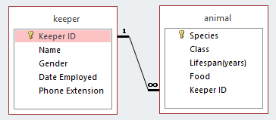

1. Draw a full entity relationship diagram below for the Zoo daabase with each entity, their attributes, the keys identified and the relationship between them shown.
2. Fully name and explain the need of the DPA law.

__________________________________________________________________________________

__________________________________________________________________________________

__________________________________________________________________________________

__________________________________________________________________________________

1. Describe a right the DPA gives the zoo Employees and 2 implications it means for the Zoo keeping and using their data.

__________________________________________________________________________________

__________________________________________________________________________________

__________________________________________________________________________________

__________________________________________________________________________________

__________________________________________________________________________________

1. Fully name SQL and describe what it is vitally used for in modern systems.

__________________________________________________________________________________

__________________________________________________________________________________

__________________________________________________________________________________

1. A new Keeper is starting with the zoo – D Douglas, male, starting 20/01/2018, phone 650 and ID number KPR011. Write the SQL to add the keeper to the correct table in the database.
2. The phone number for the primate department needs to be amended for all the related zoo keepers from 650 to 661. Write the SQL to edit the required phone numbers all at once.
3. The Dwarf Lemur is being moved to another zoo and needs removed from the database. Write the SQL to take out the specific lemur from the table.

Below are example records for the ***keeper*** and ***animal*** tables of the Zoo database to help with the following questions 8-14.

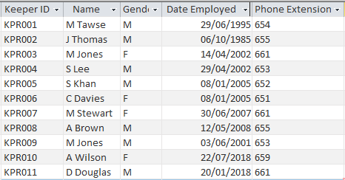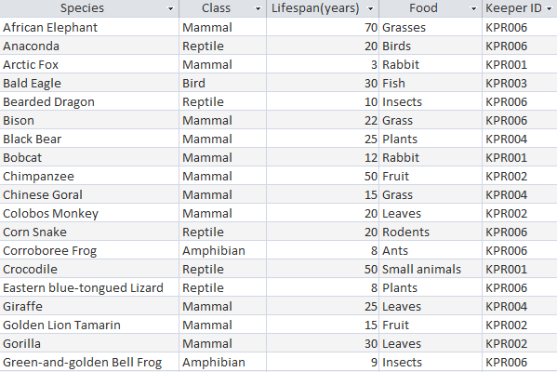

1. The zoo need the names, IDs and genders of all the male zoo keepers who started on or after the 1st of January 2000 organised from who started earliest. Write the rough SQL for this query.
2. The zoo needs all the Mammals or Amphibians found showing their species, class, lifespan and what they eat. The animals should all be sorted from longest life expectancy to shortest and any with the same years alphabetical by name. Write the rough SQL for this query.
3. Describe what an **equi-join** is and explain why they are necessary.

__________________________________________________________________________________

__________________________________________________________________________________

__________________________________________________________________________________

__________________________________________________________________________________

1. The zoo needs the zoo keeper’s names, species they look after and phone numbers for all the animals that feed on grass. Write the rough SQL for this query.
2. Evaluate the SQL statement below with the data tables at the bottom of the previous page. You’ll need to make notes/working on tables and then write out what the results will be below.

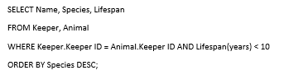

1. Mike Jones is leaving as he has a job at a different zoo and the SQL code below has been written to remove him from the database. Explain why the code will not work correctly and describe how you would fix it.



__________________________________________________________________________________

__________________________________________________________________________________

__________________________________________________________________________________

__________________________________________________________________________________

__________________________________________________________________________________

1. The mammals that eat plants need their records updated to say they eat hay and the SQL statement below has been written to amend the database. Explain why the SQL code will not work correctly and describe how you would fix it.

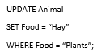

__________________________________________________________________________________

__________________________________________________________________________________

__________________________________________________________________________________

__________________________________________________________________________________

__________________________________________________________________________________

1. Describe an overview how you would go about Testing database operations like SQL.

__________________________________________________________________________________

__________________________________________________________________________________

__________________________________________________________________________________

__________________________________________________________________________________

1. In terms of Evaluating a database explain the terms Fitness for Purpose and Accuracy of Output.

__________________________________________________________________________________

__________________________________________________________________________________

__________________________________________________________________________________

__________________________________________________________________________________

__________________________________________________________________________________