N5 Computing Science – Database Design and Development

Due Date: Date

Name

Homework 1

The database for a Sales Company’s employees is shown below.

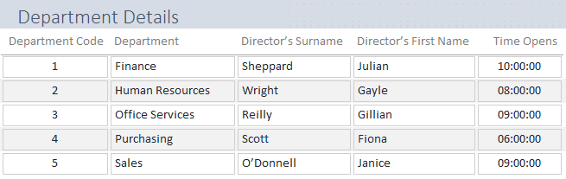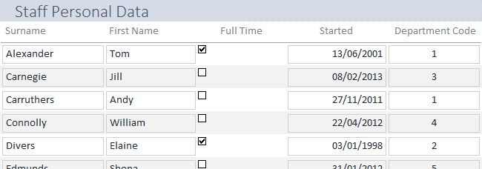

1. Using the example above explain what entities and their attributes are in a Database.

______________________________________________________________________________________________________________________________________________________________________________________________________________________________________________________

__________________________________________________________________________________

1. Complete the boxes beneath each table’s attribute fields with what their data type is.
2. Explain why we always try to have a set size for fields. For the Time Opens and Surname attributes explain how their sizes would be set.

________________________________________________________________________________________________________________________________________________________________________________________________________________________________________________________________________________________________________________________________________

1. Validation set on fields means we can make sure data entry is sensible. From the descriptions of the checks on the named fields below state the type of validation that is being sent.

|  |  |
| --- | --- |
| The Started date needs to have 10 characters including numbers and forward slashes in a set size e.g. 01/01/2018 |  |
| The Departments will appear as a drop-down list of specific named departments that must to chosen from to enter specific names |  |
| The Surname is the primary key of the Staff Personal Data attribute and can’t be left blank in a record |  |
| The Department Codes only go from 1 to 5 so these numbers are only allowed in the this field’s record |  |

1. Describe what a Relational Database is and explain a reason why databases are setup in this way.

__________________________________________________________________________________

__________________________________________________________________________________

__________________________________________________________________________________

__________________________________________________________________________________

1. Complete the table below to identify the Keys that are used to link the Sales Company’s database entities together.

|  |  |  |
| --- | --- | --- |
|  | **Table** | **Field** |
| **Primary Key** |  |  |
| **Primary Key** |  |  |
| **Foreign Key** |  |  |

1. Explain what a Primary Key is and describe the 2 in the Database above.

__________________________________________________________________________________

__________________________________________________________________________________

__________________________________________________________________________________

__________________________________________________________________________________

1. What is the purpose of the Foreign Key in a relational database? Explain the FK working in this database referring to the tables at the top of the previous page.

__________________________________________________________________________________

__________________________________________________________________________________

__________________________________________________________________________________

__________________________________________________________________________________