N5/Higher RMPS
Religious, Moral and Philosophical Studies
What topics will I study in RMPS?
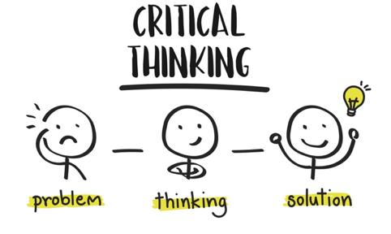
At National 5/Higher level we look at Morality and Justice, focusing on topics such as Sentencing and Causes of Crime. In addition to this we study theories for the Origins of the Universe and life; how did the world begin? We also study one of the major world religions; Buddhism. Pupils are required to complete an Assignment where they get to choose a debatable topic and complete a piece of research work which relates to either a religious, moral or philosophical issue e.g. 'Can Capital Punishment ever be justified?'
Why choose RMPS?
Pupils debate, develop opinions and build confidence and passion as they challenge each other’s viewpoints. It is a literacy based subject, developing important skills such as analysis, evaluation and critical thinking. The topics are relevant, exciting and engaging and we often look at real life examples, media examples and current affairs. There are lots of opportunities for pupils to attend trips to places such as a Sheriff Court, Religious Places of Worship and HM Prisons.
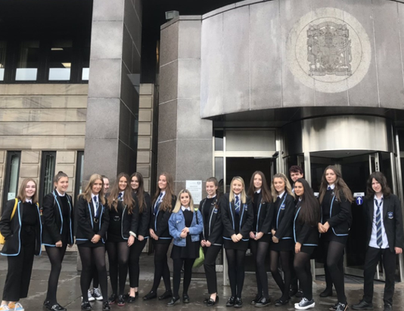
Progression
You can study RMPS at National 4, 5, Higher and Advanced Higher level. When applying to universities and colleges, RMPS is considered an essay based subject and is therefore looked on as a desirable subject to have. It helps to prepare pupils for the style of academic writing they will do at University / College. See attached sheets for more information on the University support for RMPS as a higher qualification.
Careers

- Teaching
- Police
- Law
- Psychology
- Criminology
- Social Work
- Civil Service
- Medicine
- Healthcare
- Politics
- Management
- Journalism

FAQs
Do I need to be religious to study RMPS? No. This is an academic subject and there is no expectation for you to have any particular belief.

