S5/6 History

What topics will I study in History?
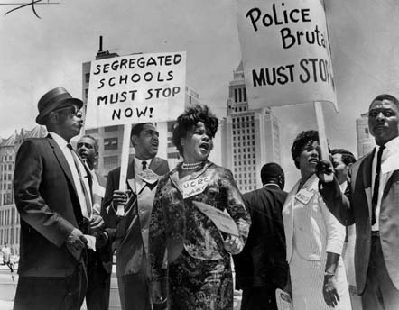
We study a Scottish, British and European/World topic. At National level, these are Scottish Wars of Independence, Making of Modern Britain and Free at Last? Civil Rights in the USA. At Higher, we study Wars of Independence, Britain and the USA. We explore how women won the vote, the introduction of the NHS, how places like Cumbernauld came into existence and how the government became more and more involved in our lives. We learn about the civil rights movement, the KKK and key figures like Rosa Parks, Martin Luther King Jr and Malcolm X. We identify key individuals in the Scottish Wars of Independence such as William Wallace and Robert the Bruce and explore the build-up and tactics to events such as the siege of Berwick and the Battle of Stirling Bridge.
Why choose History?
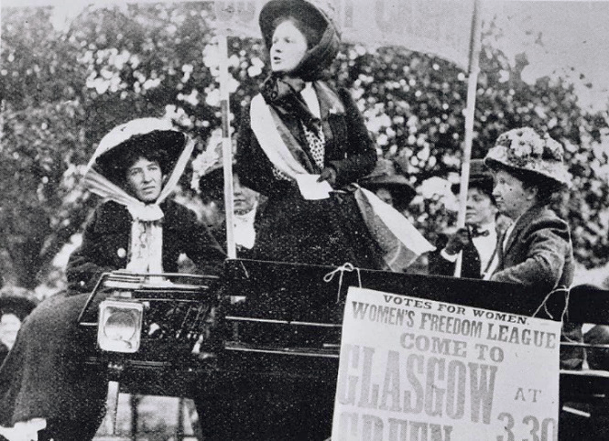
The topics you learn about allow you to study the ways changes in history took place and how those changes were embraced and sometimes resisted. You are provided with a perspective on the forces which have shaped our own society and the rest of the world. Learning about history will enhance your understanding of our modern, multi-cultural society and allow you to develop skills in empathy, literacy, critical thinking and debating. At Higher, there is a focus on essay writing skills, analysis and evaluation - important skills which allow you to see the bigger picture from information and sources, think critically to question effectively and successfully construct arguments supported with evidence.
Progression
Pupils studying at National level can progress to Higher, pupils studying Higher can pursue Advanced Higher at another school. History is seen as a desirable qualification by most universities and many of their courses. Not only is it partly an essay-based subject which prepares pupils for the level of writing required at university, but it is also renowned for preparing pupils with critical thinking and research skills.
Careers

- Anthropology
- Archaeology
- Civil Service
- Diplomatic Service
- Genealogy
- Journalism
- Law
- Museum Work
- Politics
- Publishing
- Teaching
- Tourism

