**Geography**

**What is Geography?**

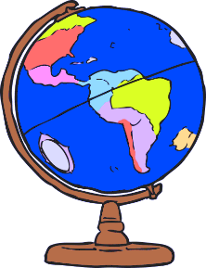Geography is the study of places and the relationships between people and their environment.

In the 21st century, with growing awareness of the impact of human activity on the environment and climate change, the study of Geography fosters positive life-long attitudes of environmental responsibility, sustainability, and global citizenship.

**What topics will I study in Geography?**

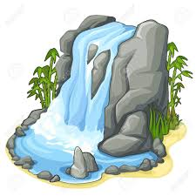In S3 we study **Ordnance Survey Mapping**, the skills learned in this topic will be used throughout S3 and beyond. We also learn about **River Landscapes** and how they are formed. Our final unit is about **Population**, including where people live and why they live there.

**Why choose Geography?**

Geography helps you make sense of the world around you. It is hands on, relevant and fun. In order to fully understand our topics there will be field trips to investigate a river and a small town. The topics also incorporate a large amount of active learning where you learn by doing activities such as population pyramids using jelly babies, sand pit rivers and 3D waterfalls.

**Progression**

Pupils can go on to study Geography at National 4 or 5 level in S4. Pupils who gain a National 5 award in S4 will then be able to progress to Higher Geography in S5/6. Geography is seen as a desirable qualification by most universities and many of their courses. Not only is it an essay-based subject which prepares pupils for the level of writing required at university, but it is also renowned for preparing pupils with problem solving and research skills.

**Careers**

* 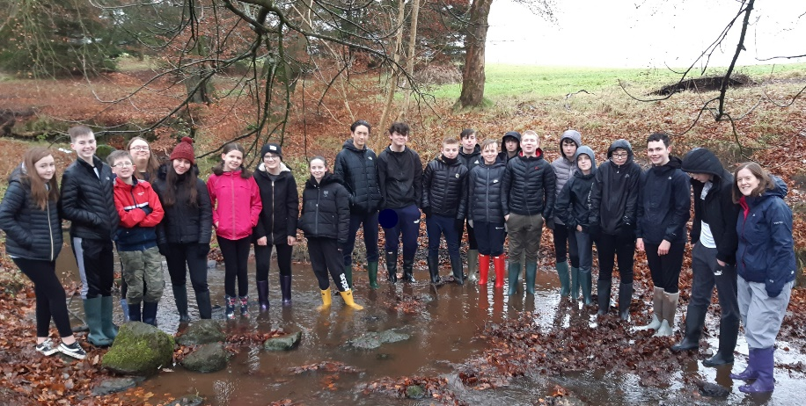Environmental work
* Engineering
* Geophysics
* Leisure and recreation
* Nature conservation
* Surveying
* Teaching
* Town planning
* Transport management
* Travel and touris