History
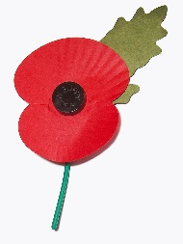
What is History?
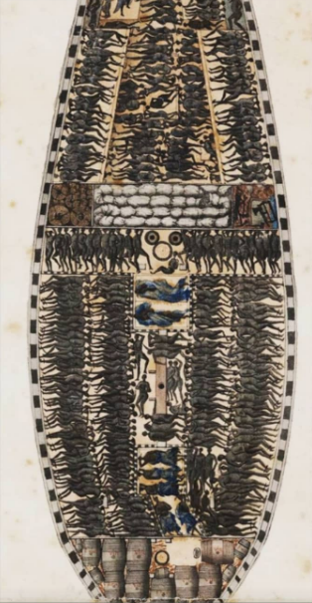
History is a subject in which you gain a strong understanding of the people, past events and societies which have shaped our world. It challenges you to think critically, compare differing sources and analyse and evaluate information to come to an informed opinion which can be communicated respectably.
What topics will I study in History?
In S3 your learning will focus on two topics. The first will be the Atlantic Slave Trade where you will explore economics, logistics, resistance, and punishments before learning about the end of slavery - abolition. Your next topic will be Era of the Great War where you will explore trench warfare, WWI battles and the impact of the war on Scotland. When you move into S4, you will then start learning about Hitler and Nazi Germany.
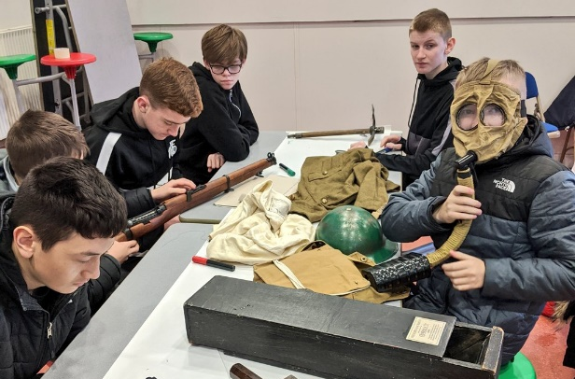
Why choose History?
In order to fully understand your learning, there will be a trip to a local museum which features a WWI trench and multiple primary sources from that time period. You will also take part in practical lessons where you experience the conditions of the middle passage and what life was like in the trenches. The topics you learn about allow you to study the ways in which changes in history took place and how those changes were embraced and sometimes resisted. You are provided with a perspective on the forces which have shaped our own society and the rest of the world. Learning about history will enhance your understanding of our modern, multi-cultural society and allow you to develop skills in imagination, empathy and debating.
Progression
Pupils can go on to study History at National 4 or 5 level in S4 History depending on progress throughout the course of the year. Pupils who gain a National 5 award in S4 will then be able to progress to Higher History in S5/6. History is seen as a desirable qualification by most universities and many of their courses. Not only is it partly an essay-based subject which prepares pupils for the level of writing required at university, but it is also renowned for preparing pupils with critical thinking and research skills.
Careers

- Anthropology
- Archaeology
- Civil Service
- Diplomatic Service
- Genealogy
- Journalism
- Law
- Museum Work
- Politics
- Publishing
- Teaching
- Tourism

