**RMPS**

**What is RMPS?**

Religious, Moral and Philosophical Studies allows pupils to look at the customs and beliefs of people around them. We study a range of contemporary moral issues that affect the world and society and cover many controversial topics.

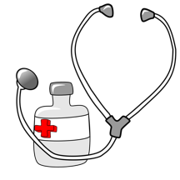**What topics will I study in RMPS?**

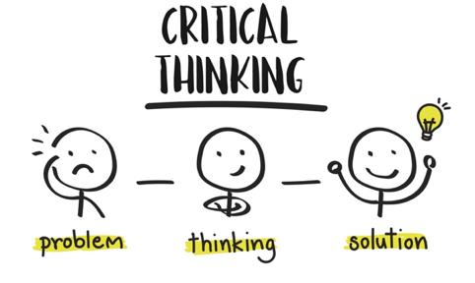**In S3/4 we will cover: Morality, Medicine, and the Human Body** - This topic looks at medical ethics and explores topics including Euthanasia, Stem Cell Research, IVF and Saviour Siblings. **Suffering and Evil -** This topic considers the existence, causes and explanations of natural and moral evil, debating issues such as terrorism and natural disasters. **One of the major World Religions -** This topic looks at the traditions, beliefs and practices of the chosen religion and its impact in the wider world.

**Why choose RMPS?**

RMPS is an exciting and exploratory subject where active learning and group work are frequently encouraged to discuss, debate, and develop opinions. Pupils build confidence and passion as they challenge each other’s viewpoints. It is a literacy based subject, developing important skills such as analysis, evaluation and critical thinking. The topics are relevant, exciting and engaging and we often look at real life examples, media examples (such as My Sister’s Keeper) and current affairs. There are lots of opportunities for pupils to attend trips to places such as a Sheriff Court, Religious Places of Worship and HM Prisons.

**Progression**

You can study RMPS at National 4, 5, Higher and Advanced Higher level. When applying to universities and colleges, RMPS is considered an essay based subject and is therefore looked on as a desirable subject to have.

**Careers**

Teaching, Police, Law, Psychology, Criminology, Social Work, Civil Service, Medicine/Healthcare, Politics, Human Resources, Management and many more.

**FAQs**

Do I need to be religious to study RMPS? *No. This is an academic subject and there is no expectation for you to have any particular belief.*   
I already get core RE, is this the same? *No. Core RE is one period per week and does not enable pupils to study RMPS in depth or gain an SQA National Qualification.*