**BRANNOCK HIGH SCHOOL**

**Higher Business Management**

# 



**Understanding Business**

**Notes**

**Understanding Business**

**Unit Outline**

**Unit 1 - Understanding Business (2 outcomes)**

This unit introduces the business environment. We will look at the main activities of businesses and organisations. We will explore the issues which relate to the external environment in which businesses operate and their effects on organisational activities

**Outcome 1**

Analyse the features, objectives and internal structures of large business

organisations by:

1.1 Comparing features of large business organisations from different sectors of the economy

1.2 Identifying the objective of large business organisations and detailing the importance of these objectives

1.3 Describing internal structures large business organisations may use, justifying why they would use this structure

**Outcome 2**

Analyse the environment in which large organisations operate by:

2.1 Explaining the impact of internal factors on a large organisation

2.2 Explaining the impact of external factors on a large organisation

2.3 Describing conflicts of interest that could exist between stakeholder

# The Role of Business in Society

All businesses exist to satisfy the needs and wants of their customers.

# 

|  |  |  |
| --- | --- | --- |
| Need | A need is something that is essential for survival. | Water, basic  food, shelter |
| Want | Items that are desired but not needed for survival. | Computer, television, makeup |
| Good | These are tangible items. Items that you buy that can been seen and touched. | Washing machine, car |
| Service | A service is intangible; something that a business does for you. | Banking, insurance, hairdressing |
| Non  durable | Items that are consumed shortly after purchase. | Newspaper, food, clothing |
| Durable | Items that last a long time and will be used regularly. | Washing machine, car, television |

# Factors of Production

In order to produce goods and services, businesses need to use resources.

These resources are the **inputs** for business activity, with the goods and services that they produce being the **outputs**.

|  |  |  |  |
| --- | --- | --- | --- |
| **Factor/ Input** | **Definition** | **Example** | **Reward** |
| Capital | These are the man-made resources used to help create products and services. | Lighting  Stationery | Interest |
| Enterprise | This is the person who has the business idea and brings together the other factors of production to produce a product or service. | Richard Branson  Alan Sugar  Michelle Mone | Profit |
| Land | This is the natural resources taken from the Earth’s surface. | Oil  Sea  Minerals | Rent |
| Labour | The people who work for the business, the workforce. | Teachers  Nurses | Wages |

# Entrepreneur

An entrepreneur is someone who brings together the factors of production.

**Roles of the entrepreneur:**

* They develop a business idea/ spot a gap in the mark.
* They take all the risks.
* They invest money in the idea and business.
* They combine all the factors of production.

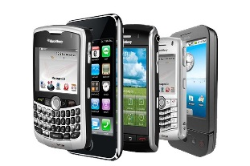Without entrepreneurs the following products may have never been brought to market.

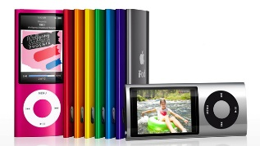

**Skills of a successful entrepreneur**

An entrepreneur must:

* Take risks – They need to see an opportunity and take it, while risking their own money to invest in the idea.
* Have good communication skills – To enable them to communicate with employees, suppliers and importantly the customers.
* Rise to the challenge – They should not give up easily and they should find solutions to overcome problems.
* Have good decision-making skills – To decide which product to produce, best methods of raising finance, what price to charge customers and which staff to hire.
* Have good leadership skills – To be able to lead and motivate his/her workers to achieve goals and targets.

# 

**Qualities of a successful entrepreneur**

* Be resilient/ determined – Entrepreneurs will often experience rejection and a lack of belief in their idea therefore they have to be determined to stick by it.
* Be creative – To come up with an innovative idea that fills a gap in the market and attract customers.
* Be driven/ hardworking/ ambitious – They will need to have a hardworking drive in order to make their idea a reality and be successful.
* Be confident – They will need to have the confidence to promote their business idea, talk to investors and manage employees.

# Sectors of Industry

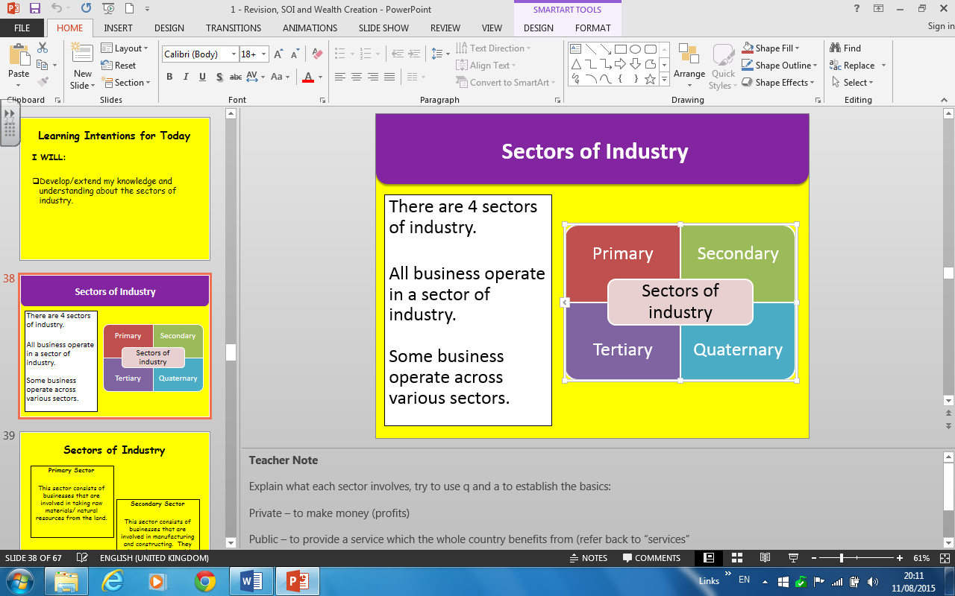

There are 4 sectors of industry.

All businesses operate in a sector of industry.

Some businesses operate across various sectors.

|  |  |  |
| --- | --- | --- |
| **Sector** | **Definition** | **Example** |
| Primary | This sector consists of businesses that are involved in taking raw materials/ natural resources from the land. | Mining  Fishing  Oil exploration |
| Secondary | This sector consists of businesses that are involved in manufacturing and constructing. They rely on the raw materials from the primary sector. | Construction  Car manufacture  Shipbuilding |
| Tertiary | This sector consists of businesses that are involved in providing services rather than goods. | Banking  Hairdressing  Travel agents |
| Quaternary | This sector consists of businesses that are providing information and knowledge based services. | Education  Research and development  Computing |

The quaternary sector is sometimes included with the tertiary sector as they are **both service sectors**.

The tertiary and quaternary sectors make up the largest part of the UK economy, employing **76%** of the workforce.

**How do the sectors work?**

Most countries will be engaged in all 4 sectors of industry but a particular country will be **more active** in one sector over the others.

All economies start out in the Primary sector and then **move towards** the Quaternary sector as they develop and become more prosperous.

This process is known as **de-industrialization** which the Scottish economy has gone through during the last 30 years.

**Changes in the sectors of industry**

***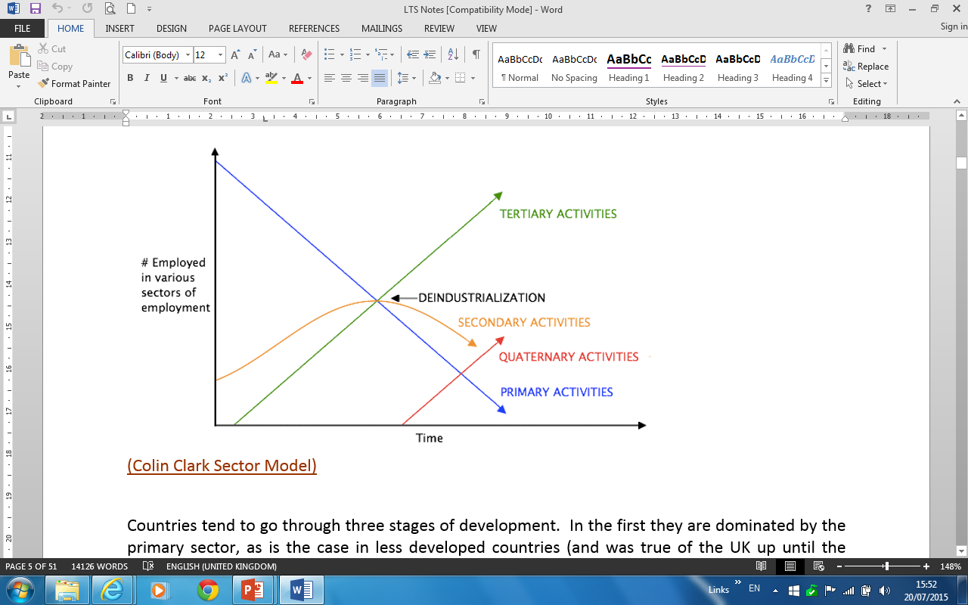****UK Employment from 1800 to 2000*

# 

Patterns of employment have dramatically changed in the last 200 years. Why?

* Global threats have changed with increased competition from abroad.
* There has been a decline the shipbuilding, manufacturing and steel factories industries.
* Technology has significantly improved with the introduction of the internet and wireless and movable technologies.
* Consumers have more disposable income to buy services. I.e.: Travel and beauty.
* The tertiary sector and the number of businesses within it have significantly grown.

# Wealth Creation

A business creates wealth by **adding value to a product** as it goes through the production process. While this happens value is also being added to the prices of the product.

When you add the value of all the goods and services in the UK this will calculate the **gross domestic product (GDP).**

|  |  |
| --- | --- |
| **Benefits of Wealth Creation** | **Issues with Wealth Creation** |
| * Jobs are created and therefore the UK’s unemployment figure reduces. * People in employment have access to training and therefore the opportunity to learn new skills. * As a result in less unemployment the demand for goods and services will increase which can increase the standard of living. * Tax is paid by the businesses and individuals when they have a job and therefore this money is paid to the Government who can then invest into public services. | * Businesses can have a large environmental impact on a country or specific location which could increase waste or pollution. * Too much demand for goods and services can cause inflation which may mean people can no longer afford to purchase some products. * Greenfield sites are lost which can lead to problems with the local community. |

# Sectors of Economy

There are 3 sectors of industry:

|  |  |
| --- | --- |
| **Private** | These are owned and controlled by private individuals and investors. |
| **Public** | These are owned and controlled by the government on behalf of taxpayer. |
| **Third** | These are set up to raise money for good causes or to provide facilities for their members. |

# Private Sector

|  |  |
| --- | --- |
| **N5 – Previous K/U** | **Higher** |
| * Sole Trader * Partnership * Private Limited Companies (LTD) * Franchises | * Public Limited Companies (PLC) * Franchises * Multinational |

**Key Facts**

All businesses in this sector are **owned by private individuals**.

The **main aims** are maximise profits, fill a gap in the market and to grow.

|  |  |  |  |  |  |  |
| --- | --- | --- | --- | --- | --- | --- |
| **Type** | **Definition** | **Examples** | **Liability** | **Aim** | **Advantage** | **Disadvantage** |
| **Sole Trader** | This is a business owned and managed by one private individual. | Hairdresser  Window Cleaner  Baker | Unlimited liability | To survive  To maximise profits | It is easier to keep overall control, because the owner has a hands-on approach to running the business and can make decisions without consulting anyone else.  The owner can keep all the profits.  Decision making can be done quickly because only the sole trader is involved in the process. | The sole trader has no one to share the responsibility of running the business with.  There is also the risk of unlimited liability, where the sole trader can be forced to sell personal assets to cover any business debts.  Sole trader often work long hours and they can find it difficult to take holidays, or time off if they are ill. |
| **Partnership** | This is a business owned by between 2 and 20 people who are called partners. | Dentist  Doctors  Lawyers | Unlimited liability | To survive  To maximise profits  To grow | The workload, responsibility and decision making can be shared amongst the partners.  Different partners can bring different experiences and skills to the business.  Finance can be raised more easily than compared to a sole trader. Also each partner will invest money when they join the business. | Arguments between partners might occur which will slow down decision making.  The profits must be shared between all partners.  All the partners must be consulted before major decisions can be made, which can take a long time.  The partners have unlimited liability for any debts, and are therefore personally liable. |

**Limited Companies**

There are 2 types of limited company:

* Private Limited Company (Ltd)
* Public Limited Company (PLC)

|  |  |
| --- | --- |
| **Who owns them?** | Shareholders |
| **Who runs/ controls them?** | A board of directors |
| **How are they financed?** | Selling shares  Ltd – To friends and family  PLC – On the stock market |
| Each shareholder will receive a share of the profits. This is known as **dividends**.  Companies are **incorporated**; this means the owner and business are separate. This means they have **limited liability**. | |

**Legal Paperwork**

To set up as a limited company requires a range of legal document to be completed.

**Memorandum of Association**

This document documents the company’s relationship with the outside world.

I.e.: The Company’s name

**Articles of Association**

This document documents the inside rules of the company.

I.e.: Voting procedures

Dividend rates

Once these document are complete and accepted they will be given a

**CERTIFICATE OF INCORPORATION**

## Private Limited Companies (Ltd)

|  |  |  |
| --- | --- | --- |
| **What is it?** | An Ltd is a company which has a limit of 50 shareholders and must have a minimum of 1 shareholder before trading. | |
| **Who owns it?** | Shareholders (1-50) | |
| **Who runs/controls it?** | Board of directors | |
| **What liability do they have?** | Limited | |
| **How do they raise finance?** | Selling shares to friends and family  **NB:** They **cannot** sell shares on the stock market. | |
| **Main objective** | Profit maximisation Satisficing  Social responsibility Growth | |
|  | | |
| **Advantages** | | **Disadvantages** |
| * Shareholders have limited liability. If the business fails the shareholders only lose the amount of money they have invested which reduced the risk of personal lose to shareholders. * Ltd’s can become larger organisations when compared to a sole trader and this means it is easier for an Ltd to raise finance due to their size. * Due to their size and Ltd can take advantage of economies of scale which will reduce the expenditure of a business. * Shares can only be purchased by friends and family which means the original owners retain greater control over their business. * Shareholders and directors can bring different experience and skills to the business which could help to gain a competitive advantage. | | * Profits have to be split between all shareholders, which reduces the amount per person. * It is not possible to sell shares to the general public through the stock market to raise additional finance. * Every year financial accounts showing the financial position of the company have to be published. This means competitors could get an insight into the financial position of the business. * Big organisations can be very difficult to manage efficiently and therefore it is more difficult to keep workers satisfied and well-motivated in a large organisation. * There is a costly legal process in setting up an Ltd as they have to comply with more regulations than sole traders or partnerships which will increase the initial costs of setting up the business. * They have to register with the ‘Registrar of Companies’. The organisation has to follow the rules set down in law by the Companies Act. |

## Tesco%20Logo%20-%20ColourPublic Limited Companies (PLC)

|  |  |  |
| --- | --- | --- |
| **What is it?** | PLC’s are companies started by at least 2 shareholders with no limit on the number of shareholders that can buy shares.  They must have a **minimum of £50,000 share capital** to start up. | |
| **Who owns it?** | Shareholders (2 to no maximum) | |
| **Who runs/controls it?** | Board of directors | |
| **What liability do they have?** | Limited | |
| **How do they raise finance?** | Selling shares on the stock market  Once they get their **certificate of incorporation** they will issue a **prospectus** to advertise their shares to the public. | |
| **Main objective** | Profit maximisation Satisficing  Social responsibility Growth | |
|  | | |
| **Advantages** | | **Disadvantages** |
| * Shares can be sold on the stock exchange therefore large amounts of finance can be raised. * PLC’s often dominate their market therefore they can force smaller organisations out of business/dictate market prices. * Very large companies can often operate more cheaply than small companies by exploiting economies of scale. Therefore they can spend money in other areas of the business. * There are greater opportunities for raising finance and lenders are more likely to give money as they have greater confidence it will be paid back. * Investors will have limited liability therefore PLC’s will find it easier to attract shareholders. * PLC’s are large in their size of operations and therefore can often dominate the market. | | * Initial set-up costs will be high resulting in poorer profit results for the first few years. * There is a large amount of legislation which must be complied with or the company may be fined/have legal action taken against them. * PLCs have no control over who buys shares which might mean investors can plan a hostile takeover. * PLCs are required by law to publish annual accounts which will be costly to produce and competitors can get access to their financial information. * The large nature of this company means that control of the company can be lost to outsiders and therefore from the original shareholders who started the company. |

## Franchise

A franchise is a business agreement between an existing business and a newcomer. The newcomer buys the right to trade under the existing businesses name.

**Who is involved?**

**Franchisor –** This is who owns the original business.

**Franchisee –** This is who has bought the right to use the original business name and enter into trade selling its products.

**What does the franchisor gain?**

* A lump sum of money from the newcomer when they set up.
* A percentage of the sales known as a **royalty payment.**

**What does the franchisor provide?**

* Training to start the business.
* Equipment such as display units, shelving and vehicles.
* Materials to make the products.
* A brand name with national advertising.

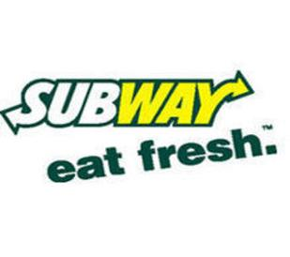

[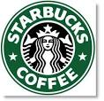](http://search.babylon.com/imageres.php?iu=http://snoo.ws/wp-content/uploads/2009/05/starbucks1.png&ir=http://snoo.ws/2009/05/24/vandals-wont-stop-starbucks/&ig=http://t0.gstatic.com/images?q=tbn:ANd9GcTKenfQ7J-A-vfM8W-DAkI4gWKPrgl24OVFc_525up5FDi6QE4NFTKmt9c&h=314&w=325&q=STARBUCKS+FRANCHISE&babsrc=HP_ss)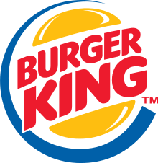

|  |  |  |
| --- | --- | --- |
|  | **Advantages** | **Disadvantages** |
| **Franchisor** | Income is guaranteed as the franchisee normally pays a percentage of profit each year to the franchisor.  If the business does not work the cost of failure is split and therefore the risk is shared.  A franchise is a very quick and efficient way for the franchisor to achieve growth. This will potentially lead to a greater number of customers and sales for the franchisor.  Therefore market share will grow.  The franchisor can demand exactly how the business operates. Therefore they retain control over their original business. | A percentage of the turnover is given to the franchisor by the franchisee and therefore this might be lower than what the franchisor could have earned themselves.  A franchisee could damage the reputation and image of the business and therefore this could cause problems for the entire franchise. |
| **Franchisee** | They can set up a business using an already established name and therefore there will be an existing customer base.  This will allow them to gain sales quickly and reduce the risk of failure.  Advertising costs are paid for by the franchisor which saves the franchisee having to spend the money that can be invested into other areas of the business.  The franchisee is buying an already established business which means their risk of failure is reduced than if they were setting up as a sole trader.  The franchisor carries out training for the whole business and therefore it is appropriate to the needs of the workforce and it will save the franchisee money. | The initial cost of purchasing the franchise can be high which reduces the amount of money they have left to invest in their franchise.  The franchisor might not renew the franchise after a period of time which means that they will have lost the investment of time and money they have put in.  The franchisee has no control over the products, pricing or store layout and therefore this reduces the injection of new ideas and creativity into the business.  Some of the profit made has to be given to the franchisor which reduces the money that the franchisee earns. |

## Multinational Companies (MNC)

A multinational company (MNC) is one that operates in **more than one country**.

They will have a headquarters based in one country and this is known as the **home country**. In other locations they have branches known as **subsidiaries**.

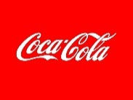

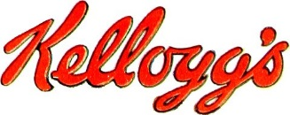

**Key features**

* They involve **operations** in several different countries.
* They have a **distinct home base** country.
* They have a **global brand** because they are operating in more than one country.
* They are able to **dominate markets** across many countries.
* They have **budgets** that are larger than some individual countries.
* They are able to greatly **influence local economies**.
* They will have **cultural variations**.
* A MNC’s distinguishing feature is that it will set up **production facilities** in more than one country.
* Many of these multinationals produce global brands with **similar marketing mixes** across the world. (The same advertising and pricing)

**The three main developed trading areas of the world are:**

North America

The European Union

South-East Asia (and Australasia)

|  |  |
| --- | --- |
| **Advantages** | **Disadvantages** |
| * An organisation **may be given grants from governments to locate in that country** and the grants will not require to be paid back improving their financial position. * **Organisations will become larger** which may result in them being safer from takeovers. * Can allow organisations to **increase their sales globally** which in turn should increase their overall profits. * Will allow organisations to **take advantage of economies of scale** and reduce unit costs of products. * Could allow organisations to **employ cheaper staff** which will result in greater profitability. * May help **avoid legal restrictions in the organisation’s own country** which could allow them to sell/produce their products abroad. * Could **allow for tax advantages** which will increase profitability. * Will mean the organisation can **avoid restrictions on imports** into a country which will help overall sales. * **Wages and raw materials costs could be lower** in host countries which reduces expenditure. * **Avoid trade barriers** like the EU Common External Tariff. | * **Profits go back to the home company** in whatever country that is and therefore some countries may miss out on an opportunity to gain income from tax. * **Legislation may be different in other countries** which may require the organisation to alter its product/service. * Legislation in different countries may **differ on how a product/service can be marketed** and may result in some marketing techniques having to be changed which could increase costs. * Cultural differences will mean that organisations **have to be sensitive to different countries cultures** and this could mean spending money to alter products and advertising to target customers. * **Different languages will exist** and this may mean that organisations have to employ specialist linguists to work with the organisation and this could delay decision making. * **Time differences can hinder communication** between head office and branches around the world which could delay decision making. * **Exchange rates** could affect purchasing and paying employees in different countries. * MNC can be so powerful that they are able to take advantage of economies of scale which **may force local businesses to close down.** |

**Multinational and Globalization**

Globalization is a term used to refer to the expansion of economies beyond national borders, in particular, the expansion of production by a firm to many countries around the world.

It has become easier to operate as a MNC due to the **improvements in**:

* Inexpensive air travel
* Infrastructure
* Single currencies (Euro)
* Growth of e-commerce

The world is now one big marketplace and this is known as **globalization** and this has given a lot of power to MNC.

**Positive points of Globalization**

|  |  |  |
| --- | --- | --- |
| **General** | **Economically** | **Development of Global Financial Systems** |
| * Helps the world’s poorest countries become globally integrated and positions them for greater growth in the 21st century. * Is good for consumers as long as it causes global competition helping us gain fair prices. * Should bring a better life for those people living in LEDC countries. * Provides a greater share of wealth throughout the world. | * Increase in international trade at a much faster rate than the growth in the world economy. * Increase in international flow of capital including foreign direct investment. * Creation of international agreements leading to organizations like the WTO and economic cartels such as OPEC. | * Increased role of international organisations such as WTO, WIPO, IMF that deal with international transactions. * Increase of economic practices like outsourcing and offshoring by multinational corporations. |

**Negative view of Globalization**

* Disruption of distribution or communications paths.
* Restrained flow of labour.
* Distribution of the benefits of free trade can be very uneven.
* Some countries are more interested in military advancement than in consumer prices, and subsidize certain specialties.
* Some countries sacrifice benefits, retirement programs, safety, environmental safeguards, and human rights to achieve low labour rates. In other words they scorch both people and planet to "beat us".

# Public Sector

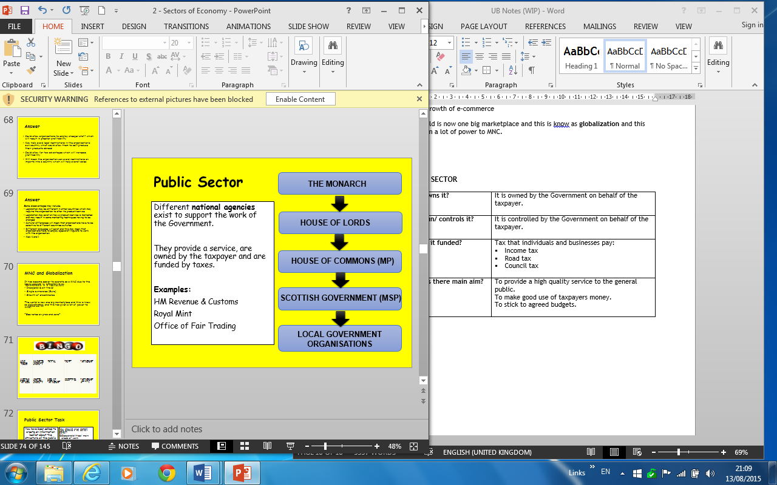

|  |  |
| --- | --- |
| **Who owns it?** | It is owned by the Government on behalf of the taxpayer. |
| **Who run/ controls it?** | It is controlled by the Government on behalf of the taxpayer. |
| **How is it funded?** | Tax that individuals and businesses pay:   * Income tax * Road tax * Council tax |
| **What is there main aim?** | To provide a high quality service to the general public.  To make good use of taxpayers’ money.  To stick to agreed budgets. |

*Public Sector Structure*

## ukHouse of Commons/ Central Government

The National Government (UK Parliament) has overall responsibility for what happens in the UK.

It is made up of **Members of Parliament (MP’s)** who are elected by the public.

|  |  |  |  |
| --- | --- | --- | --- |
| **What do they provide?** | **Who runs it?** | **Aims** | **Finance** |
| * Health (NHS) * Defence (Army) * Transport * Treasury | It is run by **Members of Parliament (MP)** who are elected by the public. | * To provide an efficient service. * To make effective use of funds. * To improve society. * To serve the public interest. * To stick to agreed budgets. | Taxation:  Income tax  Road tax  Council tax  VAT |

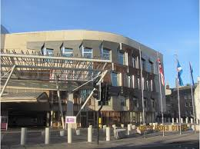

## Scottish Government

The Scottish Government has gained devolved power from the Central Government to make decisions solely for the Scottish people.

|  |  |  |  |
| --- | --- | --- | --- |
| **What do they provide?** | **Who runs it?** | **Aims** | **Finance** |
| **The Scottish Government has delegated responsibility for such services as:**   * Education * Health * Transport | It is **run** by Members of the **Scottish Parliament (MSP**) who are elected by the public. | * To provide an efficient service. * To make effective use of funds. * To improve society. * To serve the public interest. * To stick to agreed budgets. | Budget set by Central Government |

## Local Government/ Local Authorities

* There are **32** local authorities in Scotland.
* They each report to the Scottish Government.
* Local councils are **set up** by Central Government.

|  |  |  |  |
| --- | --- | --- | --- |
| **What do they provide?** | **Who runs it?** | **Aims** | **Finance** |
| **Local government services include:**   * Education * Leisure services * Social work * Planning and transport * Environmental services * Housing * Finance * Information technology | They are **run** on the Central Government’s behalf by **local councillors** who have been voted in by the people living in the local area. | * Meet local needs * Provide a wide range of services * To make cost savings * To stick to agreed budgets | * Central Government * Business rates * Council tax * Charges from leisure centres or parking * The sale of assets (i.e. council houses) |

Some local authorities **contract out** local services. This means that private businesses will be invited to submit bids to provide the particular service.

**Examples** - Bin collection and School meals

**Why contract out?**

* Cost-effective because private businesses have an incentive to keep costs low.
* The public sector will save money which will ensure they meet agreed budgets.

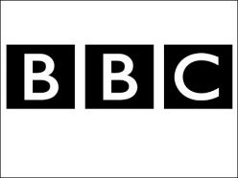

## Public Corporations

They are organisations that provide goods and services to the public.

They are **owned** by the Government on behalf of the taxpayer.

Government appoints a Chairperson and Board of Directors to **run** the business.

**Example – British Broadcasting Corporation (BBC)**

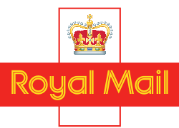Many public sector organisations were privatised by the Government during the 1980’s. I.e.: BP, British Gas, British Steel, Royal Mail

# Third Sector

There are 3 organisations that you need to understand in the Third Sector:

* Charities/ Not-for-profit organisations
* Voluntary Organisations
* Social Enterprises

## Charities/ Not-for-profit organisations

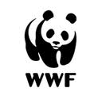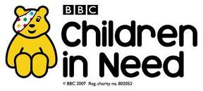

|  |  |
| --- | --- |
| **Who owns it?** | They are usually set up as trusts with no individual owners. |
| **Who runs/ controls it?** | They are usually managed and controlled by a committee of unpaid trustees. |
| **What are they set up for?** | They are set up to support a specific cause. |
| **Key features** | Charities are **regulated** by the Government and they keep a Register of Charities in the UK.  They are **exempt** from paying most taxes. |
| **Finance** | **Objectives** |
| * Donations * Government grants * Lottery Grants * Profits from charity shops * Sponsorship * Sale of goods through mail | * To relieve poverty. * To provide protection to the vulnerable. * To fund medical research. * To raise awareness of good causes to the public. * To provide support for a worthy cause. |

|  |  |
| --- | --- |
| **Advantages** | **Disadvantages** |
| Charities are exempt from paying some taxes. | It can be difficult to compete with the large marketing budgets of organisations within the private sector. |
| There are low wage costs due to volunteers working for free. | Charities rely heavily on volunteers who may leave for paid work. |
| Companies in the private sector are more willing to donate to and sponsor charities than ever before as it good for their PR. |  |

## Voluntary Organisations

These are organisations such as community football clubs or youth clubs.

* A committee is normally set up to manage the voluntary organisation.
* People will volunteer to undertake specific duties. I.e.: Chairperson, Secretary

## 



|  |  |
| --- | --- |
| **Finance** | **Objectives** |
| * Lottery/ sports council * Local Authority * A subscription/ membership fee * Sponsored events | Bring people together with similar interests |

## Social Enterprises

A social enterprise is an organisation with a **social or environmental aim**.

At **least** **half the profits** that are made, *through selling goods and services*, must be invested into meeting the stated aim of the enterprise.

They don’t make profits for owners BUT they are run in a business like way.

Social enterprises trade in all markets selling goods and services to:

* Individual customers
* 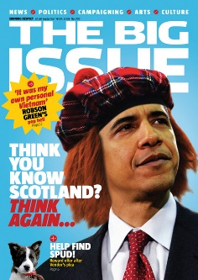[](http://www.active4all.info/)Local authorities
* Government
* Private businesses

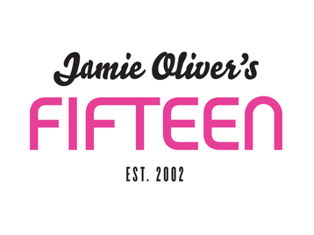

|  |  |
| --- | --- |
| **Who owns it?** | Unlike not-for-profit organisations they operate like the private sector. Therefore they **can be owned** by:  A sole trader or partnerships or shareholders. |
| **Who runs/ controls it?** | They can be controlled by private individuals or a board of directors depending on who owns it. |
| **Advantages** | |
| * They can endear a social enterprise to customers. * Good quality employees who believe in the social missions are attracted to the organisation. * They are likely to receive Government Grants due to their positive impact on society. * Asset lock means that should the enterprise be closed down the sale of any assets and any profits will be used to benefit their cause. | |

**What’s the difference between charities and social enterprises?**

|  |  |
| --- | --- |
| **Charities** | **Social Enterprises** |
| They rely on donations, grants and sponsorship money to fund their organisation.  Heavily regulated by the Government.  All money raised goes to a specific cause. | They don’t rely on grants and donations.  Less regulated by the Government.  At least half of all profits must go to the stated aim. |

## Democratic Enterprises

In the EU and USA democratic enterprises are being developed.

They differ from private sector businesses in that they aim to make but not necessarily maximise profit.

**They are popular with Governments because:**

* They encourage enterprise.
* Increase wealth in their economy.
* Want citizens to share in prosperity.

**Democratic Enterprise Example - Co-Operative**

* 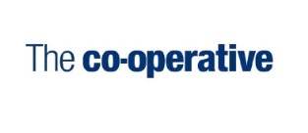They provide a quality service for the benefit of its members and customers.
* Customers can become members for £1.
* They share in decision making, ownership and profits.

# Mission Statements

A mission statement sets out the vision and goals of an organisation.

**It will:**

* Tell **employees** what it plans to do and they can think about how it will impact on their own job.
* **Prospective employees** might use it to see whether their own values match those of the organisation and whether they would fit in.
* It can be used by **customers** to learn about future plans the organisation has.
* It can be used to **raise the profile** and the image of the organisation and might attract media attention.

**

*“The Walt Disney Company's objective is to be one of the world's leading producers and providers of entertainment and information, using its portfolio of brands to differentiate its content, services and consumer products.”*

# Objectives

No matter what sector of economy a business is operating in, it will have an objective.

An objective is a goal or a target that a business has.

**Why are they important?**

* They **provide focus** for an organisation and its workforce to work towards over a period of time.
* They can be used to **measure how successful** an organisation is.

**For objectives to be effective they should:**

* Provide detail about what specifically needs to be achieved.
* Have a time limit by when they need to be achieved.
* Need to state the necessary resources that they require in order to be met.

**How to set an objective?**

Choosing appropriate objectives will depend on:

* The size of the organisation.
* PESTEC factors.
* The sector the business operates in.

|  |  |
| --- | --- |
| **Primary Objectives** | **Secondary Objectives** |
| This is the ultimate long term aim of the business.  Examples:   * Growth * Profit maximization * Diversification   They are also known as  strategic objectives. | This is the day to day objective and it makes a direct contribution to meeting the primary objectives.  Examples:   * Increase sales by 5% each year * Keep turnover low   These are also known as tactical objectives. |

**TIP:** At Higher level you need to be able to **give the impact of each objective** and not just describe what it is.

|  |  |
| --- | --- |
| **Objective** | **Description** |
| **Maximising profit** | The main aim of a business is to make as big a profit as possible. This ensures the business has enough money to continue to trade otherwise they will be forced to close down.  **NB** – Profit maximisation is not enough for the continual success of a business anymore. Growth and development as a whole is also important. |
| **Survival** | This is the overriding goal for all business to continue trading. This will keep the business safe from takeover by larger companies. Some businesses have this as a more important aim rather than making huge profit. |
| **Provision of a service** | Provide a service in the best way possible to meet the needs and wants  of the consumers and ensure customers return to the business and  attract new customers.  In the **public sector** a hospital or a school may have this as their main  objective. |
| **Increase market share** | **Market share** is the percentage of total sales in a market that a business had. The business with the most sales will become market leader.  Businesses will want to ensure that existing customers return and try to  entice rival customers to their business. This will increase the market  share the business holds in the market giving them a more powerful  position. |
| **Maximising sales** | Managers’ salaries are sometimes linked to profit and sales because they don’t have any ownership in the business. Therefore in order to generate a higher salary or bonus, the aim of the managers would be to increase sales.  They may be more interested in how many units they selling rather than the overall profits. |
| **Stick to an agreed budget** | This means to not to spend more money than is set.  Public Sector – This means taxpayers will not need to pay higher taxes to fund public services. |

|  |  |
| --- | --- |
| **Managerial objectives** | Where ownership and control are separated managers have their own  personal financial and non-financial objectives which may vary  depending upon what each manager wishes to achieve. Therefore this  will impact on how hard the manager works, how motivated they try to  make their workforce and how cost efficient they can make the business  to ensure they get their reward.  **Examples of managerial objectives:**  To increase the no. of staff reporting to them.  More perks (expense account, company car)  Developed prestige and status (new projects) |
| **Satisficing**  Satisfactory level  of profit | Instead of having an objective to make the maximum level of profits, a business may aim only to make a level of profit which is sufficient to keep all its stakeholders satisfied such as to pay acceptable dividends. Therefore employees may be more motivated in the workplace because they are not being pressured to ensure maximum profit.  This is particularly relevant to **public sector** organisations which have to operate within specific budget guidelines. |
| **Growth** | Businesses can aim to become larger by opening more branches or hiring more staff. This could allow them to take advantage of economies of scale and become more efficient by having lower costs.  Some business may sacrifice profit to reduce prices in order to destroy  any competition in the market. |

|  |  |
| --- | --- |
| **Social Corporate Responsibility** | This refers to organisations aiming to act in any way that benefits society or the environment.   * Creating a positive corporate image. By improving public relations this will reduce profitability in the short term but will help the chances of survival. * Pressure groups have influenced the emphasis for social responsibility within business. * If a business does not try to have CSR customers could be put off shopping with that business. |
| **Why have positive CSR?** | * The business can gain a good reputation for its caring nature which could attract new customers to the business. * Customers who agree with the aim are likely to use the business increasing sales. * The business can attract high quality staff who believe in the ethics of the business improving customer service. * Society and the environment are kept in good order which will benefit the business in the long term. |

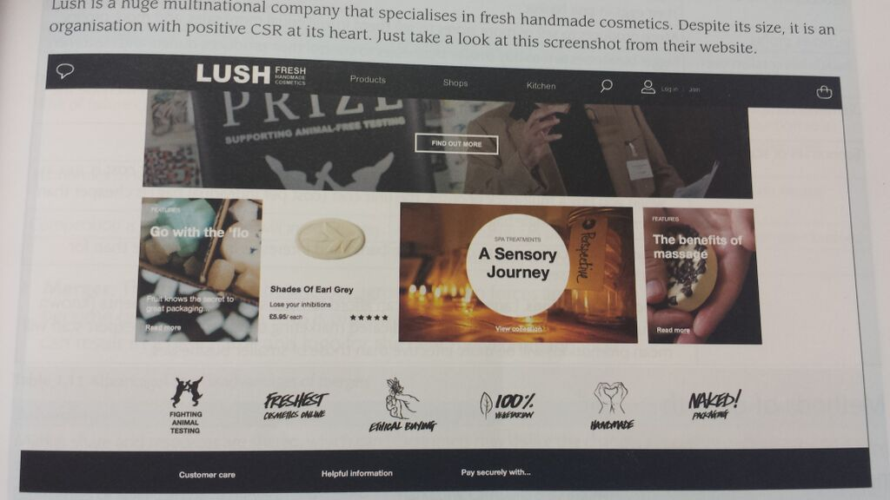[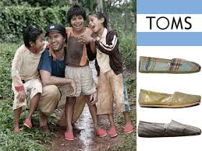](https://www.youtube.com/watch?v=7MV3HWQHl1s)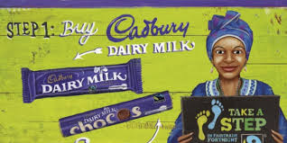\

**How to have positive CSR?**

|  |  |
| --- | --- |
| **4 main elements** | |
| **Ethical and Environmental Responsibilities** | Doing what it right and not just acting for profit.   * Make sure raw materials come from sustainable sources (can be replaced). * Make sure suppliers are paid fairly for what they produce. Fairtrade. * Try to reduce their carbon footprint as much as possible. * Recycle as much as possible to reduce landfill waste.   Sponsoring worthy causes:   * Animal free testing * No animal killing * Poverty in underdeveloped countries * Charity events |
| **Philanthropy** | Promote human welfare and goodwill. |
| **Economical Responsibilities** | Responsible to earn profits for owners. |
| **Legal Responsibilities** | Comply with the law |

# Growth

Many businesses will have the objective of growth.

However not all businesses do:

* **Local government** are more interested in serving local needs
* **Private limited companies** may prefer to stay small so they can give their customers the personal touch.

**Why do businesses want to grow?**

|  |  |
| --- | --- |
| **Reason** | **Justification** |
| To reduce the risk of failure | Bigger businesses with more products or branches can spread the risk of failure. |
| Increase customer sales and profits | More products to sell or more stores to sell them in will equal more sales and profits. |
| Avoid a takeover from another business | Bigger businesses aim to buy smaller businesses to control their products, store and customer base. Growing will allow a business to stay competitive in their market. |
| To gain a better reputation | This will encourage new customers to buy increasing sales. |
| Gain economies of scale | A bigger business can benefit from bulk buying, gain access to better finance deals and create their own specialized departments and this will reduce costs. |
| To avoid seasonal fluctuations | If a business only sells products that are popular during one season then they could be at risk the rest of the year.  Ie: Only selling ice cream in warm weather. |

## Types of Growth

## Internal Growth

If a business is successful it will become bigger every year. This is called **internal/organic growth**.

|  |  |
| --- | --- |
| **Method** | **Impact** |
| Launch new services/ products | The business can then meet the new of different target markets. |
| Open new physical branches | By opening in new locations they can reach new markets and customers. |
| Introduce e-commerce | Selling online means the business can trade 24/7 around the world. |
| Hire new staff | This will improve the business’ ability to make more sales or develop more products. |
| Increase production capacity | Businesses can invest in new capital and technology to make the product themselves. |

## External Growth

|  |  |  |
| --- | --- | --- |
| **What is it?** | This is when one business **takes** control and ownership of another smaller business.  Takeovers can often be hostile and come as a result of a small business struggling financially. | |
| **Facts and examples** | Sometimes the smaller business’ stores will take the name of the larger business. *Santander renamed the Abbey National branches.*  Other times the larger company just wants to add another product to their portfolio. *Google bought YouTube* | |
| **Advantages** | | **Disadvantages** |
| The buying business gains the market share and the resources of the smaller business.  Economics of scale can be achieved due to the bigger size of the business.  Competition is reduced which will increase sales. | | Jobs could be lost in the takeover business as the buying business may want their own management and employees.  If the buying business moves their headquarters or production to its home country then this could have a negative impact on the taken over businesses local economy.  A change of name could put off loyal customers of the taken over business. |

## Takeover

## Merger

|  |  |  |
| --- | --- | --- |
| **What is it?** | This is when 2 businesses **agree** to join forces and become one organisation. | |
| **Facts and examples** | This is often friendlier than a takeover and can result in a new name and logo for the new merged business.  *Disney and Pixar merging or Cadbury and Schweppes* | |
| **Advantages** | | **Disadvantages** |
| Market share and resources are shared which can spread the risk of failure.  Economies of scale can be achieved due to the bigger size of the business.  Unlike a takeover jobs are more likely to be spared in both businesses. | | Customers may dislike the changes a merger may bring. I.e.: A new logo or new name.  Marketing campaigns may be needed to inform customers of the changes and this could be expensive.  This can be bad for business as less competition will mean higher prices. |

## Integration

Any merger or takeover is a form of integration.

1. Horizontal integration
2. Backwards vertical integration
3. Forward vertical integration

|  |  |  |
| --- | --- | --- |
| **Horizontal Integration** | | |
| **What is it?** | Horizontal integration is when two businesses from the same sector of industry become one business. | |
| **Examples** | RBS and NatWest integrating  T-Mobile and Orange integrating | |
| **Advantages** | | **Disadvantages** |
| The new business can dominate the market as competition will be vastly reduced.  The new business can benefit from economies of scale.  Due to reduced competition the new larger business can raises prices which will increase profits. | | The merger/ takeover may breach EU competition rules.  Quality may suffer due to a lack of competition for customers.  Customer may have to pay higher prices for the same goods. |

|  |  |  |
| --- | --- | --- |
| **Backwards Vertical Integration** | | |
| **What is it?** | Backwards vertical integration is when a business takes over or merges with a business in an earlier stage of production.  Your supplier! | |
| **Examples** | Starbucks taking over a bean plantation.  A car manufacturer taking over a business that supplies component parts. | |
| **Advantages** | | **Disadvantages** |
| The business is guaranteed the supply of stock.  There is no need to pay a supplier their marked up prices so the stock is cheaper.  The quality of the supplies can be strictly controlled. | | Focusing on new activities can have a negative impact on the core activities of the business.  The business may be incapable of managing new activities efficiently meaning higher costs. |
| **TIP: Backwards vertical integration is moving towards the raw materials.** | | |

|  |  |  |
| --- | --- | --- |
| **Forwards Vertical Integration** | | |
| **What is it?** | Forward vertical integration occurs when a business takes over or merges with a business in a later stage of production.  Your customer! | |
| **Examples** | A car manufacturer taking over a car dealership.  Samsung taking over Carphone Warehouse | |
| **Advantages** | | **Disadvantages** |
| The business can control the supply of their products and could decide to not supply to the competition.  They can increase their profits by being able to sell their products directly the customer for a more expensive price. Therefore adding value to their selling price. | | Focusing on new activities can have a negative impact on the core activities of the business.  The business may be incapable of managing new activities efficiently meaning higher costs. |
| **TIP: Forwards vertical integration is moving closer to the consumer.** | | |

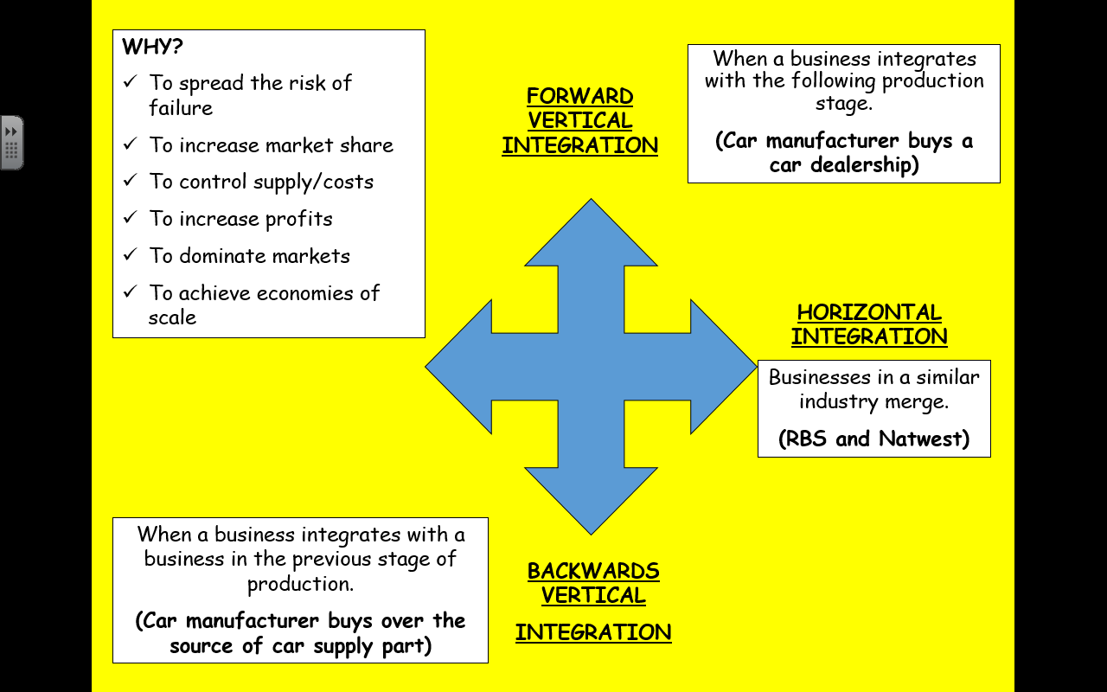

|  |  |  |
| --- | --- | --- |
| **Conglomerate Integration/ Diversification** | | |
| **What is it?** | This is when 2 businesses who sell different goods and services merge. | |
| **Examples** | RBS bought over Marriot Hotels in 2006. | |
| **Advantages** | | **Disadvantages** |
| The business can spread the risk of failure. If one markets fails then the losses can be compensated for the by the profits of another.  It can overcome seasonal fluctuations in their markets and have more consistent year round sales.  The business is larger and therefore more financially secure.  The buyer acquires the assets of the other company. | | One business may take another in a market they know nothing about and this may cause the new business to fail.  Having too many products across different markets may cause the business to lose focus on their core activities impacting on other products.  The business may become too large and inefficient to manage. |

|  |  |  |
| --- | --- | --- |
| **Contacting Out/ Outsourcing** | | |
| **What is it?** | When a business will arrange for another organisation to carry out certain activities for them instead of doing it themselves. | |
| **Examples** | Administration, IT work, Printing, Legal services, Marketing | |
| **Advantages** | | **Disadvantages** |
| Outsourcing allows a business to concentrate on doing what they are good at.  Less labour and equipment is required for outsources activities which saves money.  There should be high-quality work from the outsourced business as it should have greater expertise and specialist equipment. | | The business will have less control over outsources work so quality may fail.  Communication between the businesses needs to be very clear to make sure exact specifications are met.  The business may have to share sensitive information with the outsource business that could get into the hands of competitors. |

|  |  |  |
| --- | --- | --- |
| **De-Merger** | | |
| **What is it?** | A de-merger occurs when a single business splits into two or more separate component.  The de-merged components are still **owned** by the same organisation but they are **managed** independently of each other. | |
| **Advantages** | | **Disadvantages** |
| Each new component can concentrate on its own core activities and grow as a result.  Each new component has the best chance to operate efficiently.  De-merged components can be divested which can meet competition regulations set by the EU. | | Customers can be put off by the de-merger and abandon the businesses altogether.  There are significant financial costs involved to inform customers of the change. |

|  |  |
| --- | --- |
| **Divestment** | |
| **What is it?** | Divestment is selling off part of an organisation such as a subsidiary company or one of the company’s brands. |
| **Examples** | British Aerospace owned Rover cards they sold it to BMW. |
| **Why?** | * To focus on other more profitable areas of the business. * To focus on a specific target market. * To cash in on selling a part of the business. |
| **TIP**: Divestment is the opposite of investment.  In other words selling part of the business rather than buying a new part of the business. | |

|  |  |
| --- | --- |
| **Management Buy-Out/ Buy-In** | |
| **What is it?** | Team of managers getting together and buying an existing company from its owner.  The management team have to raise the necessary finance to **buy out** and run the organisation. This may involve large bank loans.  A **buy-in** is when the team comes from outside the business |

|  |  |
| --- | --- |
| **Asset Stripping** | |
| **What is it?** | This is taking over another company with intent to sell of its assets for a profit. |
| **Why?** | The individual assets may be more valuable than the organisation as a whole.  **BUT**  The buyer may gain a bad reputation as it often happens after they buy a business through a hostile takeover. |

# Internal Structures

## Organisation Charts

**What is an organisation?**

A group of people working towards a defined set of goals and objectives.

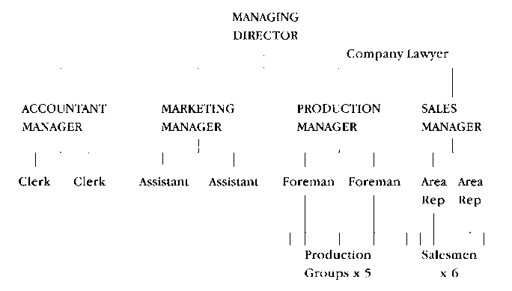**What is an organisation chart?**

A diagram that shows the formal structure of an organisation.

**Who uses an organisation chart?**

* Visitors to the organisation
* New members of staff
* Receptionist

**Why have an organisation chart?**

**So that employees and visitors in the organisation know:**

* Staff names, positions and room numbers
* Job titles
* The relationships between staff
* The lines of authority and responsibility
* Who has authority over whom
* Who is accountable to whom
* Who is in charge of the organisation and each department
* The chain of command and lines of communication
* The management structure of the business

|  |  |
| --- | --- |
| **Advantages** | **Disadvantages** |
| * They identify the **span of control** each individual has. * They identify appropriate lines of **communication**. * The **links** between individual departments can be easily identified. * **New staff members** can learn who they are responsible for and to. | * They do no show the **authority** each position in the chart carries. * They do not identify any **informal relationships** that occur. * They need to be **updated regularly** to account for staff that have left and started. |

## Organisation Terms

|  |  |
| --- | --- |
| **Subordinates** | Someone of a lower rank within an organisation. |
| **Superiors** | Someone of a higher rank in the organisation. |
| **Empowerment** | When staff are given decision making powers. |
| **Authority** | The **power** that an employee has to instruct others and take decisions. |
| **Responsibility** | The obligation an employee has to carry out a range of tasks or duties. |
| **Delegation** | When someone in the organisation passes on tasks to be completed by a subordinate.  Due to the senior staff member not having time or the subordinate being more skilled. |
| **Chain of Command** | The way in which **instructions** are passed down an organisations and how **communications** flow up and down the organisation. |

**Span of Control**

The number of people (subordinates) who report to one manager (superior) in an organisation.

The more people under control of one manager = **WIDE span of control**.

The fewer people under control of one manager = **NARROW span of control**.

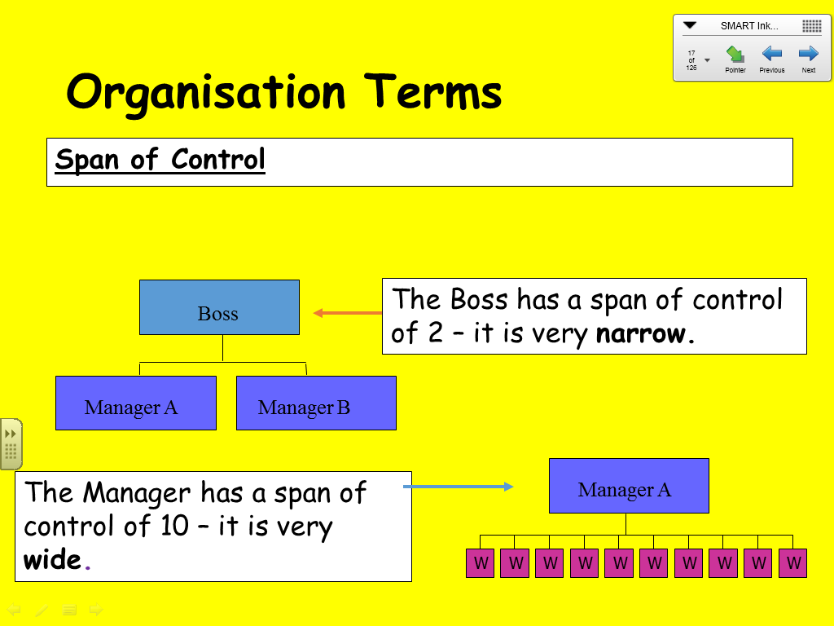

**Wide Span of Control**

* More **empowerment is possible** due to the number of subordinates.
* Tasks can be **delegated more easily** to the subordinate most suitably skilled to carry these out. However employees may feel reluctant and uncomfortable with this.
* As there are a large number of subordinates this can cause **extra stress** for the manager who may have little time to deal with staff related issues.
* Managers may feel that as they have **more subordinates to manage**, they are more powerful and this can be motivating for them.
* The organisation will have **fewer managers** and therefore saves money.
* A **shorter chain of command** will exist and therefore communication and decision making is likely to be more effective.

**Narrow Span of Control**

* There will be **less empowerment** as there are fewer subordinates to manage and the manager is unlikely to delegate as much.
* **Delegation may be more difficult** as there are fewer subordinates.
* Subordinates have **more opportunities** to communicate and interact with their manager.
* Subordinates are more likely to have the chance to participate in **decision-making** and planning.
* A **long chain of command** will exist and therefore communication and decision making might be slower.

## Organisational Relationships

There are 2 types of relationships can exist in an organisation:

* Formal relationships
* Informal relationships

**Formal Relationships**

**Line Relationships**

The relationship between a superior and a subordinate.

It can be identified as a vertical line between individual on an organisation chart.

**Lateral Relationships**

The relationship between **2 employees on the same management level** who report to the same manager.

They have the same level of responsibility and authority.

They **cannot** give instructions to each other.

**Functional Relationships**

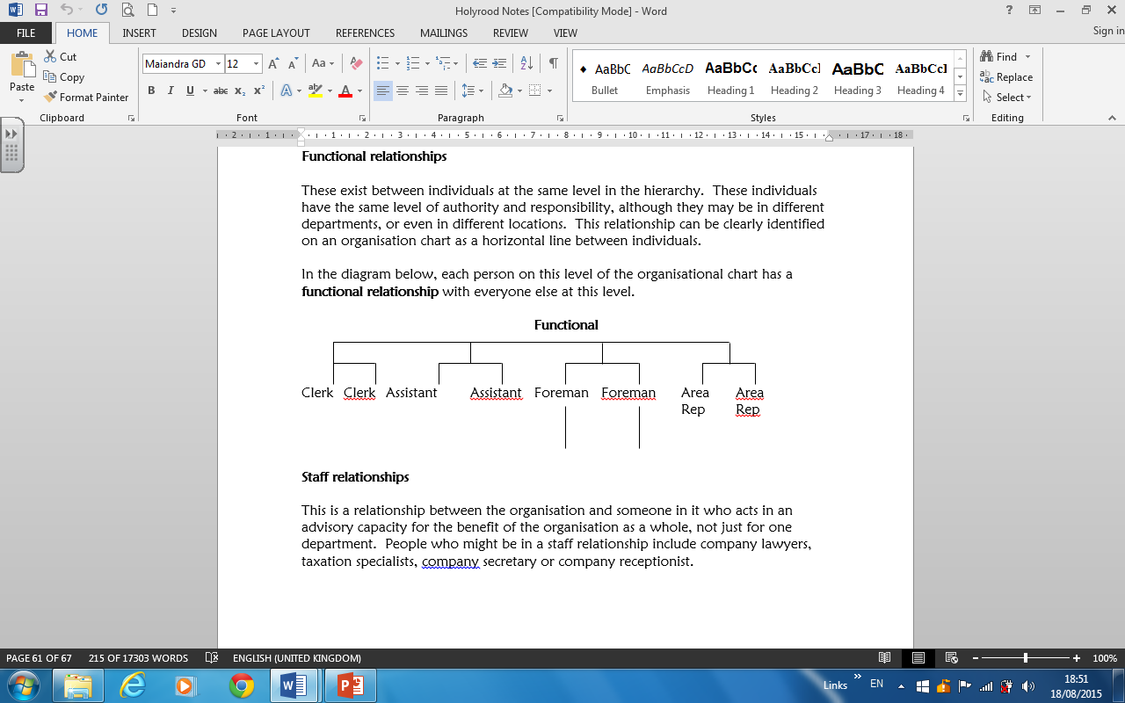These exist **between individuals at the same level** in the hierarchy although they may be in **different departments/location**.

They have the same level of authority and responsibility.

These can be identified by horizontal lines.

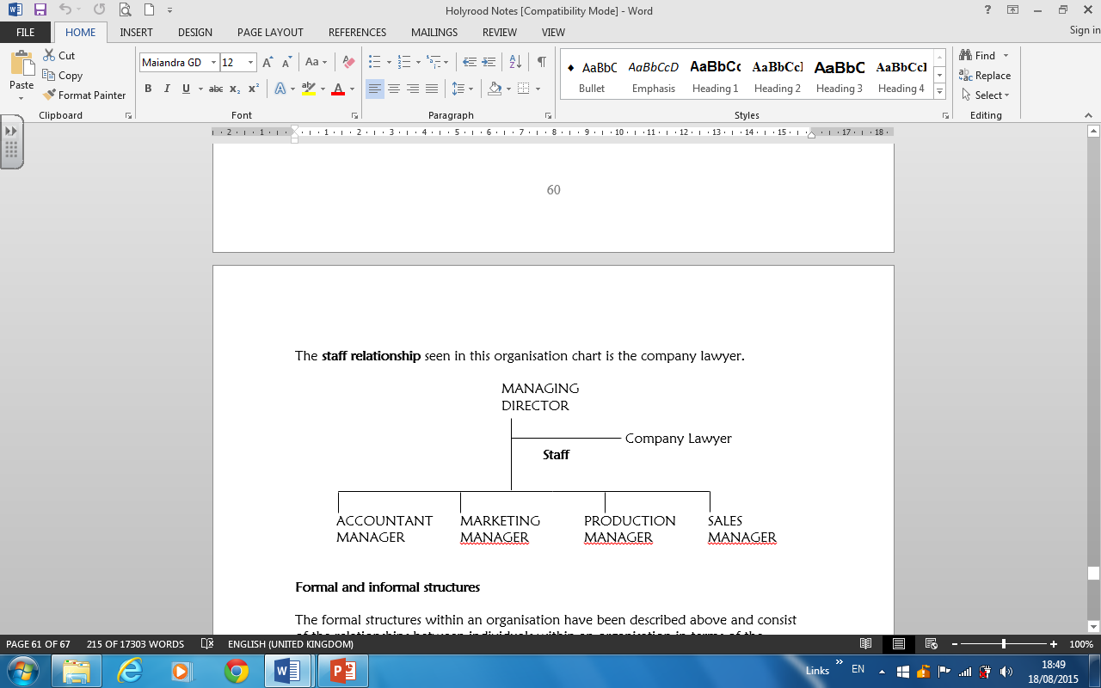**Staff Relationships**

This is the relationship between the organisation and someone in it who acts in an **advisory capacity** not just for one department.

I.e.: Lawyer, company secretary, receptionist

**Informal Relationships**

These exist as friendships between workers who may have no formal contact in the workplace.

These can develop between staff at breaks, during work and socialising. This builds up a range of sources staff can seek advice from.

Staff share information with each other and communicate regarding work-related matters.

All organisations have informal relationships within them but there can be problems if inaccurate information is passed on.

**Why do informal structures occur?**

The formal communication processes are inefficient or at least are felt to be inefficient by some staff.

**What problems can arise from informal structure?**

* The information passed through informal structures may not be accurate.
* It can lead to resentment, bad feeling and isolation between staff.
* It can sabotage the main objectives of the business.

**Therefore managers** must be aware of these structures and may manipulate them to feed information to staff quickly.

## Organisational Structures

All organisations have a management structure and a grouping structure.

|  |  |
| --- | --- |
| **Management Structures** | **Grouping Structures** |
| 1. Tall structure 2. Flat Structures 3. Matrix structures 4. Entrepreneurial structures 5. Centralised structures 6. Decentralised structures | 1. Functional grouping 2. Product/service grouping 3. Customer grouping 4. Location/ geographical grouping 5. Technology grouping 6. Line/staff grouping |

## Grouping Structures

A grouping structure is the way a business organises the activities of the organisation.

**How to choose a grouping?**

A business will chose to group their activities based on several factors:

* The **size of the organisation** as larger organisations usually needs a more formal structure.
* The **technology available and used**. This could be used to communicate with other parts of the organisations in other locations.
* The **market** the organisation targets.
* The **product, good or service** being provided.
* The **amount of finance** available to the organisation as this could limit the type of structure that could be used.

### Functional Groupings

**This involves grouping an organisation into departments called functional areas based on skills and expertise.**

* Functional grouping usually consists of marketing, finance, human resources and operations.
* Common organisational structure widely used by British companies up to the 1960s.

**What do the functional departments do?**

|  |  |
| --- | --- |
| **Function** | **What do they do?** |
| **Finance** | They manage, budget and control the finances of the business.   * Decide where to get finance from. * Receive and process payments. * Arrange employees’ wages. * Carry out financial analysis * Prepare and interpret cash budgets, balance sheets and TPL accounts. |
| **Human Resource (HR) / People** | They deal with all activities relate to the employees of the business.   * They recruit and select staff. * Motivate staff and support employee relations. * Train staff. * Keep up to date with legislation. * Maintain employee records. |
| **Marketing** | They identify, satisfy and anticipate the needs of their customer.   * They decide on the price, promotion, product, people, process and physical evidence for a business. * They conduct market research. * They devise ways to extend the product life cycle. |
| **Operations** | They transform raw materials into finished goods ready to be sold to customers.   * They decide which supplier to by raw materials from. * They ensure the quality of the raw materials. * They manage stock. |

|  |  |
| --- | --- |
| **Advantages** | **Disadvantages** |
| * Staff with **similar skills and expertise** are together allowing for specialisation and each department will become excellent at what it does. * Staff know **who to report to** and can get guidance from more experienced staff in their area of expertise. * **Career progress** is often based on functional expertise therefore employees are motivated to develop their skills in one field. * This structure provides a way of **centralising decision making** because there are fewer managers who may be responsible for a large number of employees. * **Communication and co-ordination** between members of a department are quick and efficient. | * The organisation can become **too large to manage** if functional departments grow rapidly. Therefore it may be difficult to identify who is responsible for problems within departments. * Functional grouping is often coupled with a centralised management structure so **communication** can take a while to filter though to functional departments causing slow reactions to external factors. * Functional departments can become more interested in their **own objectives** rather than the organisations objectives. * **Rivalries** can occur between departments which can detract from the overall objective of the business. * **Decision making** can be a long and slow process as each department is consulted and responds with information or suggestions which then have to be passed onto other departments for consideration. |

### Product/ Service Grouping

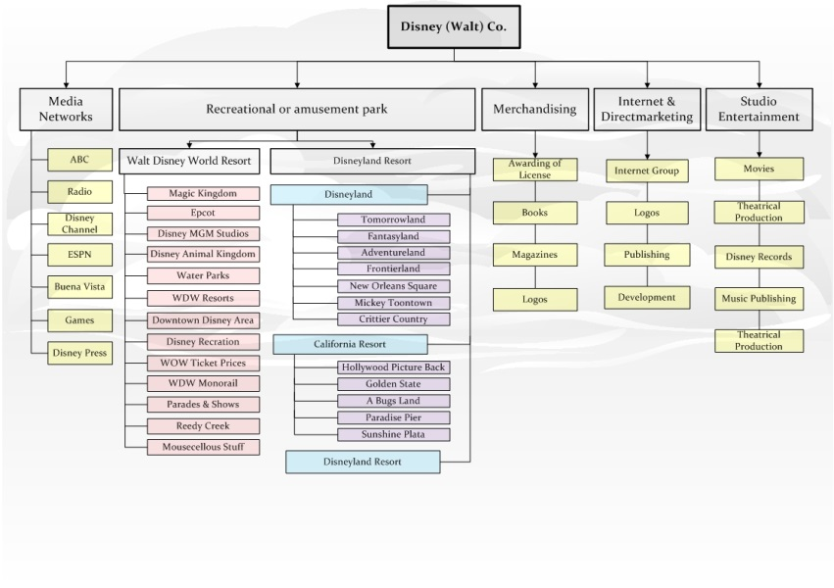**This involves grouping an organisation into divisions that deal with different products or services.**

This is suitable for large **conglomerate** organisations.

Examples: P&G, Virgin or Sky

|  |  |
| --- | --- |
| **Advantage** | **Disadvantage** |
| The business can **react to changing external factors** that affect each particular group’s market quickly. | There could be a **duplication of resources** which could increase expenditure. |
| It is easy for management to **identify struggling products** and services. | A **new group** needs to be set up every time the business launches a new product meaning more staff, equipment and premises costs. |
| **Expertise can be developed** when dealing with products/ services. | There could be **rivalry between different departments** that can be counterproductive to working relationships within the organisation. |
|  | There is a **lack of centralised control** over the various departments. |
|  | Product departments can become more interested in their **own objectives** rather than the organisations objectives. |

### Location/ Geographical Grouping

**This type of grouping exists when the organisation is structured around specific locations.**

**Examples**: Nestle, Waterboards

**Americas**

Houston, Texas

**Europe, Middle East, Africa**

Geneva, Switzerland

**Asia Pacific**

Hong Kong

**Hewlett Packard**

|  |  |
| --- | --- |
| **Advantage** | **Disadvantage** |
| Each division can meet the needs of its **local markets**. For example different fashions or tastes in different countries. | The **duplication of resources** could occur which will increase expenditure. |
| The business can **react quicker** to external factors. | **Divisions may compete** against each other and forget the overall objectives of the organisation as a whole. |
| It is easy to **identify a failing location** and hold regional managers accountable. |  |
| **Technology** can be used to communicate with staff in different locations saving travel expenses. |  |

### Customer Grouping

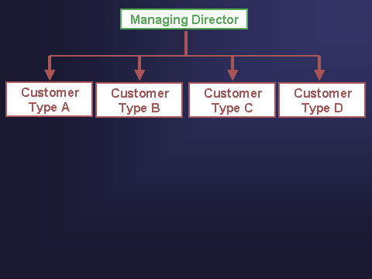

**This is grouping by customer types. Grouping by market segments or target markets.**

May have different divisions based on distribution, e.g. retail, online and international.

**Multinational businesses** would find this grouping useful for offering products to suit differing customer needs.

|  |  |
| --- | --- |
| **Advantage** | **Disadvantage** |
| Each group can **tailor its products** or services to its own type of customer. This ensures a high level of customer service is achieved. | There can be **duplication of resources** which increases expenses. |
| **Customer loyalty** can build up due to the high level of personal service that can be achieved. | This is **only suitable for large businesses** with many customer types/ segments that are of sufficient size. |
| The business can **respond to customers’ needs** immediately and develop a close relationship with customers that allows future needs to be anticipated. | This grouping results in **higher staffing costs.** |

### Technology Grouping

**Technological grouping is suitable for large organisations with different production processes as access to technology may differ from one country to another.**

Only suitable for **large organisations** with different products and production processes.

**Example**: Ford (bodywork, glass, plastics, paints)

Oil (Extraction, refinery, distribution, R&D)

|  |  |
| --- | --- |
| **Advantage** | **Disadvantage** |
| Teething problems or **technological problems** easy to identify | **Higher wages** will be required due to the highly skilled staff that will be needed which will increase expenditure. |
| The business will have **increase specialisation** which will make them more competitive. | **Specialist training** is required which will be expensive. |
| The business will be able to take advantage of **economies of scale.** | This is a **capital intensive** grouping which will increase expenditure. |

### Line/ Staff Grouping

**This is when the organisation groups their departments according to core activities which support the work of other people and line grouping is groups of management.**

Core activities are essential to the business, e.g. teachers are essential or core in the education sector.

Janitors, office staff and canteen workers are involved in the support (staff) activities that are required for a school to function.

## Management Structures

Organisations can use a variety of different methods to organise and group its staff and resources in a way that best suits its operations.

1. Tall structure
2. Flat Structures
3. Matrix structures
4. Entrepreneurial structures
5. Centralised structures
6. Decentralised structures

## Tall and Flat Structures Diagrams:

|  |  |  |
| --- | --- | --- |
|  | **Tall/ Hierarchical Structures** | **Flat Structures** |
| **What is it?** | A management structure with **many** levels of **management and supervision**. | A management structure with **few** levels of **management and supervision**. |
| **Features** | * Many levels of management. * Managers have **narrow span** of control. * Management posts usually specialised. * Clearly defined roles. | * Few levels of management. * Managers have **wider spans** of control. * Faster communications. * Quicker decision-making. |
| **Example** | NHS  Police | Dentists  Hairdresser |

**TIP-** When comparing tall and flat structures consider the following points:

* Decision making
* Communication
* Span of control
* Levels of management
* Promotion

|  |  |  |
| --- | --- | --- |
|  | **Advantages** | **Disadvantages** |
| **Tall** | * Due to there being a defined hierarchy, people know their roles and responsibilities better. * There is a clear promotional ladder, with many opportunities for promotion to different positions. This will motivate staff. * More staff will be employed at different levels, meaning that tasks can be more easily delegated. * There is a narrow span of control which means staff are more closely supervised and monitored. * Staff more likely to know their line manager and deal with them regularly leading to better communication. * It is easy to spot areas where communication breaks down in the long chain of command. | * Tall structures are slow to respond to change and due to the ever changing external factors if an organisation can’t change they may not survive. * It can take a long time for communication to pass up and down all the management levels. Furthermore, the different managers may interpret the communications differently causing further problems. * The decision making process can take a long time because of the number of levels and people that have to be consulted. * The narrow span of control can mean that mangers supervise staff more closely leading to staff feeling pressure. Also managers may have fewer staff to share ideas with. |
| **Flat** | * There can be faster communication because there is not so many levels for information to travel through. * Employees have greater responsibility which can lead to higher motivation levels. * There will be increased delegation of tasks to staff, which will make them feel more valued, so they will work harder and feel happier in the workplace * With fewer supervisors, the business saves money on wages and that money can be used elsewhere. * The business will have good working relationships as staff work more closely together. * An organisation can react quickly to change from the external factors (PEST) using this structure. | * Due to the few layers of management there is decreased promotional opportunities for employees. Therefore staff may leave resulting in high turnover. * Staff are less likely to have a close relationship with their line manager because of the wide spans of control managers have. * A manager having a wider span of control means that a manager’s time is at a premium which could lead to snap decisions being made. * The wider span of control will lead to less control of staff which may to employees abusing their freedom and working at a minimal rate. |

## Matrix Structures

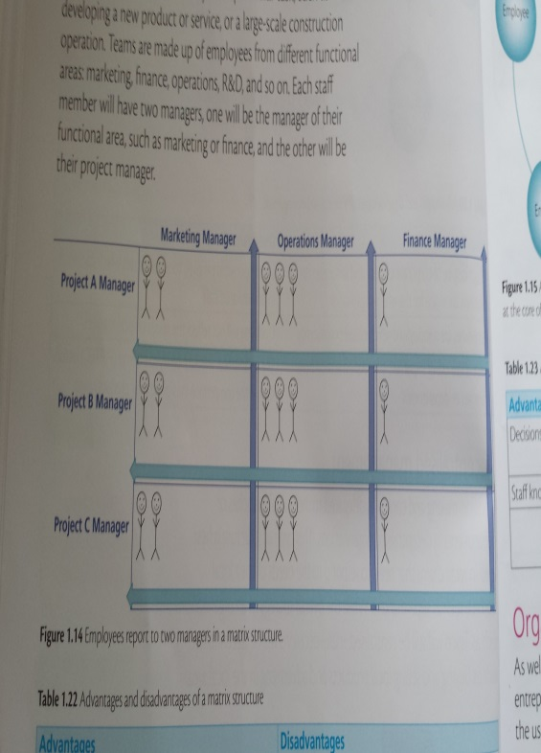

A **matrix structure** involves an organisation being arranged into **temporary** project teams to carry out a particular task.

The teams will be **made up of people** from different departments working together.

Each staff member will have **2 managers**, one from their own functional areas and one will be a project manager.

**Examples:**

Developing a new product or service

Large scale constructions

|  |  |
| --- | --- |
| **Advantage** | **Disadvantage** |
| Staff will have the opportunity to develop their own skills, increasing job satisfaction and motivation. | There could be confusion for staff over who reports to whom. |
| This is a good structure for solving complex problems. | It can be difficult to co-ordinate a team from different areas. |
| The team will be aware of the customers’ needs as they work directly with them and can make changes quickly. | Having many managers across all project teams will mean high wage costs. |

## Entrepreneurial Structure

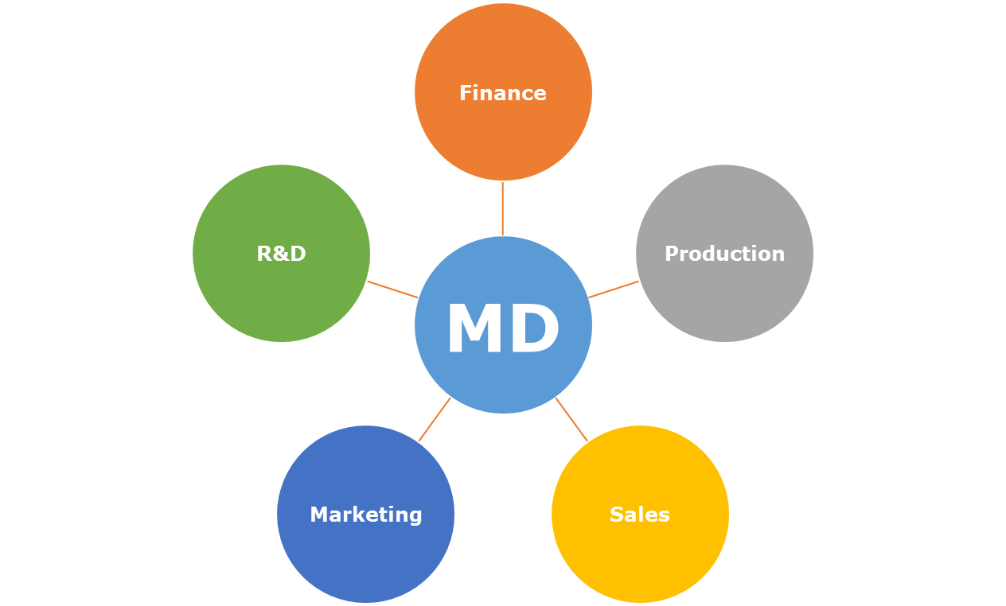This is a structure used primarily by **small organisations** when there is usually only **one main decision maker**, the owner.

Other staff may be consulted but the manager will make the final decision.

Example – Football managers make all strategic decisions during a match.

|  |  |
| --- | --- |
| **Advantage** | **Disadvantage** |
| Decisions can be made quickly because employees are not involved allowing the business to respond to external factors quickly. | Staff don’t get an opportunity to show their initiative which can reduce motivation. |
| Staff know who they need to report to which reduces confusion and inefficiencies. | If the owner is not available then key decisions can’t be made which could be costly for the business. |
|  | This structure can create a heavy workload for the main decision maker which could lead to stress. |

## Centralised and Decentralised Structures

|  |  |  |
| --- | --- | --- |
|  | **Centralised** | **Decentralised** |
| **What is it?** | This is when **control and decision –making** lies with **top management** in head office.  This structure is often **associated** with tall/hierarchical structures. I.e.: PLC | This is when **control and decision-making** is **delegated to departments**, which relieves senior management from routine day-to-day tasks and burdens.  **Example**  Tesco – Each branch can respond to local needs. |
| **Advantages** | There is a low risk of important information leading from branches.  Procedures are standardised which ensures consistency across the business.    Decisions are made for the whole organisations which can lead to a higher degree of corporate identify and strategy. | The business can respond quickly to changing external factors which could lead to gaining a competitive edge.  Decisions can be made quickly as local managers don’t need to consult senior managers. Therefore critical decisions can be made in time.  Employees will feel motivated if their ideas are considered and they feel involved in the business. |
| **Disadvantages** | Less responsibility is given to subordinates which results in demotivated staff.  Decisions will not reflect the needs of local markets.  Communication is slow to get down and back up the organisation.  The organisation is slower to respond to external changes which could lead to losing a competitive edge. | Decisions are made by individual branches which makes it harder to ensure consistency across the business.  Local branches could start to compete with each other which may distract them from achieving the overall objective of the business. |

**Factors affecting structural change**

**The size of the organisation**

As a business grows, it becomes harder to control all the staff within the organisation.

In order to keep control and supervise, managers will be appointed to look after groups of workers. Departments will be formed and the number of levels will increase.

**New technology has become available**

The introduction of new technology can change the structure of a business.

**The product that is sold**

Having a small number of large customers for your product means that a flat structure using teams may be more appropriate.

**Market conditions have changed**

If the market is small then the organisational structure will be small.

**Downsizing**

This involves **removing some of the activities** that the organisation carries out from it structure.

It results in staff being made redundant (paid off).

* If one factory/division is making huge losses, they business may decide to close it down.
* Merging two divisions to save on resource duplication.

|  |  |
| --- | --- |
| **Advantage** | **Disadvantage** |
| * The costs of wages and rent will be reduced which the business can spend on other activities. * The business can become more competitive. * More responsibility for the remaining staff, empowering members of staff. * Being smaller in size should enable them to become closer to their customers. Therefore they can respond to changing needs quicker. | * Valuable skills and knowledge are lost when redundancies are made. * Remaining staff could feel venerable in their position and this could lead to a demotivated staff. |

**Delayering**

This is where an organisation **removes** certain levels (layers) of management posts.

This will make the organisation flatter.

**Why would a business delayer?**

* If an organisation becomes too large and communication is ineffective.
* If management costs are too high.
* If the organisation was changing its structure from a tall/hierarchical structure to a flat structure.
* If an organisation becomes too large and communication is ineffective.
* If management costs are too high.
* If the organisation was changing its structure from a tall/hierarchical structure to a flat structure.

|  |  |
| --- | --- |
| **Advantage** | **Disadvantage** |
| * There is a shorter chain of command which will make communication quicker in the business. * The shorter chain of command can also make decision making quicker and more effective. * A wider span of control will empower employees, as they will have increased responsibilities. This could increase their motivation. * There will be fewer management positions therefore the wage costs will be less. * This allows an organisation to respond quickly to changes in the market because there are fewer levels for the information pass through. | * There are fewer promotion opportunities for staff which could lead to staff leaving * Redundancy payments will cost the organisation a significant amount of money which will increase business expenditure. * The organisation could lose key members of staff in the restructure and therefore crucial skills and creativity could be lost. |

# Outcome 2

# Internal Factors

These are factors which are **inside** the business. The business **has control** over them.

It includes 4 broad areas:

* Human Resources (Management & Employees)
* Finance
* Current Technology
* Corporate Culture

|  |  |  |
| --- | --- | --- |
| **Internal Factor** | **What is it?** | **Impact** |
| **Human Resources** | **This refers to the skills and qualities of the workforce to ensure that the business succeeds.**  The calibre, work ethic and attitude of staff can affect:   * Creativity * Productivity * Efficiency * Customer Satisfaction   Therefore investment has to be made in the **recruitment, training and retaining** of staff. |  |

|  |  |  |
| --- | --- | --- |
| **Internal Factor** | **What is it?** | **Impact** |
| **Finance** | **This is the funding necessary for the business to pursue its objectives.**  An organisation may need to take drastic action to cut costs such as delayering (removing management levels) or downsizing (removing activities). |  |
| **Available technology** | **Technology is constantly improving which can result in businesses falling behind their rivals.** |  |

**Corporate Culture**

**What is corporate culture?**

This is the **values, beliefs and norms** relating to the company or organisations that are shared by its entire staff.

**Formal corporate culture** is created by **management.**

**Informal cultures** are created by the **workforce.**

**Where did it come from?**

Peters & Waterman (1982) observed US and Japanese businesses to examine the differences between each.

US businesses were favorable for hard skills such as strategy.

BUT

The Japanese were favorable for soft skills such as values and culture.

**What impacts on designing a corporate culture?**

* The **vision and aims** of the organisation.
* The **opinions and views** of the employees. Consulting with them will boost motivation.
* Historic **decision making** processes.
* The **size and nature** of the business.
* The **number of employees** involved in the decision making process.
* The **management structure**.
* The **flexible working practices** employed by the business.

**How to let staff know about the corporate culture?**

This can be done through:

* Videos
* Training
* Honouring employees – awards, certificates
* Company newsletter
* Company events
* Social events
* Uniforms

**How to develop a corporate culture?**

* 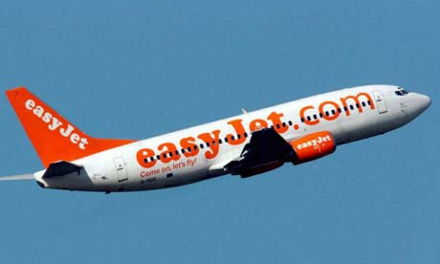Have **company values, aims and objectives** which are developed by the founder that everyone works towards.

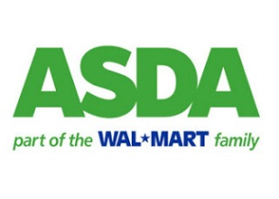

* Have **corporate colours** to help create a strong staff identify. This also helps customers recognise the business.
* The **design of store**. Have all branches laid out the same allowing staff and customers to be easily transferred between branches.
* Give **staff uniforms** with **logos and symbols** to help them feel a sense of belonging.
* Have **reward schemes** for employees to acknowledge and praise employees for hard work. This will help to motivate staff.
* Provide **team building** opportunities to allow relationships across the organisations to be improved.
* Have a **code of conduct** for staff to establish what attitudes and beliefs are appropriate within the business.
* Have **company language and jargon** which can give employees a sense of belonging to the business.

**Example**

Disneyland call their staff “Actors” or customers “Audience”

* Have **rituals** such as dress down days to help relax staff and break down the barriers that a uniform can create.
* Have **symbols, slogans and mottos** to help customers identify the business and reinforce the business objectives.

**Example** - Honda “The Power of Dreams”

* An **open plan office layout** can encourage a relaxed atmosphere in an organisation. It can encourage better communication and idea sharing among staff.

**Benefits of having a corporate culture**

* Employees **feel part of the business** which will provide them with a sense of security and motivation.
* Staff will **become motivated** which will lead to improved efficiency and higher productivity.
* It will create **better relationships** within the business which will enable better communication and decision making.
* **Employee loyalty** will be increased which will reduce staff turnover.
* **Customer loyalty** will be higher because they will associate themselves with the identity of the organisation which could help a business become multinational.
* There will be **consistency** across the whole business which will allow employees to work in difference location is necessary.
* If a business **offers perks** as part of their corporate culture this will attract the best staff to the business which will give then a competitive edge.

**Problems with having a corporate culture**

* Staff have to be **made aware** of the culture otherwise they may resist it.
* Modern office culture can leave some employees **physically and emotionally isolated** from others which could lead to demotivation.
* A culture can be **hard to introduce** which could lead to money and time being wasted unless it is done properly.

# External Factors

These are factors from **outside** the business that the business has no control over.

The business has to be **proactive** rather than **reactive**.

**P**olitical  
**E**conomic  
**S**ocial  
**T**echnology  
**E**nvironmental  
**C**ompetition

Also known as **external factors.**

## Political

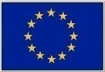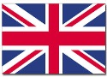

These are changes caused by the actions of Government concerning changes in laws.

|  |  |  |
| --- | --- | --- |
| **Political Influence** | **Positive Impact** | **Negative impact** |
| **A change in, or introduction of a new law** | The Government could introduce environmental protection laws and policies and by complying the organization could gain positive PR.  *This could attract customers to the business.* | If a law is changed then the organisation would have to comply with any changes that affect their products or services.  *This many result in extra costs being incurred if premises have to be upgraded or higher wages have to paid.* |
| **There was a change in the amount of income tax paid.**  **Income tax** = Tax charged on wages. | The Government could reduce taxes, such as income tax, and this will give customers a higher disposable income.  *This results in customers being more likely to spend money on products increasing sales.* | The Government could increase income tax and this will give customers a lower disposable income.  *This means customers will have a lower disposable income to spend on products which will reduce overall sales.*  For a **Public Sector** organisation a decrease in income tax may result in less money being given to the Government meaning a poorer service being delivered. |
| **VAT Rates were changed**  **VAT Rates** = This is a tax on goods and services | The Government could lower VAT rates and make products more affordable for customers.  *This will increase sales for a business.* | The Government could raise VAT which will increase the selling price and put customers off the product.  *This will decrease sales* |
| **Corporation tax is changed**  **Corporation Tax** = Money paid on profit by companies.  Ltd, PLC or MNC | The Government could lower corporation tax which would reduce the amount of money taken from a business.  *This will increase the overall profits of a business.* | The Government could raise the rate of corporation tax which means more money is taken from the business.  *This will reduce the amount of overall profit in a business.* |
| **Money is spent on funding or upgrading infrastructure** | Access to locations which have been previously restricted may enable greater trade to take place.  *This will help gain a business new customers.*  This could reduce travelling time between destinations.  *This will allow products to be transported more quickly which will satisfy customers.* | There could be significant disruption during the construction phase.  *This could impact on the business being able to transport good to customers on time.*  A business seen to support the building of a new motorway or airport may not be views favorably by all stakeholders if it aims to be socially responsible.  *This will damage the businesses reputation and image.* |
| **There was a change in relations with another country** |  | If the UK was to go to war with another country this means that you might be banned from selling in that country.  *Therefore lose out on sales.* |

## Economic

These are factors that cause changes based on the **economic situation of the country** they are operating in, concerning changes in **interest rates**, changes in **demand,** **unemployment levels** and **inflation**.

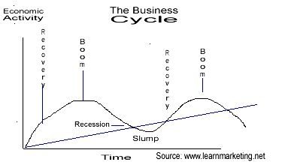

**Stages of Economic Cycle**

**Boom**

* GDP and employment are very high
* Demand is high

**Recession**

* GDP and employment levels fall
* Demand falls

**Recovery**

* GDP and employment levels begin to rise
* Demand increases

|  |  |  |
| --- | --- | --- |
| **Economic Influence** | **Positive Impact** | **Negative Impact** |
| **The country is in a recession** | **Third Sector**  For third sector organisations they might see an increase in demand for their services as people are struggling with making ends meet.  Example - foodbanks | **Private Sector**  If the economy is in recession then people are more careful with their money and less likely to spend on non-essential items.  *This means that they may stop buying a product and switch to a cheaper competitor.*  Prices will have to be cut to try and increase demand.  *This will lower the amount of profit a business can make and may even lead to losses.* |
| **The number of people unemployed is high or low** | If unemployment is low people may have more disposable income and feel more secure in their jobs.  *Therefore they will buy more products creating a greater demand and sales for businesses.* | If unemployment is high, people may be more cautious when spending money.  *This could result in less demand and sales of a product.* |
| **Changes in interest rates** | It is cheaper to borrow money when the interest rate is low.  *This may enable a business to borrow more money to grow and expand.*  Customers are more likely to be tempted to buy items on credit.  *Therefore increasing sales for a business.* | If the interest rate is high it is more expensive to borrow money. If the business is having a cash flow problem and relies on loan this could mean that suppliers do not get paid.  *This would result in a gaining a bad credit rating and reputation for a business.* |
| **Changes in exchange rates** | If the value of the pound is low compared to foreign currencies imports will become cheaper.  *This will decrease costs for businesses that sources materials from abroad.* | If the pound is high against other currencies this makes it hard to export goods abroad.  *This will reduce the number of sales.* |

## Social

These are factors relating to the **consumers** who buy the businesses products and how their **tastes**, **preferences**, **lifestyles** and **family size** change.

|  |  |  |
| --- | --- | --- |
| **Social Influence** | **Positive Impact** | **Negative Impact** |
| **Changes in fashion trends and tastes** | The business can take advantage of new opportunities by producing products that customers demand. *Therefore this will increase sales.* | The business will need to invest money into carrying out market research to enable it keep ahead of what customers want.  *This will increase expenditure and reduce overall profits.* |
| **Changes in flexible working arrangements** | It is easier to recruit employees who have the appropriate skills but who want to work flexibly*.*  *This will increase the potential number of employees from which the business can choose.* | It may not suit the requirement of the business to have employees working flexibly.  *Therefore they may need to hire additional staff costing extra money.*  The business will need to purchase and maintain technology for employees who work away from the office.  *This will increase the expenditure of the business.* |
| **Changes in demographics with people living longer** | This has created a new and growing market segment for businesses to create products for.  *Therefore a business can increase their customer base, sales and profits.* | The business will need to conduct market research to identify what this market segment wants.  *This will costs time and money to complete.* |
| **Changes in the number of woman now working** | More woman are now waiting to have children meaning that couples have more disposable income when they start a family.  *This will result in businesses being able to target them with higher quality baby products resulting in a greater profit.* | Woman will need to take maternity leave which will means the organisations need to consider flexible working practices.  *This will result in the spending time and money recruiting and training a replacement.* |
| **Environmental Concerns** |  | Customers are more concerned about the environment, forcing firms to use recycled products or to be more environmental friendly.  *This means that a business needs to spend money introducing these initiatives.* |

## Technology

These are factors related to the **vast developments and constantly changing technologies** that are available, including email, internet and selling online, which make communication quicker.

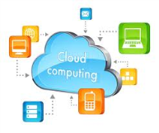

|  |  |  |
| --- | --- | --- |
| **Technology**  **Influence** | **Positive Impact** | **Negative Impact** |
| **New pieces of technology** | This may allow a business to complete tasks quicker.  *Therefore this frees up time that can spent on other activities.* | Technology can be expensive to purchase and maintain.  *This would result in higher expenses and therefore less profit.*  Employees may require training to use the technology.  *This can be time consuming and expensive to carry out.*  If a business does not keep up with current technology they may lose a competitive edge. *Therefore they may lose customers to rivals.* |
| **Growth of s-commerce** | This will increase the number of customers that can be accessed.  *Therefore increasing market share.*  Updates can be made very quickly to the sites.  *Therefore this makes communication with customer instant.* | Procedures and processes will be required to manage orders received via s-commerce.  *This can be time consuming to create and implement.*  Employees may require training in the use of s-commerce *which can be expensive and time consuming to carry out.* |

**New and emerging technologies**

**S-commerce** = Buying and selling through a social networking site.

**4G** = Provide people with superfast broadband speeds through their mobile phone. Businesses can communicate faster and download information quicker.

**Cloud computing** = Information is stored on the internet (in the cloud) which means cheaper IT and staffing costs for a business.

**Wireless computing** = Using technology without wires while on the move.

## Environmental

These are factors relating to businesses being aware of the need to be **environmentally friendly**, **sustainable** and **operating ethically**.

|  |  |  |
| --- | --- | --- |
| **Environmental**  **Influence** | **Positive Impact** | **Negative Impact** |
| **Changes in the weather** | Depending on the product being sold a certain temperature may increase demand.  *This will increase sales.* | The weather may reduce the demand for a product.  *Therefore this will decrease sales.*  Bad weather might mean that orders cannot be delivered on time.  *This will result in unhappy customers who may not return.*  A business might have to close due to flooding and then having to replace damaged stock or refurbish their shop.  *This will increase the expenditure of the business and reduce profits.* |
| **Increased pressure to recycle** | The business will be seen as being socially responsible and can use this as part of their marketing campaign to enhance their image.  *This could attract customers to the business.* | It will cost the business money to provide recycling facilities.  *Therefore this will reduce overall profits.* |

## Competition

These are factors relating to a **business’s competitors** and the decisions they can make, such as changing their pricing strategy.

|  |  |  |
| --- | --- | --- |
| **Competition**  **Influence** | **Positive Impact** | **Negative Impact** |
| **New competitor entering the market** | This might be good for consumers because competition can encourage businesses to provide loyalty schemes and reduce prices.  A competitor opening up a physical store next to a business could be good because it brings in passing trade into the area. | A business may have to provide discounts to customers to retain their loyalty.  *This can result in less profit for the business due to increased expenditure.* |
| **Competitor introducing a new product** | This will give customers a wide range of products to choose from.  It might give a business an idea that they can develop themselves.  *This could result in gaining new customers.* | The competitor’s new product may result in making one of the businesses current products out of date.  *This will result in customers going elsewhere to shop.*  It will cost the business money to carry out market research to try and stay ahead of what competitors are doing.  *This money could have been spent on other activities more effectively.* |

**Competition Policies**

**Competition and Markets Authority (CMA)** started in 2014.

It aims to **investigate markets** and enforce competition policy for the benefit of consumers.

**Promotes competition to:**

* Keep prices low for customers
* Ensure high quality products
* Ensure good customer service
* Entice markets to improve and grow which will create jobs
* Attract foreign investment.

**What does it cover?**

**Cartels**

Organisations can’t operate in cartels. Colluding with other organisations to fix prices to make higher profits can result in a business being fined or imprisoned if found guilty.

[](http://www.out-law.com/en/articles/2015/may/bt-and-ee-request-fast-track-competition-review-of-proposed-merger/)**Mergers**

The CMA can prevent mergers from happening if they would lead to the substantial lessening of competition in the market. **Example** - BT 12.5 billion takeover of EE

**Anti-competitive behavior**

Organisations can’t use their dominant position in the market to charge drastically low prices, pay lower prices to suppliers or control the supply of goods to the detriment of the market.

**Consumer protection**

Consumers have rights and are protected from unfair practices such as hidden charges and poor customer services. **Example** - PPI

# Stakeholders

**What is a stakeholder?**

Stakeholders are individuals, organisations or groups of people who have an interest in, and stand to be affected by, the success of an organisation.

Stakeholders can either be **internal or external**.

* **Internal** – People who work inside the business or have financed the business.
* **External** – People who are out with the organisation but have an interest in its success.

All stakeholders have an **interest** and an **influence/impact**:

* **Interest** – What they want from the business.
* **Influence/impact** – What they can do/ how they can affect the business

|  |  |
| --- | --- |
| **Internal Stakeholders** | **External Stakeholders** |
| Shareholders/ Owners  Managers  Employees | Customers  Suppliers  Banks  Local Community  Government  Competitors |

Stakeholders can also have **conflict and interdependence**.

* **Conflict** – The disagreements that can occur between different stakeholders.
* **Interdependence** – Why a stakeholder needs another stakeholder.

**How is conflict resolved?**

Resolution of conflict or disagreements can be resolved through:

* The stakeholder with the **greatest influence** getting their own way.
* The stakeholder with the **greatest impact** getting their own way by holding the other side to ransom.

**TIP** - At **higher level** the emphasis is likely to be placed on conflict and interdependence.

**TIP** – Competition is not a stakeholder because they don’t want other business to succeed.

|  |  |  |
| --- | --- | --- |
| **Stakeholders** | **Interdependence** | **Conflict** |
| **Owners and employees** | * **Owners need employees** to carry out different tasks and employees need owners to pay their wages. * **Owners need employees** to be as productive as they can and employees need owners to provide the necessary job training. | * Owners want to pay as low a wage as possible so that profits are higher **whereas** employees want high wages for their work. * Owners want employees to work as many hours as they can **whereas** employees want to work as few hours as possible. * Owners need employees to perform to the best of their ability to increase sales and profits through work rate and customer service **whereas** employees need owners to make good decisions to keep the business profitable and make their job secure. |
| **Owners and customers** | * **Owners need customers** to buy products from them to make profit and customers need owners to provide them with the produce they want. * **Owners need customers** to become loyal to increase market share and customers want to be rewarded for loyalty. | * Owners want to make as much profit as possible by charging the highest price they can **whereas** customers want as low a price as possible and the best value for money. * Owners want to keep costs low by providing the cheapest possible service they can **whereas** customers want the best possible service. |
| **Employees and customers** | * **Employees need customers** to buy from an organisation so that they can get paid and customers need employees to provide them with good customer service. | * Employees want customers to spend as much as possible to increase their commission **whereas** customers want as much discount as possible. * Employees may want to reduce the number of hours that a shop is open **however** customers will not be happy with this as they are now used to retailers being open 24/7 days a week. |
| **Owners and suppliers** | * **Owners need suppliers** to provide products on time and suppliers need owners to provide them with repeat orders. * **Owners want suppliers** to provide quality raw materials to improve the quality of the finished product which suppliers need owners to buy from them in order to keep in business. | * Owners want supplies for as low a price as possible **whereas** suppliers want to maximise their profits. * Owners want to wait for as long as possible before paying their debts to keep good cash flow in the business **whereas** suppliers want paid as quickly as possible. |
| **Owners and banks** | * **Owners need banks** to provide them with affordable loans and banks need owners who can make repayments on time. | * Owners want interest rates on loans to be as low as possible to keep more profit **whereas** banks want to make as much profit as possible by charging higher interest rates. * Banks want businesses to borrow so they can earn interest **whereas** borrowing decreases profit available for paying dividends to shareholders. |
| **Owners and Government** | * **Owners need the Government** to have low tax rate and the Government needs owners to provide jobs. * **Owners need the Government** to provide grants and the Government needs owners to regenerate local communities and unused prices of land. | * Owners want low tax rates to keep more profit in the business and encourage customers to spend money and therefore increase sales **whereas** the Government wants taxes to invest in the country. * The Government wants to introduce legislation to improve the society **however** owners may disagree with the legislation because they may have to increase expenditure to amend their products or processes. * Owners want to dominate the market **whereas** the Government wants competition to encourage lower prices for customers. |
| **Owners and the local community** | * **Owners need the local community** to support their business and the local community need owners to provide jobs to decrease unemployment. | * Owners want to keep costs low to maximise profits **whereas** local communities want businesses to invest in community projects. |
| **Owners and pressure groups** |  | * Becoming environmentally friendly can be costly for the owners and result in a fall in profit to make their procedures and processes fit in with an environmental agenda **whereas** pressure groups want a business to meet their environmental vision. |

# 1.3 – Decision Making

## Types of Decisions

**What is a decision?**

A decision is a choice between alternatives.

|  |  |  |  |
| --- | --- | --- | --- |
|  | **Strategic** | **Tactical** | **Operational** |
| **What is it?** | This is the long term decisions concerned with the overall direction and focus of the organisation. | Medium term decisions that are concerned with the actions taken to achieve strategic decisions. | Short term decisions that affect the day to day running of the organisation. |
| **Who makes it?** | Senior Managers | Middle Management | Supervisors/ team leaders |
| **What term is it?** | Long term | Medium term | Short term |
| **What risk factor does it have?** | High risk | Medium risk | Low risk |
| **Example** | To increase market share.  To expand into a new country.  To merge with another company. | To find a cheaper supplier.  To expand the range of products on offer.  To change the advertising campaign. | What hour’s staff will work during a week?  Calling in staff due to absence.  Phoning an engineer when machinery breaks down. |

## Role of the Manager

**Henri Fayol** (1916) specified five functions of management

|  |  |  |  |  |  |
| --- | --- | --- | --- | --- | --- |
| **POCCCDM** | | | | | |
| **HISTORIC ROLES** | | | | | |
| **PLANNING** | | **ORGANISING** | **COMMAND** | **CO-ORDINATE** | **CONTROL** |
| Looking forward and planning for future opportunities in line with the business objectives. | | Making sure resources are available and organised properly. | Instructing others to carry out tasks and trying to get the best from them. | Making sure staff and resources are in the right place at the right time so that work is carried out. | Ensuring the plan is on target and in budget by monitoring and evaluating work. |
| **MODERN DAY ROLES** | | | | | |
| **Delegate** | Giving subordinates the authority to carry out management level tasks. This will reduce the manager’s workload. | | | | |
| **Motivate** | Giving their team a reason to enjoy their work and be able to work with a range of people. | | | | |

## Factors that affect quality decision making

|  |  |
| --- | --- |
| **Internal** | **External** |
| Finance  Technology  Human Resources | Political  Economic  Social  Technology  Environmental  Competition  *See PESTEC notes |

**Internal - Human Resources**

* Manager’s ability, training and experience to make good decisions.
* How much risk the manager is prepared to take.
* Staff being resistant to change which will make implementing a decision take longer and more difficult.
* The skills and training requirements of employees.

**Internal - Finance**

* The availability of finance might mean that the most effective decision cannot be chosen.

**Internal - Technology**

* Appropriate technology might not be available to implement the best decision and therefore money will need to be spent upgrading technology. (See next page)

**Other Factors**

* The quality of information base the decision on may be poor.
* Company policy may restrict the decisions made or the options that are available to the decisions makers.

|  |  |
| --- | --- |
| **ICT** | **How can it help?** |
| **Spreadsheets** | * What if scenarios can be created to see what may happen if a decision is made. This could help prevent a wrong decision for being made and money being wasted. * Graphs can be made to allow for comparison to be made between different decisions. |
| **Databases** | * Large amount of information can be stored, edited and searched quickly therefore it can decisions can be made faster. |
| **Word Processing** | * Reports can be written exploring and detailing the decision made and the options available. Therefore these can be stored, recalled and written on to help decide on the best solution. |
| **E-mail** | * Emails can be used to send attachments containing information about the decisions being made which will reduce printing costs. |
| **Internet** | * Information can be sourced from a number of different sourced quickly using the internet which can speed up decision making. * Decisions can be communicated via a website or social networking to raise awareness of a decision. This will save on advertising costs. |
| **Video-conferencing** | * Meetings can take place with people in different locations to discuss the opinions and impacts of decisions. This will save time and travel costs. |
| **Presentation Software** | * Presentations can be used to communicate the decisions that have been made to a large number of people at a meeting. |

## Measuring Decision Making

* **Asking employees for their views** on how well the decision has worked and how effective they think it is. This will make staff motivated because they feel involved.
* **Looking at quantitative information** to see if the decision has impacted negatively or positively. The manager can then decide whether to alter their strategy or continue.
* Looking at **employees absence rates** to see if there has been an increase or decreased in the number of days employees take off work.
* Measuring the **level of employee motivation** within the workforce to see whether or not the decision has reduced or increased this.
* Ask **customers for their opinion** by carrying out research as this will give first-hand information from their opinion.

## Decision Making Models

There are many decision making techniques that a business can use to help decide on a course of action:

* SWOT
* POGADSCIE
* PESTEC analysis

### SWOT Analysis

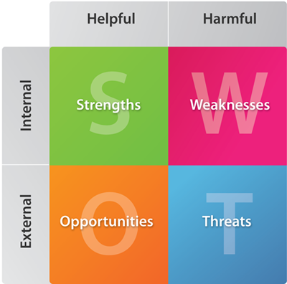A SWOT analysis can be used as part of the decision making process.

This will highlight the businesses:

* Strengths
* Weaknesses
* Opportunities
* Threats

|  |  |  |  |
| --- | --- | --- | --- |
| **Strengths**  **(Internal)** | **Weaknesses**  **(Internal)** | **Opportunities**  **(External)** | **Threats**  **(External)** |
| What the business is good at that may help and **can build on**? | What the business is currently **needing to improve on**? | Factors outside the business that the business should **take advantage of** and **exploit**. | Factors outside the business that **may harm** and they **need to minimise**. |

**Features of a SWOT analysis**

* Usually shown in a **grid**.
* **Bullet points** under each heading are quick, easy and effective.
* **Identify** strengths, weaknesses, opportunities and threats.
* **Build on** strengths, **minimise** weaknesses, **grasp** opportunities and **avoid** or counter threats.
* **Conclusions** must be drawn and **justified** by the analysis.
* **Turn** threats into opportunities.
* **Turn** weaknesses into strengths.
* **Proactive** decision making rather than **reactive** decision making.

|  |  |
| --- | --- |
| **STRENGTHS**   * Availability of finance * Well-known brands or products * Good/ services that make profits * Products that are benchmarked in the market and competitors try to copy * Assets the business owns – large modern factory, modern technology or a retail outlet in a prime location * High quality staff and good staff morale | **WEAKNESSES**   * Lack of finance * Lack of technology * Poor customer reputation * Faulty products * Products or brands that are making losses * Assets that are in a state of despair such as a crumbling factory * Untrained staff or low staff morale |
| **OPPORTUNITIES**   * A competitor going bust so the business could take on its customers * A boom period in the economy that the business can exploit * Customer tastes and fashion falling in line with the organisations specialism * Government introducing favorable legislation * Advancement sin technology that the business could exploit.   I.e.: E-commerce | **THREATS**   * Competitors actions such as cheaper prices or higher quality product * A downturn in the economy such as a recession * Customer tastes and fashions changing away from what the business specialises in * Government introduction legislation that impacts badly on a business * Advancements in technology that could leave the business behind its rivals |

**SWOT Benefits**

* **No rash decisions** are made as time is taken to gather and analyse information.
* Decisions are **based on facts**.
* **Time is taken** to think of alternative solutions to a problem.
* Ideas are enhanced by a logical process.
* Decisions are **proactive not reactive** which means they are more likely to be successful.
* Decisions allow an **organisation to build** on strengths, eliminate weaknesses, grasp opportunities or remove threats.
* Decision can be **evaluated** by using another SWOT analysis.

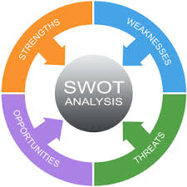

**SWOT Problems**

* A SWOT analysis is a **time consuming** process to carry out.
* Using a structured process may **stifle initiative and creativity**.
* After analysis, any **alternative solutions** may make **making a decision difficult**.

### POGASCIE Model

A structured decision making model allows for a manager to go through a number of stages in order to make a decision.

|  |  |  |
| --- | --- | --- |
|  | **Stage** | **Description** |
| **P** | Identify a **problem** | Identify the problem or issue to be resolved. |
| **O** | Identify the **objectives** | Establish what needs to be achieved. |
| **G** | **Gather** information | Gather from a variety of sources to aid decision making. |
| **A** | **Analyse** the information gathered | Look carefully and question the quality of the information that have been gathered. |
| **D** | **Devise** possible solutions | Create a list of possible solutions to the problem or issue. |
| **S** | **Select** the best option | Choose the best solution to the problem. Internal and external factors might impact on the decision being made. |
| **C** | **Communicate** the decisions | Let stakeholders know of the decision that has been made. |
| **I** | **Implement** the decision | Take action to put into practice the solution that has been chosen. |
| **E** | **Evaluate** the effectiveness of the decision | Consider how successful the decision has been. Changes might need to be made once the decision has been evaluated. |

|  |  |
| --- | --- |
| **Benefits of using a structured decision making model** | **Problems with using a structured decision making model** |
| * **No quick decisions** are made because time is take to gather and then analyse the information which will prevent incorrect decisions from being made. * **Time is given** to think about and consider the range of options available and therefore better quality decision are made. * This may **enhance innovation**, motivation and responsiveness by allowing employees to be involved in the decision making process. This will help motivate employees in the workforce. * The **decision will be shared** with relevant stakeholders therefore ensuring all those who need to be aware of it are informed. * A **range of possible solutions** are devised from the relevant facts and information that has been gathered. This will allow for a variety of responses to be chosen from. | * It is a **time consuming process** to gather information and the time could have been better spent on a different task. * It might be **difficult to obtain good quality information** as it could be time-consuming and expensive. * The **impact of each solution** cannot be seen until it is implemented which could mean the wrong decision is made. * **Instinct and gut reactions** to a situation might be constrained because of the process that needs to be followed. This could stifle risk taking. |