**VALENTINE’S DAY IN FRANCE**

No one really knows how Valentines day originally came about or even who St Valentine really was - the Catholic church has three different St Valentines and in ancient Rome the 14th of February was marked as a holiday to honour the god Juno. Custom has it that in France and England Valentines day originally came to be held in mid February because this was the time of year that birds and animals started pairing off and mating. Eventually it became popular to exchange small tokens and love letters and so the day was born.  
  
An old Valentines day custom in France and now officially banned was called the "*une loterie d'amour*" or "drawing for love". This entailed [single people](http://www.lost-in-france.com/diary-dates/405-valentines-day-in-france) of all ages entering houses that faced opposite each other and calling out through the windows till eventually they paired off with each other. The male suitor if not particularly attracted to his partner would leave her and the women left single would build a large bonfire and ceremoniously burn images of the men that had deserted them whilst simultaneously hurling abuse and curses at the ungrateful men. Though this was probably very therapeutic for the rejected women inevitably it was a practice that soon became out of hand and was eventually banned by the French government.  
  
In France Valentines cards are called *cartes d'amities*, the first recorded Valentines greeting was supposed to have been sent by the Duke of Orleans, a Frenchman who was held prisoner in the Tower of London after his capture at the Battle of Agincourt in 1415. During his imprisonment the young duke is said to have sent poems & love letters to his wife in France.  
It is also traditional for religious pilgrims in France to travel to St Valentin a pretty village in Indre that is named after St Valentine. These days the village holds many events and ceremonies dedicated to Valentines day including marriage vow renewals.

**FRENCH LOVE PHRASES**

|  |  |
| --- | --- |
| **French Phrase** | **Meaning in English** |
| Je t'aime | *I love you.* |
| Tu es ma joie de vivre. | *You are the joy of my life.* |
| Je t'adore | *I adore you.* |
| Tu es mon amour. | *You are my love.* |
| Amour de ma vie. | *Love of my life* |
| Tu es mon homme/ma femme | *You are my man/woman.* |
| Tes yeux, j'en rêve jour et nuit. | *I dream about your eyes day and night.* |
| Je veux être avec toi. | *I want to be with you.* |

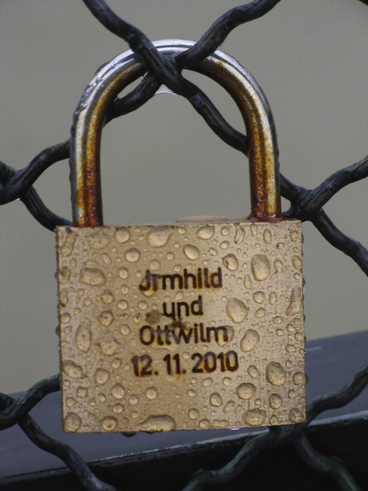 

 [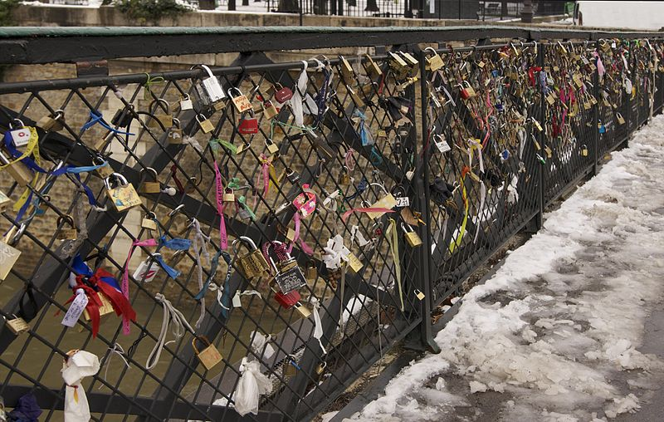](http://upload.wikimedia.org/wikipedia/commons/b/b4/Love_padlocks_Paris_pont_archev%C3%AAch%C3%A9.jpg)

Ah, l’amour, toujours l’amour. Just imagine the perfect Valentine’s Day, you and your “amoureux” in Paris to follow a recent, most romantic tradition: Snapping a padlock – symbol of your undying love, engraved with your names – to the rails lining the beautiful Pont des Arts, just in front of the picturesque Louvre Museum. The love padlocks, called ‘cadenas d’amour’, multiplied until there were more than 2,000 love tokens on the bridge, each one with an engraved message of love. After locking the love padlock onto the fence, the lovers tossed the keys into the Seine river – a sign of their eternal love.

C:\Users\Eleanor\AppData\Local\Microsoft\Windows\Temporary Internet Files\Content.IE5\P4J8W8K1\MC900034390[1].wmf