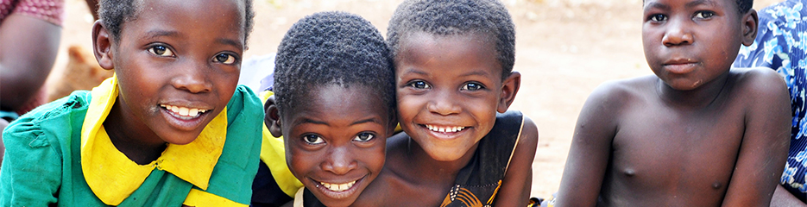
Aiming Higher in Malawi

Transforming the health and education of girls and disabled children in the poverty-stricken third world country.

www.justgiving.com/crowdfunding/
braidhurst-in-malawi
All donations welcome
Information Booklet
Braidhurst High School
J.Young
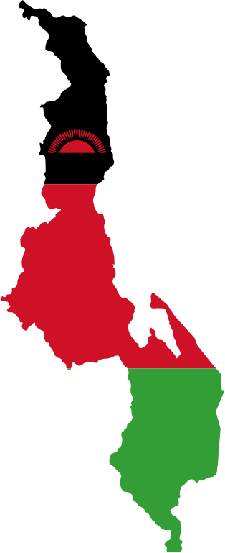
About Malawi
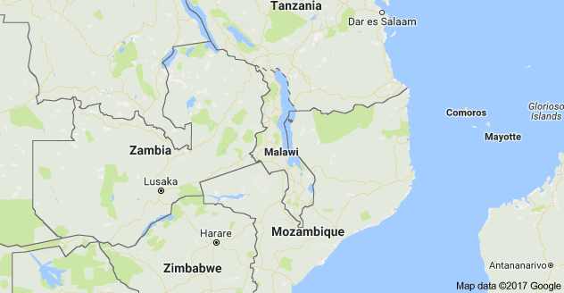
Malawi is a sub-Saharan land locked country located between Zambia, Tanzania and Mozambique. Known as 'the warm heart of Africa', Malawi has been recognised as one of the poorest countries in the world.

Capital: Lilongwe.
Official currency used: Kwacha.
Main languages: English and Chichewa, (spoken by 52% of the population).
Main Industries in Malawi: Tea, tobacco, sugar, sawmill products, cement, consumer goods, tobacco, sugarcane, cotton, tea, corn, potatoes, cassava (tapioca), sorghum, pulses, cattle, goats.
Main Trading Partners: US, South Africa, Germany, Japan, Zimbabwe, UK.
Population: 17.2million (2015 World Bank), growing at 3.1% per year
- 0 – 14 years old = 45%
- 15 – 64 years old = 52%
- 65+ years old = 3%
Life expectancy at birth: Females – 62 years
Males – 60 years
48% of children in Malawi are chronically malnourished.
42% of the population are illiterate.
1% of the population go to University.
Malawi has two distinct seasons: a wet, warm season and a dryer, cooler season. The wet, rainy season runs from October to April, while the dry season runs from May to September.
Individuals using the Internet in 2014 (%): 5.8% (estimate)
7% of the population have electricity.
Malawi has competed at eight Olympics but never won a medal. At the Commonwealth Games, it won three bronze medals, all for boxing.

‘Aiming Higher in Malawi’
The Project
‘Aiming Higher in Malawi’ is a North Lanarkshire endorsed project which was founded in 2004. Since its first development, the project has flourished momentously with many organisations, individuals and schools donating and fundraising to help change the educational lives of young children in Malawi, Africa.

Our Focus
The ‘Aiming Higher in Malawi’ charity project currently has the ambition to help to transform the health and education of girls and disabled children in the poverty-stricken third world country.

Previous Developments
Each year, the charity organises school visits for teachers, pupils, lecturers and sports coaches involved in many programmes, including:
- setting up libraries;
- creating a science laboratory;
- promoting HIV/AIDS prevention;
- photography classes;
- business enterprise lessons;
- a drama and music group;
- organising fun activities including choral lessons and rugby clubs.

The project aims to help empower the young people, in particular girls and disadvantaged disabled children in the region, to stop negative social attitudes, end harmful traditional practices and support inclusive educational opportunities.
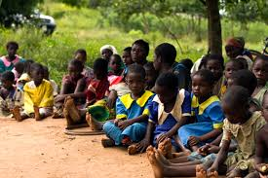
Making a Difference…
Malawi is one of the poorest countries in the world and the majority of children in Malawi do not complete their full education. We at Braidhurst want to help facilitate change.
Education
Most primary schools in Malawi are under-resourced, under-staffed and under-funded, creating extremely challenging teaching and learning conditions for students and teachers alike. Enrolment and attendance is a huge problem, especially for girls, across the whole country:
- Around one in ten primary-age children are not enrolled at school
- 45% of girls attend primary school
- 33% of girls attend secondary school

In Malawi, the quality of education has reduced
- 150+ students per class in some schools.
- National shortage of classrooms and qualified teachers to deal with huge increase in students.
- School buildings and teaching resources are very basic.
- There are limited resources available for students to use.
- Students are forced to do tests in English when they learn in their local language.
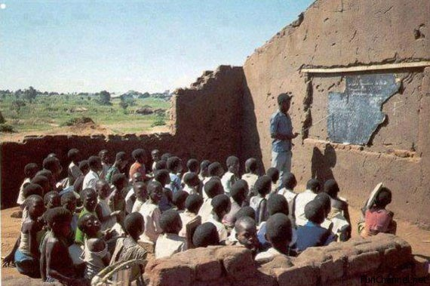
- Many students learn outside, making it impossible during the rainy season which discourages pupils to attend.
- Often three to four students share a one person desk.
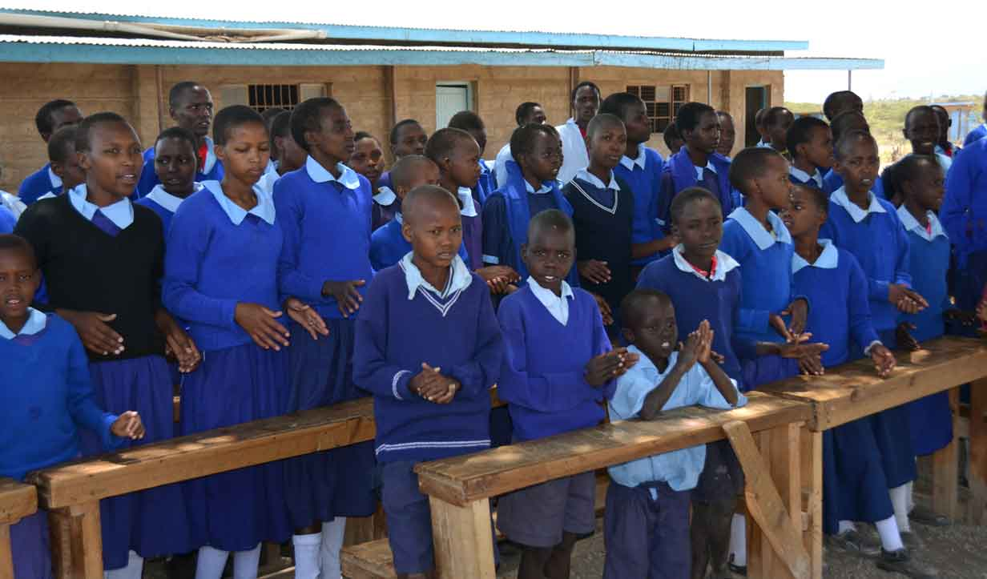
- It is extremely unusual for primary schools to have access to electricity.

We want to help to:-
- Allow all young people in Malawi the opportunity to reach their potential.
- Provide an opportunity for all pupils to be educated.
- Enrich pupil experiences by delivering CPD to local teachers.
- Improve equipment and facilities for learners.
Braidhurst
& Malawi
We are looking to join this programme and create a direct link to a Malawian school where we will work alongside them to improve the attendance and quality of education. In order to do so, we plan to do the following:
- Partnership
We will create a partnership with a school in Mulanje, a small area of Malawi. Alongside other North Lanarkshire schools, we will aim to build strong links through constant communication with the objective to develop a good working relationship.

- Employ an attendance officer
In aim to boost the attendance of girls in our school, we will employ a female attendance officer who will travel the local area and encourage young girls to attend. Transport, probably in the form of a bicycle, may also be provided. This role will be carried out by an ex-pupil of the school, a female who made it through primary and secondary and is thought to be a ‘role model’ to young girls of the community.
- Fundraising: The ’Malawi Committee’
Raising funds is key in order to send educational resources to our Malawian school and also to send some of our pupils out to visit. A committee will therefore be set up, meeting one lunch-time every two weeks, to develop ideas and organise fundraising events. We are inviting anyone in S1-6 to join and become involved in the whole school initiative.
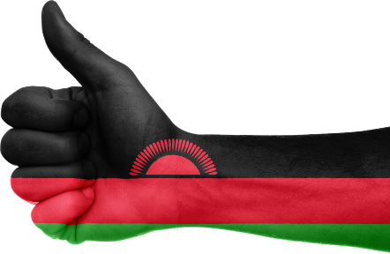
- Educational Visit to Malawi
We have the opportunity through fundraising to send several pupils to Malawi in June 2018.
The visit involves:
- Fundraising of £1750 per child
- carried out within and out with school
- Fly to Malawi in June 2018 for roughly 10 days
- In return of the visit, pupils will creating a power point of their experiences and deliver this to the school.
The Experience
Qualities and Skills
There will be a magnitude of skills and qualities that pupils will be given the chance to express and develop throughout the project. These include:
Compassion Patience Confidence Accountability Trust
Creativity Leadership Ownership Self-Reliance
Compliance Persistence Vision Determination Positive Attitudes

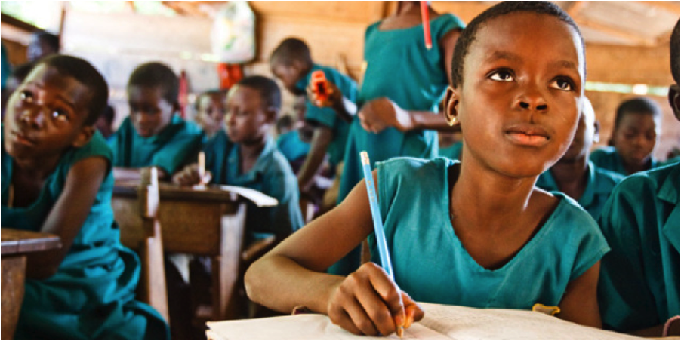

The Educational Experience
Being involved in this programme, pupils have the opportunity to:
- Develop interpersonal skills
- Become leaders in their own learning
- Take responsibility for themselves and others
- Develop their communication skills through; committee meetings, fundraising events, contacting the Malawian school and their general involvement in the project.
- Build relationships with peers and members of the community
- Develop a sense of ownership
- Cultivate an inclusive ethos
- Set targets and maximise efforts to reach each target
- Work within a motivating environment
And lastly, our pupils will have the opportunity make a change in someone else’s life by helping to develop a safe, healthy and educational experience at school.
Fundraising &
Next Steps
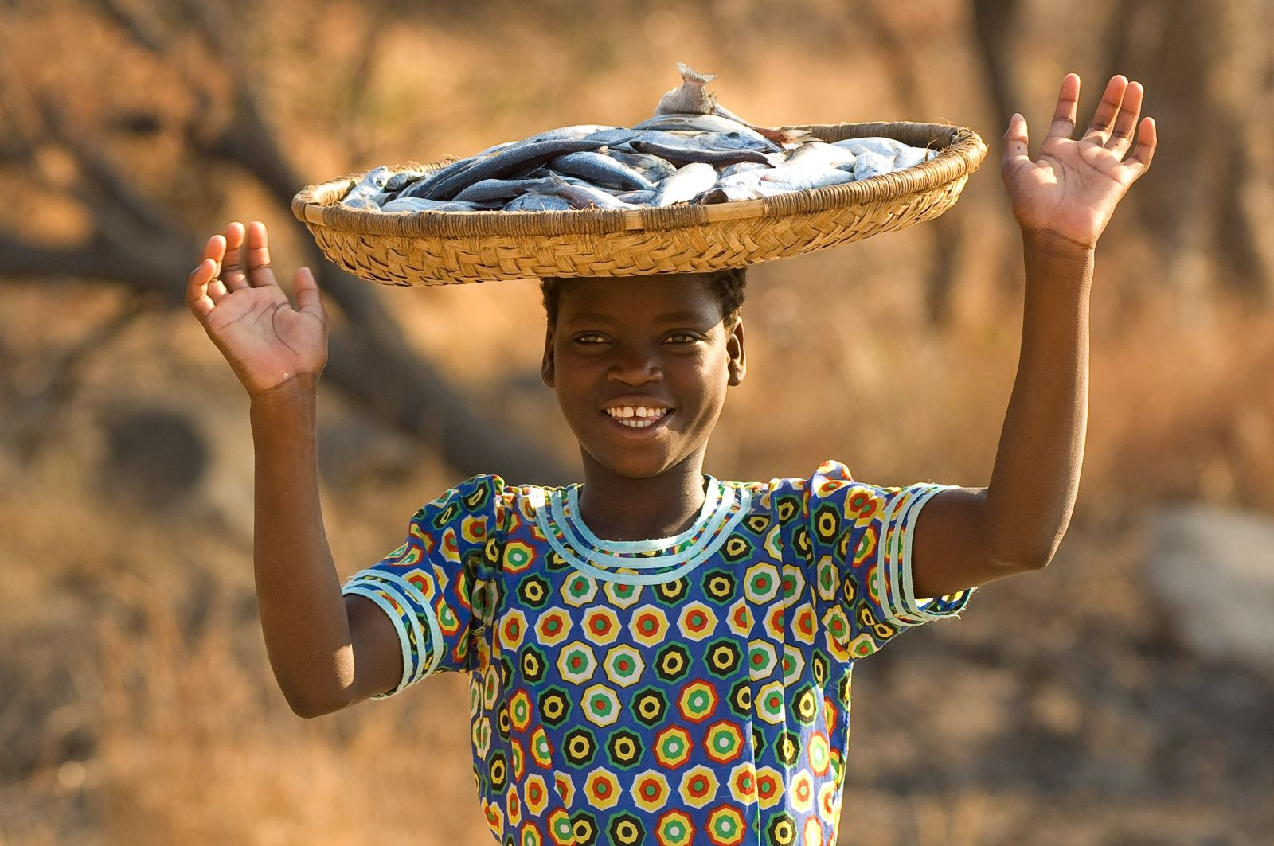
The ‘Malawi Committee’ will be set up in March and pupils will collate ideas and organise their first fundraising event by the end of March. Following this, there will be a fundraising event organised every month until the summer break. All pupils in the committee will be involved in setting targets for each fundraiser to contribute to the final sum (£) at the end of the school term. Anyone is welcome to join the committee even if they do not want to visit Malawi. Not everyone on the committee will be able to go.

Pupil Selection

S4 pupils who are interested in the project and would like to put their name forwards to join the committee, fundraise and visit Malawi should see Miss Young in the PE Department.
In order to help with the selection process, pupils will be required to demonstrate their commitment by participating in several fundraising events organised within school.
In June, all S4 pupils still interested will be required to write a ‘why me’ statement, indicating why they should be chosen to go to Malawi. In this should include why they would like to visit the school, what skills and qualities can they bring (as they have to deliver short sessions to our Malawian students) and what they would like to gain from the experience.
Lastly, pupils will be interviewed by Mrs Rooney (HT), Miss Young (PE Teacher), a member of staff from another school and a pupil from another school who has visited Malawi.
Testimonials

Charles Fawcett, the ‘Aiming Higher in Malawi’ project manager

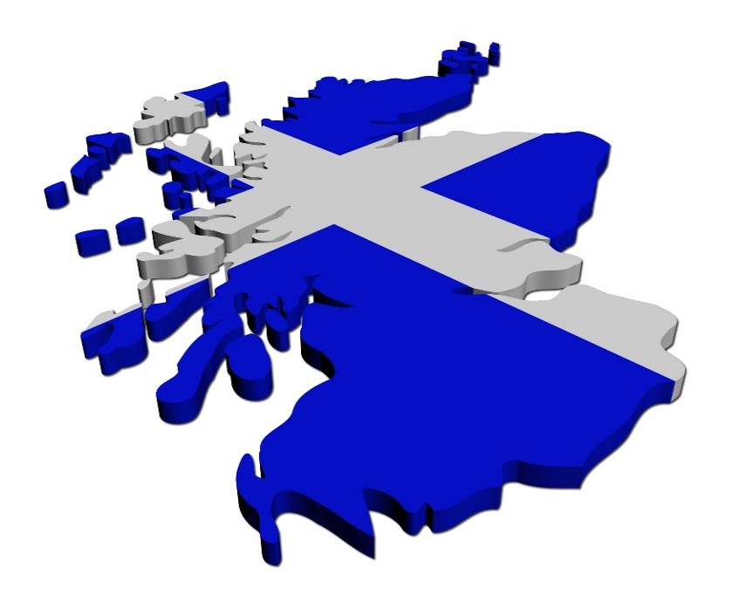
“The project makes a huge difference not only the girls' education, and disabled children but to the wider communities in Malawi tackling ongoing poverty and disease concerns.”

“Discrimination, harmful practices such as initiation ceremonies, female circumcision, forced early marriages, high infant mortality rates and discrimination seriously hamper the lives of many young disabled children and girls in Malawi.”

Jim Logue, Airdrie Councillor

“A moving and inspirational experience”
“Malawi is one of the most beautiful countries I have ever visited but the levels of hunger, poverty, destitution and HIV Aids made the visit extremely harrowing and humbling.”
"I saw schools with no desks, chairs or teaching materials, where classes of over 80 pupils were taught with all pupils sitting on concrete floors. Children as young as 5 walking bare-foot to school every day sometimes in excess of 5 miles, entire families who were all HIV positive including young infants.”

Just giving
We are aiming to raise £2000 though our just-giving page.
All donations welcome.
www.justgiving.com/crowdfunding/braidhurst-in-malawi

