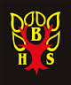

Information Skills

Information Skills

What are information skills?
This means being able to find, form an opinion on and present information.
When your teacher asks you to find out information you should work through these three simple steps:
Plan
Do
Review
Use the worksheets included below to help you complete each step.
Remember to ask your teacher for help or if you are in the library ask your school librarian Mrs Scott.

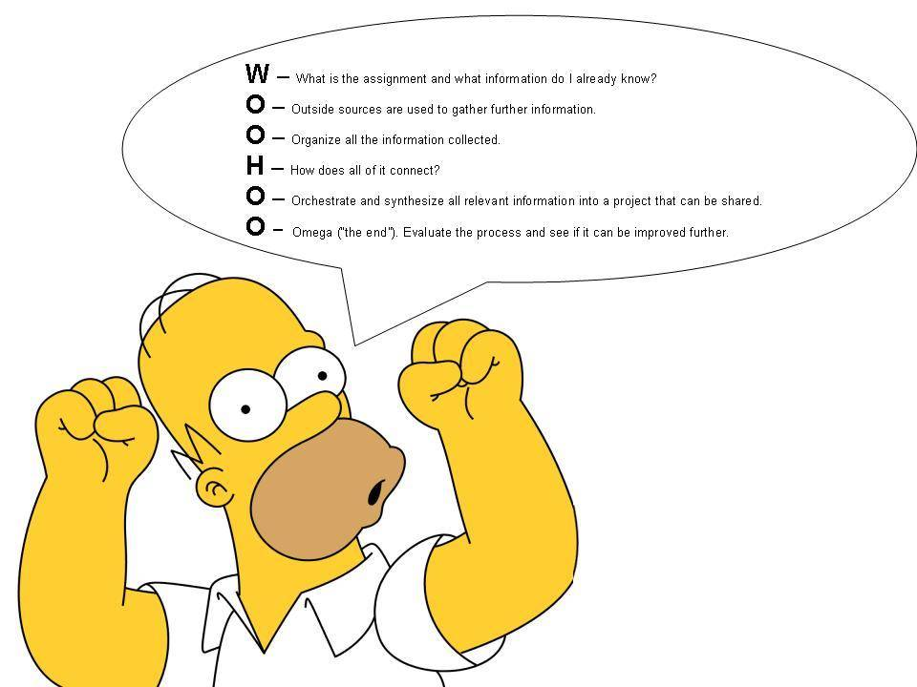

The Super3
The Super3 is a step by step plan used by pupils all over the world to carry out research. If you teacher asks you to find out about a topic as part of your course work or to answer a question for homework you can follow the Super3 steps which are:
- Plan - Before I start I will......

- Do - In order to finish the task I will.......

- Review - I will know I have finished my task when........

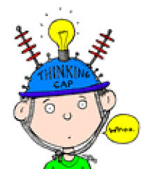

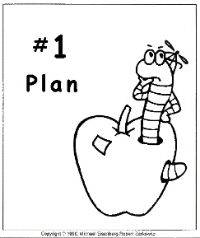
Super3 Worksheet 1

What am I supposed to do?
What will it look like if I do a really good job?
What do I need to find out to do to the job?

…………………………………………………………………………………………………………………………………………….
…………………………………………………………………………………………………………………………………………….
…………………………………………………………………………………………………………………………………………….
…………………………………………………………………………………………………………………………………………….
……………………………………………………………………………………………………………………………………………..
…………………………………………………………………………………………………………………………………………….

Super3 Worksheet 2

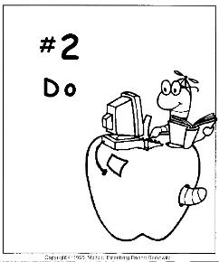
Where can I find what I’m looking for?
Is this good information?
What will my finished piece of work look like?

………………………………………………………………………………………………….
…………………………………………………………………………………………………..
…………………………………………………………………………………………………..
……………………………………………………………………………………………………
…………………………………………………………………………………………………..
…………………………………………………………………………………………………..

Super3 Worksheet 3

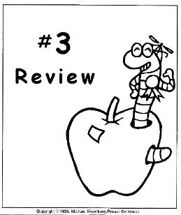
Did I do what I was supposed to do?
Do I feel ok about this?
Should I do something else before I hand it in to my teacher?

…………………………………………………………………………………………………………
…………………………………………………………………………………………………………
………………………………………………………………………………………………………….
………………………………………………………………………………………………………….
………………………………………………………………………………………………………….
…………………………………………………………………………………………………………..
………………………………………………………………………………………………………….

Finding Your Book

To help you find a non-fiction book in the school library get to know the ‘Dewey Decimal System’.

Remember a non-fiction book only has facts inside.

Dewey Decimal numbers are special numbers given to non-fiction books in all libraries across the world including your school library.

Books are grouped together by topic:

000 – Computers, Information and General Works
(Computers, the Internet, Encyclopaedias)

100 – Philosophy and Psychology
(Astrology, Dreams and Ghosts)

200 – Religion
(Religious Education, World Religion)

300 – Social Sciences
(Environment, Fairy Tales, Governments)

400 – Language
(Dictionaries, Foreign Languages, Sign Language)

500 – Science
(Astronomy, Nature, Maths)

600 – Technology
(Inventions, Human Body, Cooking)

700 – Arts and Recreation
(Arts and Crafts, Music, Sport)

800 – Literature
(Plays, Poetry, Humour)

900 – History and Geography
(Travel, Biography, Genealogy)

Bibliography / Plagiarism

Once you have finished your research and written up your final piece of work remember to include a bibliography. This is normally the last page.

A bibliography is a list of the books and websites you used to find facts.

Get into the habit of noting down the name and author of the books and websites you use as you go.

On the next page you will find a table to help you do this – one for books and one for websites.

It is also important that you use your own words when writing up your final piece of work rather than copying the words you find in your book or online.

This is called plagiarism and is a form of cheating. You risk failing if you plagiarise. Please be aware of this.

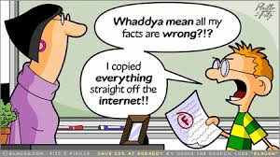

BOOK -
Author Name  (SURNAME, Initials) | Book Title  (Italicised or Underlined)

WEBSITE -
Title of Website  (Italicised or underlined) | Available From  (URL) | [Accessed: followed by date]  In square brackets

