Guitar Hero Instructions

Searching for Flights
Visit the website www.travelsupermarket.com.
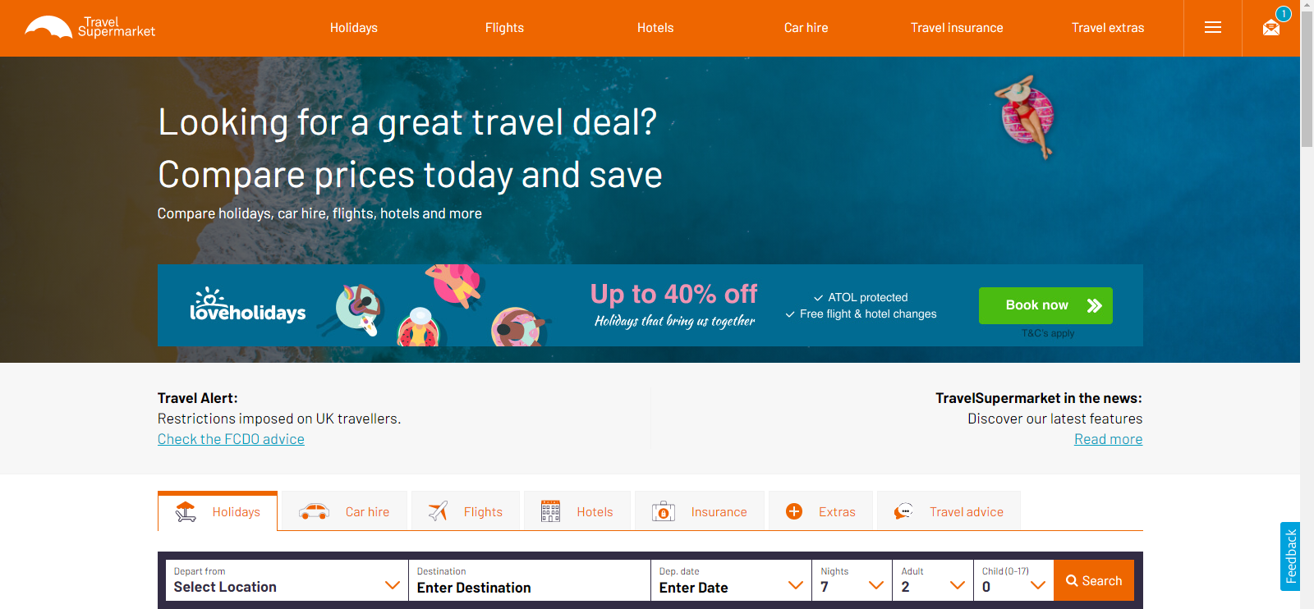
Click on the Flights option.
Click on the Return option and select One Way.
You should now have five boxes as shown below. Four white boxes and one orange box.
In the first box, type in the name of the city that you are flying from. You will see a list of airports that you can choose from. Make sure you select the first option.
Leave the second box the way that it is shown.
In the third box, type in the name of the city that you are flying to. Again, select the first option.
In the fourth box, select the date that you are flying on.
Once you have followed these steps, click on the orange box.
You will now see a list of flights that match your search.
From the search results you can find the time of the flight departure and arrival, the price of the flight and the airline.

Searching For Stadiums
Visit the website www.worldstadiums.com.
From the menu at the top left, select the area your city belongs to.
Then, choose the country your city belongs to.
Finally, you will be able to see a list of stadiums in this country. Make sure you use one which is in the city you have chosen!

