World Tour Instructions

Searching for 5-star hotels
Visit the website www.trivago.com.
In this box, type in the name of the city you want to search hotels for e.g. New York.
The check in date means the date you will arrive at the hotel. Make sure you select a date that is at least a month from today’s date.
The check out date means the date you will leave the hotel. Make sure you select the date that is one day after the check in date you chose e.g. if you chose 15th May for a check in date, then choose 16th May for a check out date.
You can leave the “1 Room 2 Guests” box the way that it is.
Click Search and you will see a list of hotels to choose from.
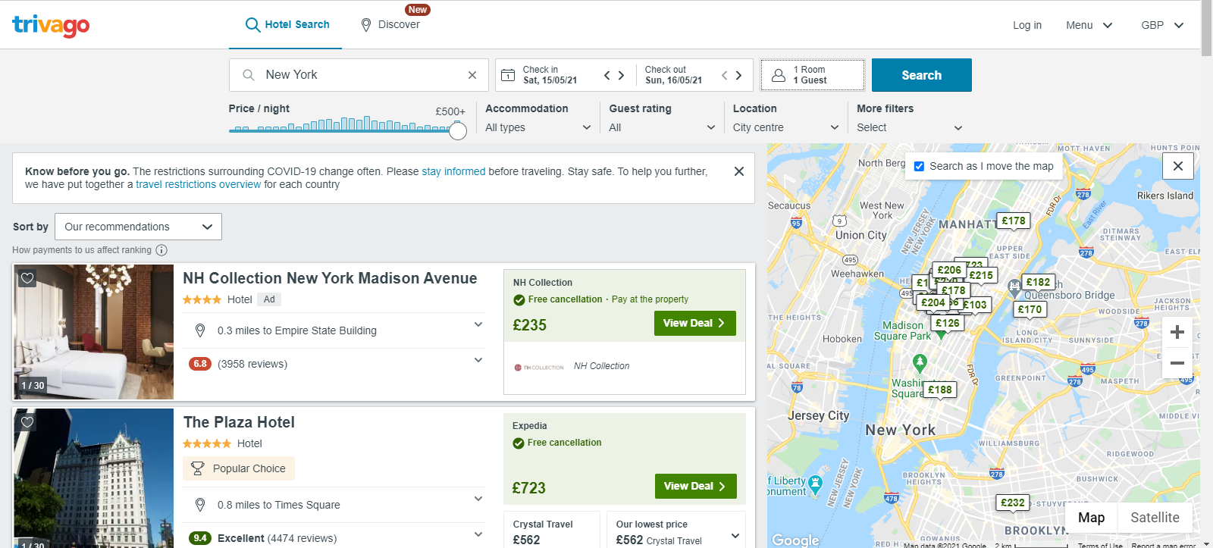
In order to find 5-star hotels only, click on the Accommodation box.

The box below show now appear.
Click on the 5-star symbol and then Done.
You will now see all of the results for 5-star hotels in your chosen city.
From the search results you can find the name of the hotel, price of the stay and view the photo album of the hotel.

Searching For Nearby Airports
Visit the website www.google.co.uk.
Type in “Airports in …” and the name of the city you want to search for e.g. “Airports in London”
From the list that appears, choose any airport type it into the box in your document.

