Negative Binary Numbers Task
At National 5 we only used positive integers. Most numbering systems have both positive and negative numbers therefore we need a method of representing these. This is known as Two’s Complement.

In Two’s complement, the most significant bit (the leftmost bit) indicates whether the number is positive or negative. If the most significant bit is a 1 then it is a negative number, if it is a 0 then it is positive.

If we were using 8-bits then using two’s complement we would know Example 1 is a positive number (because the leftmost bit is a 0) and Example 2 is a negative number (because the leftmost bit is a 1).

128
64
32
16
8
4
2
1
0
0
1
0
0
0
0
0
Example 1
128
64
32
16
8
4
2
1
1
1
1
0
1
1
1
1
Example 2

How to convert binary numbers to denary numbers?
METHOD 1
Negative binary numbers are represented in the following way:
-128 | 64 | 32 | 16 | 8 | 4 | 2 | 1
1 | 0 | 0 | 1 | 1 | 1 | 0 | 0

The example above is the denary number -100. A zero means that the number above will NOT be added. A one means that the number will be added. So, -128 + 16 + 8 + 4 = -100.
Notice that the first number is no longer 128 but -128. This indicates whether or not the number will be a negative number. So if the first number is a 1, it will be a negative number. If the first number if a 0, it will be a positive number.
EXERCISE 1
Try the following examples:
-128 | 64 | 32 | 16 | 8 | 4 | 2 | 1 |  | Ans 1
1 | 0 | 0 | 0 | 0 | 1 | 1 | 1

-128 | 64 | 32 | 16 | 8 | 4 | 2 | 1 |  | Ans 2
1 | 1 | 1 | 1 | 0 | 0 | 0 | 1

-128 | 64 | 32 | 16 | 8 | 4 | 2 | 1 |  | Ans 3
1 | 0 | 0 | 0 | 0 | 1 | 0 | 1

-128 | 64 | 32 | 16 | 8 | 4 | 2 | 1 |  | Ans 4
1 | 0 | 1 | 1 | 1 | 0 | 0 | 0

-128 | 64 | 32 | 16 | 8 | 4 | 2 | 1 |  | Ans 5
1 | 1 | 1 | 1 | 0 | 0 | 1 | 1

METHOD 2
Method 1 works well for 8-bit binary numbers, but what if we have more bits?
Let’s look at an example past paper question below.
Convert the following 16-bit two’s complement number into denary.

1111 1110 1110 1011

Method 1 isn’t a good option to use here. An easier method is to:
- Flip all of the bits
- Add 1 to the number
Flip the bits means 1 becomes 0 and 0 becomes 1.
So 1111 1110 1110 1011 flipped looks like:
0000 0001 0001 0100
Remember, we need to add one. So we are now left with:
0000 0001 0001 0101
We can ignore the first seven 0s, and that gives us the number 1 0001 0101.
256 | 128 | 64 | 32 | 16 | 8 | 4 | 2 | 1 |  | Ans
1 | 0 | 0 | 0 | 1 | 0 | 1 | 0 | 1 |  | 277

The last thing we have to do is look at the original number (1111 1110 1110 1011). As this number started with a 1, we need to remember to make the number negative. So the answer is -277.
EXERCISE 2
Try the following examples:
1. 1111 1110 0010 1011
2. 1111 1110 1110 1001
3. 1111 1110 1010 1011
4. 1110 1000 1011
5. 1111 1111 1111 1110 0000 1011

How to convert denary numbers to binary numbers?
To convert a negative denary number into its two complement representation you:
- work out the positive binary number
- invert all the bits (so a 1 becomes a 0 and a 0 becomes a 1)
- then add 1.
To show how -5 would be represented as an 8-bit binary number:
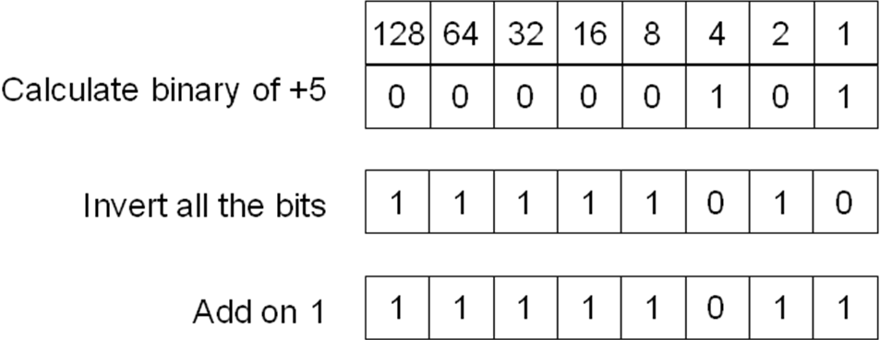
Therefore the two’s complement representation of -5 would be 11111011.
EXERCISE 3
Try the following examples:
1. -100
2. -30
3. -77
4. -81
5. -200 (Careful with this one, an extra bit is needed)

