Higher Computing Science Questions

1. A database table may have a compound key. State what is meant by the term **compound** key. (1)

2. A teacher creates a folder for pupil homework on the school network server. Pupils are able to save files to this folder but only the teacher can edit and save files in this folder.

Describe how this is implemented. (2)

3. A crèche administrator uses a database to add and edit child details. A child can have dietary requirements which are none, vegetarian, vegan and other (see notes). The administrator edits the details of a child using the form shown.



Describe **two** ways to improve the **usability** of this form. (2)

4. Web site owners use checks to ensure that users are real humans when they leave comments.

One method of achieving this is shown below.



Validation of the code entered requires a script. Explain why this script would require **server-side** processing, rather than client-side processing. (2)

5. Describe **two** benefits of **open source** software when compared to **proprietary** software. (2)

6. Anna is a beta tester for a new computer game.

a) State **when** beta testing would be placed in the development of a product. (1)

b) Describe **two** benefits of involving the **end-users** in beta testing. (2)

7. Abu was searching for "oak tables” on one web site. Since doing this, when he visits other web sites, he now frequently sees adverts for oak tables.

a) State how this is possible. (1)

b) Explain a **concern** that Abu may have with this technology. (1)

8. Two audio files are created from the same recording. One file uses perceptual coding and the other file makes use of FLAC.

a) State which of these techniques will result in a **higher** quality audio file most like the original recording. (1)

b) Both of these techniques are used to compress audio data. Compression can be lossless or lossy.

Describe how **lossless** and **lossy** compression are used to reduce the size of a file. (2)

9. Describe the role of a **server** in web hosting. (1)

10. Tables can be related by different types of relationships. State the **cardinality** between the two tables in each case below.

a) Train journeys and People (1)

b) Drivers and Cars in a grand prix (1)

11. The web page below has been created using Cascading Style Sheets (CSS).



a) Describe the purpose of **Cascading Style Sheets**. (1)

b) The code below is included in the HTML of a web page to link to an external style sheet:

|  |
| --- |
| <link rel="stylesheet" type="text/css" href="styles.css"/> |

(i) Explain the **difference** between an external and an internal style sheet. (2)

(ii) Explain **one** benefit of using an **external** style sheet. (1)

c) Describe **where** in the HTML code the link to the external style sheet would be placed. (1)

d) Describe the **purpose** of this line of HTML code used in this web page: (2)

|  |
| --- |
| <div id="content"> |

e) This webpage is categorised as a static webpage. Many users have said that it could be improved by having some dynamic content.

(i) Describe an example of **dynamic** content that could be added to this webpage. (1)

(ii) A dynamic website can contain client-side scripting or server-side scripting to generate the changing content. Describe **one** difference between client-side scripting and server-side scripting. (2)

f) For security the company makes use of a digital certificate on their web site.

Explain how the use of a **digital certificate** would reassure users when using a web site. (2)

12. Jason is an App developer. He has recently created an App for mobile devices which allows users to identify the logos of well-known brands. The home screen of this App is shown below.



a) Describe the **type of user** Jason has designed this App for. Justify your answer. (2)

b) (i) Name the type of **input device** that would be best used with this app. Justify your answer. (2)

(ii) Describe a **disadvantage** of this type of input device. (1)

c) The mobile device uses solid state storage to store the app.

(i) State **two** reasons why **solid state** storage is used to store the app. (2)

(ii) While developing the app, Jason used cloud storage to store the app file. Explain why Jason used **cloud** storage to store the app during development. (2)

d) Jason decides to create his own business and employ other workers. Security is an important issue for businesses. To improve security businesses often consider migrating to a hybrid cloud.

(i) Describe what is meant by a **hybrid** cloud. (1)

(ii) State **one** advantage for a business of switching to a hybrid cloud. (1)

e) Keylogging software is often downloaded onto a computer without the user’s knowledge and poses a serious threat to the computer system.

(i) Describe the term “**Keylogging**”. (1)

(ii) Explain what a user should do to try to **prevent** Keylogging. (1)

13. Krazy Karts is a company which organises go-kart driver training and races. Customers can book a course of training sessions with a trainer. At the end of each session each customer in the session races against the others and the trainer records the finishing positions each week. All the information for the company is held in a database with the following tables and fields.

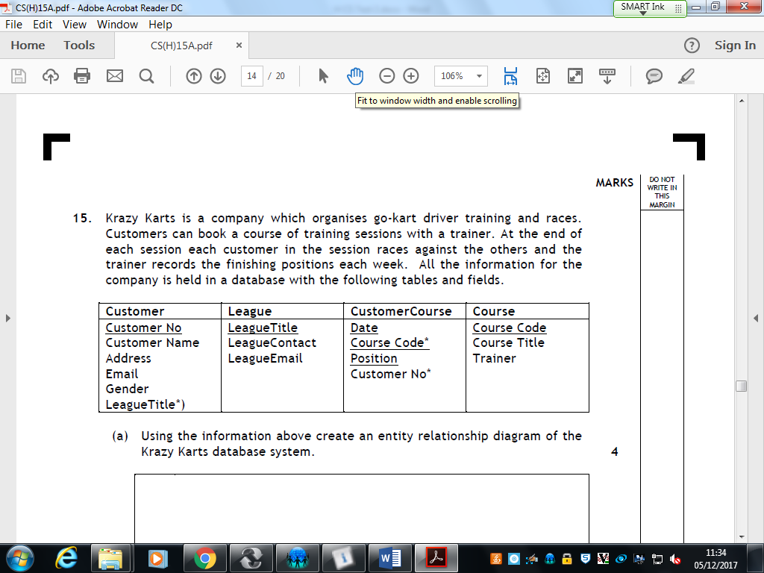

a) Using the information above create an **entity relationship diagram** of the Krazy Karts database system. (4)

b) The following report is produced for the system.

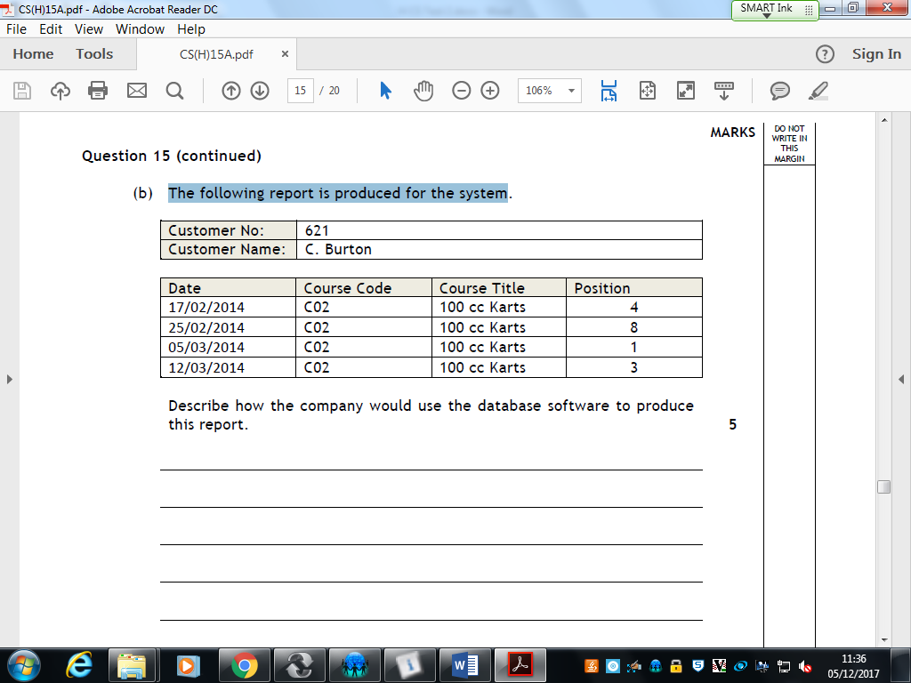

Describe how the company would use the database software to produce this **report**. (5)

c) Krazy Karts are environmentally friendly and use lifetime carbon footprint when considering their impact on the environment.

Describe what is meant by “**lifetime carbon footprint**” in relation to computer systems. (2)

d) Krazy Karts must conform with the requirements of the **Regulation of Investigatory Powers Act** (RIPA). State **two** responsibilities, detailed in this act, for the employer. (2)