Q | Answer | Marks
1a | Last stage of testing prior to release. | 1
1b | Any two of the following  • software can be tested on their own systems  • software can be tested on eventual users  • provide feedback to software development company • client needs to agree that software meets their needs before accepting/paying for it | 2
2 | H3 {  font-family : Tahoma;  font-size : 16px;  color : red;  font-weight : bold  }  Acceptable alternatives to H3:  .subheading { rules }  OR  #subheading1 {rules} | 3
3a | Any two of the following:  • walker and walk  • dog and walk  • owner and dog | 2
3b | 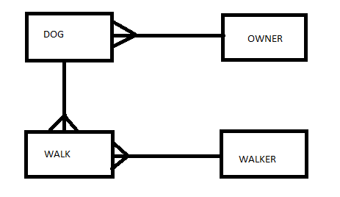 | 4
3c | • make the gender/walks well with others options Boolean with a male/female and yes/no buttons  • create drop down lists for Dog type and Owner ID | 2
3d | Create a query with the following fields:  • Walker.walker name and criteria = “Susan”  • Dog.dogname  • Dog.dogtype  • Dog.walks well with others  • Owner.owner address  And then create a report using the data from the query. | 5
4 | There is no one field that can be used as a unique identifier so multiple fields need to be selected. | 1
5a | Any two of the following  • updating centrally held data/data sources is not possible with client side scripting  • validation cannot be disabled if it is handled at the server  • can query SQL using PHP  • less security issues as data is managed at server  Or any other valid response. | 2
5b | Any two of the following  • allows multiple uses to share, edit and save files/folders  • accessible via the internet from any device  • accessible via internet from any location | 2
5c i | ISPs must implement technical systems for the storing and interception of information that may be requested by government. | 1
5c ii | Encryption is becoming more sophisticated/difficult to decrypt, etc (1 mark), requiring the cooperation of the individual to provide keys/information in order to decrypt (1 mark). | 2
6a | Perceptual Coding (1 mark) removes sounds or frequencies that cannot be heard by humans (1 mark). | 2
6b | Free Audio Lossless Coding (FLAC) (1 mark) attempts to predict frequency of future samples and using rice encoding (1 mark) | 2
7 | text files that contain information about browsing habits (1 mark) but can be designed to send as much data as possible to external servers/third parties (1 mark) | 2
8 | - Can make use of public cloud services to expand storage capabilities  - Can make use of private cloud to store essential / classified data  - Can make use of private cloud to retain control over security and maintenance | 2
9a | Any two from  - Touch screen  - Microphone  - Camera | 2
9b | Any two from  - Headphones  - Speakers  - Screen | 2
9c | No moving parts (1 mark) which makes them more robust (1 mark) | 2
10a | Novice (1 mark) because it is a simple user interface which requires no previous experience to use. (1 mark) | 2
10b | • Remote access to control heating when not at home  • Use of geolocation can automatically turn heating off when no one is home  • Takes account of external weather forecast and adjusts temperature accordingly  • Real time temperature monitoring through mobile devices can reduce unnecessary gas/fuel use  • Data can be analysed to determine how quickly a home heats and how slowly it loses heat meaning that the boiler can be used more efficiently  • Multi room control systems prevent rooms being overheated when not in use | 2
11 | Manufacture – resources used to produce the device eg finite materials  Use – electricity and energy that the device requires to function  Disposal – harmful gases that could be released into the atmosphere eg toxic chemicals | 2
12 | • Pupils have read only access to this folder (1)  • Teachers have read/write access to this folder (1) | 2

