Pseudocode Questions
1. A countdown timer on a website is created to give a user 60 seconds to enter his or her passcode before it automatically blocks the user from access the site.
The code for the timer is shown below.
Line 1. SET time to 0
Line 2. REPEAT
Line 3. WAIT 1 seconds
Line 4. SET total_time to total_time +1
Line 5. UNTIL total_time = 60
Line 6. SEND [“Time to enter has now expired”] to DISPLAY

(a) The program stops when time is equal to 60. The design is changed to include a warning message when the time is more than 45.
Use pseudocode or a programming language you are familiar with to show how this additional feature could be implemented. (3)

(b) This screenshot shows the interface used to enter a user’s passcode.
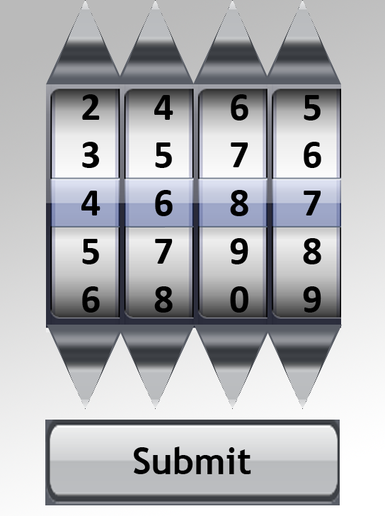
When the submit button is clicked the highlighted numbers are read into an array called usercode. This has to be matched with the passcode which is stored in an array called passcode.
Write below, using pseudocode or a language you are familiar with, code that would display the message “Unlocked” when the array elements in ‘usercode’ are equal to the equivalent elements in ‘passcode’. (3)

2. Paul is a student and has written a program to record how much he studies each day in the 30 days before his exams start. Each day he enters a value for the total number of hours used for study that day. Each of these values is stored in an array called ‘hours’.

(a) Using pseudocode or a programming language of your choice, write a short program which will tell Paul the average number of hours he studied over the 30 days. (3)
(b) The pseudocode shown below shows how the hours are entered.
Line 1: REPEAT
Line 2: RECEIVE study_time FORM keyboard
Line 3: IF study_time < 0 OR study_time > 12 THEN
Line 4: SEND error message to display
LINE 5: END IF
LINE 6: UNTIL NOT (study_time < 0 OR study_time > 12)

Describe all of the events that will occur if Paul enters the value 15. (3)

3. A factory is equipped with sensors. These sensors use embedded technology to monitor levels of toxic gas in areas of the factory.
If the temperature in an area is above 20 degrees and the toxic level is above 50 then the vents are opened in that area of factory.
Line 1: RECEIVE temperature FROM real sensor
Line 2: RECEIVE toxic_level FROM real sensor
Line 3: RECEIVE factory_area FROM keyboard
Line 4: IF temperature > 20 OR toxic_level >50 THEN
Line 5: REPEAT
Line 6: SEND open vents TO vents
Line 7: SEND [ factory_area & “ has vents open”] to DISPLAY
Line 8: UNTIL temperature > 20
Line 9: END IF

The pseudocode above shows the design for the program. There are two errors in the logic of the program. Find and describe each error. (2)

4. Dorothy has just started programming and has created an algorithm to search the array miles which holds 100 numbers. Dorothy wishes to find the largest number in the array and has developed the following algorithm.
Line
1 SET max_value TO 0
2 SET counter TO 1
3 REPEAT
4 IF miles[counter] > max_value THEN
5 SET max_value TO miles[counter]
6 END IF
7 SET counter TO counter + 1
8 UNTIL counter = 101
9 SEND max_value TO DISPLAY
Dorothy could use a variable called max_position as part of this algorithm.
She inserts a line of code after line 2.
SET max_position TO 1

With reference to the line numbers shown, state additional lines of code Dorothy would add to the program if she wished to use this variable. (2)

5. [Higher Question] A function was developed using the following algorithm to determine a council tax band for any house value.
Line
1 SET taxband TO “-“
2 IF housevalue < 80000 THEN
3 SET taxband TO “E”
4 END IF
5 IF housevalue >= 80000 AND housevalue < 106000 THEN
6 SET taxband TO “F”
7 END IF
8 IF housevalue >= 106000 AND housevalue < 212000 THEN
9 SET taxband TO “G”
10 END IF
11 IF housevalue > 212000 THEN
12 SET taxband TO “H”
13 END IF
14 RETURN taxband

(a) Explain why this algorithm would return an incorrect taxband if the housevalue is 212000. (2)
(b) The developer of the function has said that the use of a series of IF statements is inefficient.
Using pseudocode or a language with which you are familiar, rewrite the algorithm to correct the error and make the code more efficient. (3)
(c) Danny works for HomeAdvice and is writing a program to calculate housevalue’s and provide information about council tax bands.
He has downloaded the corrected function, taxband, from the development server.
Danny’s program calculates the current housevalue by multiplying two variables: base_price and percentage_increase together. The program also stores the value of the taxband in a variable called band.
Using pseudocode or a language with which you are familiar, write an algorithm for a subroutine that will:
• Ask the user for the values for variables base_price and percentage_increase.
• Use the function to assign the variable band
• Display band on screen.
(3)

