 | FOR OFFICIAL USE
National
Qualifications
 |  |  |  |  |  |  |  |  |  |  |  |  |  |  |  |  |  |  |  |  |  | Mark
 | CS(N5)14A |  |  |  |  |  |  |  | Computing Science
 | Duration — 1 hour and 30 mins
 | Fill in these boxes and read what is printed below.
 | Full name of centre |  |  |  |  |  |  |  |  |  |  |  |  |  |  |  |  | Town
 | Forenames(s) |  |  |  |  |  |  |  |  |  | Surname |  |  |  |  |  |  |  |  |  |  |  |  |  |  | Number of seat
 | Date of birth
 | Day |  |  | Month |  |  | Year |  |  |  |  |  |  | Scottish candidate number
 | D | D |  | M | M |  | Y | Y
 | Total marks – 90
 | SECTION 1 – 20 marks
 | Attempt ALL questions in this section.
 | SECTION 2 – 70 marks
 | Attempt ALL questions in this section.
 | Read all questions carefully before attempting.
 | Write your answers in the spaces provided, using blue or black ink.
 | Show all workings.
 | Before leaving the examination room you must give this booklet to the invigilator. If you do not, you may lose all marks for this paper.
 | © 2013 Perfect Papers – All rights reserved

 |  |  |  |  |  | MARKS | DO NOT  WRITE IN  THIS  MARGIN
 |  |  |  | SECTION 1 – 20 marks
 |  |  |  | Attempt ALL questions
 |  | 1. |  | Convert the value 37 into an 8-bit binary number. Show your working. |  | 1
 |  | 2. |  | Name the bus used to select memory locations to be read from or written to by the processor. |  | 1
 |  | 3. |  | The pseudocode below shows how a program could store and process the top scores of the players in an online computer game.
 |  |  |  | Line 1. | SET topscores TO [1209, 1302, 1532, 1092, 1892, 1365, 2341, 2321, 1539, 1155]
 |  |  |  | Line 2. | SET high_score TO topscores [0]
 |  |  |  | Line 3. | FOREACH score FROM topscores DO
 |  |  |  | Line 4. | IF score > high_score THEN
 |  |  |  | Line 5. | SET high_score TO score
 |  |  |  | Line 6. | END IF
 |  |  |  | Line 7. | END FOREACH
 |  |  |  | Line 8. | SEND [“The top score is: “, high_score] TO DISPLAY
 |  |  |  | State the most suitable data structure and data type for storing the highlighted variable (topscores) used above. |  | 2

 |  |  |  |  | MARKS | DO NOT  WRITE IN  THIS  MARGIN
 |  | 4. |  | A web page can be found using the URL:
 |  |  |  | http://www.ednet.com/groups/national-5-computing-science/home.php
 |  |  |  | State the protocol being used by this URL. | 1
 |  | 5. |  | The following section of code is written in the programming language Ada.
while not Text_IO.End_Of_File loop
while not Text_IO.End_Of_Line loop
Text_IO.Get (Item=>Char);
if Char in Printable then
Counts (Char) := Counts (Char) + 1;
end if;
end loop;
Text_IO.Skip_Line;
end loop;
for I in Counts
if Counts(I) > 0 then
Text_IO.Put (I & ": ");
for J in 1 .. Counts(I) loop
Text_IO.Put ('*');
end loop;
Text_IO.New_Line;
end if;
end loop;
 |  |  |  | State two techniques that the programmer could use to make this code more readable. | 2

 |  |  |  |  | MARKS | DO NOT  WRITE IN  THIS  MARGIN
 |  | 6. |  | Explain why the data values TRUE and FALSE should be stored in a field of type Boolean rather than a field of type text. | 1
 |  | 7. |  | Companies must adhere to health and safety legislation for employees using computer systems regularly.
 |  |  |  | Adjustable blinds or curtains can reduce the amount of screen glare and reflections for users to prevent eyestrain.
 |  |  |  | Name one other workstation feature and describe how it reduces a risk to health. | 1
 |  | 8. |  | State where instructions and data are held within the processor after being transferred from memory. | 1
 |  | 9. |  | Describe the role of the client in a client/server network. | 1
 |  | 10. |  | Abergow Hospital has recently upgraded all the computer systems used by staff. They have arranged for the environmentally friendly disposal of the old equipment.  Describe one other issue that should be considered when disposing of the old equipment. | 1

 |  |  |  |  |  |  | MARKS | DO NOT  WRITE IN  THIS  MARGIN
 |  | 11. |  | Describe one typical feature of an operating system developed to support smartphones of the type shown. |  |  | 1
 |  | 12. |  | Face recognition is one example of biometrics that can be used to secure access to mobile devices.
 |  |  |  | Describe one benefit of face recognition for this purpose. |  |  | 1
 |  | 13. |  | A web site has been hacked and the usernames, email addresses and passwords of users have been stolen.
 |  |  |  | (a) | Describe how keylogging software may have been used in this hacking attack. |  | 1
 |  |  |  | (b) | Explain what users should do to protect their security after this hacking attack. |  | 1

 |  |  |  |  |  |  |  |  |  | MARKS |  | DO NOT  WRITE IN  THIS  MARGIN
 |  | 14. |  | Explain why JavaScript is required to validate data in a HTML form before it is submitted. |  |  |  |  |  | 2
 |  | 15. |  | Here is part of a database used to store information about meteor showers.
 |  | Name |  |  | Rate | Ascension | Dec | From comet | Observations
 |  | Quadrantids |  |  | 100 | 15h 28m | 50° | Unknown | Average speeds
 |  | Ursids |  |  | 5 | 14h 28m | 76° | Tuttle | Average speeds
 |  | Geminids |  |  | 1 | 7h 32m | 32° | Unknown | Average speeds
 |  | Kappa Cygnids |  |  | 10 | 19h 29m | 55° | Unknown | Bright, exploding fireballs
 |  | Kappa Cygnids |  |  | 10 | 19h 20m | 55° | Unknown | Bright, exploding fireballs
 |  | S.Iota Aquarids |  |  | 15 | 22h 32m | -15° | Unknown | Double radiant
 |  | N.Iota Aquarids |  |  | 13 | 22h 04m | -6° | Unknown | Double radiant
 |  | Beta Taurids |  |  | 10 | 5h 41m | 19° | Encke | Double radiant
 |  | S.Delta Aquarids |  |  | 36 | 22h 36m | -17° | Unknown | Slow, double radiant
 |  | N.Delta Aquarids |  |  | 30 | 22h 36m | 0° | Unknown | Slow, double radiant
 |  | Capricornids |  |  | 15 | 21h 0m | -15° | Unknown | Slow, double radiant
 |  | Ophiuchids |  |  | 12 | 17h 20m | -20° | Unknown | Slow, double radiant
 |  | Perseids |  |  | 70 | 3h 04m | 58° | Unknown | Very fast
 |  | Phoenicids |  |  | 25 | 01h 00m | -55° | Unknown | Very fast
 |  | Leonids |  |  | 23 | 10h 08m | 22° | Tempel-Tuttle | Very fast
 |  | Eta Aquarids |  |  | 18 | 22h 25m | 0° | Halley | Very fast
 |  | Beta Perseids |  |  | 12 | 3h 12m | 43° | Swift-Tuttle | Very fast
 |  |  |  | Describe how the data has been sorted. |  |  |  |  |  | 2

 |  |  |  | SECTION 2 – 70 marks |  |  |  |  |  |  | MARKS | DO NOT  WRITE IN  THIS  MARGIN
 |  |  |  | Attempt ALL questions
 |  | 16. |  | Social media allows users to share web links with others.
 |  |  |  |  |  | Shares for http://www.glew.org.uk
 |  |  |  |  |  | Social Network |  | Number of Shares
 |  |  |  |  |  |  |  | 236
 |  |  |  |  |  |  |  | 231
 |  |  |  |  |  |  |  | 190
 |  |  |  |  |  |  |  | 410
 |  |  |  | To calculate the popularity of a web link, the number of times it has been shared on different social media platforms are added together.
 |  |  |  | In the table shown, the popularity is 1067 ( 236 + 231 + 190 + 410)
 |  |  |  | A program is designed to calculate the popularity of a web link from a list of shares on social media sites.
 |  |  |  | Line 1. SET popularity TO 0
 |  |  |  | Line 2. RECEIVE weblink FROM keyboard
 |  |  |  | Line 3. SET weblink TO lowercase(weblink)
 |  |  |  | Line 4. REPEAT
 |  |  |  | Line 5. RECEIVE shares FROM keyboard
 |  |  |  | Line 6. SET popularity TO popularity + shares
 |  |  |  | Line 7. UNTIL shares = -1
 |  |  |  | Line 8. SEND [″The popularity of web link ″, weblink, ″ is ″, popularity, ″.″] To DISPLAY
 |  |  |  | (a) | (i) |  | The above design was created using pseudocode. Name another design notation that could have been used instead. |  |  |  | 1
 |  |  |  |  | (ii) |  | Describe one advantage of using this design notation rather than pseudocode. |  |  |  | 1

 |  |  | Question 16 (continued) |  |  |  |  |  |  |  | MARKS | DO NOT  WRITE IN  THIS  MARGIN
 |  |  |  |  |  | (b) | Identify the variables and state their data types used in the program design. |  |  |  | 3
 |  |  |  |  |  |  |  | Variable |  | Data type
 |  |  |  |  |  | 1.
 |  |  |  |  |  | 2.
 |  |  |  |  |  | 3.
 |  |  |  |  |  | (c) | A pre-defined function is used on Line 3 of the design. State the name of another predefined function which you are familiar with and describe its purpose. |  |  |  | 2
 |  |  |  |  |  | (d) | Line 1. SET popularity TO 0
 |  |  |  |  |  |  | Line 2. REPEAT
 |  |  |  |  |  |  | Line 3. RECEIVE shares FROM keyboard
 |  |  |  |  |  |  | Line 4. SET popularity TO popularity + shares
 |  |  |  |  |  |  | Line 5. UNTIL shares = -1
 |  |  |  |  |  |  | The program above stops when the user enters -1.
 |  |  |  |  |  |  | There is an error in this program which means that -1 is always added to the “popularity” before the program finishes.
 |  |  |  |  |  |  | Use pseudocode or a programming language of your choice to show how you would correct the program so that this error is removed. |  |  |  | 3
 |  |  |  |  |  |  | Total Marks |  |  |  | 10

 |  |  |  |  |  |  |  |  |  | MARKS |  | DO NOT  WRITE IN  THIS  MARGIN
 |  |  | 17. |  |  | A programming language provides the following built-in functions.
 |  |  |  |  |  | swap(pos1, pos2, mystring) |  | Swap the character at position pos1 with the character at position pos2 in a string of text mystring.
 |  |  |  |  |  | echo(mystring) |  | Write the string mystring to the display.
 |  |  |  |  |  | These can be used by the programmer to manipulate strings of text.
 |  |  |  |  |  | An example program, with notes on the execution, are shown below. The first character in a string is always position 1.
 |  |  | SET mystring TO “Passphrase” |  |  |  |  |  | mystring = Passphrase
 |  |  | SET val TO 1 |  |  |  |  |  | val is 1
 |  |  | WHILE val < 3 |  |  |  |  |  | In the loop the following two passes occur:
 |  |  | SET mystring TO swap(val, val+3, mystring) |  |  |  |  |  | val=1,  mystring = “sasPphrase”
 |  |  | SET val TO val + 1 |  |  |  |  |  | val=2,  mystring = “spsPahrase”
 |  |  | END WHILE
 |  |  | echo(mystring) |  |  |  |  |  | Output is “spsPahrase”
 |  |  |  |  |  | (a) | State the output that would be created by the following program. |  |  | 3
 |  |  | SET newstring TO “computing”
 |  |  | SET counter TO 3
 |  |  | WHILE counter > 0
 |  |  | SET newstring TO swap(counter, counter + 2, newstring)
 |  |  | SET counter TO counter – 1
 |  |  | END WHILE
 |  |  | echo(newstring)
 |  |  |  |  |  | Show your working.

 |  |  |  |  |  |  |  | MARKS | DO NOT  WRITE IN  THIS  MARGIN
 |  |  | Question 17 (continued)
 |  |  |  |  |  | (b) | State the type of loop shown in the program. Justify your answer. | 2
 |  |  |  |  |  | (c) | The program is used to generate 800 strings each with a length of 128 characters. These are stored in a text file using an 8-bit character set.
 |  |  |  |  |  |  | Calculate the storage requirements of this saved text file. Give your answer in appropriate units.
 |  |  |  |  |  |  | Show your working | 3
 |  |  |  |  |  | (d) | A change is made to the program but when it is translated the following error message is displayed.
 |  |  |  |  |  |  | Error: Unexpected use of “;” at line 12
 |  |  |  |  |  |  | Name the type of error that has occurred. Justify your answer. | 2
 |  |  |  |  |  |  | Total Marks | 10

 |  |  |  |  |  |  |  | MARKS | DO NOT  WRITE IN  THIS  MARGIN
 |  |  | 18. |  |  | The following HTML is used to create a web page.
<!DOCTYPE html>
<html>
<head>
<title>GameZone – Hi-Scores</title>
</head>
<body>
<h1>Select Title</h1>
<a href=”player/hiscore-halo.html”>Halo Arena</a>
<a href=”http://halo-arena.com/index.htm”>Game Site</a>
<a href=”player/hiscore-gw.html”>Guild Wars</a>
<a href=”http://guildwars2.com/home.htm”>Game Site</a>
</body>
</html>
 |  |  |  |  |  | (a) | From the HTML above, identify an internal hyperlink and an external hyperlink. | 2
 |  |  |  |  |  |  | Internal hyperlink
 |  |  |  |  |  |  | External hyperlink
 |  |  |  |  |  | (b) | This web page is stored in the root directory of the server  “http://www.gamezone.com”.  Use this information to change one of the relative addresses used in the web page to an absolute address. | 1

 |  |  |  |  |  |  |  | MARKS | DO NOT  WRITE IN  THIS  MARGIN
 |  |  | 18. continued
 |  |  |  |  |  | (c) | Draw a diagram to illustrate the navigation structure used in the web page above. | 1
 |  |  |  |  |  | (d) | Describe a test that should have taken place when this web page was being developed. | 1

 |  |  |  |  |  |  |  |  |  | MARKS |  | DO NOT  WRITE IN  THIS  MARGIN
 |  |  | 18. continued
 |  |  |  |  |  |  | (e) | The follow web page code has been created to ensure accessibility.
<a href="#maincontent">Skip navigation</a>
<img src="logo.png" alt="GameZone Logo" />
<a href="home.html">Home</a>
<a href="games.html">Games</a>
<a href="players.html">Players</a>
You are at
<a href="home.html">Home:</a>
<a href="games.html">Games:</a>
<a href="haloarena.html">Halo Arena</a>
<h1 id="maincontent">Halo Arena</h1>
 |  |  |  |  |  |  |  | (i) | Give two examples, from the code above, which increase the accessibility of the web page. |  | 2
 |  |  |  |  |  |  |  | (ii) | For each example given in (i) above, explain why it makes the page more accessible. |  | 2

 |  |  |  |  |  | MARKS | DO NOT  WRITE IN  THIS  MARGIN
 |  | 18. continued
 |  |  |  | (f) | The web site provides an option for users to save pages as PDF files. | 1
 |  |  |  |  | Describe why PDF files may be used for this purpose.
 |  |  |  |  | Total Marks | 10
 |  | 19. |  | Robotic vacuum cleaners are increasingly found in modern homes. These robots move around the room and use sensors to detect when they make contact with obstacles.
 |  |  |  | (a) | A typical robot requires sensors to measure the dimensions of the room as the robot moves. It will also use other sensors to detect when it makes contact with an obstacle.
 |  |  |  |  | State the hardware that allows external hardware, such as the sensors, to be connected to the computer system in the robot. | 1

 | Question 19 (continued)
 |  |  |  |  |  |  |  |  |  | MARKS |  |  | DO NOT  WRITE IN  THIS  MARGIN
 |  |  |  | (b) |  | A robot uses an algorithm to decide how it should act when moving around a room. The robot can only move forward in the direction shown. The robot has four “Sensor Areas” and when any of these hit an obstacle the robot will respond.  If it detects contact in areas “N” or “E” it turns left. If there is contact in area “W” it turns right. If the rear of the robot is bumped it stops, waits 10 seconds and then moves forward again.
 |  |  |  |  | 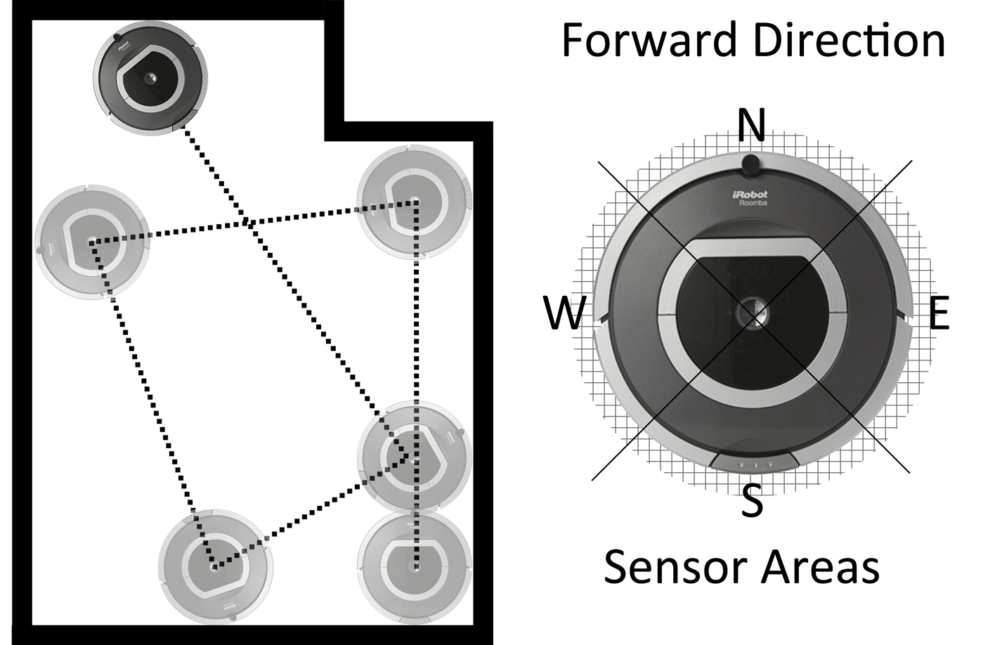  The pseudocode below shows a design for part of the program used by the robot. There are two errors in the logic of the program design. Find and describe each error made. |  |  |  |  | 2
 |  |  |  |  | Line 1. REPEAT
 |  |  |  |  | Line 2. SEND move forward TO motor
 |  |  |  |  | Line 3. RECEIVE touch FROM (string) SENSOR
 |  |  |  |  | Line 4. IF touch = “N” AND touch = “E” THEN
 |  |  |  |  | Line 5. SEND turn left TO motor
 |  |  |  |  | Line 6. IF touch = “W” THEN
 |  |  |  |  | Line 7. SEND turn right TO motor
 |  |  |  |  | Line 8. ELSE
 |  |  |  |  | Line 9. SEND stop TO motor
 |  |  |  |  | Line 10. WAIT 10 Seconds
 |  |  |  |  | Line 11. SEND move forward TO motor
 |  |  |  |  | Line 12. ENDIF
 |  |  |  |  | Line 13. ENDIF
 |  |  |  |  | Line 14. UNTIL end of cleaning session
 |  |  |  | Error |  |  | Line number |  | Description
 |  |  |  | 1.
 |  |  |  | 2.

 |  |  |  |  |  |  |  |  |  |  |  | MARKS | DO NOT  WRITE IN  THIS  MARGIN
 |  |  | Question 19 (continued)
 |  |  |  |  |  |  |  | (c) | To operate the robot two settings are entered. The length of operation, in minutes from (1 to 60) and the power setting (where 1 is economy mode, 2 regular mode and 3 is super clean).
 |  |  |  |  |  |  |  |  | (i) | Complete the table below to show the four examples of test data and the type of each example. |  | 3
 |  |  |  |  |  |  | Test data |  |  |  | Type of test data
 |  |  |  |  |  |  | operation – 27 minutes, power – 2 |  |  |  | normal
 |  |  |  |  |  |  | operation – 60 minutes, power – 1
 |  |  |  |  |  |  | operation – 65 minutes, power – 4
 |  |  |  |  |  |  |  |  |  |  | extreme
 |  |  |  |  |  |  |  |  | (ii) | Explain the purpose of fully testing a program using a variety of test data. |  | 1
 |  |  |  |  |  |  |  | (d) | There are two versions of the robot cleaner. The user interfaces for version 1.0 and version 2.0 are shown below. Version 1.0 has buttons that are pressed to change the values and control the robot. Version 2.0 has a touch screen.
 |  |  |  |  |  |  |  |  | 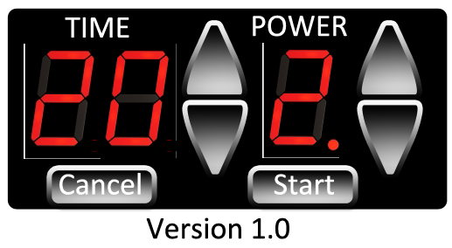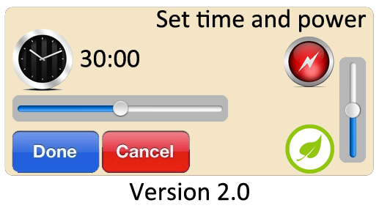
 |  |  |  |  |  |  |  |  | (i) | Describe two advantages of the user interface for version 2.0 when compared to version 1.0. |  | 2
 |  |  |  |  |  |  |  |  | (ii) | The programs used by robots are stored as binary instructions. State the name given to binary instructions. |  | 1
 |  |  |  |  |  |  |  |  |  | Total Marks |  | 10

 |  |  |  |  |  |  | MARKS | DO NOT  WRITE IN  THIS  MARGIN
 |  | 20. |  | An app is being developed for students to use to revise for their examinations. The app will show example questions, worked answers, a study planner and the location of friends with the app who are studying the same subjects.
 |  |  |  | (a) | The icons used in the app are stored using a standard file format.
 |  |  |  |  | (i) | State a standard file format suitable for storing these images. | 1
 |  |  |  |  | (ii) | Explain why the file size of an icon will be smaller if the colour depth is reduced. | 2
 |  |  |  | (b) | The app is connected to an online database which allows users to share their locations with others.
 |  |  |  |  | (i) | It is a principle of the Data Protection Act that data is held securely.
 |  |  |  |  |  | State one other principle of the Data Protection Act that the app company must comply with. | 1

 |  |  |  |  |  |  |  |  |  |  |  |  |  | MARKS |  | DO NOT  WRITE IN  THIS  MARGIN
 |  | Question 20 (b) (continued)
 |  |  |  |  |  | (ii) |  | Some users complain that using tracking and using their location is an invasion of privacy.  State what the app must do before it collects this information. |  |  |  |  |  | 1
 |  |  |  |  | (c) | Here is an example of data from the online database that stores data about users and their locations.
 |  |  | UserID |  |  |  | First  Name |  | Last  Name | Time Logged | Latitude | Longitude | LogID
 |  |  | 7283 |  |  |  | Charlie |  | Burton | 2014/03/23 16:35 | 55.8546 | -4.1625 | 231392
 |  |  | 7283 |  |  |  | Charlie |  | Burton | 2014/03/23 21:10 | 55.8515 | -4.1948 | 231393
 |  |  | 7283 |  |  |  | Charlie |  | Burton | 2014/03/24 10:27 | 55.8624 | -4.2544 | 231394
 |  |  | 1998 |  |  |  | Harry |  | Styles | 2014/03/23 16:35 | 55.8602 | -4.2900 | 231395
 |  |  | 1998 |  |  |  | Harry |  | Styles | 2014/03/23 23:10 | 55.8590 | -4.2575 | 231396
 |  |  | 2231 |  |  |  | Kerry |  | Brown | 2014/03/24 12:19 | 55.8548 | -4.2494 | 231397
 |  |  |  |  |  | (i) |  | This data is shown in a flat-file database. Describe two advantages of storing the same data in linked tables. |  |  |  |  |  | 2
 |  |  |  |  |  | 1.
 |  |  |  |  |  | 2.
 |  |  |  |  |  | (ii) |  | Two linked tables are created – USER and LOCATION.
 |  |  |  |  |  |  |  | Identify a suitable primary key for each table. |  |  |  |  |  | 2
 |  |  |  |  |  | (iii) |  | Explain the purpose of a foreign key. |  |  |  |  |  | 1
 |  |  |  |  |  |  |  | Total Marks |  |  |  |  |  | 10

 |  |  |  |  |  |  |  | MARKS | DO NOT  WRITE IN  THIS  MARGIN
 |  | 21. |  | AnyLock is a lock that can be used in most doors. The lock is controlled by mobile app. The app is used to set a 4-digit code. When the code is entered and phone is held against the lock, the door will open.
 |  |  |  | 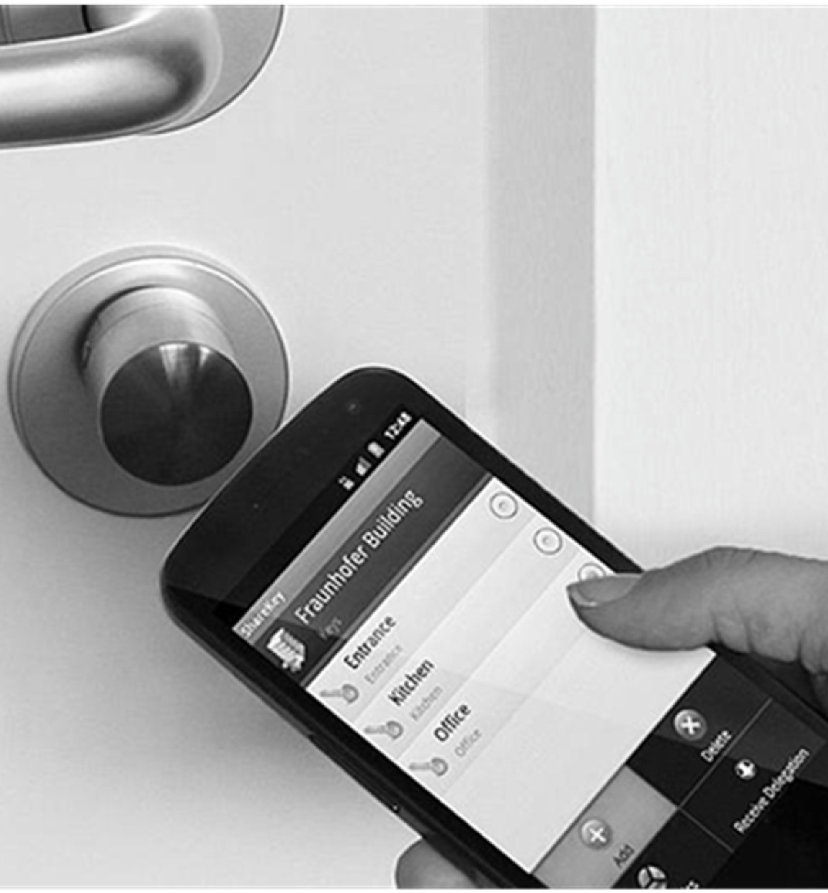
 |  |  |  | (a) | (i) | The details of the door and the pass code initially set up using the mobile app.
 |  |  |  |  |  | Using pseudocode or a language of your choice, show how a program could check that both pass codes are the same. When the two pass codes are the same a message is displayed saying “Pass Codes Set”. If the pass codes do not match an error is displayed saying, “Pass Codes don’t match”. |  | 3

 |  |  |  |  |  |  | MARKS |  | DO NOT  WRITE IN  THIS  MARGIN
 |  | Question 21 (a) (continued)
 |  |  |  |  | (ii) | Describe clearly, with reference to values and variables, what the following pseudocode does. | 3
 |  |  |  |  |  | Line 1: SET roomlabel TO doorname_field
 |  |  |  |  |  | Line 2: IF len(roomlabel) = 0 THEN
 |  |  |  |  |  | Line 3: SEND [‘Invalid, try again] TO DISPLAY
 |  |  |  |  |  | Line 4: ELSE IF len(roomlabel) > 24 THEN
 |  |  |  |  |  | Line 5: SET roomlabel TO substring(roomlabel, 24)
 |  |  |  |  |  | Line 6: END IF
 |  |  |  | (b) | Once a door and passcode are set on one mobile device the details can be automatically synced to other mobile devices.  Describe how this could be achieved. |  | 2

 |  |  |  |  |  |  | MARKS | DO NOT  WRITE IN  THIS  MARGIN
 |  | Question 21 (continued)
 |  |  |  | (c) | The app is compiled before it is made available for users of AnyLock. State two reasons why a compiler is used to translate the completed program. |  | 2
 |  |  |  |  | Total Marks |  | 10
 |  | 22. |  | A computer program is used to record the number of visits a web page receives every hour in a day. The 24 totals are stored in an array of integers called “pagehits”.
 |  |  |  | (a) | Using pseudocode or a programming language of your choice, write a short program, in the space below, to calculate the total number of web page visits over the whole day. |  | 3

 |  |  |  |  |  | MARKS |  | DO NOT  WRITE IN  THIS  MARGIN
 |  | Question 22 (continued)
 |  |  |  | (b) | The web server that stores the web page has special software on it that prevents some types of Denial of Service (DOS) attacks. The server keeps a list of banned computers. When any of these computers try to access the server the connection is refused. | 3
 |  |  |  |  | The pseudocode below shows how the system checks the id of a computer against the list of banned ids.
 |  |  |  |  | Line 1: SET banned_list TO array_of_banned_ids
 |  |  |  |  | Line 2: SET id_to_check TO request_id
 |  |  |  |  | Line 3: SET on_banned_list TO FALSE
 |  |  |  |  | Line 4: FOREACH bad_id FROM banned_list DO
 |  |  |  |  | Line 5: IF id_to_check = bad_id THEN
 |  |  |  |  | Line 6: SET on_banned_list TO TRUE
 |  |  |  |  | Line 7: END IF
 |  |  |  |  | Line 8: END FOREACH
 |  |  |  |  | Describe all the events that will occur if a request is received from a banned computer.
 |  |  |  | (c) | Describe why preventing access from certain computers can help prevent a Denial of Service (DOS) attack. | 2

 |  |  |  |  |  | MARKS | DO NOT  WRITE IN  THIS  MARGIN
 |  | Question 22 (continued)
 |  |  |  | (d) | Describe one other type of attack that can affect the security of a computer. | 2
 |  |  |  |  | Total Marks | 10
 |  |  |  |  | [END OF QUESTION PAPER]

[B

[BLANK PAGE]

