Daily Timetable
Time | Activity | Symbol | Useful Information
9:00-9:30am | Morning Routine | 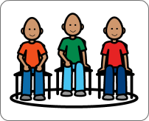 | - Talk over the daily plan, if you are able to print this your child could sort into order or write/type out.  - Talk about the day, date and month.  - Look at the weather, what clothes should we wear?  - Talk about feelings.  - Use www.bbc.co.uk>newsround This is a website most pupils use at school.
9:30-10:00am | Exercise Time | 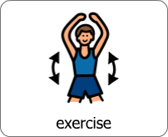 | - Joe Wicks is running daily PE sessions on youtube-Search youtube- PE with Joe Wicks.  - Jumpstart Jonny offer great warm ups, fitness sessions, cool downs and meditation. Search- www.jumpstartjonny.co.uk –See Microsoft Teams on Glow for log in details.  - GoNoodle offers dance and mindfulness activities. Search- www.gonoodel.com
10:00-10:30am | Making Snack |  | - Snack suggestions: making toast, pancakes, cereal etc.
10:30-11:00am | Snack & Free Time | 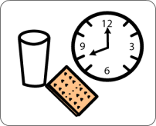
11:00-11:30am | Learning Activity |  | Some good websites for learning activities are:  - www.topmarks.co.uk- Then click on learning games in the top tool bar. You can access literacy & numeracy learning activities.  - www.intofilm.org are offering free film resources.  - www.bbc.co.uk/bitesize/primary This is a good resource for a whole host of learning activities.
11:30-12:00pm | Learning Activity | 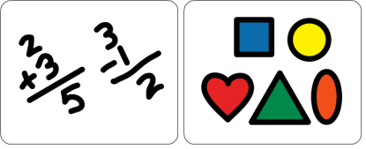 | Additional learning activities include:  - Treasure hunt for shapes, numbers, words in the house.  - Watching films and changing the ending.  - Identifying, sorting or sequencing numbers.  - Reading and creating new characters, describing current characters or sequencing the main events.
12:00-1:00pm | Lunch & Free Time | 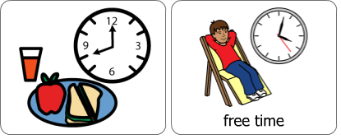 | - Encourage your child to help make lunch
1:00-1:30pm | Exercise Time |  | Some good websites for relaxation, meditation and yoga are:  - www.tacpac.co.uk-Login details are on Microsoft Teams.  - www.youtube.co.uk offer free mindfulness and yoga for young people. Once in youtube search-mindfulness for children, yoga for children.
1:30-2:30pm | Topic Time |  | Our topics for pupils this term were: Famous Scottish People and Our Community.  Topics is an area where you could cover anything. From learning about countries, food, music, or any special interests your child has.  www.topmarks.co.uk has some good topic resources.
2:30-3:00pm | Life Skills Time | 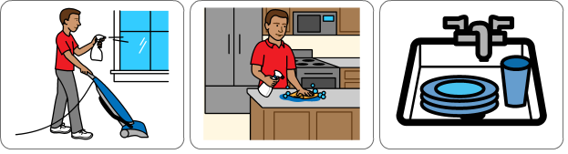 | Life skills is an important skill to develop. Some ideas are:  - Making the bed  - Dressing  - Hoovering  - Polishing  - Loading & unloading the washing machine  - Loading & unloading the dishwasher  - Washing & drying the dishes
3:00-3:30pm | Creative Time |  | Creative time ideas include:  - Lego  - Painting  - Colouring in  - Building structures  - Making slime  - Science experiments
3:30pm | work finished for today | 