Bellshill Academy



Career-Long Professional Learning (CLPL) Policy
August 2025 v2

Schedule for Review

Policy created in line with local authority guidelines | August 2022  Reviewed, updated August 2025
The implementation of this CLPL policy will be monitored by: | - Senior Leadership Team  - Extended Leadership Team
The Policy will be reviewed annually | August 2026




Article 28
Access to Education
Article 2
No Discrimination
Article 29
Aims of Education

Contents
Introduction | Page 1
National Model of Professional Learning | Page 1
Approaches to CLPL | Page 2
Example of a CLPL approach: Practitioner Enquiry | Page 2-3
In-service training | Page 4
Procedures for applying for CLPL courses | Page 4
Professional Review and Development & Professional Update | Page 4-5
Partners | Page 6
References | Page 6
Appendices | Page 6

Introduction

At Bellshill Academy, it is recognised that by engaging in high quality professional learning this leads to improved outcomes for learners.

“When a wide range of high-quality, sustained professional learning experiences are undertaken, teachers are more likely to inspire pupils and provide high-quality teaching and learning experiences, enabling learners to achieve their best.” GTCS, Professional Learning, 2022

This policy provides the rationale for supporting practitioners in developing knowledge and ensuring their practice is critically informed and up to date.

In line with the GTCS Professional Standards the vision at Bellshill Academy reflects a relentless drive to secure successful outcomes for our young people through supporting and promoting partnership, leadership, enquiry and professional learning. Professional Standards have multiple purposes including:

- to create a shared language for teaching professionals;
- as a benchmark for professional competency;
- to develop and enhance professionalism;
- to support career-long professional growth;
- to provide a framework for Initial Teacher Education, probation and leadership pathways and programmes; and
- to ensure and enhance public trust and confidence in the teaching profession.
GTCS, Professional Standards 2021

National Model of Professional Learning

Education Scotland share a national model (diagram below) to support the development for high quality professional development. The model of professional learning identifies the key principles and features of effective learning that will build capacity and promote collaborative practices. The model provides a shared language and aspiration, informing the provision, structure and nature of learning. It also outlines the kinds of learning that will empower and enable you to best meet the needs of learners.
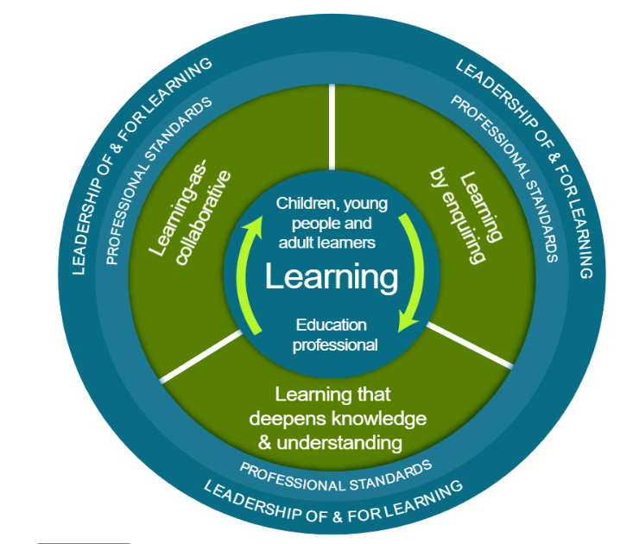

Further information on using this model can be found at Education Scotland: https://professionallearning.education.gov.scot/explore/the-national-model-of-professional-learning/

Approaches to CLPL

Bellshill Academy will support a wide portfolio of CLPL approaches in order to facilitate school improvement as well as supporting practitioners to meet the GTCS Professional Standards. As far as possible, CLPL is personalised and takes into account the needs and career aspirations of the individual member of staff alongside the needs of the school. Bellshill Academy acknowledges that successful professional development involves working in partnerships and should support a culture of trust and respect. It should:

- have a focus on improving and evaluating pupil outcomes;
- be underpinned by robust evidence and expertise;
- include collaboration and expert challenge;
- be sustained over time.

Therefore, CLPL approaches may include:

- attending a course or a conference;
- completing online training;
- attending internal training using the expertise available within the Bellshill Academy, e.g., pedagogic practices for different subjects and contexts, mentoring and coaching skills, pastoral skills; leadership development;
- practical experience, e.g. external examination marking, delivering INSET and external training, ITT subject mentoring, presentations to SLT, Local Authority and Parent Council etc;
- research opportunities and opportunities to participate in award bearing work from higher education institutions and other providers such as GTCS, Education Scotland and West Partnership;
- school-based collaboration, e.g. Practitioner Enquiry, learning study triads, department meetings, Heads of Department meetings, pastoral meetings, standardisation and moderation, working parties to research and develop aspects of learning and teaching;
- external collaboration, e.g. contributing to and delivering a training programme, co-ordinating or supporting a local or national learning forum or network, school visits to observe or participate in outstanding practice;
- job enrichment or enlargement, e.g. job sharing, acting leadership roles, job rotation, job shadowing;
- school-based work overseen by an external consultant, adviser or relevant expert;
- secondments, e.g. with a regional or national organisation, an exchange or placement, e.g. with another teacher, school, industry or higher education.

Example of a CLPL approach: Practitioner Enquiry

Practitioner enquiry has been a successful model at Bellshill Academy. Practitioner enquiry “promotes a process led, capacity building enquiry approach to professional learning and school development” and should be ‘an integral aspect of the day-to-day practice of teachers and other education professionals.’ (GTCS).

When practitioners adopt an enquiry stance it can:

- Empower individuals and encourage them to challenge and transform
- Enable fundamental and sustainable changes in pedagogical approaches and the curriculum
- Improve the quality of learning experiences
- Improve professional discussions
- Improve the link between research and practice
- Impact on professional practice
- Improve professional capacity and agency
- Impact on the wider school improvement agenda
- Ensure school improvement is evidenceinformed and critically justified

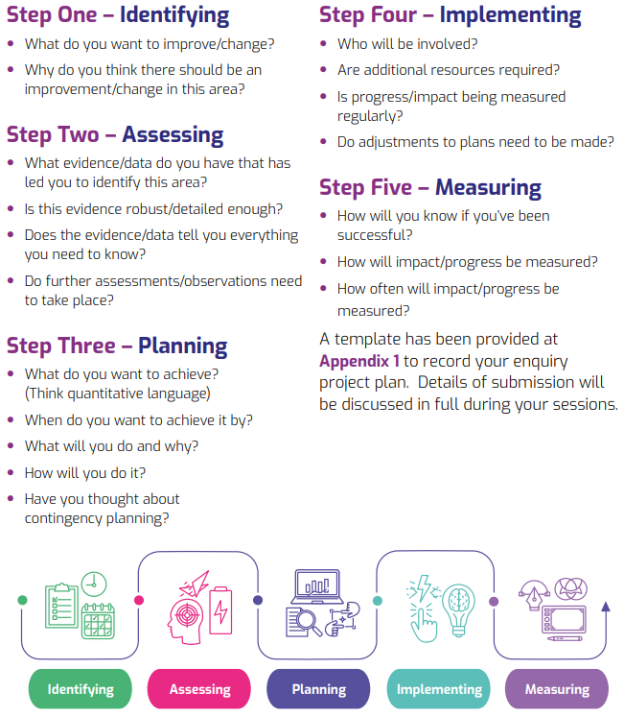
The practitioner enquiry project you undertake should follow a straightforward process of identifying, assessing, planning, implementing and measuring. Think about the following key questions during each stage of the enquiry:

When evaluating your practitioner enquiry, you should consider and report on the following prompt questions:

- What was it you wanted to improve? | - Would you do anything differently next time?
- What did you already know about it? | - Who will you communicate the findings of your evaluation to?
- What did you do about it? | - Will practice change as a result of the enquiry project?
- How did you measure it? | - Is any change in practice sustainable?
- What worked well? | - Was there an improvement?
- What didn’t work so well?

A Practitioner Enquiry project plan is attached as an appendix.

In-service training

Bellshill Academy holds in-service training days (INSET) during the academic year that are in line with dates agreed by North Lanarkshire Council. The INSET programme is planned in advance by the Senior Leadership Team, the content of which is informed by the needs of the school outlined in the Annual Improvement Plan. The principle purpose of INSET is to improve learning and teaching by:

- increasing awareness of educational developments and innovations;
- improving pedagogical knowledge and specialist knowledge, e.g. Additional Support for Learning;
- considering how to implement pedagogic practices successfully in different contexts;
- sharing examples of effective pedagogic practices to validate as well as challenge existing beliefs;
- working collaboratively to exchange ideas, draw on evidence and expertise and discuss the impact of pedagogic practices,
- enabling staff to contribute to the delivery of the school development and improvement plans.

Bellshill Academy aims to make the best use of all available resources and will draw from providers such as:

- in-school expertise; making use of the knowledge, experience and skills of staff;
- representatives of agencies or independent organisations or individuals who have specific areas of expertise;
- a variety of institutions including schools across the local authority, colleges, universities and examination boards such as SQA;
- local authority colleagues, e.g. North Lanarkshire Council

Procedures for applying for CLPL courses

In the first instance, attendance at any CLPL course must be agreed in principle with the member of staff’s line manager. The training should be formally approved by the line manager, relevant budget holder (Head Teacher and Depute Head Teacher with responsibility for CLPL). Each member of staff is responsible for booking their place on a CLPL course and arranging cost-effective transport.

Professional Review and Development & Professional Update

In line with the GTCS document “Unlocking the Potential of Professional Review and Development” (Professional Review and Development Guidelines 2019)

‘Professional Standards for teachers are core to the being, knowing and doing that is teacher professionalism. It is these standards which make useful connections between ongoing Professional Review and Development, Professional Learning and Professional Update sign-off. Through actively engaging in self-evaluation across the standards and ongoing dialogue, teachers can become agents of change, develop an enquiring mindset and take ownership of their learning journey. Professional capital, which includes human, social and decisional capital, will therefore grow across learning communities with teachers being recognised and valued by the profession as proactive role models of learning.’

The entry to every profession begins with initial professional education or training, but that will not be sufficient to equip staff for their entire professional career. In the course of a career, many changes are likely to take place:

- new knowledge, approaches, techniques and skills will be required as time goes on
- new legislation, regulation, procedures, and responsibilities will be introduced which must be acted upon
- new improvement plans will be devised to which staff are expected to contribute
- every member of staff will be able to find areas of individual skill and knowledge which can be developed further.

Teachers, as a condition of maintaining their GTCS registration, engage in all of the four bullet points within a climate of trust, mutual respect and entitlements which should be supported through high quality Professional Learning and a PRD process which is fully supported, recognised and implemented throughout the year for ‘all’ staff in ‘every’ North Lanarkshire educational establishment.

Teachers continually adapt to change while keeping professional standards high, teachers must have the chance to reflect, plan and engage in Professional Learning (PL) at all stages of their career.

Positively engaging with PRD, using Professional Standards to scaffold and support, provides a framework for teachers to critically appraise their own practice and enhances teacher professionalism to ultimately best serve our children and young people across Scotland.

The process for PRD / PU is shown in the flowchart below:

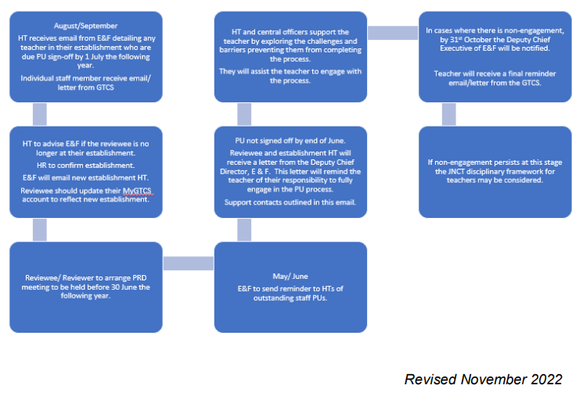

Further information regarding the process and policy for Professional Review and Development & Professional Update policy for teachers is available in Management Circular No. F21

Partners

Professional development is a continual process and requires a wide degree of support from a wide range of partners. Specific in-house training opportunities are provided within Bellshill Academy through well connected relationships that are built on a culture of trust and honesty. In addition, both local and national partners play a significant role in offering professional development opportunities that enable wider networking opportunities for staff to develop their professional knowledge and ensure their practice is critically informed and up to date.

Although the list is not exhaustive, partners include:

- Education Scotland
- West Partnership
- Scottish Government
- GTCS
- Scottish Social Services Council
- Care Inspectorate
- Scottish professional Learning Network
- North Lanarkshire Council
  - NLC Learning Hub via Teams
  - NLC Learn NL: https://learnnl.learningpool.com/login/index.php

References

Sources referred to during the creation of this policy include:
- GTCS Professional Standards. GTCS, 2021
- The National Model of Professional Learning. Education Scotland, 2022
- “Unlocking the Potential of Professional Review and Development” GTCS - Professional Review and Development Guidelines, 2019
- North Lanarkshire Council – Management Circular No. F21
- North Lanarkshire Council – Leadership Programme “Enquiry Project / Practitioner Enquiry”

Appendices

Appendix 1: Practitioner Enquiry Project Plan

