Bellshill Academy



Our Anti-Bullying Policy

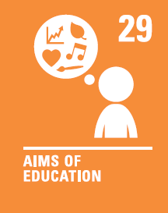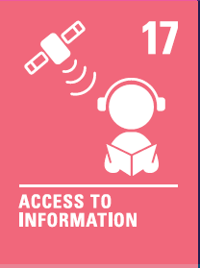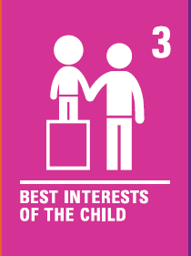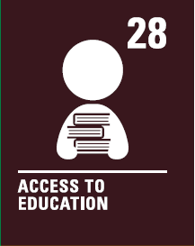

Bellshill Academy Anti Bullying Policy

Rationale

Bellshill Academy is a comprehensive secondary school in Bellshill, North Lanarkshire. The school serves a community which is varied in terms of location and its socioeconomic landscape.
The community we serve need to be confident in our ability to provide the best possible experience for our young people and as such, policies clearly outlining our stance on important issues are essential.

All schools in North Lanarkshire Council are required to have a strict anti-bullying policy which is accorded with the authority policy. The local authority policy, in turn reflects the national approach to anti-bullying. As such, this document has been created to reflect the messages found in our local authority guidelines.

It is imperative for all schools to regularly review and update their policies, taking in to account new developments in anti-bullying approaches. The requirement to review and update our policies in order to reflect these changes, remain a firm priority here at Bellshill Academy. This Policy will be updated every 3 years as a minimum.

Bellshill Academy's vision is to be a Caring community where everyone is Included, Respected and successful through hard work and Endeavour. This vision is at the heart of the curriculum, assemblies and extra-curricular activities, and in the relationships between pupils and staff. For every young person in Bellshill Academy is to feel valued we have a duty to support pupils in the development of their social, physical, emotional and mental health as, to us, this is just as important as their academic attainment. Bullying behaviour will not be tolerated within our school and will be dealt with as quickly and effectively as possible.

At Bellshill Academy we strive to ensure that each pupil is given the opportunity to thrive in line with the wellbeing indicators outlined in Getting it Right for Every Child. In order to ensure that we support each young person’s right to be Safe, Respected and Included, all staff have a responsibility to act on or report incidents of bullying.

Our Commitment

It is our commitment to provide our young people with an environment where they can:

- Be supported and valued in a safe, positive environment.
- Be respected and respect others while challenging any prejudice views against them.
- Be free from all forms of abuse, bullying and discrimination.
- Prepare our young people for the experiences, challenges and responsibilities which await them beyond their school career.

We accept that bullying has the potential to occur within our establishment and the impact this type of behaviour can have on our pupils’ wellbeing. We also understand that it has the potential to be a barrier to learning. Bullying behaviour strongly undermines the vision and values embraced by the Bellshill community and it will not be tolerated.

National Definition

What is bullying?

Bullying is both behaviour and impact; the impact is on a person’s capacity to feel in control of themselves. This is what we term as their sense of ‘agency’. Bullying takes place in the context of relationships; it is behaviour that can make people feel hurt, threatened, frightened and left out. This behaviour happens face to face and online. (respectme, 2015)

Bullying can take many forms including;
- Verbal – Persistent name calling, taunting, mocking, making offensive comments
- Physical – Physical assault on another person, kicking, hitting, pushing or any other form of violence and intimidation
- Material – Damaging or stealing possessions
- Social - Excluding people from groups and spreading hurtful and untruthful rumours.
- Written - Include sending offensive or degrading images by phone or via the internet and producing offensive graffiti
- Psychological – Being forced to do things against your will

Bullying is viewed a clear breach of the UNCRC articles.

Challenging all Types of Prejudice Based Bullying (Equality Act 2010)

Additional Support Needs, Disabilities and impairments

Children and young people with ASN, disabilities and impairments have a wide variety of needs, skills and talents. Young people with ASN may;

- Be adversely affected by negative attitudes and perceptions of difference and therefore be more isolated.
- Not understand that what is happening is defined as bullying
- Have greater difficulty telling others about incidents of bullying

Appearance or Health

Targeting and isolating children and young people;

- With visible health or medical conditions, such as eczema or acne
- Who are perceived to have a physical limitation due to size, weight or other body confidence issues

LGBTQIA+

Homophobic, biphobic and transphobic bullying may include behaviour or language which makes an individual feel unsafe or marginalised because of their perceived or actual sexual orientation. It is most commonly motivated by prejudice against individuals who are, or who are perceived to be lesbian, gay, bisexual, transgender or any part of the LGBTQIA+ community. Individuals who do not fit certain stereotypes may also experience this type of bullying.

Adverse Childhood Experiences

Children and young people who have had ACEs can be vulnerable to bullying behaviour for a number of reasons. They may find more challenging to develop positive and meaningful relationships with peers and adults. Examples of childhood adversity can include:

- Physical Abuse
- Sexual Abuse
- Emotional Abuse
- Living with someone who abused drugs
- Living with someone who abused alcohol
- Exposure to Domestic violence
- Living with someone who has gone to prison
- Living with someone with a serious mental illness
- Losing a parent through divorce, death or abondonment

Sexism and Transphobia

- Sexist bullying is based on sexist attitudes that may demean, intimidate or harm another person because of their sex or gender.
- Sexual bullying may include name calling or comments regarding an individual’s physical appearance. In addition, making inappropriate comments or innuendos, propositions and physical contact without consent.
- Transphobic bullying is behaviour or language that makes a child or young person feel judged or excluded because of their gender identify. It is often based on prejudice or negative attitudes, views and beliefs about trans people. Boys, girls and non-binary individuals may be affected. Alongside this, individuals who are still questioning their gender identity or those who do not identify as trans but do not conform to gender stereotypes.

Bigotry

Bigotry can affect anyone. It may include young people being subject to abuse and harassment because of their race, culture, background or beliefs. This may be;

- Being called derogatory names
- Witnessing offensive graffiti
- Personal attacks including violence or assault
- Being left out, treated differently or excluded
- Inappropriate or insulting jokes

Cyberbullying

This type of bullying takes place over digital devices or online in social media apps, forums or gaming platforms. Anywhere which allows young people to view, participate in or share content.
- It can include sending, posting, or sharing negative, harmful or false content about another individual.
- It may also include sharing personal or private information about someone else causing embarrassment or humiliation.
- Some cyberbullying behaviour may also cross into unlawful or criminal behaviour. For example, sharing inappropriate images or sharing sexually explicit images or videos without consent.
An expansion of North Lanarkshire Council’s Anti Bullying Policy can be found on our school website.

Intent, Persistence and Impact

Intent

When investigating bullying, intent can be difficult to prove. A young person may be modelling behaviour displayed by peers or adults. It is important that the young person who is perpetrating the alleged bullying is shown why their actions are wrong. Although intent may not be there, the impact of the bullying can still be detrimental. It’s more important to focus on the behaviour and the impact it had, rather than trying to establish whether someone acted deliberately or not.

Persistence

The issue with persistence is that the behaviour has to take place more than once, but the impacts of bullying can be felt after a single incident. Although bullying is usually persistent, a single incident can have a significant impact on some children and young people by instilling a fear that it might happen again. It is important that any display of bulling behaviour is addressed, regardless of whether it is an isolated incident or not.

Impact

Bullying can affect people in different ways, and this should be taken into consideration. If you are unsure if behaviour is bullying, look at the effect it is having on the child or young person. We should always remember that children will tease each other, fall in and out with each other, have arguments, stop talking to each other and disagree about what they like and don’t like. Although these are normal behaviours in growing up, it is important as an establishment that we educate our young people to allow them to differentiate between a difference of opinion and bullying behaviours.

Intent, persistence and impact graphics are displayed around the school to ensure all young people understand what constitutes bullying behaviour.

Community

The Bellshill Academy community prides itself on establishing an ethos which is nurturing and caring. The positive relationships between pupils and staff allows for all children and young people to learn and excel in an environment in which they feel comfortable and safe. Pupils and staff have confidence in the school pupil support system and are aware that reporting bullying incidents will be acted upon promptly.

Through a number of awareness raising sessions and the schools PSHE programme, students will come to realise that they do not have to be bystanders but can play an active role in the recognition, reporting and prevention of bullying behaviour. Including;

- Procedures and guidelines – the school’s anti-bullying policy can give pupils, parents and staff advice on how to identify and tackle bullying behaviours.
- Communication – it is essential that pupils feel confident enough to tell a teacher if they are experiencing bullying. Building positive relationships is key to this and is something that staff at Bellshill academy strive to do at all times.
- Training and support for staff – staff undertake professional learning on how to tackle bullying in school.
- The school’s Vision and Values – displayed throughout
- Anti-bullying graphics displayed in classrooms and communal areas
- The use of CCTV cameras.
- Assemblies – Regular presentations from RRS group, LGBTI+, Community Partners
- Staff present in communal areas e.g. in corridors between periods, in social are during breaks and lunch times
- Designated quiet areas for pupils
- Mentors in Violence Prevention Programme
- Mental Health Ambassadors
- Peer Guidance and Mentoring

Within the PSHE curriculum children and young people will explore the impact of bullying. This will help to:
- Raise awareness about bullying behaviour, its effect on emotional health and well-being, and how it will be combated.
- Develop personal and social skills through the promotion of friendship skills, assertiveness skills, conflict resolution and problem-solving skills, communication skills and the exploration of spiritual and moral values.
- Build and maintain self-esteem.
- Promote positive role models and positive pupil/staff relationships.

Strategies used to Prevent and to respond to Bullying

For the person who is experiencing bullying;

- Staff at Bellshill Academy will listen to any pupil who is experiencing bullying. We will listen to what has happened and to what the pupil wants us to do.
- We will also help the pupil restore agency by discussing what the pupil wants to do.
- A restorative meeting between the person being bullied and the person displaying the bullying behaviour can be arranged (but only if the person being bullied wants this.)
- We will ensure communication with all parties involved.

For the person who is engaging in bullying behaviours;

- We will work with any young person displaying bullying behaviours, to ensure that they appreciate the impact of their actions on others.
- We will contact home and involve parents/carers in discussions around bullying behaviours behaviour and seek their support in the form of parental meetings. Every bullying case will be unique and parental involvement may not be necessary.
- If a restorative meeting is desired, this will give the opportunity to demonstrate the impact and also to see the consequences of bullying behaviour and to reach a resolution.
- We will endeavour to address what is happening behind the bullying behaviour. For example, have there been issues between particular pupils who have fallen out? Are there prejudicial attitudes leading to the bullying behaviour? Is the behaviour a defence mechanism? By recognising why, a pupil is choosing to engage in bullying behaviours other, we can support them to engage in more positive relationships and interactions.

Expectations of Behaviour and Pupil Responsibilities

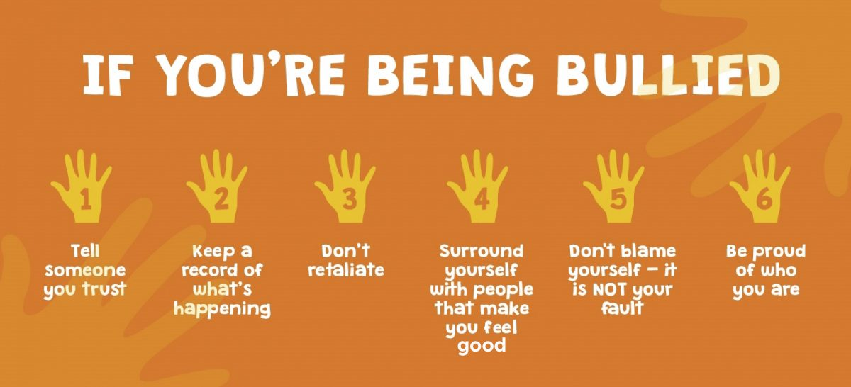

Information and advice for anyone dealing with bullying;
- https://www.nationalbullyinghelpline.co.uk/
- https://www.lgbtyouth.org.uk/groups-and-support/lgbt-advice-centre/
- https://education.gov.scot/parentzone/additional-support/specific-support-needs/social-and-emotional-factors/experiencing-bullying-behaviour/

Guidance for Staff

Every member of staff at Bellshill Academy has a responsibility to ensure our young people feel safe and included. Relationships are a huge part of this, and both teaching and non-teaching staff strive to maintain positive relationships with pupils as they interact with them within and out of the classroom. On top of this, different members of staff have different roles in tackling bullying behaviours in school.

Classroom Teachers and Support Staff

Classroom teachers should challenge any incidents of bullying behaviour that they witness in their classes as soon as they occur. If a teacher suspects that an incident could be part of a wider pattern of behaviour, or notices changes in a young person’s behaviour or demeanour that they suspect could be because of bullying, they should pass this on to the pupil’s Principal Teacher of Inclusion.

Principal Teachers of Pupil Support

Principal Teachers (PTs) of Pupil Support have pastoral responsibility for the pupils in their care. They will act on any reports of bullying, from pupils, staff or parents. They will speak with the pupil experiencing bullying and the pupil(s) displaying the behaviour to establish exactly what has happened and to facilitate a restorative meeting of both parties, if desired by the pupil experiencing bullying. If this does not stop the behaviour, PTs of Inclusion will liaise with members of the Senior Leadership Team to decide upon next steps.

Senior Leadership Team (SLT)

SLT will be kept fully informed of cases of bullying and where bullying does not stop after interventions made by class teachers and PTs of Inclusion, SLT will speak to the pupil displaying bullying behaviours. Where appropriate, SLT will also decide upon natural consequences. Where is established that an incident of bullying has occurred, this will be officially recorded on SEEMiS’ Bullying and Equalities Module.

Guidance for Parents & Carers

- Reassure your child they have done the right thing by disclosing this information to you.
- Encourage your child to report incidents of bullying to their PT Inclusion or a trusted adult.
- If you have any concerns about the child’s emotional wellbeing contact GP in the first instance and alert the school
- Report any incidents of bullying behaviour to PT Inclusion in the first instance
- In order to allow the school to deal with issues effectively, parents must allow the school to conduct enquiries and should not attempt to try to resolve the issue themselves for example, via social media.
- Regularly contact the school with any updates/ issues with regards to bullying.
- Once investigated PT Inclusion will contact parent via telephone to discuss next steps.

Additional Resources and Support

- childline.org.uk – contains tips and resources for victims
- bullying.co.uk – help and advice for victims, carers and schools
- nspcc.org.uk – help and advice for carers and families
- https://respectme.org.uk/ - help and advice for pupils, staff and carers.

Perimeters of the Policy

Where bullying occurs in Bellshill Academy and on school trips, this policy will be applied. If bullying takes place within the community but there is a school connection, the school will, if it is in our power, take action. If the bullying takes place within the community and there is no school connection, this policy cannot be invoked but the school may offer support where appropriate.

Acknowledgements

The creation of this policy has been a collaborative effort across our school community;

- Bellshill Academy Staff
- Pupil Group
- Bellshill Academy LGBTI+ Allies Group
- Parent Council

Guidance sought and received by Respectme, Scotlands Anti Bullying service in the completion of this policy.

