Hi boys and girls, hope you are all doing well and keeping safe.
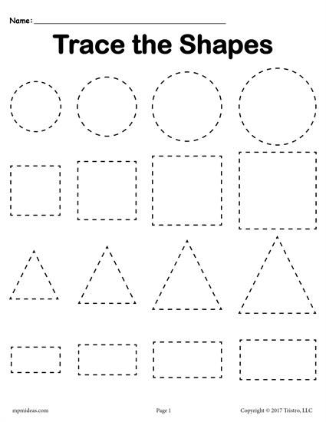
Here are some fun activities which will help develop your child’s pre writing skills. All you have to do is draw theses shapes and get your child to copy them. Are you up for the challenge? See how many pictures we can get back through Twitter or our Blog page. We can’t wait to see them. Love from all the nursery staff
