Here are some activities we could try while we are in the house.
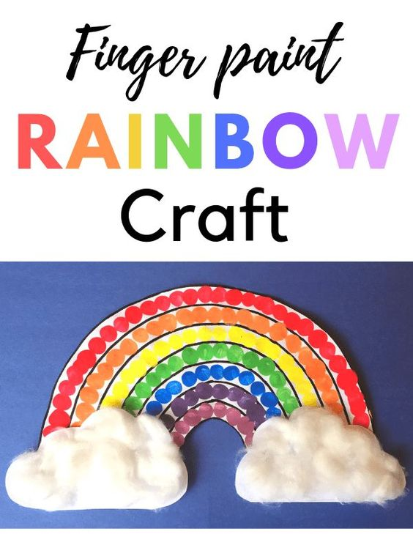
- We can make our own pictures of a rainbow and put it in our windows.
- We can find things in our house and gardens the same colours as the colours in our rainbow.
- Count how many colours are on our rainbow and count the things we find
- Talk about when we see rainbows, what is the weather like when rainbows appear?
- Learn and sing the rainbow song
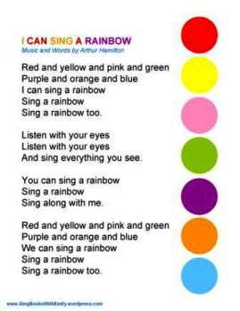

We would love to see pictures of your rainbows
On our blog or twitter page

- If you can you could even try this experiment
and make your own rainbow
