A lot of resources and supports have been aimed at primary age children, so we have decided to set weekly themes for our nursery children. These are supposed to be fun and are all based around play, imagination and creativity. Hopefully everyone finds this useful and feel free to share. We will post it on our school app, on Twitter and our website.

Our first theme is The Gruffalo. If you have the book at home, please read it with your child. Don’t worry if you don’t have it, I have included a link to the story below. Have fun in the Deep dark wood… and feel free to share your experiences via Twitter (please don’t include the child’s name).

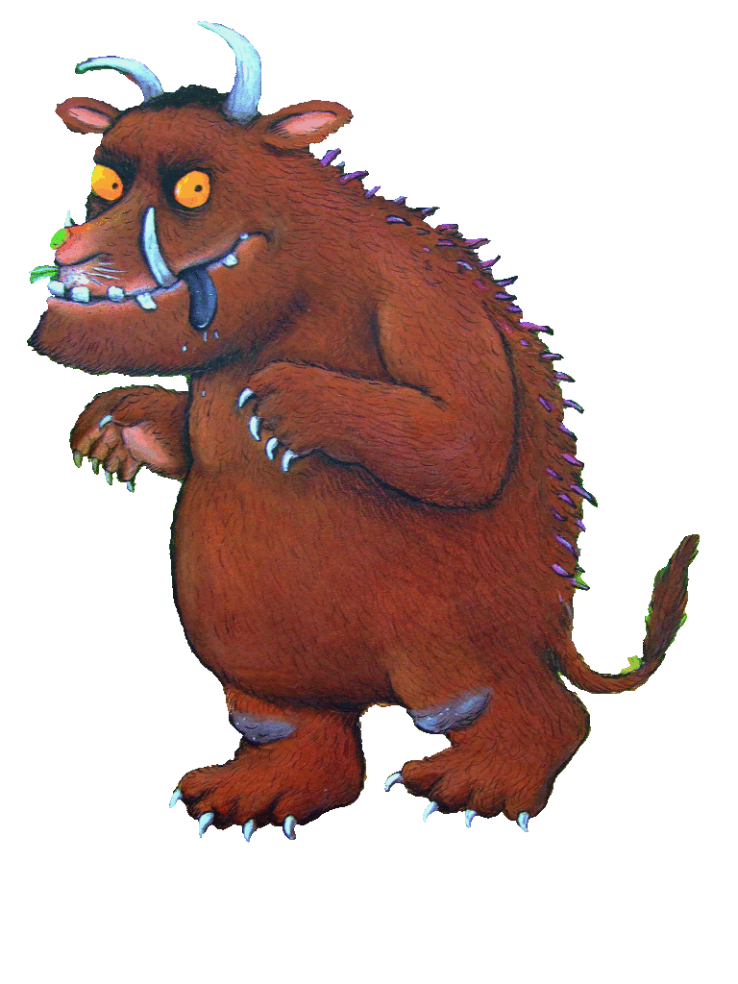

The story of The Gruffalo, by Julia Donaldson.

<https://www.youtube.com/watch?v=s8sUPpPc8Ws>

The Gruffalo Song.

<https://www.youtube.com/watch?v=mSc4TQshebk>

Julia Donaldson Author Talk and song

<https://www.youtube.com/watch?v=845w3sfbYv4>

Try these online Gruffalo activities. Type in your name and get started.

<https://www.gruffalo.com/in-the-woods/?ReturnUrl=/activities/activities>

If you are able, print off this Gruffalo colouring task.

<https://www.gruffalo.com/gruffalo/files/71/712f723a-0130-45e2-8132-1e4dd6213c43.pdf>

Sign up for your free Twinkl account and you can access all of these amazing activities. The pencil control sheets are really good.

<https://www.twinkl.co.uk/search?term=gruffalo+activities>

If you can, print off these activity sheets. You may be able to do some online.

<https://tra-resources.s3.amazonaws.com/uploads/entries/document/3391/Gruffalo_20th_Anniversary_Activities.pdf>

Be arty and creative. Look at the amazing examples below on Pinterest. Use whatever you have at home to create a Gruffalo. It could be pens, paint, play-dough, pipe cleaners, sticks or maybe have a look in your recycle bin. We would love to see some of your creations on @StTimothysPS.

<https://www.pinterest.co.uk/search/pins/?q=gruffalo%20models&rs=typed>

Other activities:

Create a Gruffalo crumble- in the kitchen or in the garden with mud and sticks.

Have a Gruffalo picnic.

Make Gruffalo footprints in the mud.

Read the Gruffalo’s Child or other Julia Donaldson books.

Find out about the animals in the Gruffalo. Do any live close by?

Make Gruffalo puppets or figures and put on your own show.

Use the Gruffalo masks on Twinkl and be a Gruffalo for a day.

Look out for The Gruffalo Movie.

Look out for The Gruffalo in Scots book.

Download the Gruffalo Party Pack <https://www.forestryengland.uk/resource/gruffalo-party-pack>

Use this pack to create your own Gruffalo den. <https://cdn.literacytrust.org.uk/media/documents/The_Gruffalo_toolkit.pdf>