

**Bargeddie**

**Primary School**



**School Handbook**

**2023 - 2024**

**Contents Page**

**Head Teacher’s Message 3**

**Vision and Values 4**

**School Information 5**

**Our Staff Structure 6**

**Promoted Staff Remits 8**

**Class Structure 9**

**Community Facilities 10**

**School Hours 11**

**Proposed Holiday Arrangements for Session 2022-2023 12 Enrolment 13**

**Equal Opportunities and Social Inclusion 14**

**Curriculum for Excellence 15**

**Additional Support Needs 29**

**School Improvement Plan 31**

**Homework 32**

**Extra-Curricular Activities 33**

**Freedom of Information / Data Protection 34**

**Child Protection / Adult Protection 41**

**School Ethos / Promoting Positive Behaviour 42**

**Anti-Bullying 43**

**Home / School Links 44**

**Attendance at School 45**

**Family Holidays during Term Time 47**

**Extended Leave with Parental Consent 48**

**Exceptional Domestic Circumstances 48**

**Community Links 49**

**Clothing and Uniform 50**

**School Meals 52**

**Transport 55**

**Medical Health Care 56**

**Information in an Emergency 57**

**Parent Forum 57**

**The Parent Council 58**

**Supervision in Non Class Times 59**

**Placing Requests 60**

**Associated Secondary School / Transfer to Secondary 61**

**Useful Contacts 62**

**Qualifying Statement 65**

**Head Teacher’s Message**

Dear Parents/Carers

Welcome to Bargeddie Primary School. Our handbook presents you with an introduction to our school. It provides you with information relating to the life and work of the school.

Bargeddie Primary aims to provide a high quality education, which meets the needs of all pupils. The education we provide and the information contained within this handbook is determined by North Lanarkshire Council Policies and National Guidelines. Children’s experiences within our school reflect those outlined in a ‘Curriculum for Excellence.’

We ask you for your co-operation and support, so that we may work in partnership, in order to make your child’s time at Bargeddie Primary a happy and rewarding experience.

**Covid 19 Pandemic**

North Lanarkshire Council will continue to align supports, from across the service, in response to the Covid 19 pandemic, to support children and families and maintain educational provision. Further information is available directly from the school or from North Lanarkshire Council’s website [www.northlan.gov.uk](http://www.northlan.gov.uk)

If at any time, you wish any further information about our school, or if there is something you would like to discuss, please do not hesitate to contact me.

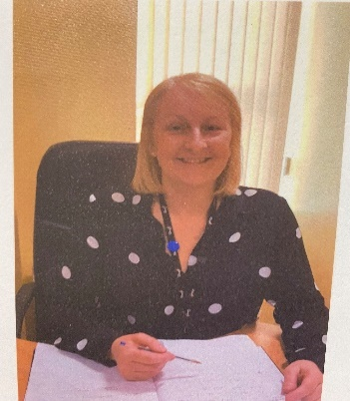

Kind regards,

Gillian Brady, Head Teacher

**Vision and Values**

In Bargeddie Primary School, we aim to work in partnership with all members of our school community, to encourage our pupils to maximise their potential and to ensure all children are safe, happy, achieving, nurtured, active, respected, responsible, included and valued.

We will undertake the following:

* Provide a happy, welcoming learning environment where an ethos of trust and mutual respect is evident.
* Provide engaging learning opportunities which challenge and support pupils, as appropriate and meet the needs of all learners.
* Encourage the development of personal and social skills which allow pupils to become responsible citizens who show tolerance and respect towards others.
* Celebrate attainment, achievement and recognise the development of wider skills and talents.
* Provide pupils with the knowledge and skills to make sensible choices to remain safe, fit and healthy.

**School Information**

**Bargeddie Primary School is non-denominational and co-educational. We admit boys and girls from Primaries One to Seven.**

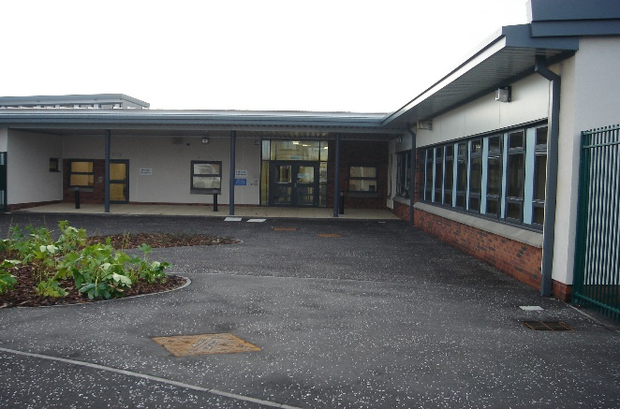

**Bargeddie Primary School**

Langmuir Road

Bargeddie

Glasgow

G69 7RS

Telephone: 01236 632150

Fax: 0141 773 3100

Email: [enquiries-at-bargeddie@northlan.org.uk](mailto:enquiries-at-bargeddie@northlan.org.uk)

Website: [Bargeddie Primary (glowscotland.org.uk)](https://blogs.glowscotland.org.uk/nl/bargeddiepsblog/)

Twitter: @bargeddieps

**Our school currently consists of the follows areas:**

6 class bases and an area for additional support.

These bases can be changed, if required. This is dependent on the size of the incoming classes.

We also have communal areas which are shared with St Kevin’s Primary School and which are timetabled for use. These consist of the following:

1 library

1 noisy / quiet room

1 medical room

1 gym hall

1 dining hall

1 interview room

**We have access to a community facility which again, is timetabled and shared.**

**This area consists of the following;**

1 community room

Male and Female changing facilities

Planning Capacity 165 Working Capacity 144

Parents should note that the working capacity of the school will vary and is dependent upon the number of pupils at each stage and the way in which the classes are organised.

**Our Staff Structure**

**Head Teacher Principal Teacher**

Mrs Gillian Brady Mrs Lynn Logan

**Teaching Staff**

Mrs Sharon Bennett Mrs Caitlin McFadden

Mrs Jennifer Morrison Miss Lynsey Hayworth

Mrs Danielle Millar Miss Lorraine Fisher

Miss Kyla Connolly Miss Laura Gillies

Miss Janie Dunbar

**Senior Clerical Assistant Classroom Assistant**

T.B.C. T.B.C.

**Additional Support Needs Assistants Janitors**

Ms Michelle Prentice Mr Andrew Watt

Ms Lisa Nisbet Mr John Sloan

**Dining Hall Staff Cleaning Staff**

Mrs Claire McLaughlan Ms Leslie Beaton

Ms Beverly Grimason Ms Sheena Glen

Ms Laura McQuade

Ms Jacqueline Sutherland

Ms Sharon Moan

Ms Lisa O’Malley **Crossing Patrols**

Ms Elaine Gallagher Mrs Betty Kerr

Ms Amanda Porter Mrs Jeanette Shanley

Ms Anne Robertson

**Breakfast Club Supervisor Dining Hall Supervisor**

Ms Anne Kearney Ms Monica Harriosn

**Visiting Staff**

Education Manager Ms Jan McCrone

Educational Psychologist Ms Susan Neary

Cluster Integration and Ms Paula McGhie

Improvement Lead

Kodaly Music Specialist Mrs Heather Ewart

Musical Instruction Tutors Mr Stephen Dowling (violin)

Mrs Elaine Smith (brass)

Active Schools’ Co-ordinator Mr Craig McIntyre

School Chaplain T.B.C

**Promoted Staff Remits**

**The Role of the Head Teacher**

The role of the Head Teacher is, within the resources available, to conduct the affairs of the school to the benefit of the pupils and the community it serves, through pursuing objectives and implementing policies set by Education and Families, under the overall direction of the Executive Director.

This includes the management and development of the curriculum, monitoring of teaching and learning, selection and appointment of staff, deployment of staff, promoting professional development of staff, liaison with other departments of the council and partner agencies, the management of school finances and other resources and the implementation of health and safety policies etc.

**The Role of the Principal Teacher**

The role of the Principal Teacher is to assist and, where necessary, deputise for the Head Teacher in the conduct of the school’s affairs. The Principal Teacher is the direct line manager of Teachers, Classroom Assistants, Additional Support Needs Assistants and support staff and as such will provide advice, direction and assistance, as required. The Principal Teacher works in partnership with the Head Teacher to undertake the development, management and implementation of policies and practices relating to learning and teaching, assessment and attainment, pastoral care, behaviour management, pupil welfare and support etc.

**Class Structure**

This year our class structure is as follows:

P1/2 Ms Lorraine Fisher

P2/3 Ms Laura Gillies

P3/4 Ms Kyla Connolly/Mrs Sharon Bennet

P4/5 Ms Janie Dunbar

P5/6 Mrs Caitlin McFadden

P6/7 Mrs Danielle Millar/Mrs Jennifer Morrison

McCrone Cover Mrs Jennifer Morrison/Mrs Sharon Bennet

Total Roll 126 pupils

**Teaching Staff Full-Time Equivalent -** 6.96 F.T.E.

Under the McCrone agreement all teaching staff are permitted 2½ hours each week for preparation and correction.

Currently, the curricular areas being delivered during this time, are physical education, modern languages, writing, health and wellbeing etc. Also, pupils participate in a weekly school assembly.

**Composite Classes**

From time to time it may be necessary to form composite classes within the school. This is simply due to roll numbers. In the formation of composite classes, account is taken of Language and/or Numeracy working groups in order to ensure continuity and progression, appropriate to the ability and aptitude of the children. Social factors may also be taken into account. As in classes of a single year stage, pupils will work in social groups, mixed ability groups and ability groups according to the tasks, in which they are involved and the teaching methods employed.

**Community Facilities**

Our school building has excellent facilities, which are available for community use, when not being utilised by either St Kevin’s or Bargeddie Primary Schools. These facilities include the following:

Gym Hall

Dining Hall

Library

Noisy / Quiet Room

Community Room

Outdoor Sports’ Field

Applications must be submitted and approved prior to community use. Application forms can be obtained from Community Learning and Development. Their contact details are as follows:

Community Learning and Development Locality Office

Coatbridge Community Centre

9 Old Monkland Road

Coatbridge ML5 5EA

Telephone 01236 638470

Email [CLD-Coatbridge@northlan.gov.uk](mailto:CLD-Coatbridge@northlan.gov.uk)



**School Hours**

School hours are as follows:

|  |  |
| --- | --- |
|  |  |
| Morning session | 9am – 10.30am |
| Morning Interval | 10.30am – 10.45am |
| Lunch break | 12.30pm – 1.15pm |
| Afternoon session | 1.15pm – 3pm |

Please encourage your child to develop good time keeping habits, arriving at the set time, as noted above. Late coming can cause disruption to lessons. We aim for our pupils to be settled and working, very quickly after entering class.

Each day pupils have an interval of 15 minutes. Whenever possible, we aim for our pupils to get some fresh air and go outside to play with their friends. Therefore, we ask that children bring suitable outdoor clothing every day e.g. a warm, waterproof jacket and appropriate footwear for all weathers. Please note pupils will still be encouraged to go outside, even when it is raining.

Bargeddie Primary encourages healthy eating and so we ask that your child is provided with a small, healthy snack. It is important for pupils to have a drink during the course of the school day. We encourage pupils to bring water bottles each day to school. As we participate in the ‘Childsmile,’ oral health initiative, **only plain water is permitted in water bottles.**

**Please note, all Primary One pupils will be required to attend full time, from the first day of the new school session in August.**

**Proposed Holiday Arrangements for Session 2023 – 2024**

|  |  |
| --- | --- |
| **Term 1** | |
| In Service Days | Monday14thAugust 2023 and Tuesday15th August 2023 |
| Pupils Return | Wednesday 16th August 2023 |
| Local Holidays | Friday 22nd September - Monday 25thSeptember 2023 (inclusive) |
| Pupils Return | Tuesday 26th September 2023 |
| Mid-Term Week | Monday 16th October – Friday 20th October 2023 (inclusive) |
| In-Service Day | Monday 13th November 2023 |
| Christmas Holiday | Monday 25th December – Friday 5th January 2024 (inclusive)  **Schools close on Friday 22nd December at 2.30pm** |

|  |  |
| --- | --- |
| **Term 2** | |
| Pupils Return | Monday 8th January 2024 |
| Mid-Term Break | Monday 12th and Tuesday 13th February 2024 |
| In-Service Day | Wednesday 14th February 2024 |
| Pupils Return | Thursday 15th February 2024 |
| Easter Holiday | Friday 29th March – Friday 12th April 2024 (inclusive)  Good Friday 29th March2024  Easter Monday 1st April 2024  **Schools close on Thursday 28th March at 2.30pm** |

|  |  |
| --- | --- |
| **Term 3** | |
| Pupils Return | Monday 15th April 2024 |
| In-Service Day | Thursday 2nd May 2024 |
| May Day Holiday | Monday 6th May 2024 |
| Pupils Return | Tuesday 7th May 2024 |
| May Holiday | Friday 24th - Monday 27th May 2024 (inclusive) |
| Pupils Return | Tuesday 28th May 2024 |
| Summer Holiday | **Schools close on Wednesday 26th June 2024 at 1.00pm** |

**Enrolment**

#### Dates and times of enrolment of reception children, are intimated to parents by notices in the press, notices in local shops and also through correspondence from the school, via our own pupil post. Parents of children of school age are asked to enrol their child at the local school, within their catchment area. If they would prefer their child to attend a different school, they will then be directed to the link on the council website for a placing request form, which should be completed and submitted.

#### Our pre-school liaison encourages early partnership between home and school. Parents and children are invited to attend several transition events e.g. Teddy Bears’ Picnic, Parent and Child Literacy and Numeracy Events, Parent and Child School Lunch etc. Children are also invited along to the class base, to join with our Primary One pupils, where they engage in a variety of activities.

#### Parents are invited to attend informal, information sessions, to ensure the transition process is seamless. Invitations are extended to join us at our School Sports’ Day during the summer term.

In addition to these arrangements, our Primary One teacher will visit pre-school children in their nursery / play school environment and begin to form relationships with them, providing staffing allows. The above practices will be ongoing throughout the spring and summer terms and will begin soon after enrolment.

At other times, parents offered or seeking a place in the school are invited to telephone the school to arrange a visit and meet with the Head Teacher.



**Equal Opportunities and Social Inclusion**

Bargeddie Primary School aims to provide a secure, caring environment where each child is afforded equal opportunity, irrespective of gender, race, religion, age, sex, disability etc. Social harmony is encouraged at all times. Pupils are encouraged to celebrate diversity and benefit from it. Throughout the session, pupils engage in a range of activities and initiatives which promote equality e.g. ‘Show Racism the Red Card,’ Nil by Mouth activities, Global citizenship, Black History Month, Human Rights’ Day etc. Bargeddie Primary School has been awarded Silver Rights’ Respecting School status. As part of this work, on a fortnightly basis, pupils learn more about children’s rights and regularly discuss and debate current affairs which may impact on these rights. We hope that by engaging in this type of activity, our pupils will become responsible, caring, global citizens of the future, who respect and value the views, beliefs and cultures of others.

In line with North Lanarkshire Council’s policy, procedures are in place to monitor any racist incident. This may include counselling of pupils and / or written notification to parents. The school is committed to ensuring its policies and practices do not impact adversely on any particular group(s) of people and opportunities to promote equality are actively pursued. Pupil Equality and Diversity Champions feature within our school and strive to promote the importance of these key values amongst their peers.

Implementation of North Lanarkshire Council’s Equality and Diversity Policy and Equality Strategy 2019 – 2024, forms the basis of our practice. Furthermore, the Equality and Human Rights Commission’s Technical Guidance for Schools in Scotland details the essential requirements of the Equality Act 2010 for schools. This can be accessed at-

https://www.equalityhumanrights.com/en/publication-download/technical-guidance-schools-scotland



**Curriculum for Excellence**

**What is Curriculum for Excellence?**

Curriculum for Excellence is Scotland’s national curriculum. It provides a coherent and inclusive curriculum from 3 – 18 years, wherever learning is taking place, including early learning childhood centres, schools, colleges and community learning. It places children and young people at the heart of Scottish Education.

The purpose of Curriculum for Excellence is encapsulated in the four capacities – to enable each child or young person to be

* a successful learner
* a confident individual
* a responsible citizen and
* an effective contributor

These four capacities govern the entire curriculum from age 3 to 18 and aim to raise the standards of achievement for all learners. Curriculum for Excellence is underpinned by the values inscribed on the mace of the Scottish Parliament – wisdom, justice, compassion and integrity.

Throughout Curriculum for Excellence there is a strong focus on Literacy, Numeracy and Health and Wellbeing across all aspects of learning and every teacher will support learners with the development of these, including digital literacy skills. Curriculum for Excellence is defined as:

**‘The totality of all that is planned for children and young people throughout their education.’**

The opportunities for learning and teaching are governed by the Four Contexts for Learning, which ensure that the education your child receives is informative, interesting, relevant and fun.

These contexts are:

* Ethos and life of the school as a community
* Curriculum areas and subjects
* Interdisciplinary learning
* Opportunities for personal achievement



**What are the Curriculum for Excellence Levels?**

**Curriculum for Excellence Levels**

There are five levels and these are flexible depending on pupils’ needs and abilities (some children and young people may achieve these levels earlier or later, dependent on ability).

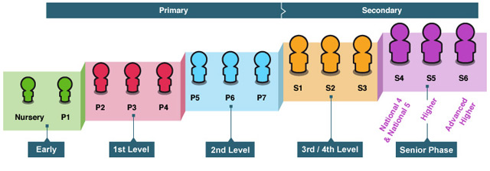

Early Level – pre-school to P1

First Level – to the end of P4

Second Level – to the end of P7

Third and Fourth Levels – S1 to S3

Senior Phase - S4 to S6 and other forms of study

**What is the Broad General Education?**

The Broad General Education (BGE) is the first phase of two closely connected phases of education. The BGE phase stretches from age 3 until the end of S3 after which, learners move into the Senior Phase which starts in S4.

**Curriculum Areas and Subjects**

The BGE is delivered via eight curricular areas which, in secondary school, cover years S1 to S3 and may be subdivided further into individual subjects. The eight curricular areas are-

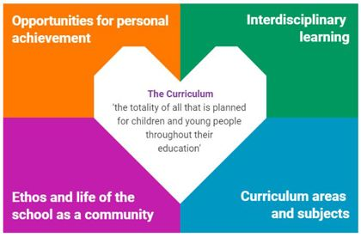

* Expressive Arts
* Languages and Literacy
* Health and Wellbeing
* Mathematics and Numeracy
* Religious and Moral Education
* Sciences
* Social Studies
* Technologies

**The Senior Phase**

The senior phase curriculum, from S4 to S6, follows a young person's broad general education, building firmly on the experiences and outcomes they will have experienced and achieved by the end of S3. It enables them to extend and deepen their learning and continue to develop skills for learning, life and work, through qualifications and also through a range of opportunities for personal development, such as awards and wider achievements. It is designed to support young people in moving on to positive, sustained destinations, whether that is college, university, training or employment. In the Senior Phase, schools and their partners (such as colleges, employers or community learning and development providers) now have flexibility to offer a range of pathways that meet the needs and raise the attainment levels of all learners – including pupils who might previously have become disengaged from education.

Schools are taking a range of approaches to the senior phase and are able to offer greater personalisation and choice for young people in a variety of ways, for example by:

• designing the senior phase as a three-year experience rather than planning each year separately

• delivering qualifications over different timescales in response to young people's needs and prior achievements

• developing pathways for able learners, which bypass qualifications at lower levels to allow more time to be spent on more challenging learning at higher levels

• providing specific and appropriate programmes that maximise achievement and attainment for young people planning to leave after S4.

**Personal Support / Career Planning**

From 3-18 years, learners are supported to achieve their full potential and, as they progress through the broad general education into the senior phase, to plan and prepare for further learning, training or employment. All schools and nurseries in North Lanarkshire are working hard to raise standards so that children and young people will develop all of the skills necessary to continue to be successful when leaving school and entering the world of higher education, training or work. As part of developing skills for learning, life and work, young people will be offered careers information advice and guidance to ensure they leave school and enter a positive, post-school destination of higher education, further education, pre-employment training, employment (including modern apprenticeships), activity agreement or volunteering.



**Assessment and Reporting**

Assessment is an important part of the Curriculum for Excellence and, at all levels, pupils’ progress is closely monitored by teachers and staff. In turn, teachers and staff work with pupils to reflect on their results, looking at their strengths and learning needs, agreeing next steps and action, based on these. As they progress, pupils become more involved in this process, as they develop the skills to make effective judgments on their own learning, developing personal expertise that will be important to them throughout life. Assessment also helps teachers plan learning experiences which are motivating and challenging. Children who may have additional support needs will be assessed using methods best suited to their individual requirements.

In Bargeddie Primary, pupils are encouraged to take a more active part in identifying their own strengths and areas for further development. Teachers provide constructive feedback which clearly identifies areas, which require further development. Pupils engage in both self and peer assessment using set criteria to help guide them. Throughout the session, pupils set personal targets in Literacy, Numeracy and Health and Wellbeing, which they work towards and update, as appropriate. On a daily basis, teachers informally assess. However, throughout the session more formal assessments are administered, usually at the end of a block of work to gauge levels of understanding and to help identify next steps in learning. Where necessary, more specialised assessments may be administered to ensure pupil needs are effectively met.

Parents are kept informed of pupil progress.

September ‘Meet the Teacher’ event

October Parents’ Meetings or telephone discussions

December Interim Report

April Full Report

May Parents’ Meetings or telephone discussions

Ongoing Additional Support Meetings, where appropriate.

At other times, parents may be invited to school to meet with staff and discuss their child’s development needs and next steps in learning. Recently due to Covid restrictions discussions have been conducted online or via telephone calls.

In classrooms, staff will be using improved ways of assessing children’s learning, taking account of national and local advice and guidance. Your child’s progress will be reported to you, so that you know how well your child is doing. Each year the school will let you know what is being done to continue to implement Curriculum for Excellence so that you can be confident that your child is receiving a high quality education.

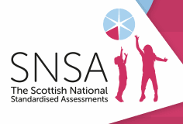

**Language (literacy)**

**Listening and Talking**

Listening and talking have implications for speech development, thinking and learning, generally. In the early years, listening is one of the most important means by which knowledge is acquired. Listening is an active process which has to be encouraged and developed. Talking is the main means of social communication and interaction. Children are given the opportunity to talk in groups, to the whole class and in assemblies, about a wide range of topics. As pupils become more competent they are then encouraged to prepare and deliver presentations to their peers and present at special events and in so doing, develop greater self-confidence.

**Reading and Writing**

In our infant department children follow a programme, ‘Active Literacy.’ This involves the children in a wide variety of activities to develop Literacy skills. These basic skills are promoted through a systematic and progressive programme. Each week children are introduced to new sounds and commonly used, every day words. Gradually, this knowledge, which is essential for reading and writing, is developed. Pupils will also receive several reading books each week, which are tailored to match the child’s specific level of ability. These books cover both fiction and non- fiction. We ask that parents and carers spend time with their child reading and discussing these books, regularly each week.

In our junior and senior departments the focus is on teaching children to become more reflective and responsive readers who can not only read the lines, but who can also ‘read between and beyond the lines.’ To do this, children engage in novel studies. Children read and enjoy selected children’s novels and then explore the text in depth, developing their comprehension skills and further developing their vocabulary.

Each class has a well-stocked fiction library. Pupils in the junior and senior stages, borrow these books to read at home. Pupils in the infant department receive ‘Story Bags,’ to promote reading for enjoyment. Furthermore, a mobile library also visits regularly. When reading for specific information, the internet is also utilised.

Pupils will use their knowledge of phonics and common words to help them produce pieces of writing. As children progress through the school, they will develop skills in handwriting, spelling, punctuation, grammar and structure. The development of reading and writing skills is extremely important as pupils use these skills across all areas of the curriculum.



There are two aspects to the languages area of the curriculum.

1. The first covers experiences and outcomes in the language a young person needs in order to engage fully in society and in learning - whether that is English, Gaelic or for young people who need additional support, the means of communication which enables them to communicate most effectively.
2. The second covers experiences and outcomes in modern languages.



**Modern Languages**

Across all stages of our school, pupils are introduced to a modern language. The main language taught in our school is French. We are fortunate in that we have several members of staff trained to teach this language. In line with national guidelines, we have introduced a second modern language, Spanish. Mrs Logan and Mrs Morrison are responsible for delivering this to specific stages within our school. Please note Bargeddie Primary does not provide Gaelic Language instruction.



We reflect, communicate and develop our ideas through language. Literacy offers an essential passport to learning, helping children and young people to achieve their full potential and be ready for active involvement in society and work. Furthermore, literature opens up new horizons and a love of reading can be an important starting point for lifelong learning. As we communicate increasingly through digital technologies, we need to be able to interpret and convey information in new ways and to apply discernment. Also Scotland has a rich diversity of languages, including Scots and the growing number of community languages such as Urdu, Punjabi and Polish. This diversity offers rich opportunities for learning. Learning other languages enables children and young people to make connections with different people and their cultures and to play a fuller part as global citizens.

Learning through the languages area of the curriculum enables children and young people to:

* develop their ability to communicate their thoughts and feelings and respond to those of other people
* develop the high level of skills in listening, talking, reading and writing which are essential for learning, life and work
* use different media effectively for learning and communication
* develop a secure understanding of how language works and use language well to communicate ideas and information in English and in other languages
* exercise their intellectual curiosity by questioning and developing their understanding and use creative and critical thinking to develop ideas and arguments
* enhance their enjoyment and their understanding of their own and other cultures though literature and other forms of language
* develop competence in different languages so that they can understand and communicate effectively



**Mathematics and Numeracy**

Putting mathematical knowledge and understanding to constructive use has been one of the decisive factors in shaping societies. Engineering, science, technology and business rely upon mathematics and continue to find new applications for mathematics. Also cultural development and artistic endeavour are influenced by mathematics. Each of us uses mathematical skills and concepts in everyday life. To face the challenges of the 21st century, each young person needs to have confidence in using mathematical skills and Scotland needs both specialist mathematicians and a highly numerate population.

Learning through mathematics and numeracy enables children and young people to:

* develop essential numeracy skills,  which allow them to participate fully in society
* develop a secure understanding of the concepts, principles and processes of mathematics and apply these in different contexts, including the world of work
* have an understanding of the application of mathematics, its impact on our society past and present and its potential for the future
* establish firm foundations for further specialist learning e.g. for those who will be the mathematicians of the future.

In Bargeddie Primary, children will be introduced to concepts within the following areas of mathematics and numeracy --

* Number, Money and Measure
* Shape, Position and Movement
* Information Handling
* Problem Solving

We also aim to develop skills in mental maths calculations. Children work as individuals, in pairs and/or as part of a group during maths/numeracy time. We incorporate interactive activities within our programmes of work to teach, reinforce and consolidate maths/numeracy concepts. I.C.T. is a regular feature and children utilise interactive programmes and websites on a daily basis.

**Health and Wellbeing**

Health and Wellbeing includes experiences and outcomes for personal and social development, for developing an understanding of health, physical education and physical activity and also includes aspects of food technology.   
Children and young people need to experience what it feels like to develop, enjoy and live a healthy lifestyle. They also need to learn ways of dealing with the many new and challenging situations they will experience throughout their lives.   
A healthy lifestyle supports physical, social and emotional wellbeing and underpins successful learning.   
Concerns about the health, diet and activity levels of Scotland’s children and young people, social factors and inequalities in health, emphasise the importance of a focus on health and wellbeing throughout education, starting in the early years.

Learning through health and wellbeing enables children and young people to:

* experience positive aspects of healthy living and activity for themselves
* develop the knowledge and understanding, skills, abilities and attitudes necessary for their physical, emotional, social and mental wellbeing now and in their future lives
* make informed decisions in order to improve their physical, emotional, social and mental wellbeing
* apply their physical, emotional, social and mental skills to pursue a healthy lifestyle
* make a successful move to the next stage of education
* take advantage of opportunities where they can excel in sport or pursue careers in health and leisure industries.

**Health and Wellbeing Programme**

The Getting it right for every child (GIRFEC) approach supports children and young people so that they can grow up feeling loved, safe and respected and can realise their full potential. At home, in school or the wider community, every child and young person should be:

safe, happy, active, nurtured, achieving, respected, responsible and included

Each month, all pupils focus on one of the Girfec Wellbeing Indicators, as mentioned above and most of their Health and Wellbeing class work, is directly linked.

Please note, information relating to sensitive subjects, such as Relationships, Sexual Health and Parenthood, and Drug Awareness will be available to parents prior to the delivery of lessons. Parental information sessions may also be provided, as required.

**Physical Education**

Physical Education plays an important role in the wellbeing of all children, as they learn to understand the importance of exercise, in the promotion of good health. Our children are encouraged to develop a positive attitude to an active lifestyle and an awareness of physical wellbeing and what this entails.

Our Physical Education Programme P1 – P7 is based on North Lanarkshire Council’s guidelines, supplemented, where appropriate, by other resources. Through our programme we provide opportunities for the development of physical competence, social skills, fitness and a healthy lifestyle. Pupils participate in a variety of physical activities such as games, team sports, gymnastics, athletics etc.

We aim to ensure that our pupils receive 2 hours of P.E. each week. Identified year groups receive one twelve week block of swimming instruction and specialist sports’ coaching. Throughout the session our pupils receive tuition in Physical Education from our Active Schools’ Co-ordinator and also from visiting specialists. Pupils regularly participate in sporting festivals and competitions. To further encourage our pupils to engage in physical activity, we offer many different clubs both at lunchtimes and after school e.g. football, hockey, netball, archery, badminton, infant games etc. Furthermore, each year during the summer term pupils participate in a Health Week which, once again, encourages our pupils to participate in a range of different types of physical activity.

Bargeddie Primary School has been awarded a, ‘Sports Scotland Gold Award,’ in recognition of our focus on promoting sport within our establishment. Furthermore, in recent years, Bargeddie Primary was credited as being one of the top three primary schools in North Lanarkshire for promoting sporting activity to pupils, which was a fantastic achievement for us, one of which we are extremely proud.



**Please note P.E. activities take place both indoors and outside on our pitch. Therefore pupils require to have suitable, outdoor clothing. At the beginning of each school session, the days and times of P.E. sessions are issued to parents and carers.**

**Religious and Moral Education**

|  |
| --- |
| Religious and Moral Education includes learning about Christianity and other world religions and supports the development of beliefs and values. Scotland is now a nation which reflects a wide range of beliefs, values and traditions. Religious and Moral Education, enables children and young people to explore the world’s major religions and approaches to living. This awareness and appreciation assists in counteracting prejudice and intolerance, as children and young people consider issues such as sectarianism and discrimination more broadly.  The study of Christianity, which has shaped the history and traditions of Scotland and continues to exert an influence on national life, is an essential feature of Religious and Moral Education for children and young people.  Learning through religious and moral education enables children and young people to:   * develop knowledge and understanding of Christianity and other world religions and recognise religion as an important expression of human experience * explore moral values such as wisdom, justice, compassion and integrity * investigate and understand the responses which religions can offer to questions about the nature and meaning of life * develop the skills of reflection, discernment, critical thinking and deciding how to act, when making moral decisions * develop beliefs, attitudes, moral values and practices through personal search, discovery and critical evaluation, and make a positive difference to the world by putting beliefs and values into action. |

Education is about the development of the whole person. Religious and Moral Education deals with the development of the person in relation to self-awareness, relationships with others and the realm of beliefs, values and practices which go to make up a religious outlook on life.



**Christianity and Other World Religions**

Throughout the school year, our pupils study a variety of topics based on Christianity and other world religions. Pupils may also visit places of worship linked to their topics.

It is normal practice for assemblies to take place throughout the school session. Our main assemblies take place at Christmas, Easter and summer. Under normal circumstances, each class has responsibility for leading one assembly each year, to which parents and friends are invited. At key points during the school year our school chaplain or a church representative also leads assemblies in school or in Bargeddie Parish Church.

It is recognised that the Education (Scotland) Act allows parents to withdraw their child from any instruction in religious subjects and from any religious observance. Parents are invited to come along and discuss the R.E. programme with the Head Teacher if they have any concerns regarding this aspect of the curriculum.

Parents/carers from ethnic minority religious communities may request that their children be permitted to be absent from school in order to celebrate recognised religious events. Only written requests will be considered. Appropriate requests will be granted on not more than three occasions in any one school session and the pupil noted as an authorised absentee in the register.

**Expressive Arts**

The Expressive Arts includes experiences and outcomes in art and design, drama, dance and music. Through the Expressive Arts, children and young people have rich opportunities to be creative and imaginative and to experience inspiration and enjoyment. They develop an understanding of the important role of the arts in developing and changing society. Through their experience of Expressive Arts, children and young people can appreciate the contributions of the arts on the lives of individuals and communities.

Learning through Expressive Arts enables children and young people to:

* express themselves in different ways and be creative
* experience enjoyment (and contribute to other people’s enjoyment) through creative and expressive performances and presentations
* develop important skills specific to Expressive Arts and also transferable skills
* develop an appreciation of aesthetic and cultural values and ideas
* prepare for advanced learning and future careers by building foundations for excellence in Expressive Arts.

**Art & Design**

Art and Design promotes discovery and understanding of ideas and feelings and provides a means of expressing these visually. Pupils are provided with a variety of opportunities to develop a range of skills in drawing, painting, collage, printing and modelling etc. In the upper school pupils study the work of great artists. Throughout the school session, pupils will be involved in a variety of art and design competitions e.g. Christmas Card Competition, Road Safety Poster Competition etc.

**Music**

Music is an important part of social culture and can enrich the lives of children. In Bargeddie, we utilise, ‘Charanga,’ and ‘Kodaly Music,’ to deliver music from Primary One to Primary Seven. Our junior and senior pupils can opt to receive musical tuition on brass and stringed instruments. Our Primary Five pupils develop their musical knowledge and skills through specialist, ‘Kodaly’ instruction, which is delivered by Mrs Heather Ewart. Furthermore, Bargeddie Primary has an excellent school choir, which consists of pupils from P4-7. Each year our choir competes in the Glasgow Music Festival and also performs on other special occasions. On various occasions, throughout the year, performances take place to showcase our pupils’ musical talents.

**Drama**

Through drama, our children learn to communicate ideas and feelings via language, expression and movement, in real and imaginary contexts. This helps our pupils to develop confidence and self-esteem. In the main, we utilise North Lanarkshire Council’s Drama Programme of Study. However, Drama opportunities are often inter-disciplinary and have links to other areas of the curriculum.

**Dance**

Through dance, learners have rich opportunities to be creative and to experience inspiration and enjoyment. Creating and performing are the core activities for all learners and taking part in dance contributes to their physical activity. Learners develop their technical skills and the quality of their movement and use their imagination and skills to create and choreograph dance sequences. They further develop their knowledge, understanding and capacity to enjoy dance through evaluating performances and commenting on their work and the work of others.



**Sciences, Social Studies and Technologies**

Within Curriculum for Excellence*,* the technologies curriculum relates particularly to contexts that provide scope for developing technological skills, knowledge, understanding and attributes through creative, practical and work-related activities.   
Learning in the technologies enables children and young people to be informed, skilled, thoughtful, adaptable and enterprising citizens, and to:

* develop an understanding of the role and impact of technologies in changing and influencing societies
* contribute to building a better world by taking responsible ethical actions to improve their lives, the lives of others and the environment
* be capable of making reasoned choices, relating to the environment to sustainable development and to ethical, economic and cultural issues
* gain the skills and confidence to embrace and use technologies now and in the future, at home, at work and in the wider community
* become informed consumers and producers who have an appreciation of the merits and impact of products and services
* broaden their understanding of the role that information and communications technology (I.C.T.) has in Scotland and in the global community
* broaden their understanding of the applications and concepts behind technological thinking, including the nature of engineering and the links between the technologies and the sciences
* experience work-related learning, establish firm foundations for lifelong learning and, for some, for specialised study and a diverse range of careers.



**Please note more detailed information relating to all aspects of a Curriculum for Excellence can be accessed at** [www.educationscotland.gov.uk](http://www.educationscotland.gov.uk)

**Additional Support Needs**

Bargeddie Primary School complies with the Additional Support for Learning (Scotland) Act 2004 as amended by the Additional Support for Learning (Scotland) Act 2009 and the Additional Support for Learning: Statutory Guidance 2017.

North Lanarkshire Council’s policy is contained within, ‘Support for Learning Policy into Practice 2,’ a copy of which is available in school. The school has a Support for Learning Policy, available from the school on request, which is consistent with North Lanarkshire Council guidelines. Our school policy in relation to pupils with additional support needs, reflects North Lanarkshire Council’s staged intervention process.

**Staged Intervention**

The pathway for planning is built around three stages of support. This enables appropriate interventions to be provided for children, as wellbeing concerns change.

Universal Support – interventions provided through support from the core provision of universal services e.g. class teachers adapting the curriculum or learning resources, in-house school supports, consultation with Educational Psychologist etc.

Additional Support – interventions to support the child are provided from more specialised services such as social work, health, 3rd sector etc.

Intensive Support – interventions provided are targeted and integrated with input usually from more than one agency or service, as listed below e.g. bespoke /flexible packages of support, additional support needs provision etc.

* Support for Learning
* Psychological Services
* Physiotherapists
* Speech/Language Therapists
* Bilingual Support
* Inclusion Support
* English as a Second Language
* Child/Adolescent Mental Health Service (CAMHS)
* Occupational Therapists

Parents/carers and pupils are an essential part of the assessment, planning and review process. Regular consultation meetings are a feature of our practice. These meetings allow all parties to contribute. Parents/carers and young people can request that the authority establish whether a child has additional support needs. They can also request an assessment at any time. Looked after Children i.e. children who are cared for directly or whose care is supervised by the local authority are deemed to have Additional Support Needs unless assessment determines otherwise.

**Getting it Right for Me Plans (GIRFMe)**

GIRFMe Plans enable staff to plan effectively for children and young people when interventions are required to support their learning and improve outcomes. Parents/carers and pupils are an essential part of the assessment, planning and review processes and their views will be actively sought.

Some children and young people may require significant support from education and at least one other agency, such as health, social work and/or voluntary agencies to help them meet their learning targets. Where this support requires a high level of co-ordination the opening of a Co-ordinated Support Plan (CSP) may be considered. A CSP may be initiated by the school or another agency.

Parents/carers and young people can, if they wish, request that a CSP be considered and would be involved in the process. Parents/carers will receive letters from the Education Authority throughout the CSP process. Parents/carers and young people will be invited to take part in multiagency meetings and their views will be recorded in the plan.

Where more intensive support for a child or young person, needs to be planned for, usually when a number of agencies are involved in supporting their wellbeing, then a Child’s Plan may be developed. The plan will tell you what actions need to be taken and who will help with each action. It will usually be someone called a ‘Lead Professional’ who will have the job of making sure that the actions outlined in the plan take place and things get better for the child or young person.

**Dispute Resolution**

North Lanarkshire Council is committed to resolving any differences of views through discussion, dialogue and building on common ground.

If the matter cannot be resolved with the Education Authority you have the right to request mediation. An independent mediation service is available to parents/carers and young people through Resolve (see contact details at the back of this handbook). Mediation is free through Resolve and independent of the Education Authority.

In the event that a disagreement cannot be resolved through mediation, then an application for Independent Adjudication (see contact details at the back of this handbook) can be made by parents/carers, free of charge. The Independent Adjudicator will make recommendations to the Education Authority about how the dispute should be resolved.

**The Additional Support Needs Tribunal**

The Additional Support Needs Tribunal has been set up to hear appeals made by parents/ carers or young people on the decisions made by the Education Authority relating to Co-ordinated Support Plans, ASN placing requests and post school transition. If you disagree with any decision relating to your child’s Co-ordinated Support Plan, either the creation of a CSP, or the content of it, you may be entitled to refer to the tribunal.

**School Improvement Plan**

During session 2022/2023 the improvement priorities for Bargeddie Primary School were as follows -

1. Attainment in Literacy & Numeracy will show improvement through improving attendance rates by 5% across the Cluster average through the GIRFEC Pathway.

2. Literacy attainment in reading and writing will be increased, by June 2023, through a range of initiatives such as, an increased focus on pupils within the junior stages, a reintroduction of NLC’s Active Literacy writing practices, through further development of spelling and grammar skills and through involvement in the Scottish Book Trust, ‘Reading School’ initiative etc.

3. The curriculum will be further improved and made more relevant, through an increased focus on sustainability, which will impact positively on pupils by developing responsible, compassionate attitudes linked to a range of current issues, thereby encouraging global citizenship.

Further information regarding our school may be found on the following websites-

[www.educationscotland.gov.uk](http://www.educationscotland.gov.uk)

<https://blogs.glowscotland.org.uk/nl/bargeddiepsblog/>

Twitter Page @bargeddieps

<https://education.gov.scot/education-scotland/inspection-reports/reports-page/?id=1582>

Over the next three years Bargeddie Primary intends to continue to develop and further improve partnership working with parents and other agencies, to ensure maximum benefit for our pupils. We intend placing an increased focus on, ‘Developing the Young Workforce’ and will be providing our pupils with an improved range of opportunities to develop knowledge and skills for their future working lives, via the use of an enhanced number of community partnerships.

Furthermore, we intend to continue our focus on celebrating diversity and promoting inclusion and equality. Following COP 26 and COP 27, sustainability will continue to feature, further developing pupil knowledge and skills, obtained to date and expanding these to include aspects such as social justice, fair trade, human rights, ethical issues, LGBTQ etc.

We intend to enhance our curriculum by providing new and improved opportunities for our pupils, which are both relevant and enjoyable and which encourage development of the four capacities within our pupils.



**Homework**

Children have regular homework set by their class teachers. The amount of homework will vary from stage to stage. In the early stages, Reading and Phonics homework is provided on a weekly basis. It is crucial that these aspects of homework are revised and consolidated regularly, to ensure that pupils have a firm grasp of this learning. Other areas may be included, as and when appropriate e.g. Numeracy, Inter-Disciplinary Learning etc. In the junior and senior stages of the school, the amount of homework will increase. More independent research will be required at home, personal topics undertaken and also personal talks prepared.

All pupils have access to Glow, the first national intranet for education. This

on – line resource fully supports a Curriculum for Excellence and provides access to various activities, which are suitable for all ages and levels of ability and which reinforce and consolidate concepts taught in class. We encourage pupils to regularly utilise this resource. Within Glow, children also have access to Sum Dog, Education City, the Virtual Classroom and other interactive I.C.T. programmes. Class teachers regularly provide homework activities using these resources to reinforce concepts, previously taught in class.

Homework is a key aspect of home/school partnership. Homework is provided to reinforce work taught in class, to encourage independent learning in pupils and to enable parents and carers to keep a regular check on the progress of their child. Parents and carers are therefore asked to work in partnership with the school, by encouraging good homework habits. We ask that homework is completed to a high standard and returned to school by the due date.

Children may also be asked to finish, at home, work which has not been completed in class. We ask that parents support the school, by ensuring any such work is completed. By working in partnership with school staff, parents can help ensure their child keeps abreast of the learning taking place in school.



**Extra-Curricular Activities**

Our pupils enjoy a wide variety of extra – curricular activities.

* Football
* Archery
* Netball
* Dance
* Arts and Crafts
* Book Club
* Sign Language Club

Our pupils regularly participate in local sports’ festivals. We work in partnership with our Active Schools’ Co-ordinator, Mr Craig McIntyre and take full advantage of any sporting opportunities which are on offer. We are fortunate to have a full size football pitch, which we utilise regularly, to participate in outdoor sporting activities.

Under normal circumstances, throughout the school year our pupils are involved in a variety of stage productions e.g. Christmas Nativity, concerts, assemblies etc. All classes also participate in regular educational outings. Our Primary Seven leavers enjoy a special end of year event to mark the end of their primary education.

Pupils in Bargeddie Primary are also provided with opportunities to adopt responsibilities, for areas of development, within our school. Pupils are invited to join various committees and groups. e.g.

* Equality and Diversity Monitors
* Junior Sports’ Leaders
* Rights’ Respecting School Committee
* Eco Committee

Furthermore, senior pupils are regularly involved in monitoring and ‘buddying’ our younger pupils. They are also trained to deliver playground games at lunch breaks and intervals. We believe it is important for our pupils to become effective contributors and take an active part in the life and work of our school. Pupils across all stages evaluate the work of our school via questionnaires and by using criteria contained within a special document entitled, ‘How Good is our School?’ Pupil voice is a vital feature of our evaluations towards further improving our practices within our school, across a range of different areas.

**Other Activities**

Throughout the school year, parents are invited to join with us for various events. We encourage parental involvement and are keen to utilise the talents and expertise of our parents /carers. Any parent who has a particular skill or who has available time and is willing to help in school, is invited to contact the school office, to arrange to become a member of the ‘Protecting Vulnerable Groups’ scheme. After this check has been approved, then the parent/carer is permitted to work alongside staff in school, helping and assisting, where appropriate. Previously, as a result of restrictions in place, due to the Covid pandemic, volunteers and visitors to our school were discouraged. However, now that restrictions have been relaxed we are able to have parents and volunteers working closely in partnership with us once again.

**Freedom of Information**

The Freedom of Information (Scotland) Act, 2002 came into force in 2005. The Act allows anyone to ask for information held by the Council and imposes a timescale of 20 working days for the Council to respond. To deal with Freedom of Information requests, the Council has appointed a Corporate Freedom of Information Officer, with the support of an officer in each service. The Freedom of Information Co-ordinator can be contacted by telephone on 01698 302484

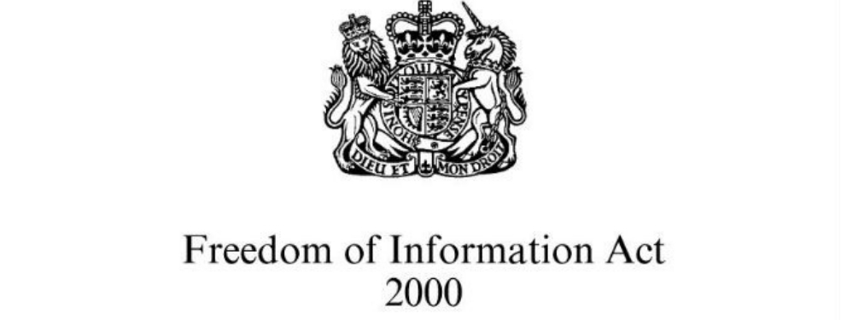

**General Data Protection Regulations (GDPR) Statement for Education**

**What is this statement?**

This statement explains when and why we collect personal information about you, your child or young person and how this information is used, the conditions under which it may be disclosed to others and how it is kept secure.

**Who are we?**

North Lanarkshire Council is a Local Authority established under the Local Government etc. (Scotland) Act 1994. Education and Families is located in Civic Centre, Motherwell ML1 1AB.

**Why do we need your personal information and that of your child or young person?**

The council has a legal obligation to deliver an effective education service to all children and young people in North Lanarkshire. In order to do this we need to collect personal information about children, young people and their families so that we can help them to learn and keep them safe.

**Legal basis for using your information**

We provide this service as part of our statutory function as your local authority. Processing your personal information is necessary for the performance of a task carried out in the public interest by the council. If the information we have asked for is not provided, then we will not be able to provide this service to your child or young person.

**Your personal information**

Education uses the national I.T. system SEEMIS, to store personal information electronically. We ask parents/carers during registration and enrolment to provide us with their child’s name, date of birth, gender, address, family contact details (phone / email). We will also ask you to update this information annually.

We may also ask you for information about medical conditions, additional support needs, religion and ethnicity. We may also record information you may wish to provide about your family circumstances. We require this information to ensure children and young people are educated appropriately, supported, and that we take account of their health and wellbeing.

During a child’s journey through education a pupil’s record is kept. This core record is mainly paper based and is stored securely in the child or young person’s establishment. If the establishment has requested assistance from educational staff out with the nursery or school, key staff from these services may also store information securely about your child or young person.

**How will we use this information?**

Your personal information will be used:

* to enrol your child or young person in nursery or school
* to provide your child or young person with an appropriate education
* for teaching, assessment and planning purposes and to monitor the educational progress of children and young people
* to support pupil learning, improve outcomes and identify where additional support is needed to help children and young people
* to provide appropriate pastoral care to support the health and wellbeing of children and young people
* to keep children and young people safe
* to maintain records of attendance, absence, attainment and behaviour of children and young people (including exclusions)
* to support children and young people during transitions when moving on each year from nursery to primary, primary to secondary and when they move or leave school
* to enable schools and establishments to process personal data in support of SQA and further education
* to monitor and report on pupil attainment and achievement in relation to the National Improvement Framework issued by the Scottish Government
* to assure the quality or our education services in line with national expectations from Education Scotland
* when we require to contact you by post, email, telephone or text

**Who do we share information with?**

To support your child or young person’s access to appropriate education and meet our legal obligations, personal information may be shared internally between services of the council. From time to time, education staff may also need to share information about you, your child or young person with another person from another agency or service e.g. Social Work, Health etc.

We also share information with Scottish Government and bodies such as Education Scotland, Scottish Qualifications Authority, Skills Development Scotland and other organisations that support children and young people’s learning.

When a child or young person moves or transfers to another school the council has an obligation to pass on information with regards to pupil records to the new school.

Only identified staff and those who require to have the information to enable them to carry out their job, will have access to you, your child or young person’s information. We care about the information we hold in respect to the education of children and young people. We will keep this information safe and secure.

**For how long do we keep your information?**

We only keep personal information for the minimum period of time necessary. Sometimes this is set out in law, but in most cases it is based on what we need to fulfil our function. We maintain a ‘records retention and disposal schedule,’ which sets out how long we hold different types of information. You can view this on our website at

[**http://www.northlanarkshire.gov.uk/index.aspx?articleid=15003**](http://www.northlanarkshire.gov.uk/index.aspx?articleid=15003)

**Your rights under GDPR**

**You can:**

* **Request access to your information** – you have the right to request a copy of the personal information that we hold about you, your child or young person. You can ask us to confirm what personal information is being used and with whom it has been shared.
* **Request a correction to your information** – we want to make sure that all personal information is accurate, complete and up to date. Therefore you may ask us to correct any personal information that you believe does not meet these standards.
* **Request the restriction of processing** – this enables you to ask us to suspend the processing of personal information about you, your child or young person, for example if you want us to establish its accuracy or clarify the reason for processing it.
* **Request the transfer** – you can request the transfer of your information to another party.
* **Deletion of your information** – you have the right to ask us to delete personal information about you, your child or young person where:
* you think that we no longer need to hold the information for the purposes for which it was originally obtained
* you have a genuine objection to our use of personal information
* or, use of personal information is contrary to law or our legal obligations.

**If you wish to update any personal information, retrieve it, or have it removed from records please contact your child or young person’s Head Teacher or head of establishment in the first instance.**

**The Council’s Data Protection Officer**

If you have any questions or are unhappy about the way that we use the personal information of your child, young person or yourself you can contact the Data Protection Officer.

Data Protection Officer (DPO)

Civic Centre,

Windmillhill Street,

Motherwell ML1 1AB

or by email to [AITeam@northlan.gov.uk](mailto:AITeam@northlan.gov.uk)



**The Information Commissioner**

You also have the right to complain to the Information Commissioner about the way the council has handled your rights, to enquire about any exercise of these rights or to complain about the way the council has dealt with your rights (or any other aspect of data protection law).

Information Commissioner's Office,

45 Melville Street,

Edinburgh, EH3 7HL

or by e-mail to

[casework@ico.org.uk](mailto:casework@ico.org.uk)



**Transferring Educational Data about Pupils**

Education authorities and the Scottish Government Education Portfolio (SGEP) exchange data about pupils either on paper or electronically through the ScotXed programme.

The data collected and transferred covers areas such as date of birth, postcode, registration for free-school meals, whether a pupil is looked after by his/her local authority, additional support needs, including disability, attendance, absence and exclusions from school. Pupil names and addresses are collected by the school and the council but they are not passed to SGEP. The postcode is the only part of the address that is transferred. Data is held securely and no information on individual pupils can be published by SGEP.

Providing national identity and ethnic background data is entirely voluntary. You can choose the ‘not disclosed’ option if you do not want to provide this data. However, we hope that the explanations contained in this message and on our website will help you understand the importance of providing the data.

**Why do we need your data?**

In order to make the best decisions about how to improve our education service, SGEP and education authorities need accurate, up-to-date data about our pupils. We are keen to help all our pupils do well in all aspects of school life and achieve better educational outcomes. Accurate and up-to-date data allows SGEP, education authorities and schools to:

* plan and deliver better policies for the benefit of all pupils,
* plan and deliver better policies for the benefit of specific groups of pupils,
* better understand some of the factors that influence pupil attainment and achievement
* target resources better



**Your GDPR rights**

The collection, transfer, processing and sharing of ScotXed data is done in accordance with the GDPR. We also comply with the National Statistics Code of Practice requirements and other legislation related to safeguarding the confidentiality of data. GDPR gives you the right to know how we will use your data. This message can give only a brief description of how we use data. Fuller details of the uses of pupil data can be found on the ScotXed website ([www.scotxed.net](http://www.scotxed.net)).

SGEP works with a range of partners including Education Scotland and the Scottish Qualifications Authority. On occasion, we will make individual data available to partners and also academic institutions to carry out research and statistical analysis. In addition, we will provide our partners with information they need in order to fulfil their official responsibilities. Any sharing of data will be done under the strict control and prior agreement of the Data Access Panel in SGEP, which will ensure that no subject specific data will be made public as a result of the data sharing and that such data will not be used to take any actions in respect of an individual.

Further details are available on:

<https://www2.gov.scot/Topics/Statistics/ScotXed/PrivacyInformation>

**Any Concerns**

If you have any concerns about the ScotXed data collections you can email [school.stats@scotland.gsi.gov.uk](mailto:school.stats@scotland.gsi.gov.uk) or write to:

The ScotXed Support Office

SGEP

Area 1B

Victoria Quay

Leith

EH6 6QQ

Alternative versions of this page are available, on request from the ScotXed Support Office, in other languages, audio tape, braille and large print.

**Want more information?**

Further details about ScotXed data exchanges are available on the ScotXed website, http://www.scotxed.net

**Child Protection**

Pupil safety is crucially important to us. We are very aware of the need to identify and protect children who are at risk. In recognition of this, North Lanarkshire Council has clear policies and procedures, to ensure all children are protected from harm. If a member of staff has reasonable cause to believe that a child may have been subjected to harm, this will immediately be referred to the Head Teacher. The Head Teacher will, in turn, follow council procedures and notify Social Work, who will make a decision whether or not to pursue the Notification of Concern. Every adult in Scotland has a role in ensuring all our children and young people are safe and protected from harm, at all times and in all situations. If you have any concerns regarding a child’s wellbeing or safety then we ask that you notify the Head Teacher immediately, as the Head Teacher is responsible for the school’s actions in response to Child Protection concerns.

**If there are any Child Protection concerns the Head Teacher or the Child Protection Co-ordinator will follow North Lanarkshire Child Protection Procedures and Guidelines.**

**Child Protection Co-ordinator** **Mrs Gillian Brady – Head Teacher**

**Telephone - 01236 632150**

**Adult Protection**

The council has responsibility under the Adult Support and Protection (Scotland) Act 2007 for the protection and support of adults at risk of harm within North Lanarkshire. Its employees therefore have the responsibility to ensure the welfare of all adults at risk of harm, with whom they come into contact, as well as providing the highest possible standard of care for some of the most vulnerable members of society. If there are any Adult Protection concerns the Head Teacher or the Adult Protection Co-ordinator will follow North Lanarkshire’s Adult Protection Procedures and Guidelines.

**Adult Protection Co-ordinator Mrs Gillian Brady – Head Teacher**

**Telephone - 01236 632150**

**School Ethos / Promoting Positive Behaviour**

In Bargeddie Primary we promote and encourage high standards of behaviour. We aim to create a positive ethos, via a system of praise, rewards and certificates. We hope that by creating a positive ethos within Bargeddie Primary our school will provide a safe, secure and caring environment for all members of our school community. We strongly promote mutual respect between peers but also between staff and pupils.

In classes, teachers reward appropriate behaviour and at weekly assemblies, certificates relating to the four capacities (successful learners, confident individuals, effective contributors and responsible citizens) are awarded to those pupils who have achieved success in these specific areas. Other rewards and certificates are also distributed, as appropriate.

Bargeddie Primary School also operates a House System, with each child being allocated to a particular house. Our four houses are Cuilhill, Langmuir, Dykehead and Mainhill. During intervals, lunch breaks and at other times, pupils can earn points for their particular house, if they exhibit good behaviour, are kind to others or show exemplary manners etc. Points are counted regularly during the school session. At the end of each school year, at our Awards’ Ceremony, a special trophy is awarded to the house with most points.

Bargeddie Primary has achieved silver, ‘Rights’ Respecting School,’ status, with pupils’ rights being regularly discussed across all stages of our school and linked to aspects of school life. This initiative is closely linked to our school ethos and reinforces and consolidates our vision and values. Currently we are working on our Gold Action Plan, to further develop our work in this area.

Bargeddie Primary pupils are empowered to further enhance the work of our school and apply to become members of specific groups, which focus on improving an aspect of school life e.g. Rights’ Respecting Committee, Eco Committee, Mental Health Ambassadors, Digital Champions etc. Through such empowerment, developments can be advanced with staff and pupils working together in partnership, to reach a common goal.

Unfortunately, there are times when pupils do not follow school policy. On such occasions we work closely with pupils and their parents/carers and at times, outside agencies, to agree strategies to address any issues. On some occasions, a GIRFMe plan may be required. Throughout this process, the child and parent will be fully consulted and their views will be carefully considered.

**Anti-Bullying**

In Bargeddie Primary School we aim to provide a safe, secure and caring environment for pupils and therefore bullying of any kind is not tolerated. Bargeddie Primary School adheres to NLC’s Promoting Positive Relationships : Respect for All : Anti-Bullying Policy (May 2019). Throughout our school, pupils are encouraged to show care and consideration for others. Each year our children undertake a block of work which reinforces the, ‘anti-bullying message.’ The knowledge and skills gained from this programme of work, is continually reinforced and consolidated by class teachers as part of lessons and during assemblies. Furthermore, each year we participate in National Anti-Bullying Week. During this week anti-bullying messages are highlighted to pupils and relevant information booklets, websites etc. are shared with parents/carers to remind them of our policy.

Children are taught to report any bullying incidents so that these can be investigated and resolved swiftly. Where necessary, parents and carers may be contacted and made aware of any situations. We ask that parents/carers work in partnership with school staff to help resolve any bullying incidents.

Cyber bullying is another type of bullying, which can occur. All parents and pupils in our school sign an agreement at the beginning of each session to confirm that the internet will be used responsibly. No child will be permitted to utilise the internet until both parent and child have signed this agreement. Parents should report any concerns to the school if they suspect cyber bullying.

**Additional, useful information relating to bullying is available on our school website.**



**Home / School Links**

Our pre-school liaison (see notes on enrolment) encourages early partnership between home and school and from this initial contact we establish links, which will be further developed during your child’s time in Bargeddie Primary. Partnership with parents is encouraged and welcomed. Parents are invited to help with a variety of class/school activities e.g. making of resources,

art/craft activities, school concerts, parties, outings, general administration etc.

**Please Note**

It is now a requirement, for any parent who is involved in school activities, to be registered in the, ‘Protecting Vulnerable Groups’ scheme. This is arranged by the Head Teacher. Please contact the school office if you are willing to become involved in this process.

**Parent Meetings**

Invitations are extended to parents and carers to come along to school to discuss their child’s progress. These visits take place during the first and fourth terms of the school year. Individual appointments are booked via the online Parent Portal. In addition to this parents/carers are issued with both an interim and end of session pupil report. We also have a ‘Drop in Facility,’ which allows parents and carers to drop in to discuss any pressing concerns with members of the Management Team or class teachers. Please telephone beforehand to ensure staff are available to meet with you. If you wish to arrange a meeting you should, in the first instance, telephone Bargeddie Primary, 01236 632150, in order that a mutually convenient appointment can be arranged.

**Parental Involvement**

To allow children to participate in activities out with school, we greatly rely on parental support and assistance to ensure an appropriate level of adult supervision. Many parents, carers, even grandparents assist with such outings and this help is greatly appreciated. Parents are also invited to join us at assemblies, sports days, fundraising activities etc.

**Communication**

Communication between home and school comes in many different forms. Parents/carers can expect termly school newsletters, individual class newsletters, telephone calls, as well as updates on classwork via termly ‘Snapshot Jotters’ which are sent home to allow parents to monitor and comment upon their child’s progress, in addition to the above mentioned opportunities.

**Attendance at School**

Section 30 of the 1980 Education Act places a duty on every parent/carer of a child of ‘school age’ to ensure that their child attends school regularly. Attendance must be recorded twice a day, morning and afternoon. Regulation 7 of The Education (School and Placing Information) (Scotland) Amendment, etc. Regulations 1993 requires each child’s absence from school to be recorded in the school register as authorised or unauthorised, as defined by the Scottish Government.

At the start of each school session, parents/carers will be asked to provide contact details including at least one emergency contact number. Parents/carers are required to inform the school if these contact details change during the course of the year.

**Absence Procedures**

If your child is absent from school:

* Please telephone the school from 8.30am to inform office staff that your child will be absent on that day. The absence will immediately be logged on our computer system.
* On return to school please send a note explaining your child’s absence. This will be recorded and retained as part of our monitoring procedures.
* If your child is in school A.M. and is absent P.M. please telephone the school and inform office staff that your child will be absent that afternoon.
* The absence will immediately be logged on our computer system.

**Please note**

If your child is absent from school and you have not telephoned the school office, staff will access the main contact number provided for your child. A text message will be sent to this mobile. Please telephone the school office when you receive this message, to inform us of your child’s absence and to reassure staff that your child is safe. If we receive no response to this text message then all other emergency numbers will be attempted. To ensure child safety, police will be contacted if all attempts to locate the child have been exhausted.

**Monitoring Attendance**

* Your child’s attendance will be monitored in school on a monthly basis.
* At certain times during the school session, you will receive a print-out showing actual and possible attendance.
* If there is cause for concern, you will receive a letter from school alerting you to the issue, which hopefully can be resolved.
* Unexplained absences, which impact on the child’s learning, can result in the pupil being referred to the Reporter of the Children’s Hearing.

If your child is likely to be absent from school for some time please inform the school by letter or telephone. When your child returns to school, following an absence, a note should be sent to the teacher, confirming the reason for absence.

**Please note** – If you request permission for your child to attend an appointment during school hours, you must collect your child from the main office. You will be asked to record the date, time and reason for removing your child from school. When your child returns to school the return time will be recorded in our register. This information is kept for our records.

**Please note, no child is permitted to leave the school building, unattended, during school hours.**



**Family Holidays**

**During Term Time**

Every effort should be made to avoid family holidays during term time, as this both disrupts the child’s education and reduces learning time. Parents/carers should inform the school by letter, of the dates, before going on holiday. Absences will be classified as authorised only in exceptional circumstances. Such circumstances may include:

A family holiday judged to be important to the wellbeing and cohesion of the family, following serious or terminal illness, bereavement or other traumatic events.

**A family holiday classified under the ‘authorised absence’ category will not include such reasons as:**

* the availability of cheap holidays
* the availability of desired accommodation
* poor weather experienced during school holidays
* holidays which overlap the beginning or end of term
* parental difficulty obtaining leave (except in cases where evidence is provided by the employer that it cannot accommodate leave during school holidays without serious consequences)

**Family holidays with the above similar characteristics will be classified as unauthorised absences. Where the Head Teacher’s prior agreement has not been sought the absence will automatically be classed as unauthorised.**



**Extended Leave with Parental Consent**

Where most family holidays will be recorded as unauthorised absence, extended leave with parental consent will not be considered the same as a family holiday. Leave in such circumstances will be authorised under circumstances such as:

* Extended overseas educational trips not organised by the school
* Short-term parental placement abroad
* Family returning to its country of origin (to care for a relative, or for cultural reasons)
* Leave in relation to the children of travelling families

**Exceptional Domestic Circumstances**

Parents/ccarers may request permission for such leave in writing and the school may authorise such requests under the following circumstances:

* The period immediately after an accident or illness
* A period of serious or critical illness of a close relative
* A domestic crisis which causes serious disruption to the family home, causing temporary relocation.

**It should be emphasised that the school investigates unexplained absence and that the authority has the power to write to, interview or prosecute parents/carers, or to refer pupils to the Reporter of the Children’s Panel, if necessary. To ensure pupils continue to progress appropriately in aspects of their learning across the curriculum, high levels of attendance are crucial.**

As mentioned previously, pupil attendance is monitored on a monthly basis and where attendance is below that expected by North Lanarkshire Council, a letter will be sent home to parents, to alert them to this. School staff and parents will then work in partnership to address and ideally resolve any difficulties, which may have been preventing regular attendance.

**Community Links**

Bargeddie Primary School enjoys a good reputation in the local community. Strong partnerships have been established, over a number of years, with many different community groups e.g. Amey, Viridor, Lochside Manor Care Home, Community Food and health Partnership, Bargeddie Parish Church, Community Police, Safety Zone Community Centre etc. Invitations are regularly extended to members of the local community to join us in fund raising activities and we appreciate excellent support from local businesses. Throughout the school session, pupils participate in local competitions and festivals.

Throughout the school year, pupils contribute to a variety of charities such as St Andrew’s Hospice, Red Nose Day, Children in Need, Show Racism the Red Card etc. We also work in partnership with other local schools in our area. We work closely in partnership with our joint campus school, St Kevin’s Primary School and enjoy good relations with Coatbridge High School and its associated cluster schools.

**Community Facilities**

It is council policy that school accommodation is made available for use by community groups. Our premises are regularly utilised in the evenings and at weekends by many different groups and clubs. Letting procedures must be adhered to and enquiries regarding further details should be directed to-

#### Community Learning and Development Locality Office

#### Coatbridge Community Centre

#### 9 Old Monkland Road,

#### Coatbridge, ML5 5EA

#### Telephone 01236 638470

**Childcare**

Many of our pupils utilise local child care facilities after school. We have one local ‘After School Club’ based in the Safety Zone Community Cantre, which is a short distance from our school. Many of the pupils on our campus utilise this facility. Pupils are collected from the school gate by staff and taken safely to their base at the end of the school day. Any information regarding this service or other childcare should be directed to the school office.

**Clothing and Uniform**

All North Lanarkshire schools must have a dress code which encourages pupils to dress in a way which is appropriate to attendance at school. This dress code must not lead to direct or indirect discrimination on the grounds of race, religion, gender or disability. Prior to drawing up the dress code the parents/carers, pupils and staff were fully consulted. It is the expectation of Education and Families that parents/carers will be keen to support the dress code and written agreement may be sought.

The uniform of Bargeddie Primary School is as follows:

* grey or black trousers, skirt or pinafore
* white school shirt
* Bargeddie Primary school tie
* Royal blue sweatshirt, cardigan or pullover, with school badge for pupils in

Primaries 1-6

* Navy blue sweatshirt, cardigan or pullover, with school badge for pupils in Primary 7

**Pupils are required to wear the above uniform every day, unless communication has been issued, stating otherwise.**

There is also a uniform, which children wear for indoor P.E. The uniform consists of:

* Pale blue polo shirt, with school badge
* Navy blue gym shorts, with school badge
* Indoor training shoes

The above kit is required for indoor P.E. For outdoor P.E. instead of shorts, pupils are asked to wear navy/black jogging trousers and bring a waterproof jacket.

The above items of uniform, with the school badge can be purchased from Scotcrest, our local supplier. In addition to the above, outdoor jackets, blazers, school bags and homework folders are also available. Other items can be sourced in local shops and supermarkets. We also have a selection of good quality, pre-loved clothing, which has been donated and is freely available. A ‘pop-up’ shop operates periodically throughout the school year. We are delighted when families can make good use of these items of clothing.

**Please ensure that all items of clothing are clearly labelled with your child’s name and class, to avoid any confusion.**

**Clothing which is unacceptable in school under any circumstances, includes items which:**

* could potentially encourage factions e.g. football colours
* could cause offence e.g. anti-religious symbolism or political slogans
* could cause health and safety difficulties such as loose fitting clothing, dangling earrings and other potentially dangerous jewellery.
* are of flammable materials which may be a danger in certain classes e.g. shell suits
* could cause damage to flooring
* carry advertising in particular for alcohol or tobacco
* could be used to inflict injury to other pupils or to be used by others to do so.

Parents/carers in receipt of a clothing grant from the council will be encouraged to purchase items which are in accordance with the school dress code. Approval of any requests for such grants in other circumstances, is at the discretion of the Executive Director of Education and Families. Information and application forms may be obtained from the council website. [www.northlan.gov.uk](http://www.northlan.gov.uk)

Parents/carers are entitled to receive a clothing grant if they are in receipt of any of the following benefits: Income Support, Job Seeker’s Allowance (income based), Employment and Support Allowance (income related), Universal Credit (with an income below £660 per month), Housing Benefit (Please note that the housing element of Universal Credit is not housing benefit), Council Tax reduction (Please note that single person’s discount/council tax exemption is not council tax reduction). The deadline for school clothing grants is March 2023.

Whilst in general terms it would not normally be the policy of the authority to exclude a pupil from school solely on the basis of his/her dress, persistent refusal to respond to a reasonable dress code may be deemed to be a serious challenge to the Head Teacher’s authority and to be detrimental to the wellbeing of the whole school community. In such circumstances a Head Teacher may justify the use of the school discipline procedure.

The council wishes to minimise claims arising from the loss of pupils’ clothing and/or personal belongings. Parents/carers are asked to assist in this area by ensuring that valuable items and unnecessarily expensive items of clothing, jewellery etc. are not brought to school**.**

**Parents/carers should note that any claims submitted to cover the loss of such items, are likely to be met only where the authority can be shown to have been negligent.**



**School Meals**

All eligible two year olds and all children aged from 3 to those not yet attending primary school, that attend a North Lanarkshire Council Nursery or a funded provider (childminder or voluntary/private nursery), are entitled to1140 hours Early Learning and Childcare provision. Those children attending for four hours per day, or more, will receive a free meal as part of the Early Learning and Childcare entitlement.

All P1 to P5 pupils are entitled to a free school meal and free milk. Pupils in P6-P7 who qualify for a free school meal, are entitled to free milk. However, milk will be available to purchase at lunchtimes for all other pupils. All nursery pupils are entitled to free milk and a fruit or vegetable snack.

Children of parents/carers receiving Income Support, Job Seeker’s Allowance (income based), and Employment and Support Allowance (income related), Universal Credit (with income below £660 per month) are entitled to a meal without charge. Information and application forms for free school meals may be downloaded from the council website [www.northlan.gov.uk](http://www.northlan.gov.uk)

Arrangements for lunch are recorded, each morning, on entry to class. Children can choose from the following-

* School Dinner
* Packed Lunch

Pupils who choose to bring packed lunches are requested to bring their packed lunches in suitable containers and also bring drinks in plastic bottles. No glass bottles are permitted. As a health promoting school we ask that parents encourage healthy eating and consider this when preparing packed lunches.

The options for school meals are –

* a main meal
* a ‘snack to go’ (similar to a packed lunch)
* a vegetarian option

**Please note, pupils are not permitted to visit any local shops at lunchtime.**

**Special Diets**

Diets required, as a result of a medical condition (a medically prescribed diet e.g. coeliac disease, diabetes, PKU, food allergy or intolerance) can be provided in school. A medically prescribed diet form, form1A must be completed and signed by the child’s registered dietician or General Practitioner. Procedures and forms can be accessed online through North Lanarkshire Council’s website, by the school, the catering service or also in some cases by the child’s dietician or doctor. For some conditions (PKU, coeliac) parents / carers may be asked to supply prescription foods or attend a meeting to discuss the child’s dietary requirements.

Some children with additional support needs may require food to be adapted to an appropriate texture and consistency. In this instance, the child’s registered dietician or Speech and Language Therapist will liaise with the Head Teacher and school catering service to ensure appropriate food provision. In this case a form will still need to be signed by a medical professional including a Speech and Language Therapist. Any forms that have not been signed by a medical professional will be rejected. The form will be returned to the parent along with a letter stating the reason for the refusal and also they will be issued with a new form.

Any change in the child’s dietary requirements must be advised through a registered dietician or medical practitioner to the Facilities Support Services’ (FSS) Nutritionist. When children move to secondary school or change schools FSS will need to be informed as soon as possible. Special diets such as vegan and ethnic diets can also be accommodated. In this case a different form, form B, should be completed and can be signed by the parent/carer.Complete forms should be returned to [specialdiet@northlan.gov.uk](mailto:specialdiet@northlan.gov.uk)

**Breakfast Club**

We are extremely fortunate to have a breakfast club operating in our school. At 8.15am children line up at the gate beside our football pitch, on Langmuir Road and wait to be escorted to the dining hall. The children can then choose from the following:

Fruit juice, milk, water

Various cereals

Toast

No prior booking is required. Children simply choose their breakfast and pay at the till, using their swipe cards. This is a fabulous facility, which costs £1.00. Many of our pupils take advantage of this service and visit regularly. Supervision is provided. Pupils in P1-5 are all entitled to a free breakfast.

When the weather is particularly bad many children enjoy their breakfast and then remain in the dining hall where they can play table top games and participate in various other, quiet activities, whilst remaining warm and dry.

**Please note, only children wishing a breakfast should attend Breakfast Club. Other children should attend school at their allocated times.**

**Snacks**

We ask that parents/carers provide small, healthy snacks for their children to enjoy during intervals. The interval lasts for 15 minutes, so there is not a great deal of time to eat large amounts. It is also a good idea to provide your children with a drink. We are a health promoting school so we ask that parents/carers reinforce this message, when selecting snacks.

**Sample Menu**

Main Meal £3.10

Sweet and Custard £0.50

Snack To Go £3.10

Fruit Pot £0.50

Fruit £0.40

Baked Potato and Filling £3.10

Milk Plain or Flavoured £0.20

Home baking £0.50

Yoghurts £0.40

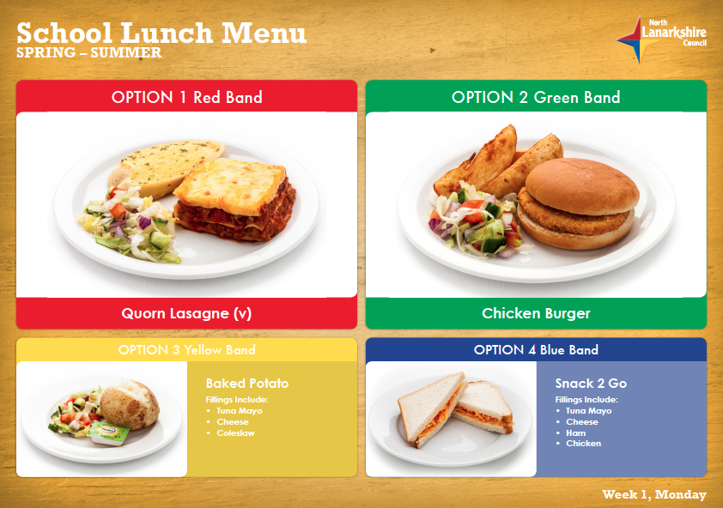

**Transport**

**General**

The council has a policy of providing free transport to primary pupils who live more than one mile from their catchment school by the shortest, suitable walking route. This policy is more generous than the law requires. This provision may be reviewed at any time. Parents/carers who consider they are eligible can apply on the council website. Applications should be submitted by the end of February for those pupils beginning school in August, to enable the appropriate arrangements to be made. Applications may be submitted at any time throughout the year but may be subject to delay whilst arrangements are made.

**There is discretion in certain circumstances to grant privilege transport for pupils to travel in transport provided by the authority, where spare places are available and no additional costs are incurred.**

**Pick up points**

While free transport is provided it may be necessary for pupils to walk a certain distance to the vehicle pick-up point. Walking distance in total, including the distance from home to the pick-up point and from the drop-off point to the school in any one direction, will not exceed the authority’s limits (see above paragraph). It is the parent/carer’s responsibility to ensure that their child arrives at the pick-up point in time. It is also the parent/carer’s responsibility to ensure their child behaves in a safe and acceptable manner while boarding, travelling in and alighting from the vehicle. Misbehaviour could result in a loss of the right to free transport.

**Placing requests**

**The council does not provide transport for those pupils in receipt of a placing request other than in exceptional circumstances.**

In the case of early entry requests, if a child is offered a place in the catchment area school, transport will be provided in accordance with the council’s policy stated above.

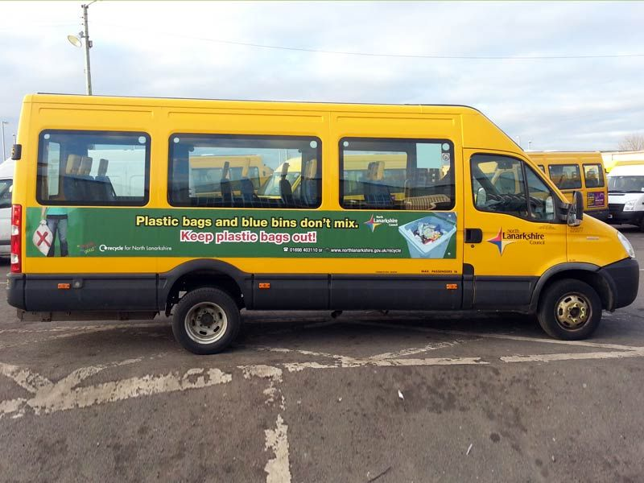

**Medical and Health Care**

NHS Lanarkshire works closely with the school. Medical and dental inspections are carried out during the course of your child’s primary schooling.

Where a child has an accident or falls ill in school, parents/carers, or if they are not available, the emergency contact, will be informed. It is essential therefore, that school records i.e. telephone numbers and emergency contact names etc. are kept up to date. It is essential that a suitable arrangement is made, in case a child has to be sent home from school.

It is of great importance that the Head Teacher is informed of any medical or general wellbeing issues which may affect the child’s behaviour or progress in school. Please discuss with the Head Teacher any particular medical/wellbeing requirements, your child may have.

If a young person is unable to attend a suitable educational establishment as a result of prolonged ill health, North Lanarkshire Council must make special arrangements for the pupil to receive education elsewhere, other than at an educational establishment. In North Lanarkshire, children and young people are treated in the paediatric in – patient unit within University Hospital Wishaw. It is not common for children and young people to have extended stays in University Hospital Wishaw and therefore North Lanarkshire Council does not require a dedicated hospital education service.

Children and young people resident in North Lanarkshire and in hospital in Glasgow, may access education through the Hospital Education Service (HES). The service is provided by Glasgow City Council Education Department and Social Work Services. For further information, please contact the school office.





**Information in Emergencies**

We make every effort to maintain a full educational service, but on some occasions, circumstances arise which lead to disruption. For example, schools may be affected by severe weather, temporary interruption of transport, power failures or difficulties of fuel supply. In such cases we shall do all we can to let you know about the details of closure or re-opening. We shall keep you informed by using letters, notices in local shops and community centres, announcements in local churches and in the press, on local radio, on the North Lanarkshire Council website and Twitter. We may also send text messages and so it is crucial that the school has all up to date emergency contact details. If at any time, during the school session, there are changes to contact details, please inform the school office immediately.

**The Parent Forum**

As a parent/carer of a child at Bargeddie Primary School you are automatically a member of the Parent Forum. The Parent Forum is composed of all the parents and carers of children at the school.

As a member of the Parent Forum you can expect to:

* get information about what your child is learning
* get information about events and activities at the school
* get advice/help on how you can support your child’s learning
* be told about opportunities to be involved in the school
* have a say in selecting a Parent Council to work on behalf of all parents/carers at the school
* be invited to identify issues for the Parent Council to work on with the school

**The Parent Council**

Bargeddie Primary School has an established Parent Council. The following are members of Bargeddie Primary School’s Parent Council.

Parent Member

Amy Mooney - Chairperson Amy Smith

Sara Cameron Kimberlie Mitchell

Susan Livingstone

Karen Ferrie

Lynsey Donnelly

Council Staff Member Advisor to the Parent Council

Lynn Logan P.T. Gillian Brady H.T.

Co-opted Members

T.B.C.

The Parent Council’s rights and duties include:

(a) supporting the work of the school

(b) representing the views of parents/carers

(c) consulting with parents/carers and reporting back to the Parent Forum on matters of interest

(d) promoting contact between the school, parents/carers, pupils and the wider community

(e) fundraising

(f) taking part in the selection of senior promoted staff

(g) receiving reports from the Head Teacher and education authority

(h) receiving an annual budget for administration, training and other expenses.

(i) improving home school partnership and facilitating parental involvement.

Members of the Parent Council are selected for a period of two years, after which they may put themselves forward for re-election, if they wish. In the event that the number of volunteers exceeds the number of places, as set out in the constitution, members will be selected by drawing lots. Anyone not selected to be a member of the Parent Council may be offered the opportunity to be part of any sub groups set up by the council.

Each year an Annual General Meeting is held to reassess the composition of our Parent Council. Where appropriate, positions are reallocated and any vacancies are advertised to the Parent Forum.

Bargeddie Primary Parent Council can be contacted by email. The email address is: [bargeddiepc@hotmail.co.uk](mailto:bargeddiepc@hotmail.co.uk)

Bargeddie Primary School also encourages pupils to take an active part in decisions affecting them in school and so pupils in our school have an opportunity to become members of Bargeddie Primary School’s Pupil Council.

**Supervision in Non-Class Times**

Supervision during non-class time, is provided as far as possible, by Classroom Assistants, office staff and members of the management team. Additional Support Needs supervision will be provided, as appropriate. Our senior pupils may also assist, with monitoring, when necessary.

**An adult presence is provided in playgrounds at break times, in terms of the Schools (Safety and Supervision of Pupils) (Scotland) Regulations, 1990.**



**Placing Requests**

You have the right to make a placing request for your child to be educated in a school, other than the local school. In December each year, the authority will advertise its arrangements for placing requests. There are sound educational reasons for trying to ensure that the transfer or admission of children to a school, takes place at the start of a school session. Other than those who are moving home, to a new area, parents/carers are advised to time any placing requests so that they take effect from the beginning of the new school session. Every effort will be made to try to meet the parental wishes, but you should note that it is not always possible to grant every placing request, to a particular school.

Placing requests to a primary school does not necessarily ensure that your child will have direct entry to the associated secondary. Advice on this must be sought from the primary school Head Teacher. Further information on placing requests and procedures is available from the school or the council’s website.

Parents/carers and young people have a right under the Additional Support for Learning Act 2009 to make a placing request for their child or young person to attend a nursery (including partnership nursery), special school or special class managed by the home authority. In the event of a successful placing request, the authority is not required to provide transport.The Act also enables parents/carers and young people to make a placing request to attend a

School/establishment belonging to another authority.

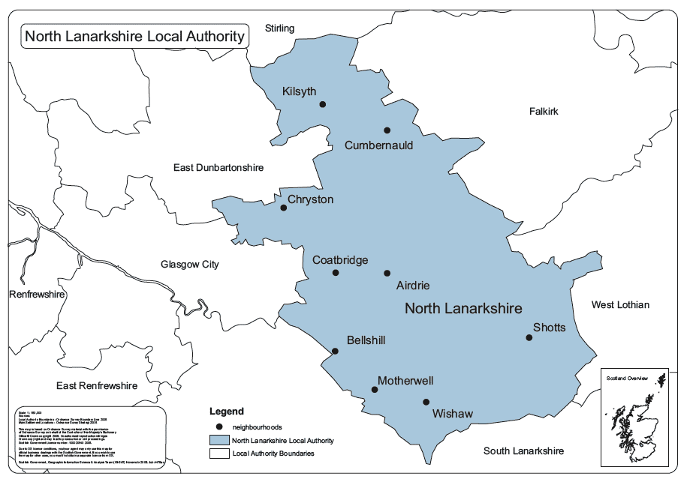

**Transfer from Primary to**

**Associated Secondary School**

Coatbridge High School is our associated secondary school.The contact details are as noted below -

Ms. Christine Creaney, Head Teacher

Coatbridge High School

17 Park Street

Coatbridge

ML5 3NP

Telephone: 01236 794848

Fax: 01236 710493

Email: enquiries-at-coatbridge.org.uk

Pupils normally transfer to secondary between the ages of 11½ and 12½, so that they will

have the opportunity to complete at least four years of secondary education. Parents will be informed of the transfer arrangements no later than December of the year preceding the date of transfer.

Throughout the school year we work closely in partnership with Coatbridge High School. In preparation, for transfer to secondary school, many, varied transition opportunities are provided for our pupils, beginning as early as Primary Five. Staff from Coatbridge High School visit our school regularly to deliver lessons and meet with our pupils. Our pupils are also provided with several opportunities to visit the secondary setting, allowing them to become familiar with the layout of the building and meet senior pupils and members of staff and the management team. Furthermore, our pupils meet their future class mates from other local primary schools and begin to develop new friendships. Importantly, staff meet regularly to ensure all information relating to our pupils’ continued development is passed to the receiving school. Where pupils have additional support needs, an enhanced transition is arranged. Of course, any additional provision is discussed and agreed beforehand with parents and carers, who are encouraged to contribute to this process.

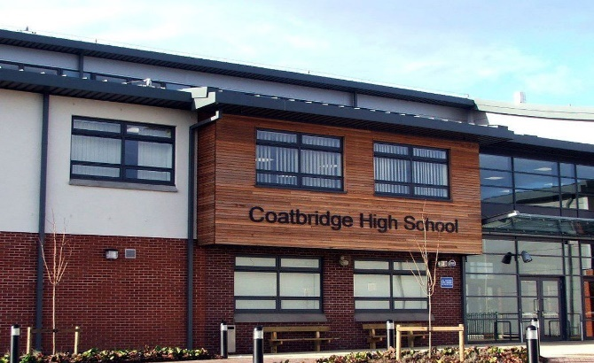

**Useful Contacts**

**Education and Families**  **Chief Executive’s Area Office**

North Lanarkshire Council North Lanarkshire Council

Civic Centre Civic Centre

Windmillhill Street Windmillhill Street

Motherwell Motherwell

ML1 1AB ML1 1AB

Telephone: 01698 403140 Telephone: 01698 302452

**Local Councillors**

K Docherty Tel: 07939280040 or [DochertyKe@northlan.gov.uk](mailto:DochertyKe@northlan.gov.uk)

L Mitchell Tel: 07581032688 or [MitchellLes@northlan.gov.uk](mailto:MitchellLes@northlan.gov.uk)

G Robinson Tel: 07581044089 or [RobinsonGa@northlan.gov.uk](mailto:RobinsonGa@northlan.gov.uk)



Member Services Department

Civic Centre

Windmillhill Street

Motherwell

ML1 1AB

**Head of Education**

Gerard McLaughlin Email: [McLaughlinG@northlan.gov.uk](mailto:McLaughlinG@northlan.gov.uk)

Civic Centre

Windmillhill Street

Motherwell

ML1 1AB

**Education and Families Managers**

Jan McCrone Email: [mccronej@northlan.gov.uk](mailto:mccronej@northlan.gov.uk)

**Cluster Integration and Improvement Lead** Paula McGhie Email: [McGhiePa@northlan.gov.uk](mailto:McGhiePa@northlan.gov.uk)

**Contacts in Relation to Support for Learning**

Help and advice on any matters relating to Support for Learning can be obtained from:

Paula McGhie

Coatbridge High School Cluster

[McGhiePa@northlan.gov.uk](mailto:McGhiePa@northlan.gov.uk)

You can also get more help and advice from:

**Enquire** – the Scottish advice service for additional support for learning, operated by Children in Scotland. Enquire offers independent, confidential advice and information on additional support for learning. Enquire also provide a range of factsheets.

**Enquire**

Children in Scotland

Rosebery House

9 Haymarket Terrace

Edinburgh

EH12 5EZ

Telephone 0345 123 2303

Email: info@enquire.org.uk

Website: [www.enquire.org.uk](http://www.enquire.org.uk) for parents/carers and practitioners

Website: [www.enquire.org.uk](http://www.enquire.org.uk) for children and young people

**Children in Scotland – Resolve Mediation**

Telephone 0131 313 8844

Email: [resolve@childreninscotland.org.uk](mailto:resolve@childreninscotland.org.uk)

**Independent Adjudication**

Scottish Government

Directorate for Learning

Support and Wellbeing Unit

Area 2C North

Victoria Quay

Edinburgh

EH6 6QQ



**Reference to Additional Support Needs Tribunal (Scotland)**

ASNTS

Health and Educational Chamber

First Tier Tribunal for Scotland

Glasgow Tribunals Centre

20 York Street

Glasgow

G2 8GT

Helpline: 0141 302 5860

Email – [www.asntscotland.gov.uk](http://www.asntscotland.gov.uk)

**NHS Lanarkshire**

Coatbridge Health Centre

1 Centre Park Drive

Coatbridge

ML5 3AP

01236 432200

**Social Work**

Coatbridge Social Work Department

c/o Airdrie Social Work Department

Coats House

Gartlea Road

Airdrie

01236 622100

**Community Learning and Development Locality Office**

Coatbridge CLD Locality Office

Coatbridge Community Centre

9 Old Monkland Road

Coatbridge

ML5 5EA

01236 638470

Email: [CLD-Coatbridge@northlan.gov.uk](mailto:CLD-Coatbridge@northlan.gov.uk)



**Complaints / Concerns**

In Bargeddie Primary we value all stakeholders and aim to achieve high standards. Throughout the session we will seek your views and opinions on a range of different areas via surveys and questionnaires. However, there may be occasions where you feel we have not met your expectations and so we ask that if you have any concerns or issues you wish to discuss, that you telephone the school office to arrange a mutually convenient meeting with a member of staff. Also, our Parent Council represents the views of our Parent Forum so if you feel your concern applies to the school, in general, then you may wish to bring your concern to the attention of a member of our Parent Council, who will then raise this on your behalf. Please note, Bargeddie Primary School adheres to North Lanarkshire Council Complaints guidelines and follows the procedures detailed on North Lanarkshire Council’s website.

**Qualifying Statement**

Although this information is accurate at the time of printing, there could be changes affecting any of the matters dealt with in this document –

(a) before the commencement or during the course of the school year in question

(b) in relation to subsequent school years

Education authorities, are required by law to issue a copy of the school handbook to certain parents/carers in December each year. It details the current policies and practices of both the council and the school.