How to Access Glow
- Open your web browser and type https://sts.platform.rmunify.com/account/signin/glow into the address bar.

- You should now be looking at a screen similar to the image below:
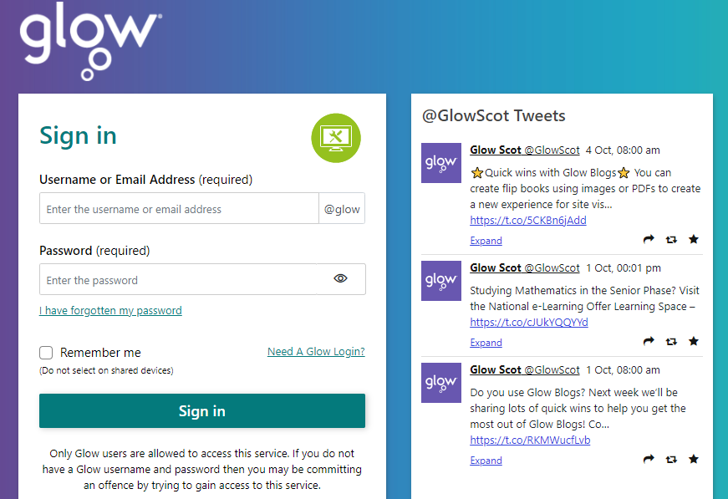

- Using the log in details provided to you from the school, please enter your username and password and click the sign in box.

- Once you have successfully signed in, you should see a page similar to the one below:
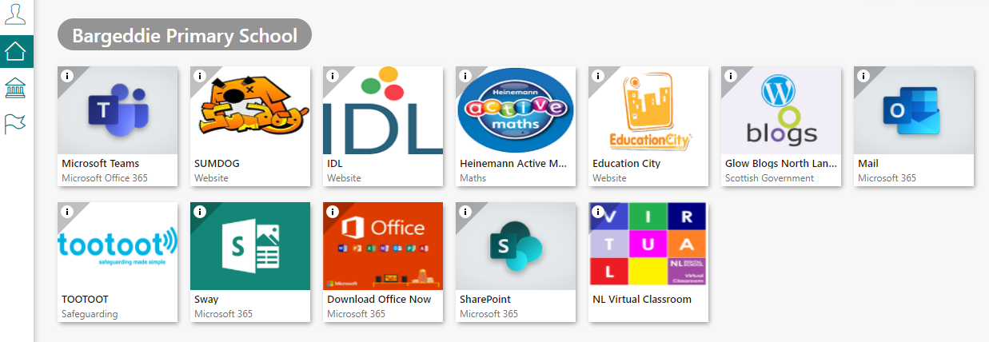

This is your glow launch pad, you can access lots of different apps from here.

