How to use Microsoft Teams

- Follow the link below to take you to the Glow homepage.
https://sts.platform.rmunify.com

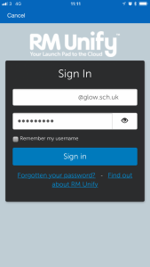
- Sign in to your Glow account using your own log in details. When you have logged in, you will then see the Launch Pad.
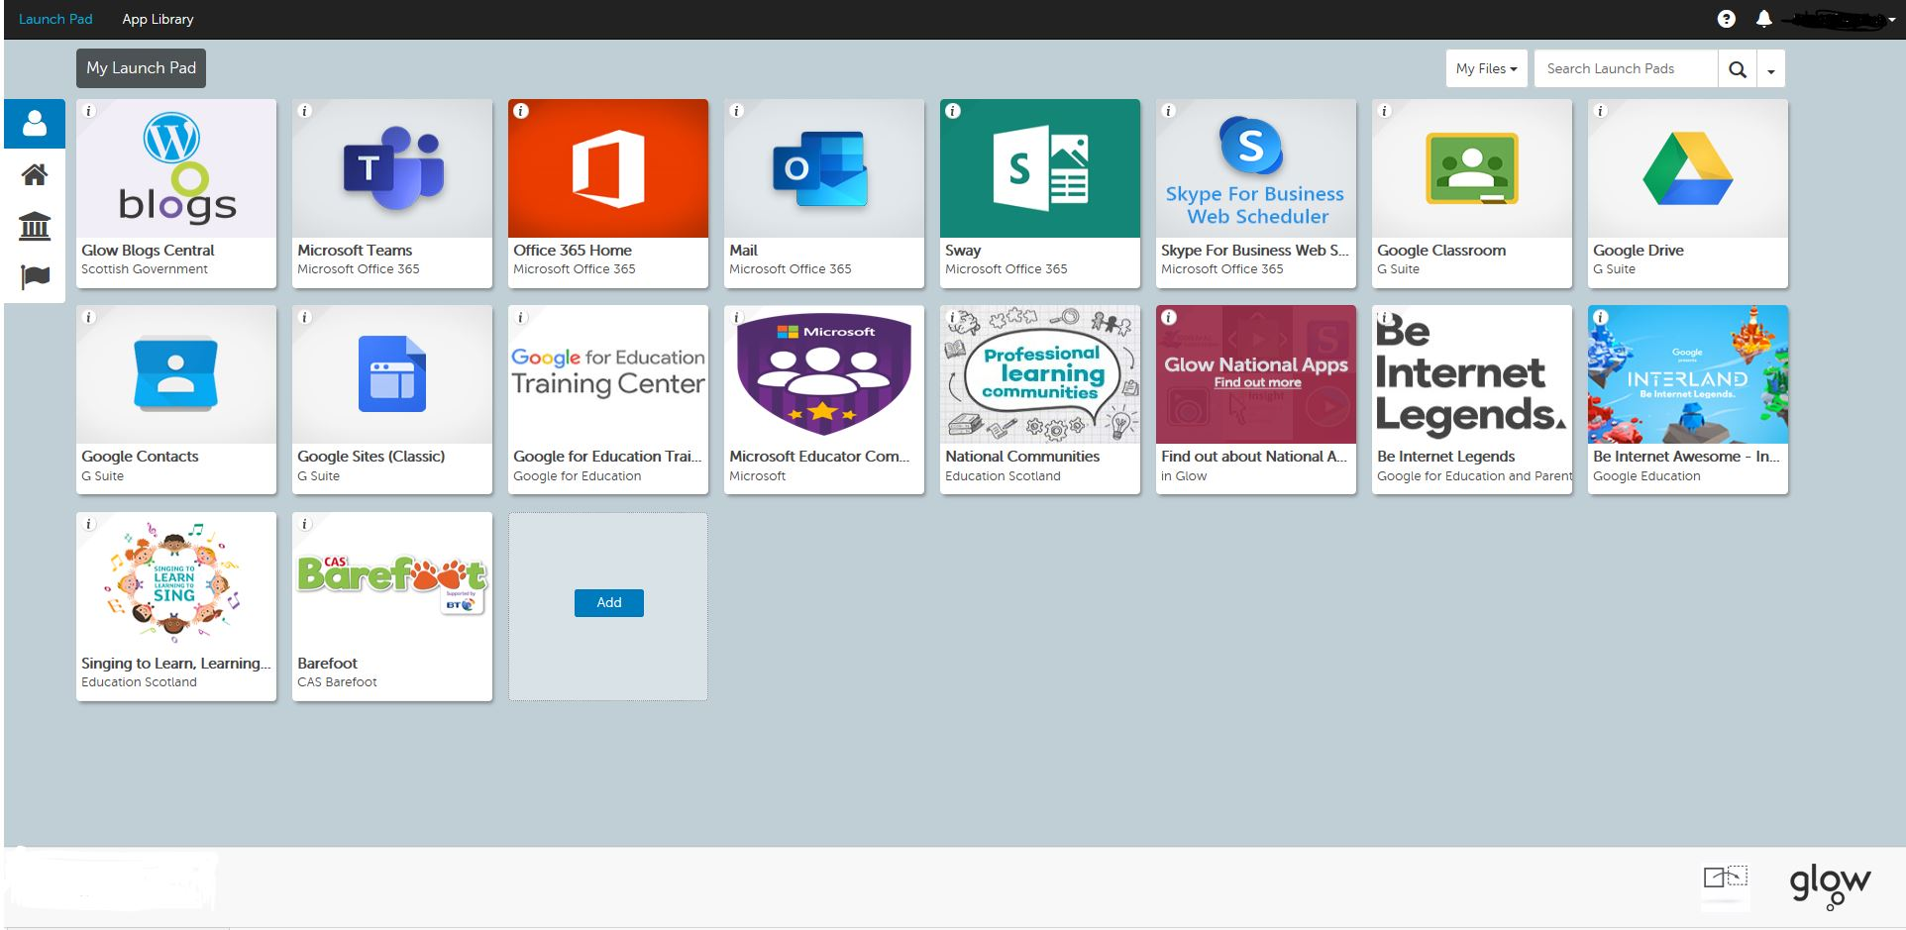

- Click on Microsoft Teams, which will open a new tab.

- You might see this picture if you do click on Use Web App.

- Once you are in Microsoft Teams click on the tile that relates to your class.

6. You will see the banner for join the meeting, click on this banner.
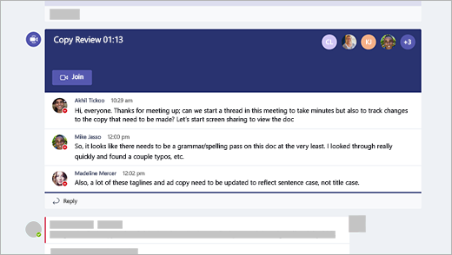

Click here to join.

- Please DISABLE the camera. You can see us but we can’t see you!

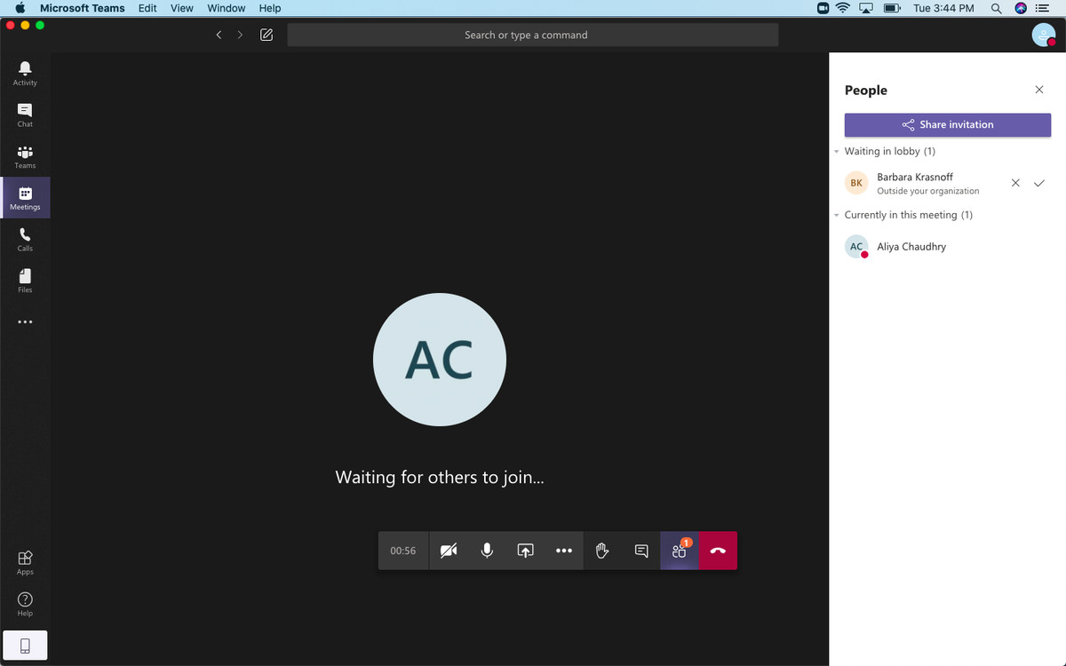

Click here to disable to camera.

Microsoft Teams App

You can download Microsoft Teams to your phone through the App Store or Google Play.

- Once you have downloaded the App you will need to sign into Microsoft Teams using your Glow username and password.

You will need to add @glow.sch.uk to the end of your username

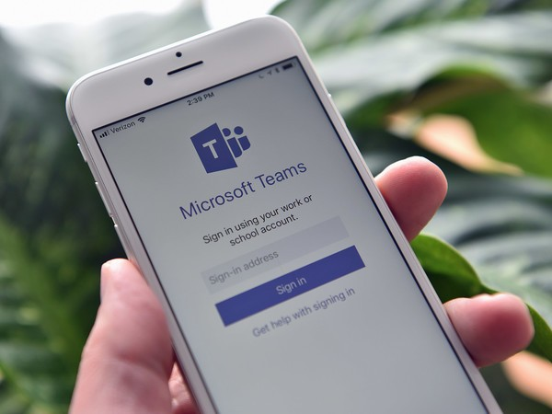

- Click on the relevant Class Team.
- This will allow you to:-
    - Access resources from page
    - Find tasks to complete and resources to support you
    - Hand in assignments
    - Contact your class teacher
- During a team meeting please DISABLE your camera, you can see us but we can’t see you!

