NLC Maths and Numeracy Learning at Home
Second Level: Data and Analysis

The graph below shows how many times people visited the ice rink.
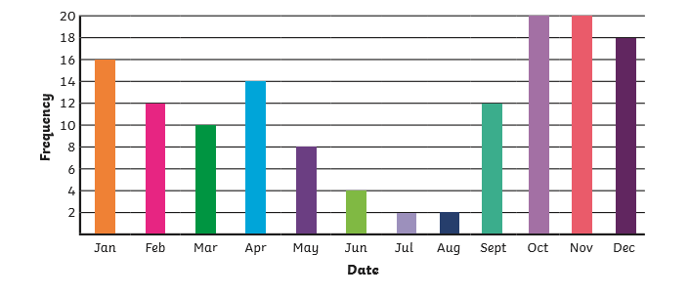

What month did the ice rink have the most visitors?

What month did the ice rink have the least visitors?

How many visitors did the ice rink have altogether over the whole year?

What’s the difference between the number of visitors in October compared with June?

What was the average number of visitors per month?

