NLC Maths and Numeracy Learning at Home
Second Level: Data and Analysis
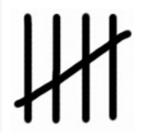
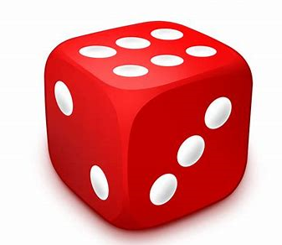

Roll a dice 20 times. Keep track of the number that is rolled each time using tally marks.
Number Rolled | Tally Marks
1
2
3
4
5
6

Predict what the answers will be if you roll a dice 40 times. Now roll the dice 40 times and keep track of the numbers. Were you close?
Number Rolled | Tally Marks
1
2
3
4
5
6

Now choose a different way to display the data. You can choose from a bar graph, a pie chart, a pictograph or a line graph.

