NLC Maths and Numeracy Learning at Home
First Level: Data and Analysis
Block Graph
Colour a box for each item you find.
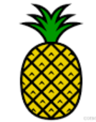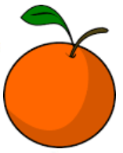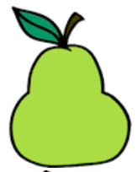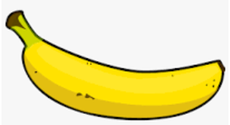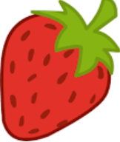

6
5
4
3
2
1
How many apples are there?
How many bananas are they?
Which fruit has the most amount?
Which fruit has the least amount?
How many more oranges than strawberries are there?
Can you create your own block graph?

