NLC Maths and Numeracy Learning at Home
First Level: Data and Analysis
Bar Graph
John carried out a survey in his class to find out what everyone’s favourite pets are. He put the information in this bar graph. Using the bar graph, answer the questions below.
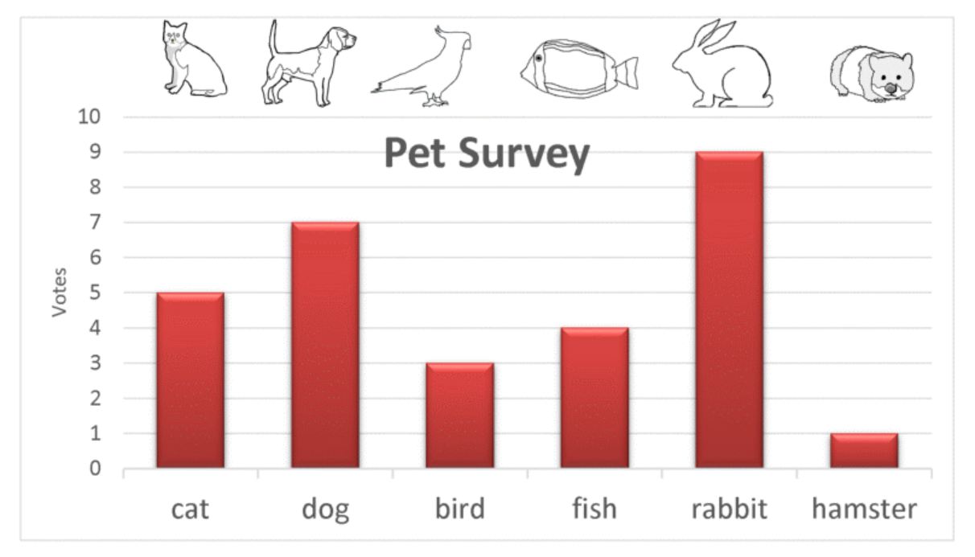
Which pet got the most votes?
Which pet got the least votes?
How many votes did the fish and cats get altogether?
How many more votes than the birds did the rabbit get?
How many votes did the dog get?
What’s the difference between the votes for the fish and the hamster?
Carry out a survey with your family. It could be eye colour, favourite food, hair colour or something you choose. Make a bar graph to show the information you found.

