Auchinloch Primary School
&
Nursery Class

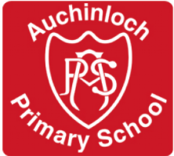

Twitter Policy

Auchinloch Primary & Nursery Class
Social Media: Twitter Policy

What is Twitter?
Twitter is used primarily as a method of communication. It is an information network made up of 140-character messages called Tweets. It's an easy way to discover the latest news related to subjects and topics of interest.

What is the purpose of @Auchinloch1
@Auchinloch1 has been created principally to be followed by staff, parents and the community in order to share information and publicise the excellent work of the school.

Aims of Using Twitter:
- To enhance and improve communication with parents and the school community.
- To share and celebrate children’s achievements and successes.
- To provide daily school updates.
- To demonstrate safe and responsible use of social media.
- To meet the needs of a digital age by engaging in the use of 21st Century technology.

The school Twitter account was set up in November 2016 as a public account. It will be updated by School staff members.

Code of Conduct:
The HT and teaching team in the school will monitor followers and block any who:
- appear to not be school focused.
- have user names not in keeping with NLC objections or the ethos of the school e.g.
sexualised, football team affiliated, alcohol or drug related names.

The school Twitter account will:
- welcome positive comments only, favourites and retweets.
- only follow educationally link accounts. No personal accounts, unless they are educationally linked, will be followed.
- only use children’s first names when referencing children.
- not respond to any ‘replies’ on Twitter. It is not designed as a platform to discuss or debate school related issues.

