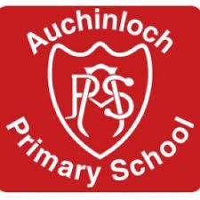

Auchinloch Nursery Class

Complaints Procedures

January 2020

Auchinloch Nursery Class
Complaints Procedure

Our complaints procedure aims to provide a quick, simple solution. In the first instance matters of concern should be raised with a member of staff within the nursery. Staff will make every attempt to resolve the issue quickly and will inform the management team of the complaint before any action is agreed.

You may wish to contact a member of the management team directly. Complaints may be directed to:

Mr Andrew Brown Ms Megan McCrossan
Head Teacher Principal Teacher
01236 794824 01236 794824
ht@auchinloch.n-lanark.sch.uk mmccrossan@auchinloch.n-lanark.sch.uk

We will always strive to resolve complaints at school level. We pride ourselves in having good relationships with our parents and partners. If you feel we have not resolved a complaint to your satisfaction, then you should go onto North Lanarkshire Council’s website and download a form which can be completed online.

http://www.northlanarkshire.gov.uk/index.aspx/articleid=1161

All service users have the freedom to contact the Care Inspectorate at any time by,
- Filling in an online form
https://www.careinspectorate.com/index.php/complaints
- Calling 0345 600 9527
- Writing to the following address,
Princes Gate
Castle Street
Hamilton
ML3 6BU
Any complaint made under the complaints procedure will be fully investigated and, where appropriate, the complainant will be informed of any action taken.

