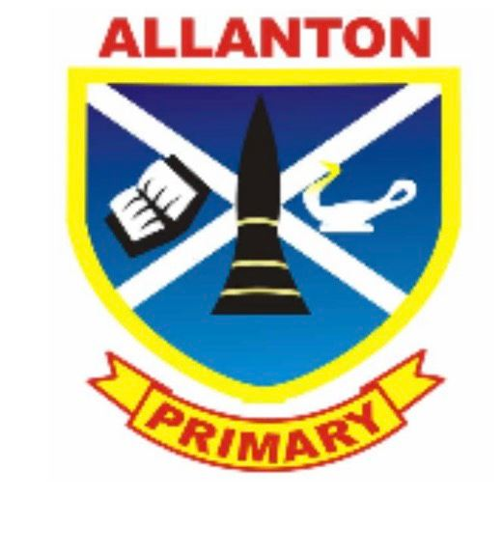
30th October 2023

ALLANTON PRIMARY PARENT COUNCIL
CHAIR’S REPORT

FOREWORD

Since our October meeting I am pleased to say that plans and actions are well underway. I am very honoured at the support I have received so far in my role, and I am enjoying aiming to strive for our children.

I am delighted to say that just a few months into our first term back it is so nice to see all the children new and old settling into their new classes.

COUNCIL MEMBERS

The current members are as follows:

- Moira Williams (Chairperson)
- Holly Hanley (Secretary)
- Julie Mc Millan (treasurer)
- Kirsti Hutchison
- Nicola Wilson
- Deseree Pettigrew
- Vikki McMillan
- Kerry Wilson
- Alisdair Kilgour
- Gemma Mc Lellan
- Carolyn Ford
- Kerry Kaczmarek
- Vicki Thomson (co-opted)
- Natalie Waddell (co-opted)
- Kirsty Brown (co-opted)
- Kirsty Wemyss (co-opted)

FINANCIAL REVIEW

Please see additional Treasurers Report

FUNDRAISING

We have recently signed up for MY NAMETAGS fundraising.
- My Nametags – online ordering service for you to purchase nametags to put on your children’s clothing at school so it does not get lost. All funds raised go towards our children.
When ordering please use School ID code 65464
https://www.mynametags.com/affiliate?id=65464
www.MyNametags.com

We have arranged BAG PACKING at the Co-op in Shotts – this is open to the full parent forum. Dates are.
- Saturday 4th November 2023
- Saturday 23rd December 2023

We have various continuous fundraising.

- Charity boxes – these are located within Spar, Premier Shop and Damside Cafe we have purchased more charity boxes to distribute.

- Your school lottery – weekly lottery not related to the national lottery. All funds raised are used to benefit the Nursery and Primary School children.
For those of you not involved please have a look at
https://www.yourschoollottery.co.uk/lottery/school/allanton-primary-school

- Easy fundraising – 100% free and easy to use.
As easy as 1 2 3
- Download easyfundraising app or go onto www.easyfundraising.org.uk
- Register
- Shop
If you use easy fundraising when ordering online, then we receive funds for our school, and it doesn’t cost you anything.
A few online shops you can use are Argos, Amazon, Sports direct, Tesco, Pets at home,
eBay, booking.com, Sainsburys, Just eat, Tui, H&M, Boots, JD Sports and many more.

EVENTS

- Halloween party – our Halloween party took place during school time for all children. Unfortunately, we were let down last minute with NLC unable to allow the let due to staff shortages. This however didn’t bother our children as they had a fantastic time.

- Christmas Fayre – our Christmas Fayre will take place on Thursday 7th December 2023. Times will be published via the school and our Facebook page. We currently already have a few stalls booked and look to take deposits prior to the evening. Deposits will be returned if cancelled, only if we can replace the stall space with someone else.

- Valentines Disco – our Valentine’s disco will take place at Allanton Primary School on Thursday 8th February 2023. Times will be published nearer the date.

- Pantomime – Booked for Thursday 14th December 2023 and we can confirm this will definitely go ahead with the venue changing to the Ravenscraig Sport Facility.

- Nursery Christmas trip – Booked for Monday 18th December 2023 Believe in Santa at M&Ds Motherwell

- P7 leavers prom

Dykehead Primary School have confirmed that they want to run things together again. We will meet up in November to discuss the prom with Dykehead PC.

- Prize bingo – Date to be confirmed.

All updates will be given as we progress.

PARENTAL ENGAGEMENT

We are looking to obtain as much parental engagement throughout the parent forum.

We currently have our existing Friends of Allanton closed Facebook group page. We have appointed a PC member to add additional security questions to restrict it to parents/carers of Allanton Primary School and nursery only. This will allow us to publish our minutes from meetings within that group.

To allow us to keep those up to date that are not on social media, we have started to do a Parent Council newsletter which will be sent out via email by the school office.

TOILET REFURBISHMENT

Our toilet refurbishment is ongoing. We are still chasing and following this up but have been advised that it is only out for Tender. I will continue to follow this up and details will be given.

HMI INSPECTION

The report was issued on 19th September 2023 and as was expected our school received a glittering report.

I would like to thank and congratulate all our staff at Allanton Primary School for this outstanding report. It makes parents feel good that our children are part of such a wonderful school and come to a safe and nurturing environment each day.

OUTDOOR LEARNING AREA

With North Lanarkshire Council aiming schools towards outdoor learning, we are looking at trying to help our school develop our outdoor learning area. We will look at what funding is available through grants.

MULTI-USE GAMES AREA (MUGA)

Our MUGA is ongoing there is no further update from Colin Shearer. Updates will be given when available.

THANKS

I would like to thank everyone in our parent council for all their help organising events and supporting myself.
I would also like to thank all the staff within the school for continuing to provide a safe happy environment for our children.
Another thanks go to all our parents and local community for all their generous donations and support.

Moira Williams (chairperson)

