Thank you all so much for your continued support in following the recovery plan that is keeping us all safe. To support infection control procedures, we ask that all adults remember the 2-metre distance rule that is in place at drop off and pick up time, where possible this should mean being 2 metres from staff too. To support this could children please carry their own bags and lunch boxes into the building.
When collecting your children at 2.45pm could you please leave the playground as promptly as possible ensuring the playground is free from adults when the schoolchildren are dismissed from class at 3pm. This will help reduce the possible spread of covid-19.
Thank you for your continued cooperation.

Learning and Teaching
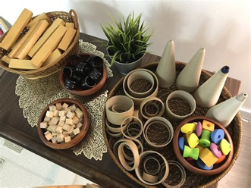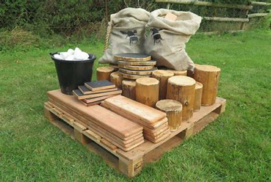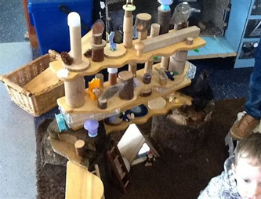
Children are currently helping to develop loose parts play within the nursery environment both indoors and out. Research has shown that loose parts play can facilitate the development of children’s creativity, exploration and imagination. It also leads to discovering more about the world by learning about natural and manmade materials with different textures, shapes and colours that encourages counting, sorting, grouping, matching and identifying patterns and designs.
Loose parts are open-ended materials that children can use in many ways providing endless imaginative opportunities. A box can become a rocket, a home or a boat!
Watch out for your children’s creations in the coming weeks on twitter.
Children have also been involved in creating a real-life home corner in the small room where they can explore the endless possibilities that using real resources bring. From using scarves as dresses to go to a wedding , tablecloths for having tea on and even kites blowing in the wind to trying on different sized and shaped shoes to see which pair fits who the best the children have been so engaged in touching, smelling, talking about, sharing and role playing with these open ended resources.

As we enter the winter season and outdoor play is on offer to all children every day you may want to consider placing some hats, gloves, scarves and maybe a warm jumper (clearly labelled) into your child’s bag to keep them warm and comfortable should they choose to learn outdoors on a cold wintery day.

Monday 16th November – In service day

