Outdoor Learning at Allanton Primary

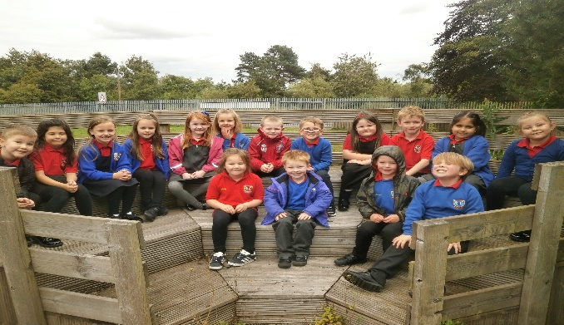

Learning outdoors can be enjoyable, creative, challenging and adventurous and helps children and young people learn by experience and grow as confident and responsible citizens who value and appreciate the spectacular landscapes, natural heritage and culture of Scotland.
(Curriculum for Excellence through Outdoor Learning)
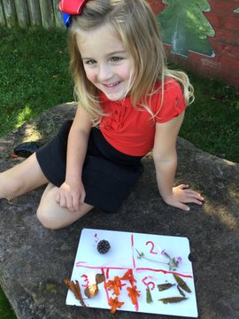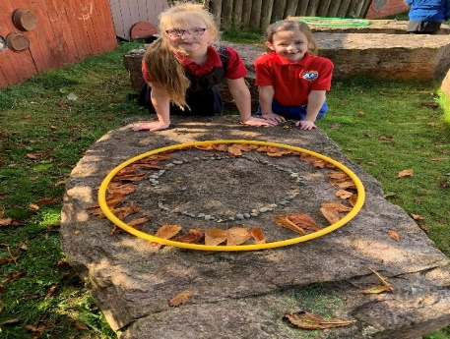
At Allanton Primary we have developed our out-door space into a variety of different areas. We have:
- A Sports Field where all pupils can do P.E outside and play many different sports such as football, rounders, badminton etc. We also hold our school Sports Day every year in this space.
- An amphitheatre which is used for Drama, story-telling and music.

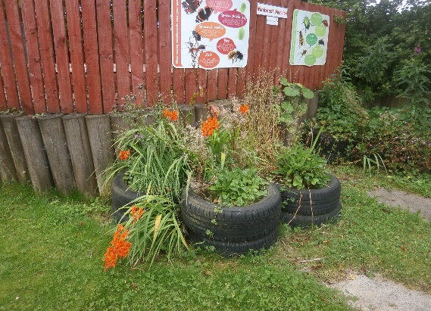
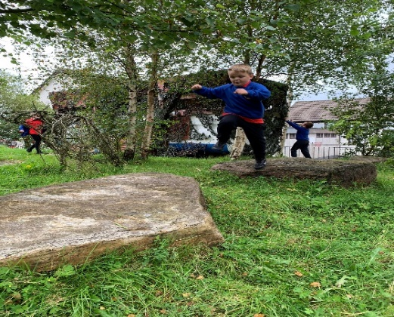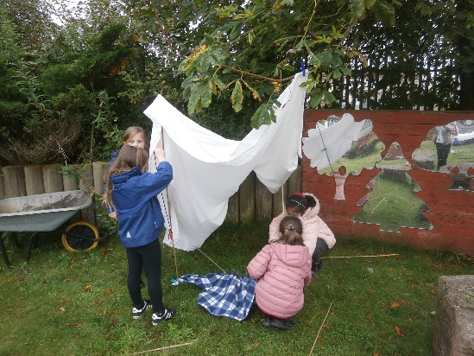
- An Orchard area which we use for den making and a Bird Hyde which we used when taking part in the Great British Bird Watch.

- A vegetable garden and poly tunnel where we plant seeds and vegetables such as potatoes, lettuce, onions, courgettes and herbs. In the past we have made soup from our garden produce and apple muffins from our apple trees.
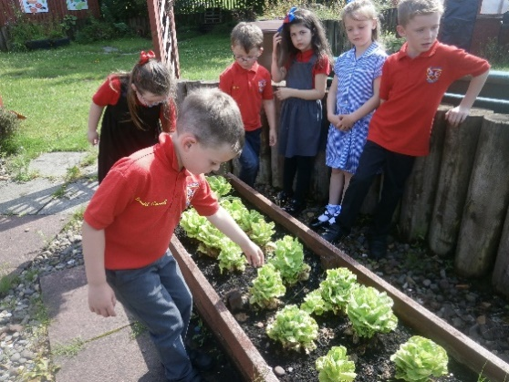

- An Outdoor classroom which is used mostly during spells of good weather.
- A mini-beast mansion which is used for Science and Nature activities.
- A mud kitchen and Nursery garden with a pirate ship which is used to help develop social skills, talking and listening and co-operative learning.
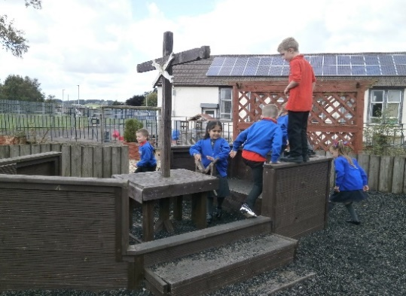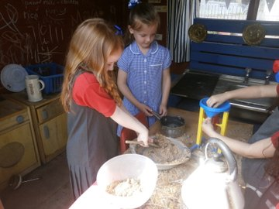
Well-constructed and well-planned outdoor learning helps develop the skills of enquiry, critical thinking and reflection necessary for our children and young people to meet the social, economic and environmental challenges of life in the 21st century. Outdoor learning also connects children and young people with the natural world,

