Allanton Primary school and Nursery Class
Digital remote learning

During this difficult time, teachers have been working hard over the past couple of weeks in order to be able to continue to provide quality learning for our children. We appreciate that these are very difficult times for everyone and to help sustain a level of normality we encourage you as much as possible to access these materials for your child to continue learning at home. At Allanton our main digital resources for remote learning are Glow and Twitter.
Glow
Each child has been provided with their own unique Glow login and password. This is a digital platform where children can access learning materials via Sharepoint, have their own Glow email and also use Teams to communicate with their teacher. Glow can be accessed on any digital device which has internet access. (Mobile phone, Ipad, tablet, Xbox, Playstation, Smart TV) When accessing materials, children can print off work, or use the jotter provided in the home learning pack to complete tasks. They can then send them via Glow email or Teams back to their teacher.

Twitter
Twitter is being used by families to interact with the staff from the school. Some parents are posting photos of children completing various tasks and challenges. This is a nice way for the school to continue the lovely community spirit we are all used to. Twitter is also a very quick way to communicate with staff from the school regarding Glow password changes or log in issues. Teachers can rectify these quickly and efficiently. We encourage as many families as possible to follow the school Twitter page and to check it frequently for challenges and posts by teachers and friends. The school page is @allantonprimary
Sumdog
Our children are all very familiar with Sumdog and can use their school logins at home. Sumdog is a great maths resource which is tailored specifically to your child’s ability. During school closures Sumdog is also providing free access to their Spelling program. Teachers have been posting class challenges and competitions on Sumdog to encourage interaction. The Sumdog app can be downloaded on any digital device or accessed via Google.

We encourage you to access as many of these digital learning resources as possible and thank you for your continued support in this difficult time.

Miss Arbuckle
ICT Co-ordinator
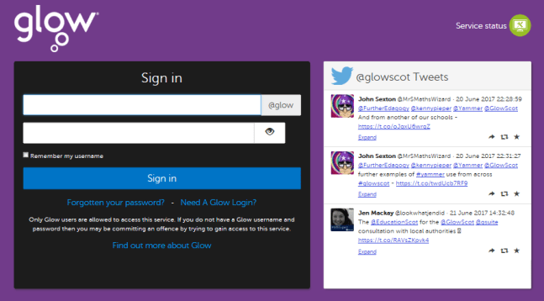
How to access Glow

Step 1: Visit the Glow sign in screen from any internet platform
https://glow.rmunify.com/
Step 2: Enter Glow login and password provided
Step 3: When you log in to Glow, you will see a Launch Pad like this
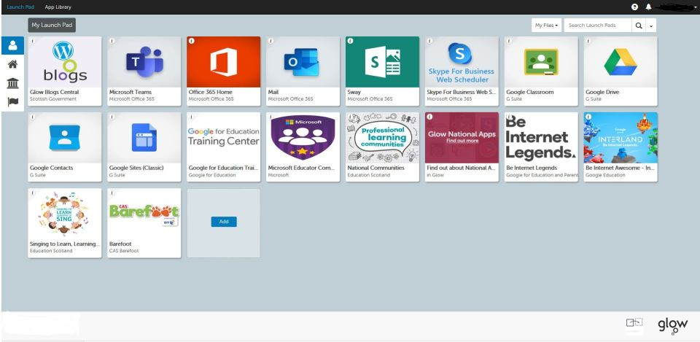
Step 4: Each tile represents different access points.
- Sharepoint (learning materials)
- Mail (personalised email)
- Teams (class group communication)

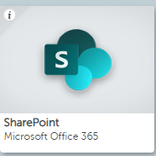
To access learning materials
Step 1: Click on the Sharepoint tile on Glow Launchpad
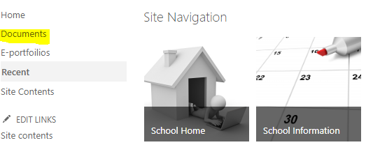
Step 2: Select documents on the left hand side.
Step 3: From documents select class folder
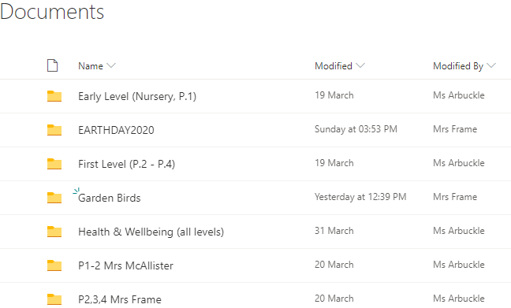
any appropriate learning materials

To access Teams via Glow
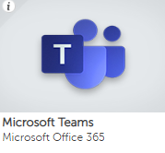
(Teams can be accessed via Glow or an app can be downloaded onto a digital device)
Step 1: Click on the Teams Tile on Glow Launchpad
Step 2: Select the Team you have been added to
Step 3: Use this to communicate with your teacher and class mates
To access Teams via app
Step 1: Download the Microsoft Teams app using your normal app store
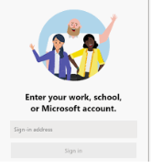
Step 2: The login will require and email address and password
Username: your Glow login (including @glow.sch.uk)
Password: your Glow password

Step 3: Select the Team you have been added to

Step 4: Use this to communicate with your teacher and class mates

To access Glow Email
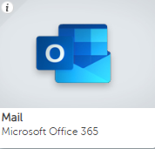
Step 1: Click on the Mail Tile on Glow Launchpad

Step 2: Use the Email interface to send and receive emails with
your teachers. (This is the most efficient way to send
examples of your work)

P1 | gw09mccallumvivien@glow.sch.uk
P2/3 | gw09frameelizabeth@glow.sch.uk
P3/4 | gw18mcallisterlisama@glow.sch.uk
P5/6 | gw19arthurcarolyn@glow.sch.uk
P7 | gw12arbucklecheryl@glow.sch.uk

